**Task 1:**

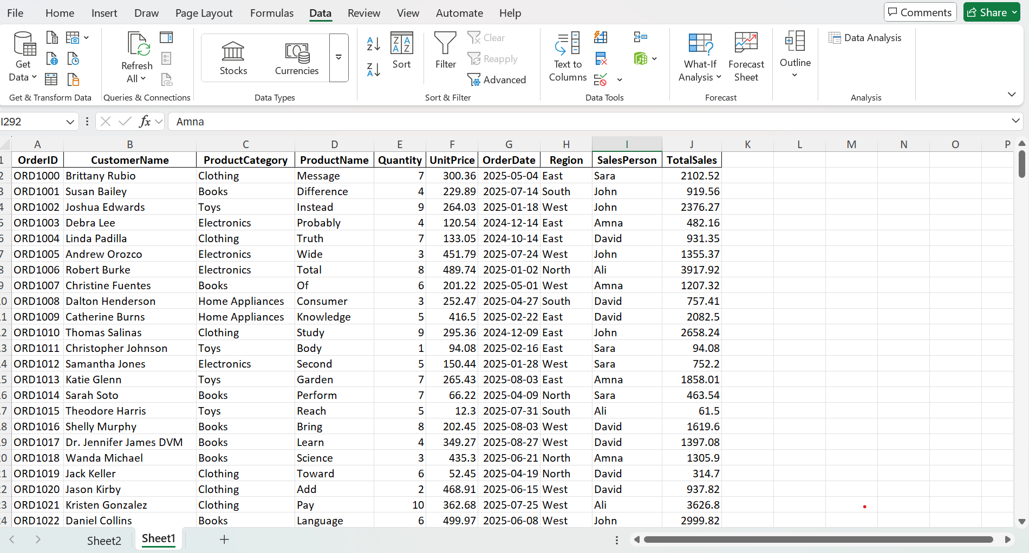

**Task 2:**



Category with highest sales is **Clothing**.

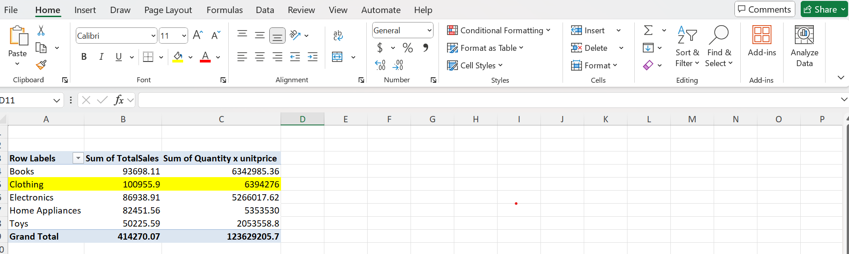

**Task 3:**



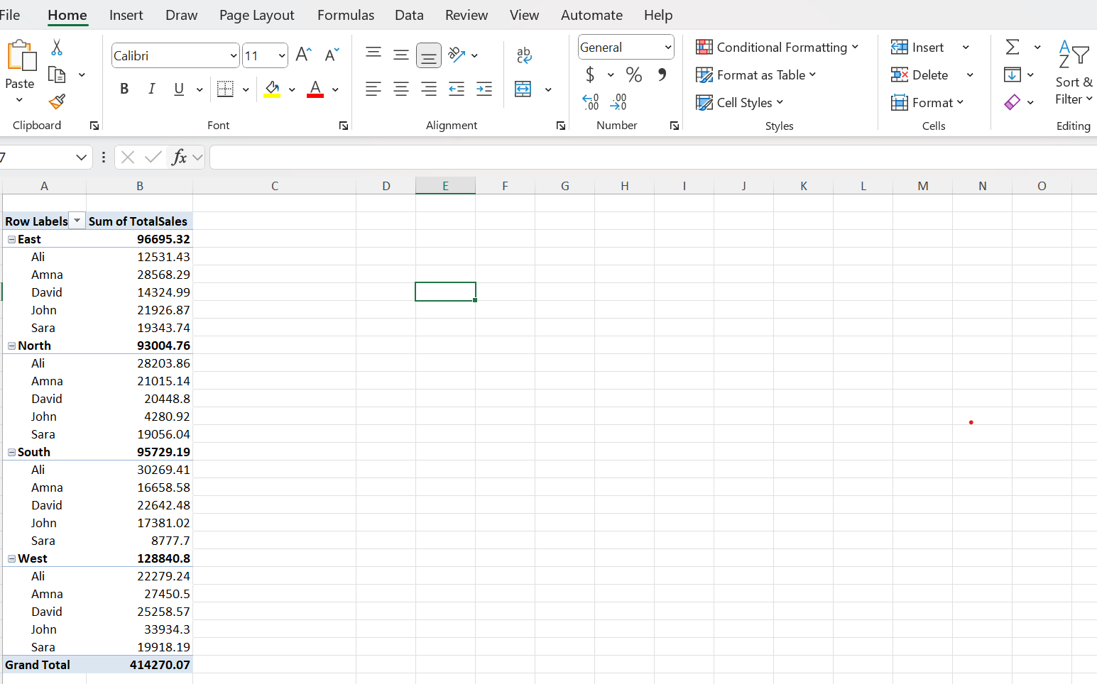



The Top performing **Region** is **West** which has Total sales is **128840.8**.

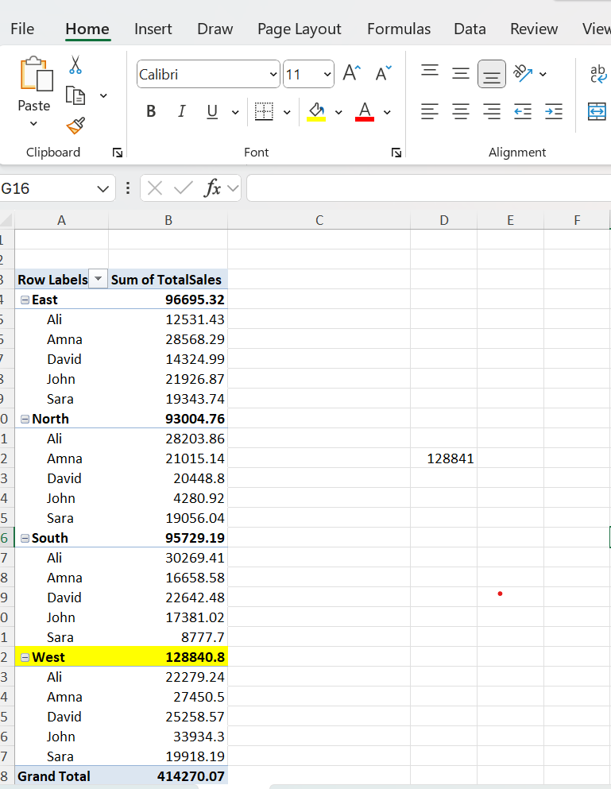

**Task 4:**

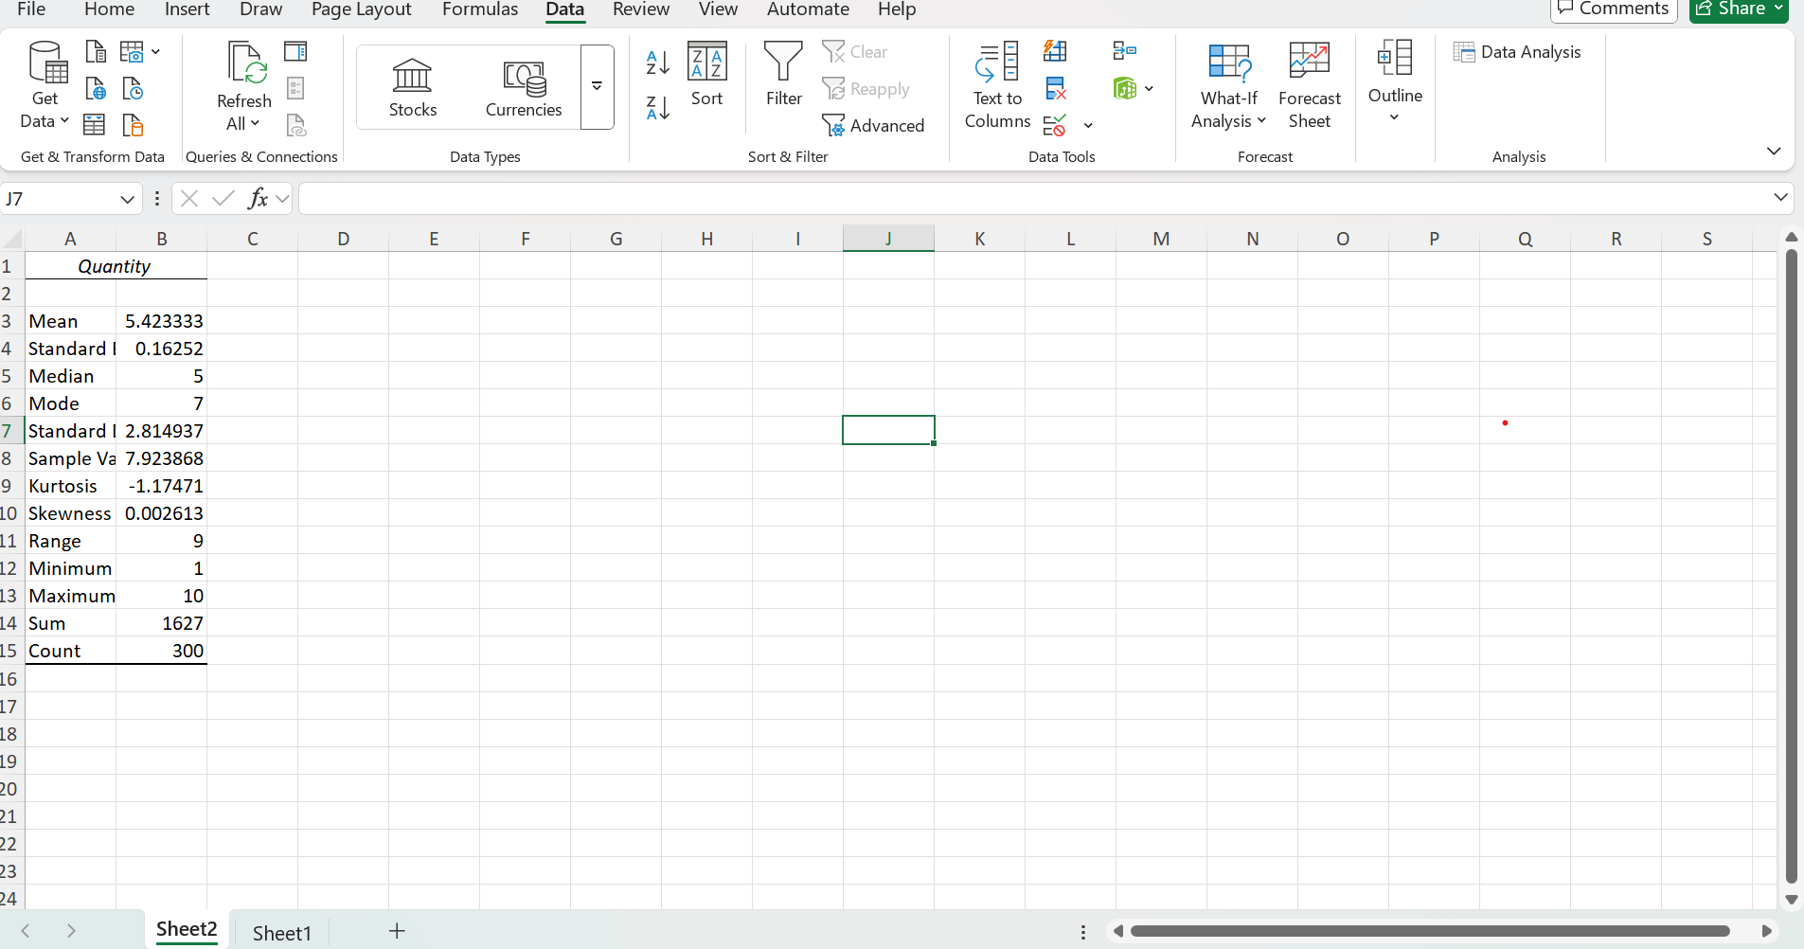

**Task 5:**

We prefer **Median** when skewness is **greater** than **±1** and prefer **Mean** when skewness is **less** than **±1**.

In this Analysis **Skewness value** is **0.002613** which is not greater than **1** so, we can use both mean and median **But**, in this case, **we prefer Mean** which is **5.423333**.