***Question 1:***

**Imagine a teacher has a gradebook for 3 classes, with each class having 4 students. The teacher wants to find the average score for each class.**

**Class 1: 85, 92, 78, 90**

**Class 2: 88, 76, 95, 84**

**Class 3: 90, 85, 88, 92**

**Calculate and show the average score for each class.**

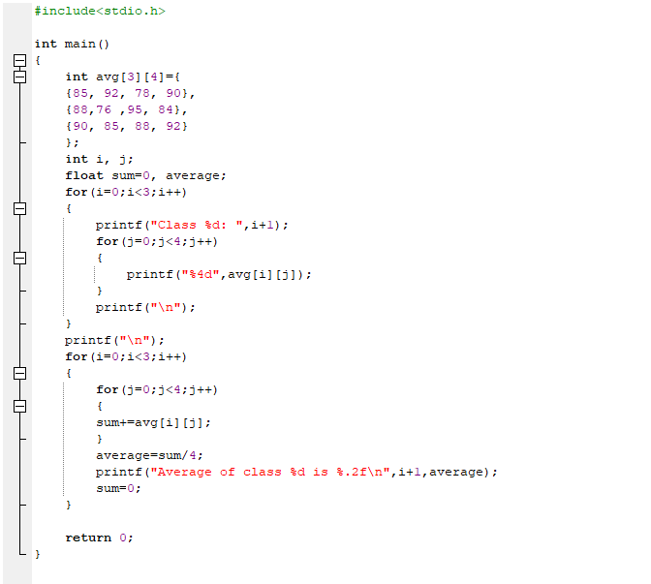

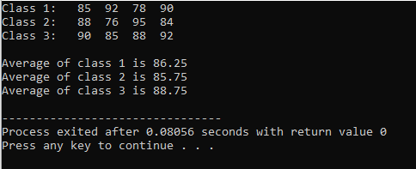

***Question 2:***

**A family has a photo album organized by year and then by month. They want to list how many photos they took each month for the last 2 years.**

**Year 1: 12, 10, 15, 8, 5, 20, 25, 30, 10, 5, 8, 15**

**Year 2: 10, 12, 18, 9, 6, 22, 28, 35, 12, 7, 9, 16**

**Print the number of photos for each month of each year.**

***Output:***

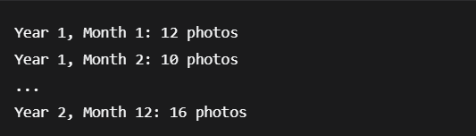

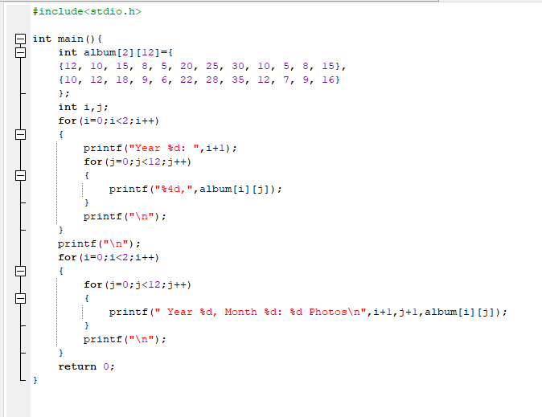

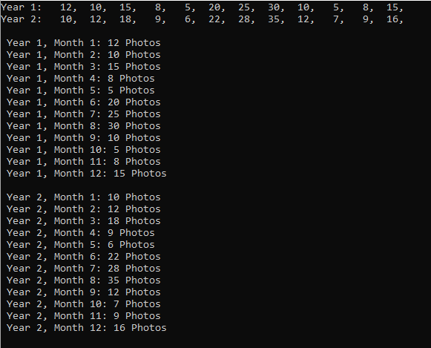

***Question 3:***

**Create a program that works with a small 4x4 black and white image. The program should:**

**Create an original image where 1 represents white pixels and 0 represents black pixels**

**Display the original image**

**Create an inverted version (negative) of the image where white becomes black and black becomes white**

**Display both images side by side**

**Count how many white pixels are in the original image**

***Original Image 4x4:***

**{1, 0, 1, 0},**

**{0, 1, 0, 1},**

**{1, 1, 0, 0},**

**{0, 0, 1, 1}**

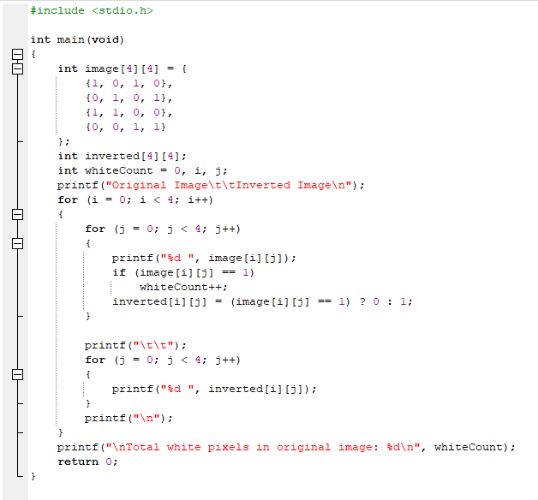

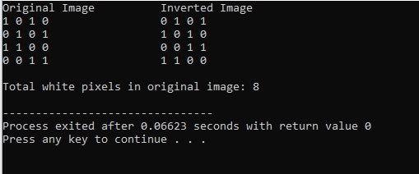

***Question # 4***

**A small cinema has 3 rows with 3 seats in each row. The booking system marks a seat as 1 if it's booked and 0 if it's available. Find the total number of available seats and list their positions.**

**Row 1: 1, 0, 1**

**Row 2: 0, 0, 1**

**Row 3: 1, 1, 0**

**Count all available seats and print their row and seat number.**

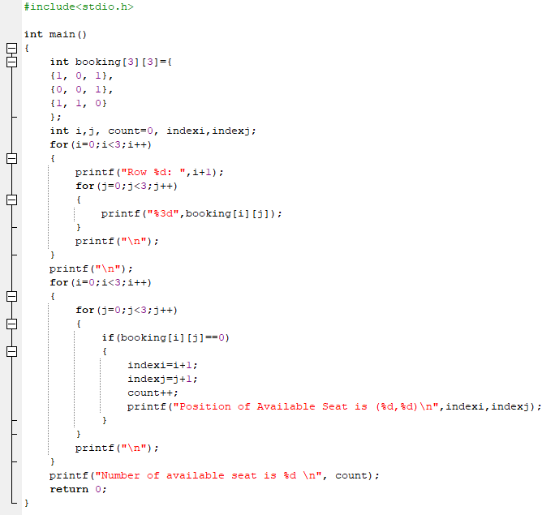

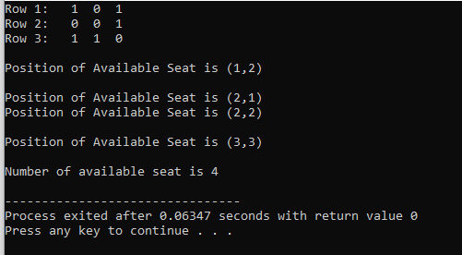

***Question # 5***

**A research team has placed sensors in a mountain valley arranged in a grid. Each sensor records the daily temperature. They need to find all "cold spots" - sensors where the temperature is lower than all of its immediate neighbors (to the north, south, east, and west). Sensors at the edge of the grid have fewer neighbors.**

**Grid of Temperatures (°C):**

**12, 15, 10, 9**

**11, 8, 12, 13**

**14, 13, 9, 7**

**16, 11, 10, 8**

**Find and report the location (row, column) and temperature of all cold spots. A cold spot must be colder than all its existing adjacent neighbors.**

***Output:***

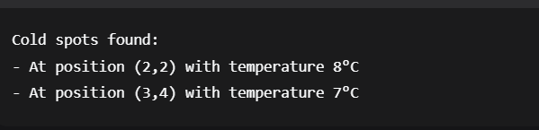

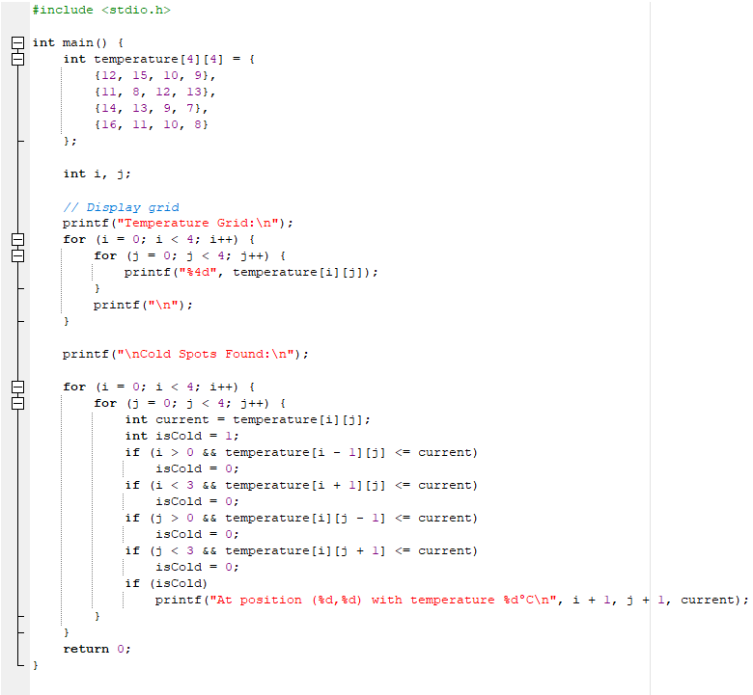

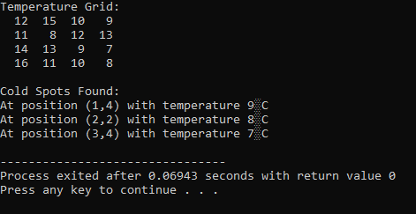

***Question # 6***

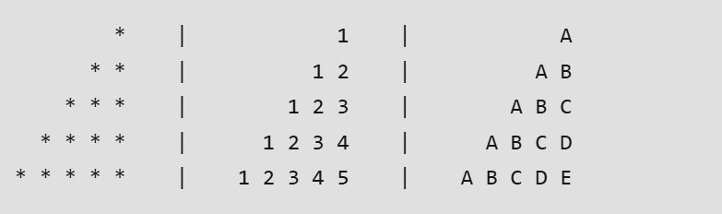

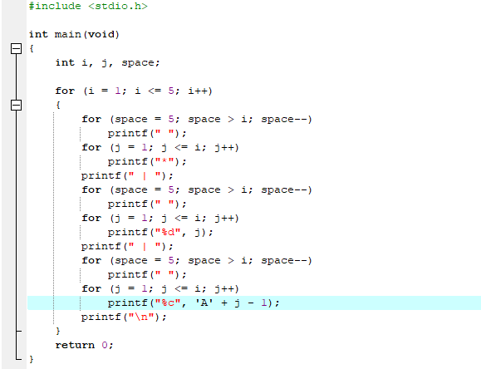

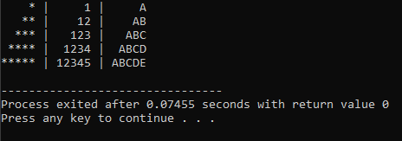

***Question # 7***

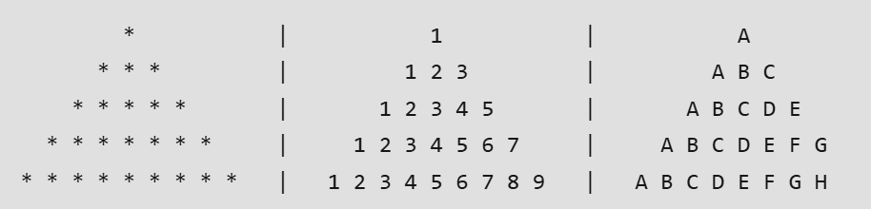

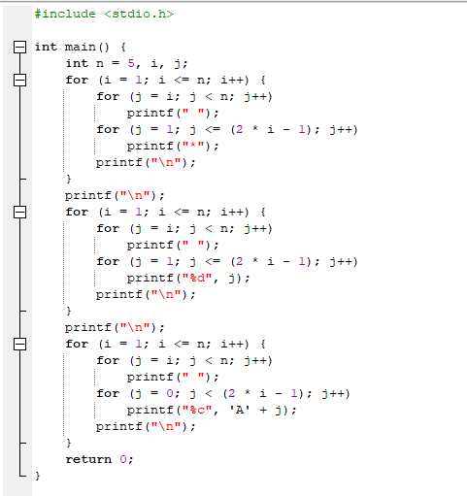

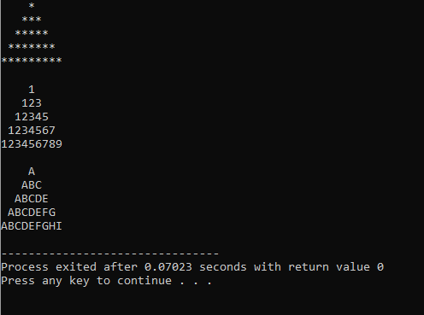

***Question # 8***

**A teacher needs to organize seating for students in a classroom that has 5 rows with 5 desks in**

**each row. Create a program that shows which desks are occupied and which are empty.**

**The seating should follow this pattern: students sit in every other desk, creating a checkerboard-**

**style arrangement where occupied desks are separated by empty ones.**

**The program should display the final seating chart showing exactly where students are sitting.**

