Workflow Audit
Task | Classification | Rationale
Scholarship research | Collaborate with AI | AI can find opportunities, but I must judge fit and eligibility.
Writing scholarship SOPs | Collaborate with AI | AI helps draft and improve structure, but personal experiences must come from me.
Requesting recommendation letters | Delegate to AI with Review | AI can create strong templates that I customize before use.
Reading research papers | Just Me | Understanding and critical thinking cannot be delegated.
Literature review summaries | Collaborate with AI | AI can summarize papers while I verify claims and relevance.
DisasterWatch feature brainstorming | Collaborate with AI | AI generates ideas, but engineering decisions remain mine.
Writing Python boilerplate code | Delegate to AI with Review | AI speeds implementation, but I must test and validate code.
Debugging code | Collaborate with AI | AI can suggest fixes, but diagnosis and verification require me.
Organizing study schedules | Fully Automate | AI can generate schedules automatically from constraints.
German vocabulary practice | Fully Automate | AI can create drills, quizzes, and flashcards automatically.
Career roadmap planning | Collaborate with AI | AI provides options, but long-term decisions are mine.
Research topic exploration | Collaborate with AI | AI helps survey ideas, but final topic selection requires judgment.
Exam preparation | Just Me | Mastery and retention require my own effort.
Weekly progress tracking | Fully Automate | AI can summarize tasks and generate progress reports.
Email drafting | Delegate to AI with Review | AI drafts quickly, but I review before sending.

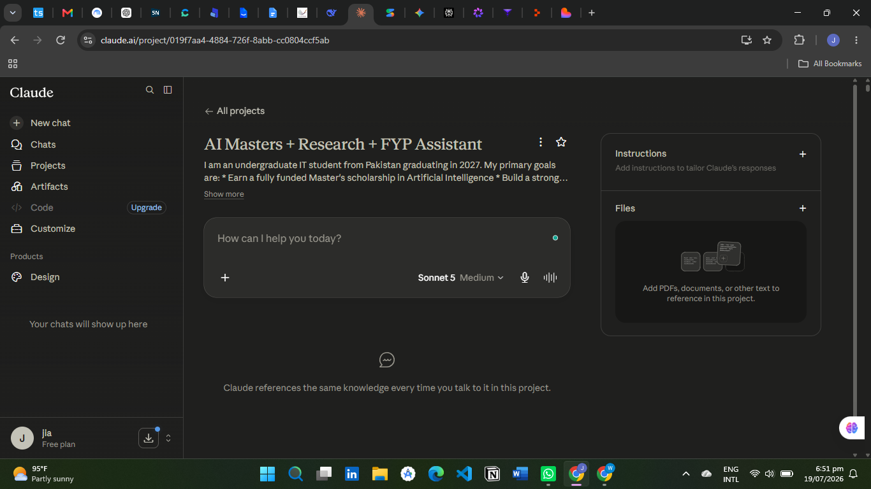

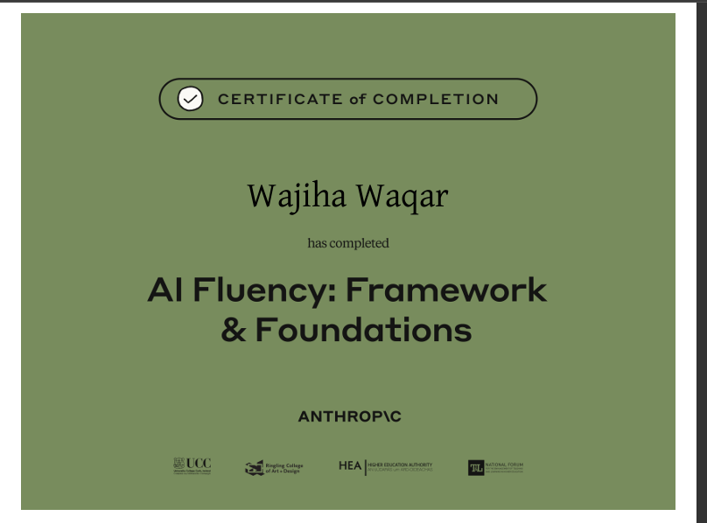

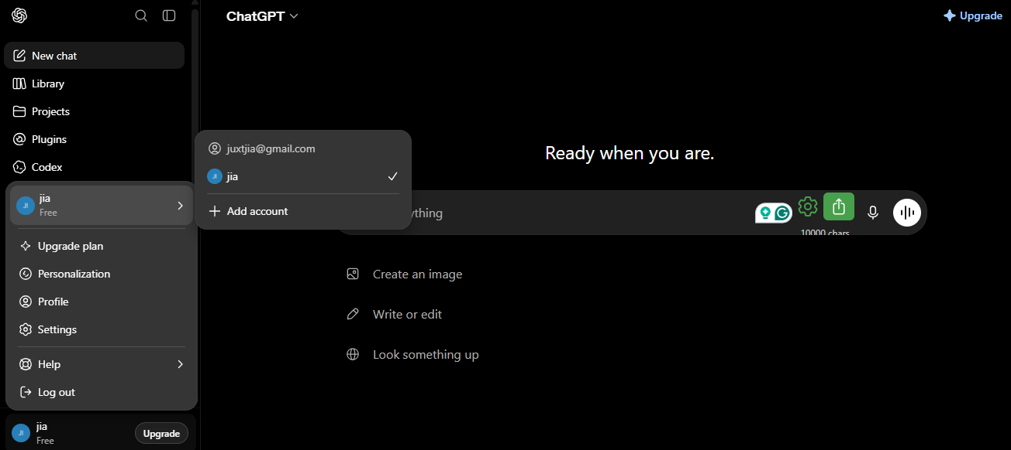
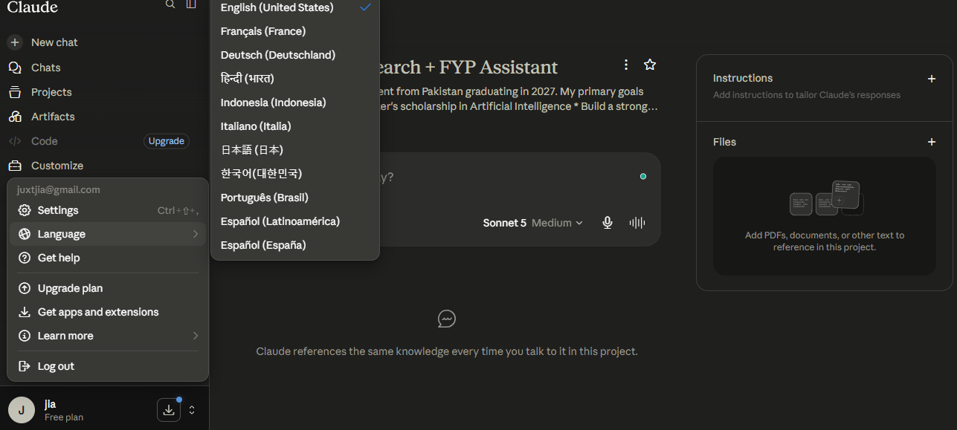
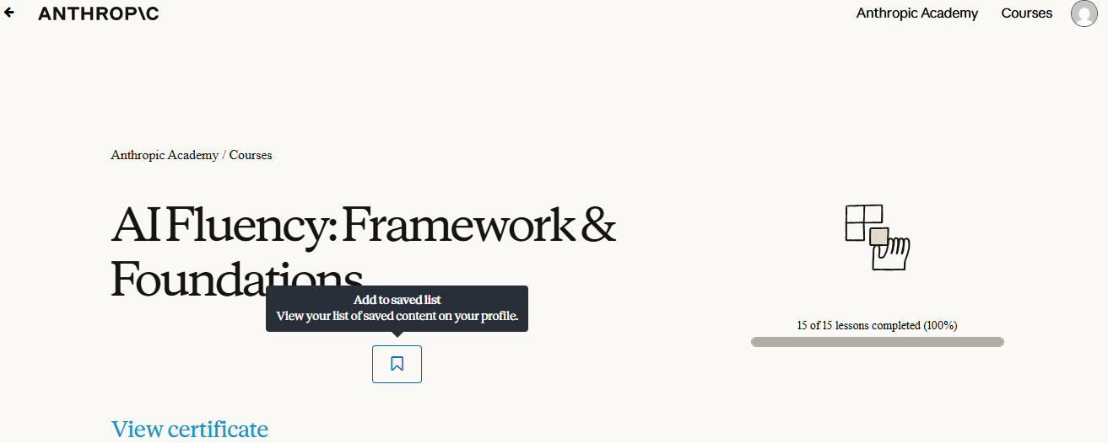
Task 1
Scholarship Research
Success Definition:
Identify at least 5 fully funded AI-related scholarships, verify deadlines and eligibility, and rank them based on fit, funding coverage, and competitiveness,
verify deadlines and eligibility,
and provide a ranked comparison table.

Task 2
Research Paper Literature Review
Success Definition:
Produce summaries of at least 10 papers, including methodology, findings, limitations, and relevance, with no factual errors found during manual verification with key findings, methods,
limitations, and relevance to my topic.

Task 3
Disastro Development Support
Success Definition:
Generate implementation plans and code guidance that can be implemented successfully, with at least one tested feature integrated into the Disastro project,
architecture suggestions,
and code guidance that can be
successfully implemented and tested.

✓ ChatGPT account active
✓ Claude account created
✓ Anthropic Academy account created
✓ Enrolled in AI Fluency: Framework & Foundations
✓ Completed Module 1
✓ Claude Project configured
✓ Screenshot attached

