FL-05: Workflow, Agents, and Model Context Protocol (MCP)
1. Workflow vs. Agent
After reading Building Effective Agents by Anthropic, I learned that a workflow and an agent are related but fundamentally different approaches to building AI systems.
A workflow is a sequence of predefined steps where the developer decides exactly what happens and in what order. The AI completes one task, passes its output to the next step, and follows a fixed path designed by the user. This approach is predictable, easier to understand, and easier to debug because every stage is known in advance.
An agent, on the other hand, is much more autonomous. Instead of following a predetermined sequence, the AI decides for itself which tools to use, what information it needs, how many steps are required, and when the task is complete. Agents continuously observe the results of their actions, reason about what to do next, and adjust their plan based on feedback from the environment. This flexibility allows agents to solve open-ended problems but also increases complexity, cost, and the possibility of errors.
Anthropic recommends starting with the simplest solution possible and only moving toward agents when the additional flexibility provides measurable benefits.

2. Classification of My FL-04 Pipeline
The workflow I built in FL-04 is a workflow, specifically a prompt-chaining workflow, not an agent.
My pipeline consists of five predefined stages:
- Gather sources using NotebookLM
- Generate the initial draft in Claude
- Improve clarity and structure using ChatGPT
- Review and critique the draft in Claude
- Produce the final formatted version in ChatGPT
Each step always follows the previous one in the same order. The AI models do not decide which tool to use or whether additional steps are necessary. I designed the sequence, and the workflow simply executes it.
This matches Anthropic's definition of a workflow because the orchestration is predefined by the developer rather than dynamically controlled by the AI.

3. What is the Model Context Protocol (MCP)?
The Model Context Protocol (MCP) is an open standard that allows AI applications to connect to external systems through a common interface.
The official documentation compares MCP to a USB-C port for AI. Just as USB-C allows many devices to communicate through one standardized connection, MCP provides one standardized method for AI systems to interact with external tools, data sources, and services.
Instead of every AI application requiring custom integrations for different software, MCP provides a consistent protocol that works across multiple applications and platforms.
This makes AI assistants significantly more useful because they can access information outside the conversation and perform real actions.

4. The Three MCP Primitives
According to the MCP documentation, the protocol is built around three core primitives.
Tools
Tools allow an AI model to perform actions.
Examples include:
- Searching a GitHub repository
- Reading Google Drive documents
- Querying a database
- Accessing Gmail
- Searching the web
Rather than simply generating text, the AI can execute these operations and use the results during its reasoning.
Resources
Resources are the data sources that the AI can access.
Examples include:
- Local files
- PDFs
- Databases
- GitHub repositories
- Google Drive documents
- Notion pages
Resources provide the information the AI needs to complete tasks accurately.
Prompts
Prompts are reusable instructions that guide how the AI performs a task.
Examples include:
- Summarize a research paper.
- Review Python code.
- Explain a concept for beginners.
- Generate meeting notes.
Prompts help standardize repeated tasks while ensuring consistent outputs.

5. MCP Connector Demonstration
For this assignment, I connected Claude to the GitHub connector.
This allowed Claude to perform tasks that ordinary chat alone cannot perform because they require direct access to an external system.
The three completed tasks were:
Task 1
Read my GitHub repository and list the project files.
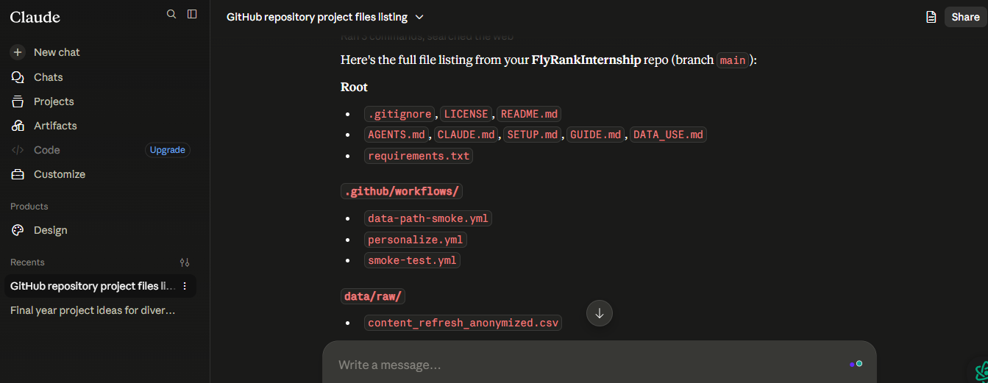
Task 2
Open and summarize my repository README file.
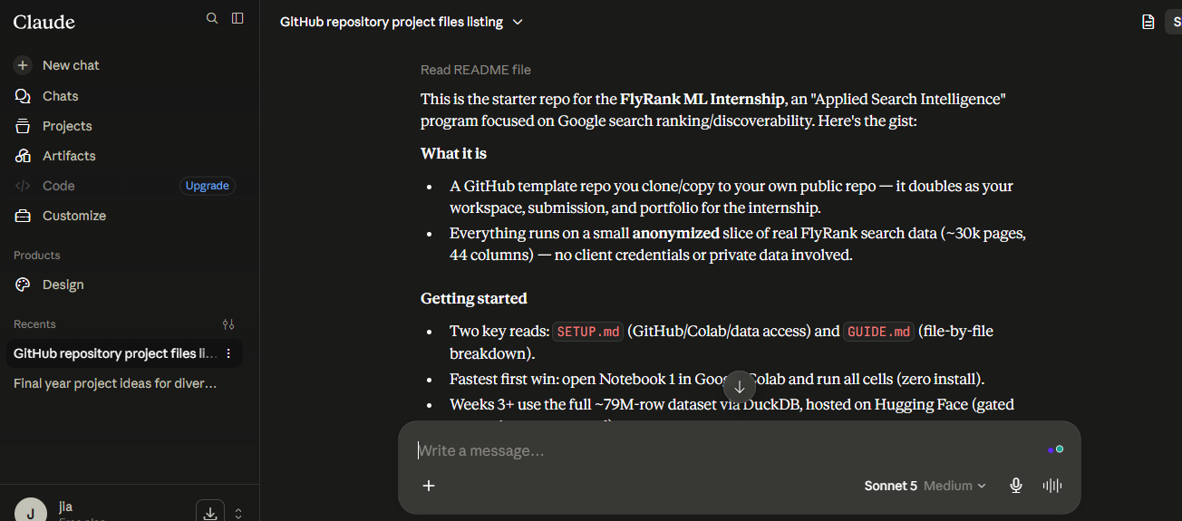
Task 3
Read one of my project notebooks and explain its purpose.
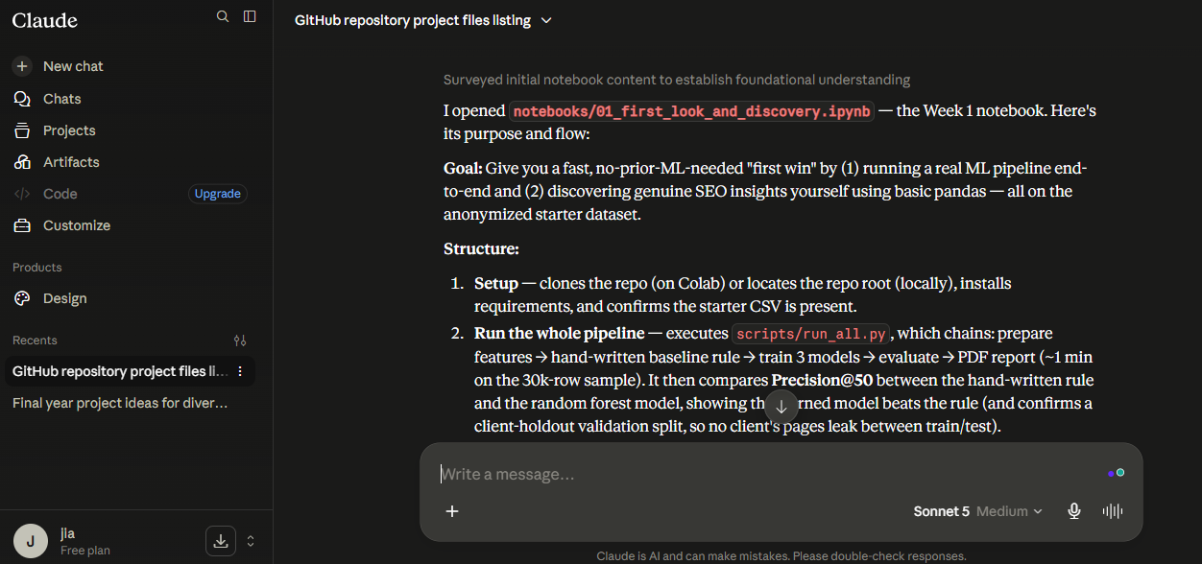

6. How My Workflow Could Become an Agent
Although my current pipeline is an effective workflow, it could be upgraded into an agent by giving the AI greater autonomy.
Instead of always following the same five-step sequence, the AI could first analyze the user's request and decide what actions are necessary.
For example, it could:
- determine whether additional research is required,
- automatically search for relevant sources,
- choose the most appropriate tool,
- evaluate the quality of its own draft,
- perform additional revisions, if necessary,
- stop only after meeting predefined quality criteria.
In this version, the AI not the user would decide which tools to use, how many iterations are required, and when the task has been completed.
This would satisfy Anthropic's definition of an agent because the model would dynamically direct its own reasoning and tool usage instead of following a fixed workflow.

7. Reflection
This assignment helped me understand that not every multi-step AI system is an agent. My FL-04 pipeline demonstrates how a well-designed workflow can solve structured tasks efficiently while remaining transparent and easy to maintain.
I also learned that MCP is not itself an agent. Instead, it is a standardized protocol that enables AI systems to connect with external tools, resources, and services. MCP expands what an AI system can access and do, while workflows and agents determine how those capabilities are used.
For my current projects, a workflow is the right choice because it is predictable, easier to maintain, and well suited to research and technical writing. As my projects become more complex, I can gradually introduce agent-like behaviour by allowing the AI to make decisions about tool selection, planning, and iterative improvement while still keeping appropriate human oversight.

