CLASSIFICATION OF CAT VOCALISATIONS

Table of Contents
Abstract…………………………………………………….………………………………………………………………………………………………..…….……..5
1.0 Introduction & Background……………………………………………………………………………………………….…………....5
1.1 Introduction……………………………………………………………………………………………………………………………….……….5
1.2 Aim & Objectives………………………………………………………………………………………………………………………………….6
1.3 Literature Review……………………………………………………………………………………………………..………………………….7
2.0. Methodology…………………………………………………………………………………………………………………………………10
2.1 Dataset…………………………………………………………………………………………………………………………………………….12
2.2 Data Preprocessing…………………………………………………………………………………..………………………………………..12
2.2.1 Silence Removal……………………………………………………………………………………………………………………………….12
2.2.2 Mono Conversion………………………………………………………………………………………………….…………………………..12
2.2.3 Resampling…………………………………………………………………………………………………………………..………………….12
2.2.4 Amplitude Normalisation……………………………………………………………………………………………………………………13
2.2.5 Spectrogram Preprocessing……………………………………………………………………………………..…………………………15
2.3 Feature Extraction…………………………………………………………………………………………………………….…………………15
2.3.1 MFCC Features…………………………………………………………………………………………………………………………………15
2.3.2 Spectrogram Features…………………………………………………………………………….…………………………………………15
2.4 Model Design……………………………………………………………………………………………………………………...…………….16
2.4.1 Classical Models………………………………………………………………………………………………….………………………….16
2.4.2 Convolutional Neural Network ………………………………………………………….……………………………………………….16
2.5 Training Setup……………………………………………………………………………………………………….………………………….18
2.6 Evaluation Metrics………………………………………………………………………………………….………………………………….18
3. Results.…………………………………………………………………………………………………………………………………………….19

3.1 Model Performance Comparison……………………………………………….……………………………………………………….19

3.2 Analysis of SVM Confusion Matrix………………………………………………….…………………………………………………….20
3.3 CNN Training Behaviour………………………………………………………………………..…………………………………………….23
3.4 Analysis of CNN Confusion Matrix……………………………………………………………………………………………………….25
3.5 Summary of Findings………………………………………………………………………………………………………………………….27
4. Discussion…………………………………………………………………………………………………………………………………….….27

4.1 Performance of SVM and Classical Models…………………………………..……………………………………………………….27

4.2 Underperformance of the CNN Model………………………………………………………………………………………….……….28

4.3 Performance of Ensemble Methods……………………………………………………….…………………………………………….28

4.4 Comparison with Existing Literature………………………………………………………………………………………….………….29
4.5 Limitations………………………………………………………………………………………….…………………………….………………29
4.6 Conclusion………………………………………………………………………………………………………………………………….……30
Reference…………………………………………………………………………………………….………………………………………….……31

Abstract
The automatic classification of cat vocalisations presents a challenging problem due to the variability and context-dependent nature of acoustic signals, as well as limitations in annotated data. This study investigates the effectiveness of machine learning approaches for classifying cat vocalisations into three behavioural categories: feeding, brushing, and isolation. Audio data were pre-processed and transformed into two distinct representations: Mel-Frequency Cepstral Coefficients (MFCCs) for classical machine learning models, and spectrograms for a convolutional neural network (CNN). A range of classifiers, including Support Vector Machines (SVM), ensemble methods, and deep learning architectures, were implemented and evaluated using accuracy, balanced accuracy, precision, recall, and F1-score.
The results demonstrate that MFCC-based classical models outperform the CNN under the given conditions, with the SVM achieving the highest performance (accuracy = 0.77, F1-score = 0.77). Ensemble methods did not yield significant improvements over individual classifiers, while the CNN achieved lower performance (accuracy = 0.64), likely due to limited data. Confusion matrix analysis further revealed that isolation vocalisations were the most distinguishable, whereas feeding exhibited the highest misclassification rate.
This study contributes a systematic comparison of feature representations and modelling approaches within a unified framework, highlighting the effectiveness of classical methods in data-constrained bioacoustics classification tasks.
- Introduction & Background
1.1 Introduction
Understanding communication between humans and animals is important for companion species such as dogs (Canis familiaris) and cats (Felis silvestris catus), which live near humans and depend on them for care, health, and social interaction (Ntalampiras et al., 2019). Domestic cats are among the most widespread companion animals and are regarded as social partners within households (Eriksson et al., 2017; Turner & Bateson, 2000). Despite their prevalence, the mechanisms underlying feline vocal communication remain underexplored, particularly in computational contexts.
The study of animal vocalisations has gained attention within computational bioacoustics, as acoustic signals provide a non-invasive means of analysing behaviour, communication, and environmental interactions (Karaaslan et al., 2024; Owens et al., 2017; Smirnova et al., 2016; Stowell, 2022). However, traditional approaches rely on manual annotation of large audio datasets, which is time-consuming, subjective, and difficult to scale. Consequently, machine learning and deep learning methods have been adopted to automate the classification of animal sounds. Nevertheless, many approaches still depend on supervised learning frameworks requiring substantial annotated data, making them resource-intensive (Miao et al., 2025).
Automatic classification of animal vocalisations remains challenging due to the variability of acoustic signals. Vocalisations exhibit high intra-class variability and low inter-class separability, while recordings are affected by environmental noise, recording conditions, and signal duration (Xu et al., 2020). These challenges are particularly evident in domestic cat vocalisations, which are typically short, irregular, and context dependent.
Two primary approaches are commonly used in audio classification. The first involves extracting handcrafted features such as Mel-Frequency Cepstral Coefficients (MFCCs), which capture spectral characteristics and are widely used in speech and environmental sound recognition (Hu et al., 2023). The second uses deep learning, where audio signals are transformed into time–frequency representations, such as spectrograms, and processed using Convolutional Neural Networks (CNNs) (Carvalho & Gomes, 2023). While both approaches are effective, their comparative performance in cat vocalisation classification remains insufficiently explored.
This study addresses this gap by investigating the classification of cat vocalisations into three activity-based categories: feeding, brushing, and isolation.
1.2 Aim & Objectives
- To evaluate the effectiveness of machine learning approaches for classifying cat vocalisations based on behavioural context.
Objectives
- To preprocess and prepare audio data for analysis
- To extract MFCC-based features and develop classical machine learning models
- To generate spectrogram representations and implement a convolutional neural network
- To compare the performance of both approaches using standard evaluation metrics
- To assess whether ensemble methods improve classification performance
Research Question
- How effectively can different audio representation and modelling approaches classify cat vocalisations based on behavioural context?
By systematically comparing these approaches, this study contributes to the development of scalable and data-driven methods for analysing animal vocal behaviour, with potential applications in animal welfare and behavioural monitoring.
1.3 Literature Review
The automatic classification of animal vocalisations has become an important research area within computational bioacoustics, driven by the need for scalable, objective, and reproducible methods of analysing animal behaviour. Traditional approaches rely heavily on manual annotation and subjective interpretation, which are not only time-consuming but also prone to human bias. As a result, machine learning and signal processing techniques have been increasingly adopted to enable automated extraction of meaningful patterns from acoustic data, improving both efficiency and consistency in analysis (Ntalampiras et al., 2019). However, despite these advances, the variability and complexity of animal vocalisations continue to pose significant challenges for robust classification.
A key difficulty in this domain lies in the inherently complex and context-dependent nature of animal sounds. Domestic cat vocalisations exhibit substantial variability in frequency, duration, and tonal structure, often influenced by behavioural and emotional states. Early studies have attempted to characterise these vocalisations using descriptive acoustic features such as frequency ranges and spectrogram visualisations. For example, Fatima et al. (2024) identified distinct frequency bands associated with common vocal behaviours, including purring (25–150 Hz), meowing (200–2000 Hz), and hissing (1000–5000 Hz). While such findings provide useful baseline insights, they remain largely descriptive and do not offer the statistical or computational rigour required for reliable classification. Consequently, these approaches are limited in their ability to generalise across varying contexts and recording conditions.
To address these limitations, more recent work has focused on quantitative acoustic analysis combined with data-driven techniques. Schwartz et al. (2025) employed acoustic feature extraction alongside unsupervised clustering methods, using parameters such as fundamental frequency (F0), jitter, shimmer, and harmonic-to-noise ratio (HNR). Their findings revealed that cat vocalisations form a graded acoustic continuum rather than discrete categories, and that human perception only partially aligns with the underlying acoustic structure. This challenges the assumption of clearly separable classes and highlights a fundamental difficulty for supervised classification models, which typically rely on well-defined class boundaries. As such, these findings underscore the importance of adopting modelling approaches capable of handling ambiguity and overlap in acoustic data.
Within machine learning, one of the most widely used approaches for audio classification involves the extraction of handcrafted features, particularly Mel-Frequency Cepstral Coefficients (MFCCs). MFCCs provide a compact representation of the spectral envelope of audio signals and have demonstrated effectiveness across speech and environmental sound recognition tasks (Hu et al., 2023). In the context of cat vocalisation classification, Ntalampiras et al. (2019) combined MFCC features with temporal modulation characteristics within a Directed Acyclic Graph Hidden Markov Model (DAG-HMM), achieving a recognition rate of 95.94%. This performance suggests that carefully engineered features, when paired with structured probabilistic models, can effectively capture relevant acoustic patterns. However, such approaches inherently depend on predefined feature representations, which may limit their ability to capture more complex temporal, and hierarchical structures present in vocalisations.
In contrast, deep learning approaches aim to overcome these limitations by learning feature representations directly from data. A common strategy involves transforming audio signals into time–frequency representations, such as spectrograms, which can then be processed using Convolutional Neural Networks (CNNs) (Carvalho & Gomes, 2023). These models can learn hierarchical and spatial features without manual feature engineering, making them particularly suitable for complex audio classification tasks. More recently, Kucukkulahli and Kabakus (2024) extended this approach by applying Vision Transformers (ViTs) to mel-spectrogram representations, achieving an accuracy of 96.95% on a multi-class cat vocalisation dataset. While this result indicates the potential of transformer-based architectures to capture global patterns more effectively than conventional CNNs, such performance is often dependent on dataset size, quality, and experimental setup. Consequently, direct comparison with earlier studies remains challenging, particularly when evaluation protocols differ.
The contrast between handcrafted feature-based methods and deep learning approaches highlights a fundamental trade-off. Classical machine learning models, when combined with features such as MFCCs, offer interpretability and lower computational requirements, making them suitable for scenarios with limited data. In contrast, deep learning models provide greater representational capacity but typically require larger, well-annotated datasets and increased computational resources. This trade-off suggests that the relative effectiveness of each approach is context-dependent and cannot be assumed a priori. Furthermore, the absence of standardised evaluation frameworks in existing studies makes it difficult to determine whether reported performance improvements arise from model architecture, feature representation, or dataset characteristics.
Although prior research has explored both handcrafted and deep learning-based approaches, there remains a limited body of work that directly compares these methods within a unified experimental framework, particularly for the classification of cat vocalisations by behavioural context. Existing studies tend to focus on specific aspects, such as acoustic characterisation (Schwartz et al., 2025), descriptive frequency analysis (Fatima et al., 2024), or individual modelling approaches including DAG-HMM (Ntalampiras et al., 2019) and Vision Transformers (Kucukkulahli and Kabakus, 2024). However, the lack of systematic comparison under consistent conditions limits the ability to draw definitive conclusions regarding their relative strengths and weaknesses.
This study addresses this gap by developing a unified framework that integrates MFCC-based feature extraction, spectrogram-based deep learning, and ensemble modelling techniques for the classification of cat vocalisations into activity-based categories. By evaluating classical machine learning models, convolutional neural networks, and ensemble approaches under consistent experimental conditions, this work aims to provide a clearer and more rigorous comparison of modelling strategies for domestic cat vocalisation classification.

2.0. Methodology
2.1 Dataset
This study utilised the CatMeows dataset, a publicly available corpus of feline vocalisations introduced by Ludovico et al. (2021). The dataset consists of 440 WAV recordings from 21 domestic cats of two breeds: Maine Coon and European Shorthair. Each recording captures a single meow produced in one of three controlled behavioural contexts: brushing, waiting for food, and isolation in an unfamiliar environment. These contexts were selected to elicit vocal responses associated with affiliative interaction, anticipatory behaviour, and mild stress, respectively (Ludovico et al., 2021).
The dataset was collected under controlled yet ecologically valid conditions. In the brushing condition, cats were brushed by their owners for up to five minutes in their home environment. In the isolation condition, cats were placed in an unfamiliar room, given a 30-minute recovery period, and then isolated for up to five minutes. In the food condition, owners initiated the feeding routine, with food delivered within five minutes. These procedures ensured that vocalisations reflected natural behavioural states while maintaining experimental consistency.
Recordings were stored as PCM WAV files, retaining their original sampling rate (typically 8 kHz). File names encode metadata including context, cat ID, breed, sex, owner ID, session, and vocalisation index, following Ludovico et al. (2021). The dataset exhibits class imbalance, with 221 isolation, 127 brushing, and 92 food recordings (Figure 1). Class imbalance is a known challenge in animal sound classification, as models may bias toward majority classes without mitigation (Stowell, 2022).
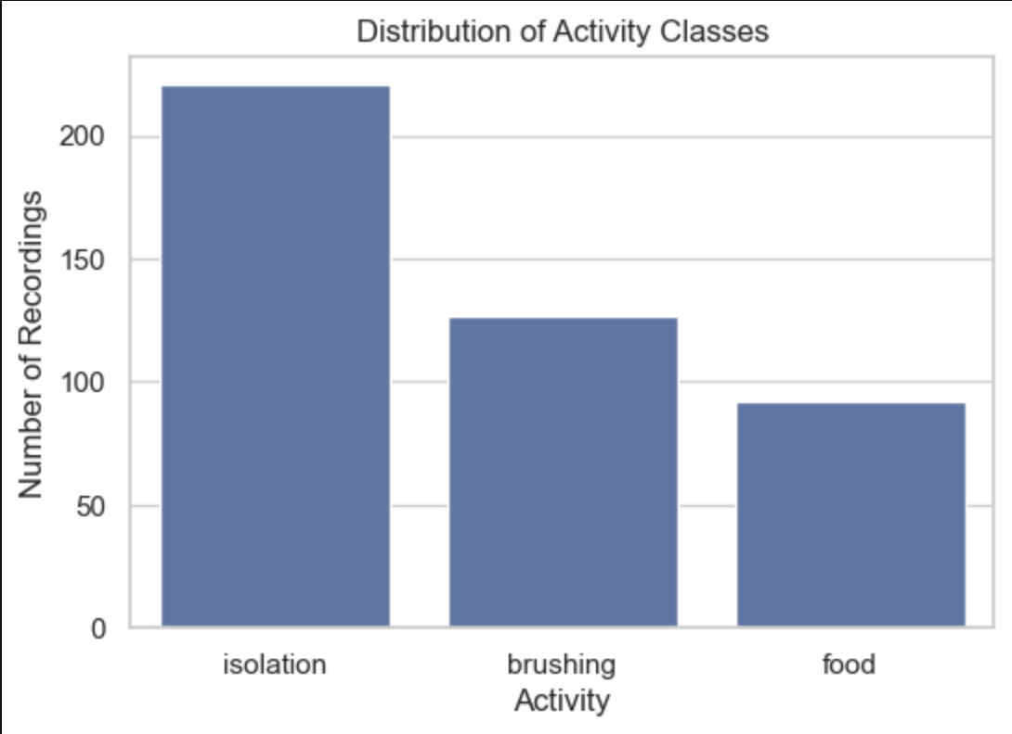
Figure 1: Distribution of vocalisation recordings across behavioural contexts in the CatMeows dataset. The bar chart illustrates the class distribution of the 440 feline vocalisations used in this study, categorised into isolation, brushing, and food contexts. The dataset is markedly imbalanced, with isolation meows (n ≈ 221) forming the largest proportion, followed by brushing (n ≈ 127) and food-related vocalisations (n ≈ 92)
To ensure robust evaluation, the dataset was partitioned into training (80%) and testing (20%) subsets using a stratified sampling strategy. Stratification preserved the original class proportions in both subsets, ensuring that minority classes remained adequately represented and reducing the risk of biased performance estimates.
2.2 Data Preprocessing
Preprocessing aimed to standardise audio signals, remove irrelevant segments, and prepare the data for feature extraction. All steps were applied consistently to both training and testing sets.
2.2.1 Silence Removal
Each audio signal was processed using an energy-based segmentation algorithm. The signal was divided into overlapping frames, and short-time energy was computed for each frame. Frames with energy below 10% of the maximum frame energy were considered silent. The algorithm identified the first and last frames exceeding this threshold and cropped the signal accordingly. Energy-based segmentation is widely used in bioacoustics analysis because it effectively removes non-informative regions while preserving vocal content (Colonna et al; 2018).
2.2.2 Mono Conversion
Recordings containing multiple channels were converted to mono by averaging across channels. Mono conversion reduces computational complexity and ensures consistent input dimensionality without compromising the spectral characteristics relevant to vocal classification.
2.2.3 Resampling
To ensure uniformity across recordings, all signals were resampled to a target sampling rate of 16 kHz. Resampling is essential when combining recordings with heterogeneous sampling rates, as inconsistent temporal resolution can distort spectral features and degrade model performance (Purwins et al., 2019).

2.2.4 Amplitude Normalisation
Each cropped signal was peak-normalised by dividing the waveform by its maximum absolute amplitude. This scaled all signals to the range [ [-1, 1] ], reducing loudness variability and preventing amplitude differences from influencing downstream feature extraction (Figure 2).
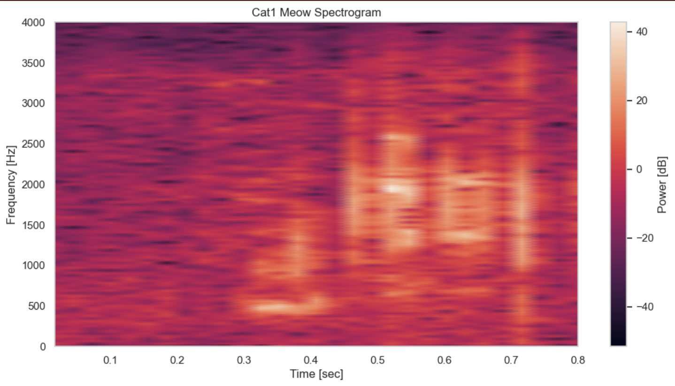Figure 2 illustrates the effect of this preprocessing step, showing a log-scaled spectrogram of a normalised cat meow. The plot displays a concentrated burst of acoustic energy within the first 100–800ms, with harmonically rich frequency components extending up to approximately 4 kHz.

2.2.5 Spectrogram Preprocessing
For the spectrogram-based pipeline, additional steps were applied. After silence removal, resampling, and normalisation, each signal was transformed into a linear-scale spectrogram using the short-time Fourier transform. The spectrogram was converted to log scale, which enhances perceptual contrast and stabilises dynamic range. Finally, each spectrogram was resized to 128 × 128 pixels using anti-aliased interpolation, producing a consistent input format for convolutional neural networks (CNNs). Log-spectrograms are widely used in animal sound classification because they preserve fine-grained time–frequency structure (Stowell et al., 2019).
2.3 Feature Extraction
Two complementary feature extraction strategies were employed: MFCC-based statistical features for classical machine-learning models, and log-spectrogram images for deep learning.
2.3.1 MFCC Features
Mel-Frequency Cepstral Coefficients (MFCCs) were extracted to capture the spectral envelope of each vocalisation. MFCCs are widely used in speech and animal sound analysis because they approximate human auditory perception and provide a compact representation of timbral characteristics (Purwins et al., 2019). For each recording, 13 MFCC coefficients were computed. To summarise temporal variation, the mean and standard deviation of each coefficient were calculated across time, producing a 26-dimensional feature vector. This statistical compression reduces dimensionality and mitigates overfitting, making MFCC features well-suited for classical machine-learning models.
2.3.2 Spectrogram Features
Spectrograms preserve both temporal and spectral structure, making them particularly suitable for CNNs, which excel at learning hierarchical spatial features. Each spectrogram was converted to log scale and resized to 128 × 128, producing a standardised image-like representation. A channel dimension was added to match CNN input requirements. Spectrogram-based CNNs have demonstrated strong performance in recent bioacoustic research due to their ability to capture harmonic patterns, formant trajectories, and noise bursts (Stowell, 2022).
2.4 Model Design
Two modelling approaches were implemented: classical machine-learning models trained on MFCC features, and a deep learning model trained on spectrograms.
2.4.1 Classical Models
A suite of baseline models was evaluated, including Logistic Regression, Support Vector Machine (SVM), Decision Tree, Random Forest, Extra Trees, Gradient Boosting, and XGBoost. These models were selected to provide a broad comparison across linear, kernel-based, and ensemble-based classifiers. Class weights were applied to mitigate the dataset’s imbalance. The SVM and XGBoost models demonstrated the strongest performance, reflecting their ability to model non-linear decision boundaries in low-dimensional feature spaces.
2.4.2 Convolutional Neural Network
A custom CNN was designed to learn directly from spectrogram images (Figure 3). The architecture consisted of three convolutional blocks with ReLU activation, batch normalisation, and max-pooling, followed by fully connected layers with dropout regularisation. The final softmax layer produced class probabilities for the three behavioural contexts. This architecture enables the model to learn low-level spectral edges, mid-level harmonic structures, and high-level vocalisation patterns.
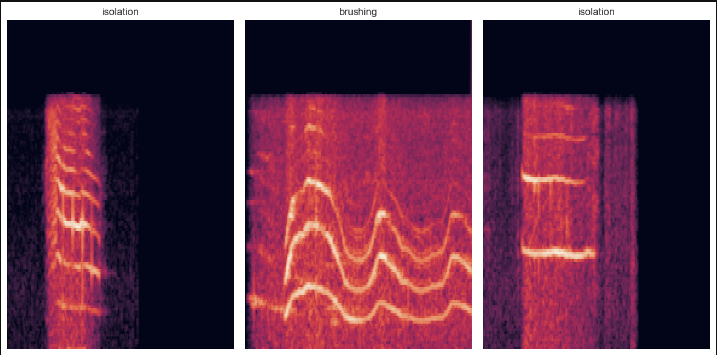Figure 3: Log-scaled spectrogram examples representing the three behavioural contexts in the dataset (Isolation, Brushing, Food)

2.5 Training Setup
Logistic Regression was configured with L2 regularisation, the lbfgs optimiser, and an increased iteration limit to ensure convergence. The Support Vector Machine employed a radial basis function (RBF) kernel with tuned hyperparameters (C=10, γ=0.05) to capture non-linear decision boundaries. Tree-based models, including Decision Tree, Random Forest, and Extra Trees, were parameterised with controlled depth, minimum sample constraints, and a high number of estimators (up to 500) to balance bias–variance trade-offs, with parallel processing enabled where applicable (n_jobs = -1). Gradient Boosting was implemented with a low learning rate and subsampling to improve generalisation. Across all applicable models, class weighting was applied to mitigate class imbalance, and a fixed random state ensured reproducibility.
The CNN is designed for classification of 128 x 128 x 1 spectrogram inputs and is intentionally lightweight due to the limited dataset size. It consists of two convolutional blocks, each using 16 3 x 3 filters with ReLU activation and same padding. Each block is followed by batch normalisation, max pooling, and dropout (0.4) to stabilise training, reduce spatial dimensions, and limit overfitting.
Feature extraction is followed by global average pooling, which replaces flattening to reduce parameter count by summarising each feature map into a single value. A dense layer with 32 ReLU units and dropout (0.4) provides further regularisation before the final softmax layer, which outputs class probabilities corresponding to the number of target classes.
The model is trained using the Adam optimiser with a learning rate of 0.0001 and categorical cross-entropy loss. Early stopping (patience = 30) and model checkpointing based on validation accuracy are applied to prevent overfitting and retain the best-performing model. Training is conducted for up to 80 epochs with batch size 8 and an 80/20 validation split.
2.6 Evaluation Metrics
Performance was assessed using accuracy, precision, recall, F1-score, balanced accuracy, and confusion matrices. Balanced accuracy was emphasised due to class imbalance. Accuracy alone can be misleading when one class dominates; a model may achieve high accuracy by predicting the majority class while performing poorly on minority classes. Balanced accuracy weights each class equally, providing a fairer assessment. Precision, recall, and F1-score further quantify performance across classes, while confusion matrices reveal specific misclassification patterns.
3. Results
This section presents the performance of the evaluated models for the classification of cat vocalisations across three behavioural categories: brushing, feeding, and isolation. Results are reported using standard evaluation metrics, including accuracy, balanced accuracy, precision, recall, and F1-score. In addition, confusion matrices and training curves are analysed to provide further insight into model behaviour.

3.1 Model Performance Comparison
The overall performance of all models is summarised in Table 1
Model | Feature Type | Accuracy | Balanced Accuracy | Precision | Recall | F1-Score
SVM | MFCC | 0.77 | 0.74 | 0.77 | 0.77 | 0.77
Extra Trees | MFCC | 0.76 | 0.71 | 0.76 | 0.76 | 0.76
Stacking Ensemble | MFCC | 0.75 | 0.70 | 0.75 | 0.75 | 0.75
Voting Ensemble | MFCC | 0.74 | 0.67 | 0.73 | 0.74 | 0.73
Random Forest | MFCC | 0.70 | 0.64 | 0.69 | 0.70 | 0.70
Gradient Boosting | MFCC | 0.68 | 0.63 | 0.67 | 0.68 | 0.68
Logistic Regression | MFCC | 0.66 | 0.62 | 0.69 | 0.66 | 0.66
CNN | Spectogram | 0.64 | 0.58 | 0.64 | 0.64 | 0.64
Decision Tree | MFCC | 0.50 | 0.46 | 0.53 | 0.50 | 0.51
The results indicate that models based on MFCC feature representations consistently outperform the spectrogram-based convolutional neural network (CNN). Among all models, the Support Vector Machine (SVM) achieved the highest performance, with an accuracy of 0.77 and an F1-score of 0.77, followed closely by the Extra Trees classifier (accuracy = 0.76) and the stacking ensemble (accuracy = 0.75). In contrast, the CNN achieved an accuracy of 0.64, representing a lower overall performance compared to classical approaches.
A similar trend is observed in balanced accuracy, where the SVM again achieves the highest score (0.74), suggesting better handling of class imbalance relative to other models. Ensemble methods, including stacking and voting, do not demonstrate a substantial improvement over individual classifiers, indicating that combining models does not necessarily yield performance gains in this context.
Overall, the results suggest that handcrafted MFCC features combined with classical machine learning models provide a strong baseline for this task, outperforming more complex deep learning approaches under the given experimental conditions.

3.2 Analysis of SVM Confusion Matrix
The confusion matrix for the SVM classifier provides detailed insight into class-level performance across the three vocalisation categories (Figure 4)
Isolation is the best-performing class, with 37 correctly classified instances and minimal misclassification (6 as brushing and 1 as feeding). This indicates that isolation vocalisations exhibit more distinct acoustic characteristics, allowing the model to separate them effectively from other classes.
Brushing demonstrates moderate classification performance, with 20 correct predictions. However, some confusion is observed with feeding (4 instances) and isolation (2 instances), suggesting partial overlap in acoustic features between these categories.
Feeding is the weakest-performing class, with only 11 correct classifications. Misclassifications occur both as brushing (3 instances) and isolation (4 instances), indicating that feeding vocalisations are less acoustically separable and share characteristics with the other classes.
Overall, the confusion matrix reveals a clear pattern: isolation is well separated in the feature space, while brushing and feeding exhibit overlapping acoustic properties. This suggests that MFCC features are effective for capturing dominant patterns but may be less discriminative for subtle differences between similar vocalisations.

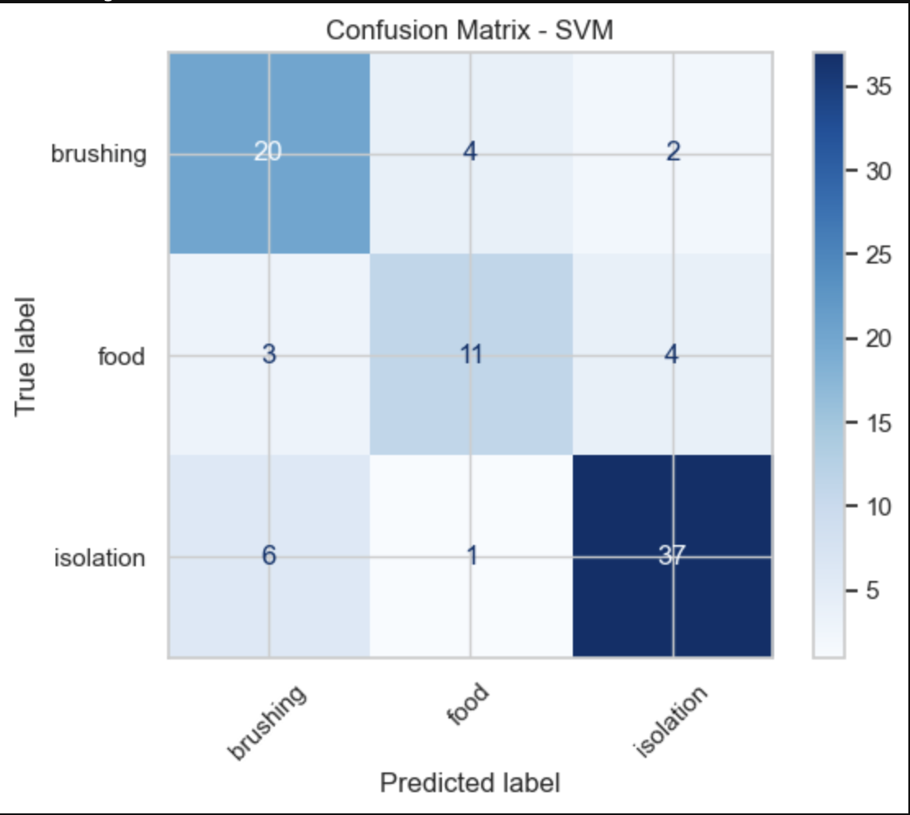
Figure 4: Confusion matrix for the SVM classifier across the three vocalisation categories. The model achieves strong performance on isolation calls, while brushing and food calls show moderate confusion, reflecting partial overlap in their acoustic features.
3.3 CNN Training Behaviour
The training loss decreases steadily throughout the training process, indicating that the model successfully learns from the training data. Minor fluctuations are observed but do not disrupt the overall downward trend (Figure 5).
The validation loss initially increases during the early epochs, which is a common phenomenon as the model begins adapting to the data distribution. Subsequently, the validation loss decreases and stabilises, eventually remaining close to the training loss. This behaviour suggests that the model achieves stable convergence without significant overfitting.
The relatively small gap between training and validation loss indicates that the model generalises reasonably well, despite its lower overall classification performance compared to classical methods.

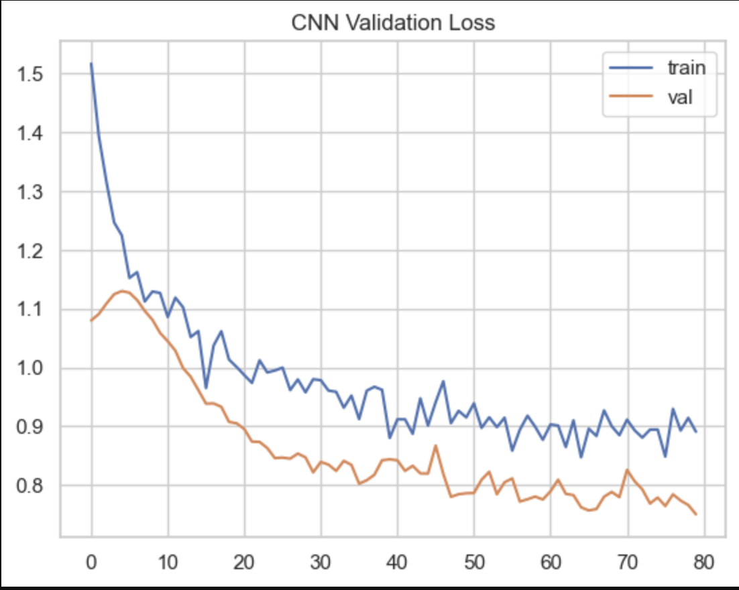
Figure 5: Training and validation loss curves for the CNN model across 80 epochs. The training loss decreases steadily with minor fluctuations, while the validation loss initially rises slightly before stabilising and converging below the training curve, indicating improved generalisation and the absence of overfitting.
3.4 Analysis of CNN Confusion Matrix
Isolation remains the best-classified category, with 34 correct predictions, although misclassifications occur as brushing (5 instances) and feeding (5 instances). This suggests that, like the SVM, the CNN can capture the dominant acoustic structure of isolation vocalisations (Figure 6).
Brushing shows moderate performance, with 15 correct classifications. However, a notable number of instances are misclassified as isolation (7) and feeding (4), indicating difficulty in distinguishing between these acoustically similar classes.
Feeding is the weakest-performing category, with only 7 correct predictions and a high number of misclassifications, particularly as brushing (9 instances). This reinforces the observation that feeding vocalisations lack distinctive acoustic features, making them difficult to separate.
Overall, the CNN exhibits similar class-level patterns to the SVM but with reduced classification accuracy. While the model captures general acoustic structures, it struggles with fine-grained distinctions between brushing and feeding, likely reflecting limitations in data representation and dataset size.

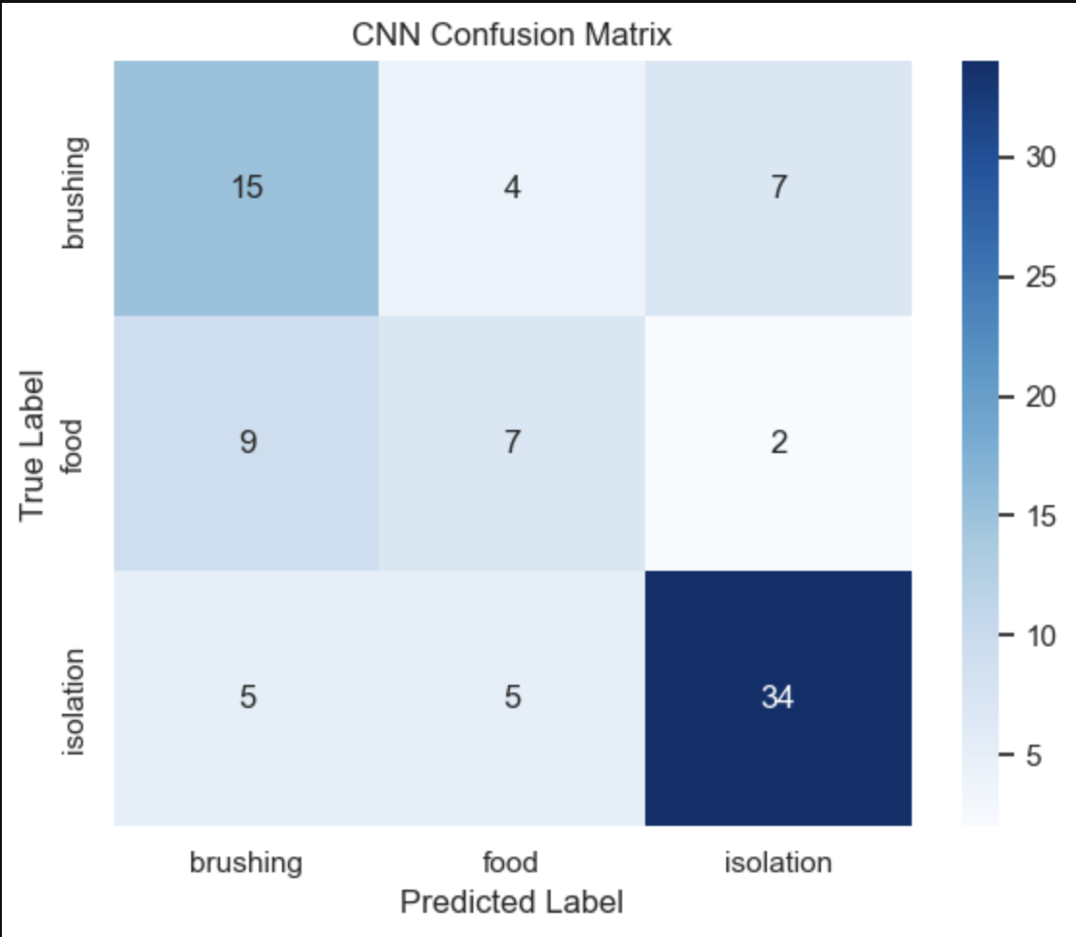
Figure 6: Confusion matrix for the CNN classifier across the three vocalisation categories. The model shows strong discrimination for isolation calls, while brushing and food calls exhibit higher misclassification rates, indicating overlapping acoustic patterns and reduced separability between these two classes
3.5 Summary of Findings
Across all experiments, isolation is consistently the most distinguishable vocalisation category, while feeding remains the most challenging. Classical machine learning models using MFCC features outperform the CNN in all evaluation metrics, suggesting that, under the given conditions, handcrafted feature representations are more effective than learned representations from spectrograms. Additionally, ensemble methods do not provide significant performance improvements over individual models.
4. Discussion

4.1 Performance of SVM and Classical Models
The results show that the Support Vector Machine (SVM) achieved the highest classification performance across all models. This aligns with prior work in audio classification, where SVMs perform strongly when combined with engineered acoustic features such as MFCCs. SVMs are effective in high-dimensional spaces, constructing optimal decision boundaries that maximise class separation even with complex data distributions (Li & Guo, 2000).
A key factor in this performance is the use of MFCC features, which provide a compact and discriminative representation of spectral properties. When such structured features are used, classical models often outperform more complex architectures, particularly in constrained data settings. Similar findings have been reported in environmental sound classification, where classical methods outperform deep learning models on limited or moderately sized datasets due to lower model complexity and reduced overfitting (Lhoest et al., 2021).
Furthermore, both theoretical and empirical studies show that deep learning methods tend to underperform in low-resource scenarios, while models such as SVM maintain strong generalisation (Shulby et al., 2019). This is consistent with the results of this study, where the SVM achieved the highest balanced accuracy and F1-score, indicating stable performance across classes.

4.2 Underperformance of the CNN Model
In contrast to the classical models, the CNN achieved lower performance across all metrics. This can be attributed primarily to the limited dataset size. Deep learning models require large, labelled datasets to learn hierarchical representations effectively; in small-data settings, they often fail to generalise and underutilise their representational capacity (Shulby et al., 2019).
Although spectrograms provide rich time–frequency information, they introduce higher-dimensional inputs that demand more data for effective training. Without sufficient data, the CNN struggles to capture fine-grained distinctions between acoustically similar classes. Prior studies show that CNN performance in audio classification depends strongly on data availability and representation quality (Sharan et al., 2021).
Additionally, acoustic similarity between classes particularly brushing and feeding contributed to misclassification. The confusion matrix indicates that the CNN captured general patterns but failed to learn class-specific features. This limitation is further exacerbated by class imbalance and variability in recording conditions, both of which negatively impact deep learning performance.

4.3 Performance of Ensemble Methods
The ensemble methods evaluated in this study, including stacking and voting classifiers, did not yield significant improvements over the best-performing individual model. While ensemble learning is generally expected to enhance performance by combining multiple models, its effectiveness depends on the diversity and complementary strengths of the base learners.
In this case, the ensemble models were primarily built upon classifiers trained on the same MFCC feature space, limiting their diversity. As a result, the models likely captured similar patterns and made correlated errors, reducing the potential benefit of aggregation. Previous research has shown that ensemble methods are most effective when base models exhibit complementary decision boundaries; otherwise, performance gains may be marginal (Nanni et al., 2020).
Moreover, the strong performance of the SVM suggests that the underlying feature representation was already highly effective, leaving limited room for improvement through model combination. This indicates that, in this context, feature quality played a more significant role than model complexity.

4.4 Comparison with Existing Literature
The findings of this study are broadly consistent with existing literature in audio classification. Ntalampiras et al. (2019) demonstrated that MFCC-based approaches combined with structured models can achieve high classification accuracy in cat vocalisation tasks, supporting the effectiveness of handcrafted features. Similarly, studies in environmental sound recognition have reported competitive or superior performance of classical models compared to deep learning approaches in data-constrained settings (Lhoest et al; 2021).
While more recent work, such as transformer-based models applied to spectrograms, has reported high classification accuracy, these approaches typically rely on larger datasets and extensive training procedures. The relatively lower performance of the CNN in this study highlights the importance of dataset size and experimental conditions when interpreting results across different studies.
Overall, the results reinforce the view that there is no universally superior model for audio classification; rather, performance depends on the interaction between data size, feature representation, and model complexity.
4.5 Limitations
A primary limitation of this study is the relatively small dataset size, which likely constrained the performance of data-intensive models such as CNNs. Limited data reduces the ability of models to learn generalisable patterns and increases sensitivity to noise and variability.
In addition, class imbalance may have influenced model performance, particularly for the feeding category, which exhibited the highest misclassification rate. Variability in recording conditions, including background noise and differences in signal duration, may have further impacted classification accuracy. Another limitation is the reliance on a single feature extraction approach (MFCC) for classical models and a single representation (spectrogram) for deep learning. Alternative representations or hybrid approaches may yield different results.

4.6 Conclusion
This study aimed to evaluate the effectiveness of machine learning approaches for classifying cat vocalisations based on behavioural context. The results demonstrate that classical machine learning models, particularly the SVM using MFCC features, achieved the highest performance, while the CNN based on spectrogram representations underperformed under the given conditions. All stated objectives were achieved: the audio data were successfully pre-processed, MFCC and spectrogram features were extracted, multiple models were implemented, and their performance was systematically compared using standard evaluation metrics. Additionally, ensemble methods were assessed but did not provide significant improvement over individual models.
The research question is therefore answered: classification effectiveness depends strongly on the choice of feature representation and model, with MFCC-based classical approaches proving more effective in this study. Future work should focus on utilising larger, more balanced datasets and applying transfer learning approaches to improve model generalisation and performance.

Reference
Brodersen, K.H., Ong, C.S., Stephan, K.E. and Buhmann, J.M. (2010), August. The balanced accuracy and its posterior distribution. In 2010 20th international conference on pattern recognition (pp. 3121-3124). IEEE.
Breiman, L., Friedman, J., Olshen, R.A. and Stone, C.J. (2017). Classification and regression trees. Chapman and Hall/CRC.
Carvalho, S. and Gomes, E.F. (2023). Automatic classification of bird sounds: using mfcc and mel spectrogram features with deep learning. Vietnam Journal of Computer Science, 10(01), pp.39-54.
Chen, T. and Guestrin, C. (2016) August. Xgboost: A scalable tree boosting system. In Proceedings of the 22nd acm sigkdd international conference on knowledge discovery and data mining (pp. 785-794).
Colonna, J.G., Nakamura, E.F. and Rosso, O.A. (2018). Feature evaluation for unsupervised bioacoustic signal segmentation of anuran calls. Expert Systems with Applications, 106, pp.107-120.
Cortes, C. and Vapnik, V. (1995). Support-vector networks. Machine learning, 20(3), pp.273-297.
Davis, S. and Mermelstein, P. (1980). Comparison of parametric representations for monosyllabic word recognition in continuously spoken sentences. IEEE transactions on acoustics, speech, and signal processing, 28(4), pp.357-366.
Eriksson, M., Keeling, L.J. and Rehn, T. (2017). Cats and owners interact more with each other after a longer duration of separation. PLoS One, 12(10), p.e0185599.
Fatima, B., Nigam, R., Siddiqui, A.A., Rai, S. and Singh, C. (2024) ‘To Study the Different Types of Vocalizations in Domestic Cats (Felis catus)’, International Journal of Innovative Science and Research Technology, 9, pp. 1437–1443.

Friedman, J.H. (2001). Greedy function approximation: a gradient boosting machine. Annals of statistics, pp.1189-1232.

Gholamy, A., Kreinovich, V. and Kosheleva, O. (2018). Why 70/30 or 80/20 relation between training and testing sets: A pedagogical explanation. International Journal of Intelligent Technologies and Applied Statistics, 11(2), pp.105-111.
Giri, G., Iza, K.C., Khatiwada, P., Adhikari, S.K. and Shakya, S. (2025). CNN-based bird sound detection: a comparative performance study. International Journal on Engineering Technology, 2(2), pp.176-187.
Geurts, P., Ernst, D. and Wehenkel, L. (2006). Extremely randomized trees. Machine learning, 63(1), pp.3-42.
He, H. and Garcia, E.A. (2009). Learning from imbalanced data. IEEE Transactions on knowledge and data engineering, 21(9), pp.1263-1284.
Hu, S., Chu, Y., Wen, Z., Zhou, G., Sun, Y. and Chen, A. (2023). Deep learning bird song recognition based on MFF-ScSEnet. Ecological Indicators, 154, p.110844.
Karaaslan, M., Turkoglu, B., Kaya, E. and Asuroglu, T. (2024). Voice analysis in dogs with deep learning: development of a fully automatic voice analysis system for bioacoustics studies. Sensors, 24(24), p.7978.
Kopparapu, S.K. (2014). Voice Analytics Process. In Non-Linguistic Analysis of Call Center Conversations (pp. 11-27). Cham: Springer International Publishing.
Kucukkulahli, E. and Kabakus, A.T. (2024) ‘Towards Understanding Cat Vocalizations: A Novel Cat Sound Classification Model Based on Vision Transformers’, Applied Acoustics, 226, p. 110218.
Labied, M., Belangour, A., Banane, M. and Erraissi, A. (2022), March. An overview of automatic speech recognition preprocessing techniques. In 2022 international conference on decision aid sciences and applications (DASA) (pp. 804-809). IEEE.
LeCun, Y., Bengio, Y. and Hinton, G. (2015). Deep learning. nature, 521(7553), pp.436-444.
Lhoest, L., Lamrini, M., Vandendriessche, J., Wouters, N., da Silva, B., Chkouri, M.Y. and Touhafi, A. (2021). Mosaic: A classical machine learning multi-classifier based approach against deep learning classifiers for embedded sound classification. Applied Sciences, 11(18), p.8394.
Li, S.Z. and Guo, G.D. (2000). Content-based audio classification and retrieval using SVM learning. In First IEEE Pacific-Rim Conference on Multimedia, Invited Talk, Australia.
Lostanlen, V., Salamon, J., Cartwright, M., McFee, B., Farnsworth, A., Kelling, S. and Bello, J.P. (2018). Per-channel energy normalization: Why and how. IEEE Signal Processing Letters, 26(1), pp.39-43.
Ludovico, L.A., Ntalampiras, S., Presti, G., Cannas, S., Battini, M. and Mattiello, S. (2021), January. Catmeows: A publicly-available dataset of cat vocalizations. In International Conference on Multimedia Modeling (pp. 230-243). Cham: Springer International Publishing.
Miao, Z., Elizalde, B., Deshmukh, S., Kitzes, J., Wang, H., Dodhia, R. and Ferres, J.L. (2025). Multi-modal Language models in bioacoustics with zero-shot transfer: a case study. Scientific Reports, 15(1), p.7242.
Nanni, L., Rigo, A., Lumini, A. and Brahnam, S. (2020). Spectrogram classification using dissimilarity space. Applied Sciences, 10(12), p.4176.
Nema, B.M. and Abdul-Kareem, A.A. (2017). Preprocessing signal for speech emotion recognition. Al-Mustansiriyah Journal of Science, 28(3), pp.157-165.
Ntalampiras, S., Ludovico, L.A., Presti, G., Prato Previde, E., Battini, M., Cannas, S., Palestrini, C. and Mattiello, S. (2019) ‘Automatic classification of cat vocalizations emitted in different contexts’, Animals, 9(8), p. 543.
Oikarinen, T., Srinivasan, K., Meisner, O., Hyman, J.B., Parmar, S., Fanucci-Kiss, A., Desimone, R., Landman, R. and Feng, G. (2019). Deep convolutional network for animal sound classification and source attribution using dual audio recordings. The Journal of the Acoustical Society of America, 145(2), pp.654-662.
Owens, J.L., Olsen, M., Fontaine, A., Kloth, C., Kershenbaum, A. and Waller, S. (2017). Visual classification of feral cat Felis silvestris catus vocalizations. Current zoology, 63(3), pp.331-339.
Purwins, H., Li, B., Virtanen, T., Schlüter, J., Chang, S.Y. and Sainath, T. (2019). Deep learning for audio signal processing. IEEE Journal of Selected Topics in Signal Processing, 13(2), pp.206-219.
Schwartz, J.W., Polly, N.E., Deshon, A.K., Duffy, V.A., Muñoz, R. and Hardin, A.M. (2025) ‘Acoustic classification and human perception of domestic cat vocalizations’, Animal Behaviour, 224, p. 123204.
Sharan, R.V., Xiong, H. and Berkovsky, S. (2021). Benchmarking audio signal representation techniques for classification with convolutional neural networks. Sensors, 21(10), p.3434.
Shulby, C.D., Ferreira, M.D., de Mello, R.F. and Aluisio, S.M. (2019). Theoretical learning guarantees applied to acoustic modeling. Journal of the Brazilian Computer Society, 25(1), p.1.
Smirnova, D.S., Volodin, I.A., Demina, T.S. and Volodina, E.V. (2016). Acoustic structure and contextual use of calls by captive male and female cheetahs (Acinonyx jubatus). PLoS One, 11(6), p.e0158546.
Sokolova, M. and Lapalme, G. (2009). A systematic analysis of performance measures for classification tasks. Information processing & management, 45(4), pp.427-437.
Stowell, D., (2022). Computational bioacoustics with deep learning: a review and roadmap. PeerJ, 10, p.e13152.
Stowell, D., Wood, M.D., Pamuła, H., Stylianou, Y. and Glotin, H. (2019). Automatic acoustic detection of birds through deep learning: the first bird audio detection challenge. Methods in Ecology and Evolution, 10(3), pp.368-380.
Tsiatas, G.C., Kotsiantis, S. and Charalampakis, A.E. (2022). Predicting the response of laminated composite beams: A comparison of machine learning algorithms. Frontiers in Built Environment, 8, p.855112.
Turner, D.C. and Bateson, P.P.G. eds. (2000). The domestic cat: the biology of its behaviour. Cambridge University Press.
Xu, W., Zhang, X., Yao, L., Xue, W. and Wei, B. (2020). A multi-view CNN-based acoustic classification system for automatic animal species identification. Ad Hoc Networks, 102, p.102115.

