

WAK Solutions
WhatsApp AI Chatbot

Solution Design Document

March 2026 | Version 1.0 | Confidential

1. Executive Summary
WAK Solutions has built a WhatsApp-first customer service platform that uses artificial intelligence to handle customer enquiries automatically — around the clock, in multiple languages — without requiring a human agent to be present for every interaction.

Customers interact through the WhatsApp application they already use every day. The AI agent understands their questions, looks up live order data from the company database, and responds instantly in the customer's preferred language. When a situation is too complex for the AI to handle, the system automatically escalates the conversation to a human agent, who can take over seamlessly from a dedicated web dashboard.

Key Business Outcomes
- 24/7 customer support with no additional staffing cost for routine enquiries.
- Instant order tracking: customers receive real-time delivery status without waiting in a queue.
- Multilingual coverage: the AI responds natively in Arabic, English, Chinese, and other languages.
- Escalation safety net: any conversation that exceeds AI capability is immediately flagged for human review.
- Full audit trail: every message — AI or human — is stored and searchable.

Document Scope
This document provides a non-technical overview of the system for business and management stakeholders. It covers what the system does, how its components fit together, the flows a customer and agent experience, and the infrastructure that underpins it. Implementation-level code details are intentionally excluded.

2. How the System Works
The platform is composed of three integrated components that work together in real time: an AI Service that talks to WhatsApp, an Agent Dashboard that human staff use, and a shared database that keeps both in sync.

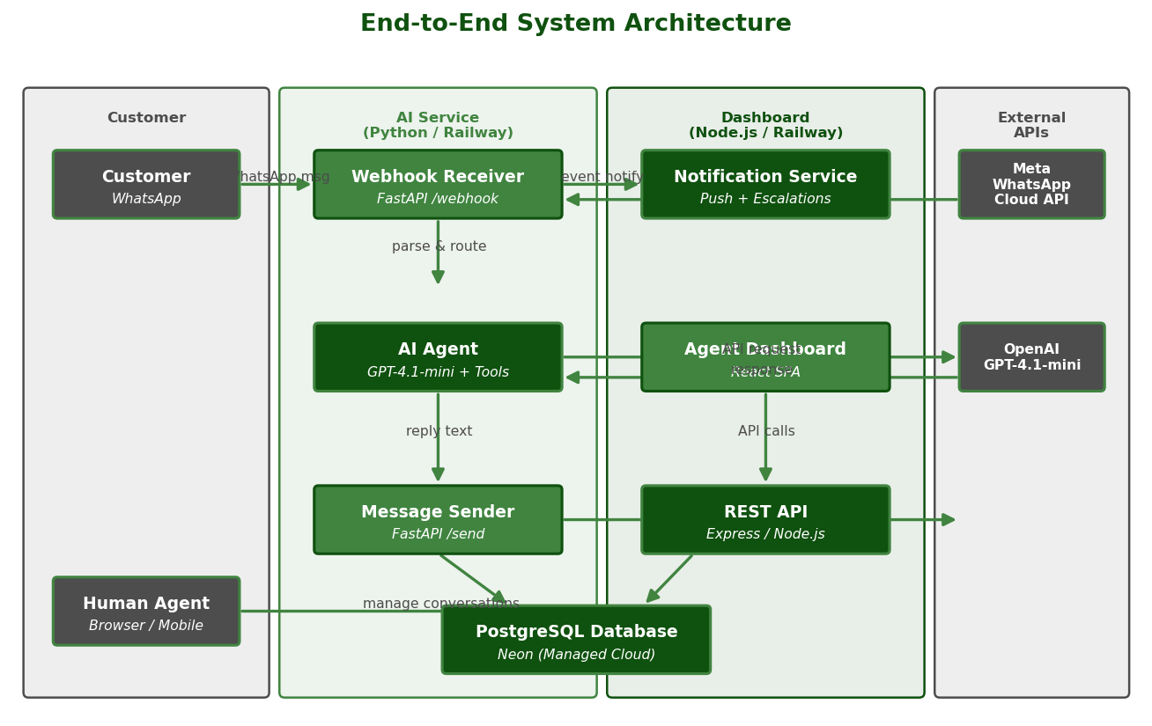
Figure 1 — End-to-End System Architecture

Component Summary
Component | Role | Technology
AI Service | Receives WhatsApp messages, calls the AI, and sends replies back to the customer. | Python / FastAPI on Railway
Agent Dashboard | Web interface where human agents monitor conversations and reply manually when needed. | React / Node.js on Railway
PostgreSQL Database | Central store for every message, conversation, and escalation record. | Neon Managed Cloud
Meta WhatsApp API | The channel through which customers send and receive messages. | Meta Cloud API v19.0
OpenAI GPT-4.1-mini | The AI model that understands customer messages and generates natural replies. | OpenAI Cloud API

3. The Three Core Flows
Every interaction in the system follows one of three paths. The diagram below shows how each flow progresses from start to finish.

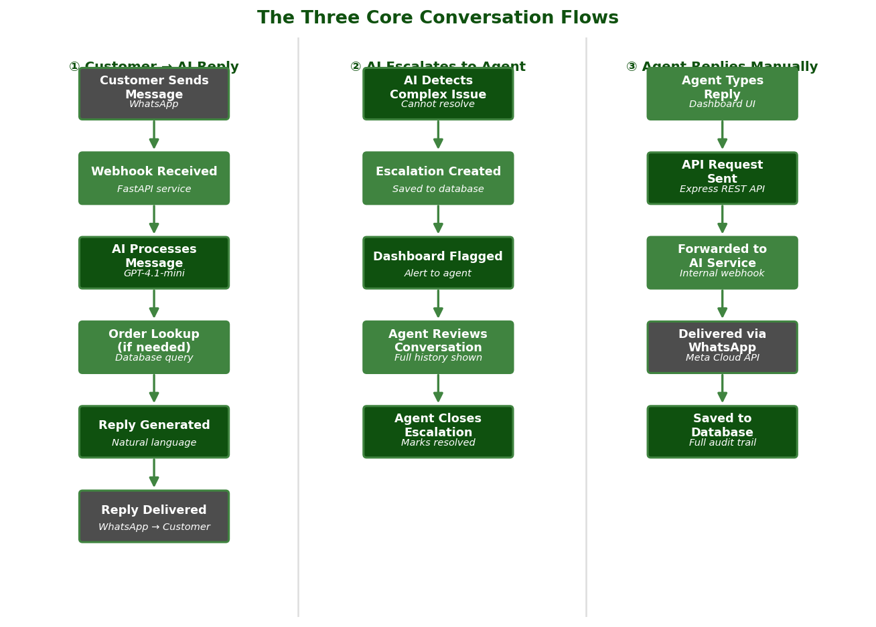
Figure 2 — The Three Core Conversation Flows

Flow Descriptions
Flow | Trigger | Outcome
① Customer → AI Reply | Customer sends any WhatsApp message to the business number. | AI reads history, queries the database if needed, and sends an instant reply via WhatsApp.
② AI Escalates to Agent | AI cannot resolve the issue (e.g. a complaint or sensitive request). | Escalation record is created, the dashboard flags the conversation, and an agent is notified.
③ Agent Replies Manually | Agent types a response in the dashboard after reviewing the conversation. | Message is delivered to the customer via WhatsApp and saved to the database.

4. The Agent Dashboard
The Agent Dashboard is a web application that human agents open in any browser or install as a mobile app. It gives agents a real-time view of all active conversations and the tools they need to respond.

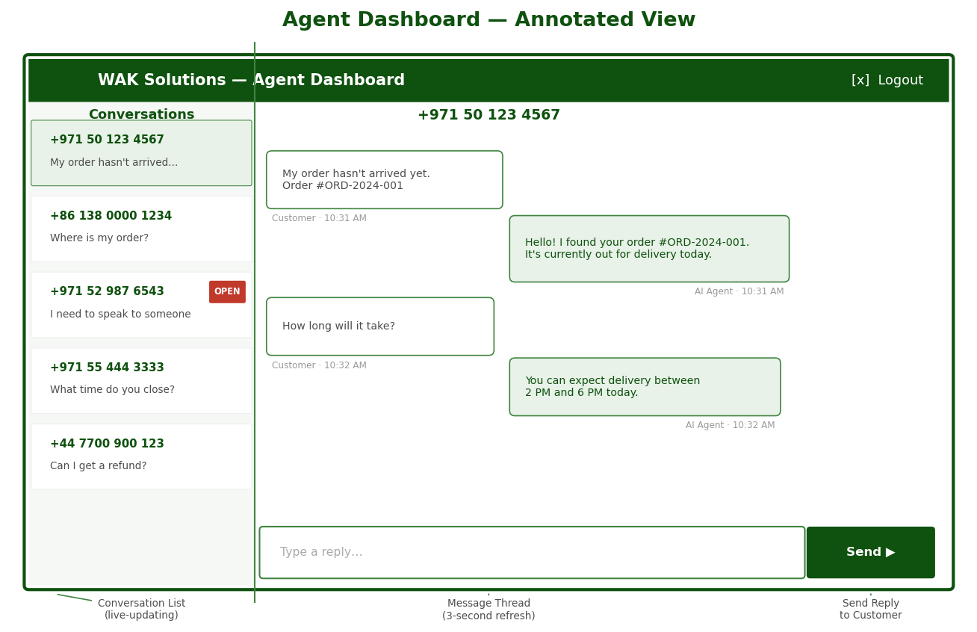
Figure 3 — Agent Dashboard Annotated View

Key Features
Feature | Description
Conversation List | Left sidebar shows all active conversations sorted by most recent activity. Escalated conversations are highlighted with a red badge.
Message Thread | Clicking any conversation opens the full chat history, showing messages from the customer, the AI, and previous agent replies.
Agent Reply Box | Agents type a reply at the bottom and click Send. The message is delivered to the customer's WhatsApp immediately.
Push Notifications | The browser or mobile app sends a notification when a new message arrives or an escalation is opened — even when the dashboard tab is not active.
Biometric Login | Agents can register their device fingerprint or Face ID to log in securely without typing a password each time.
Close Escalation | Once an agent has resolved an escalated conversation, they mark it closed. The dashboard removes the alert and the record is archived.
Mobile / PWA Support | The dashboard can be installed as a Progressive Web App on any smartphone, giving agents full functionality on the go.

5. AI Agent Capabilities
The AI agent is powered by OpenAI's GPT-4.1-mini model. It is configured with a system prompt that defines its identity, tone, and the tasks it is authorised to perform on behalf of WAK Solutions. The table below summarises what the AI can and cannot do.

Capability | Status | Detail
Respond in the customer's language | YES — Can Do | Detects and replies in Arabic, English, Mandarin Chinese, and other languages automatically.
Answer product enquiries | YES — Can Do | Handles questions about products, services, pricing, and operating hours from its knowledge base.
Look up a specific order | YES — Can Do | When a customer provides an order number, the AI queries the live database and reports the current status.
Handle complaints | YES — Can Do | Acknowledges the complaint, apologises appropriately, and escalates to a human agent for resolution.
Escalate to a human agent | YES — Can Do | Automatically hands off conversations it cannot resolve, with a reason recorded for the agent.
Maintain conversation history | YES — Can Do | Remembers the last 20 messages so customers do not have to repeat themselves.
Process payments or place orders | NO — Cannot | The AI has read-only access to order data and cannot make changes or process transactions.
Access personal account details | NO — Cannot | The AI only looks up orders by order number; it cannot access full account or payment information.
Operate across other channels | NO — Cannot | The current implementation is WhatsApp-only; email, web chat, or SMS are not currently connected.

Language Support
The AI does not require manual language selection. It detects the language of the customer's message and responds accordingly. Supported languages include Arabic, English, Mandarin Chinese, French, and others supported natively by GPT-4.1-mini.

6. Infrastructure & Integrations
The entire platform runs on cloud infrastructure with no on-premise hardware required. The two application services are hosted on Railway, a managed cloud platform, while the database is provided by Neon, a managed PostgreSQL service. Both are production-grade services with automatic scaling and uptime guarantees.

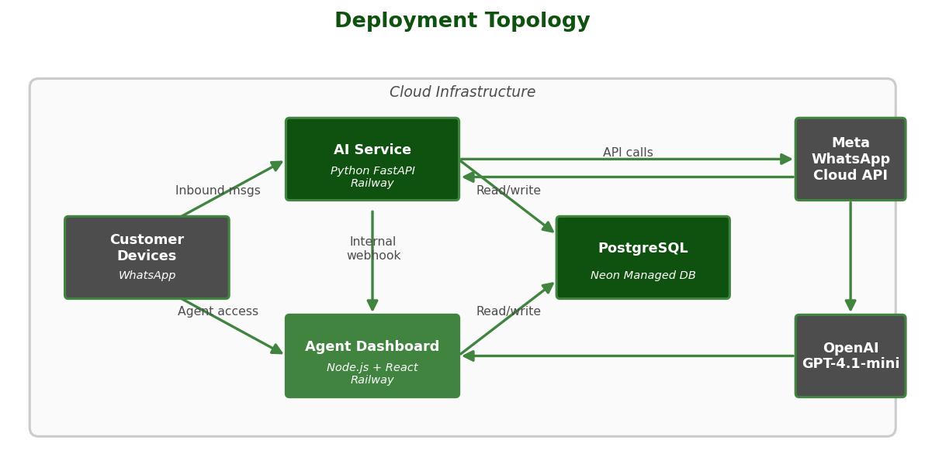
Figure 4 — Deployment Topology

External Services
Service | Provider | Role | Managed By
WhatsApp Channel | Meta (Facebook) | Customer messaging channel — sends and receives all WhatsApp messages. | Meta Cloud
AI Language Model | OpenAI | Understands customer messages and generates contextual replies. | OpenAI Cloud
Application Hosting | Railway | Hosts both the AI Service and the Agent Dashboard as separate services. | Railway Cloud
Database | Neon | Stores all messages, escalations, and conversation records. | Neon Cloud
Push Notifications | Web Push / VAPID | Delivers browser and mobile notifications to agents. | Self-managed via Railway

7. Assumptions, Constraints & Next Steps

Current State (v1.0)
The current version is a fully functional system. The following items represent known characteristics of the v1.0 build that should be addressed before a high-volume production launch:

Area | Current Behaviour / Constraint
Authentication | Agent login uses a single shared password. For a multi-agent team, individual accounts with role-based access should be introduced.
Session Storage | User sessions are held in server memory, which means agents are logged out if the server restarts. A Redis-backed session store is recommended for production.
Real-time Updates | The dashboard refreshes conversation data every 3–10 seconds by polling. A WebSocket-based push would reduce latency and server load at scale.
Single WhatsApp Number | The platform is configured for one WhatsApp Business number. Multiple numbers or teams would require additional configuration.
Order Lookup Scope | The AI can look up orders by order number but cannot access customer account history or initiate any changes — by design.

Recommended Next Steps
- Introduce individual agent accounts with login audit logging.
- Move session storage to a persistent Redis or database-backed store.
- Replace polling with WebSockets for real-time message delivery in the dashboard.
- Add a reporting module: volume of conversations, escalation rate, average response time.
- Extend order lookup to support additional query types (e.g. search by phone number).
- Evaluate adding additional channels (e.g. web chat widget) using the same AI backend.

