Skill Proof: An Immersive Simulation Platform for Demonstrating , Assessing Practical Skills Competency In Eswatini.

Section 1: Scope Alignment & Feature Validation

The table compares the planned features with what was built.
Planned Feature | Intended Purpose | Status | Evidence
Sign Up, Login, Logout, FireBase Authentication, storage | Link every result to a known user | Complete | Figure 1
User Profile Screen | Show user ID, email, average scores | Complete | Figure 2
Cloud Firestore data layer | Stores users, simulations and performance records | Complete | Figure 3
Activity and trigger system | Track each step of a task | Complete | Figure 4
Task progress screen and hints | Show live progress, errors and The next instruction | Complete | Figure 5
Electrical Wiring full Simulation (5 activities) | Show wiring competence and safety. | Complete | Figure 6
Solar Panel full Simulation  (5 activities) | Show solar panel installation competence and safety | Complete | Figure 7
Testable circuits breaker, sparks, test switches | Penalise wrong wiring and unsafe work, plus test option at the end. | Complete | Figure 8
Sound effects, correct sub activity sound, and complete activity sound, wrong activity sound, machine sounds | Give audio feedback, | Complete | Figure 9
Results Screen | Show complete time,errors, safety and competence, feedback | Complete | Figure 10
Evidence PDF and email | Give users proof they can keep and share | Completed | Figure 11
In app screen recording. | Record a session on headset , to share as proof | Complete | Figure 12
XR Keyboard | Lets user type in VR | Complete | Figure 13
Tutorial Menu videos | Guides user on how to use system | Complete | Figure 14
Changes to original scope:
- Firestore instead of Realtime Database: The data is structured by user and session, which handles well.
- Testing in Rwanda instead of Eswatini: Currently in Rwanda, so testing and data collection use participants here. The product is still designed for the Eswatini context.
-Evidence email sent: The feature to save evidence to a local device was changed to save evidence by sending the user an email with evidence.
- Testing with a simulator and on the headset: The laptop does not meet the Quest link requirements so testing used the XR device Simulator and built and ran on the Quest 2.
Section 2: Technical Product Demonstration
A. Core Functionalities
Session tracker - The SessionTracker is the central script of the system. Every other script reports to it, and it is the only place where a session’s results are calculated. When in the simulation it records five things, which activities are complete, procedural accuracy, errors, safety compliance and time used. When simulation ends, it turns these records into the safety, competency and procedural scores and results of competent or not competent.
Activities and triggers - Each simulation has 5 activities and each activity has a side activity which will be counted to if each activity is completed. Triggers that share the same activityID are the tasks of one activity, if one of these activities with the same ID are not done then the full activity will not be complete until they are done. Socket tasks use an XR Socket interactor that accepts only the correct object.

Errors and safety - A wrong zone plays a warning sound first. The error is counted only if the object is still in the wrong place when the simulation ends. Testing a circuit the wrong way counts as an error at that moment. Starting work while the breaker is still ON is a safety violation, shown with sparks and sound.
Scoring - The session tracker records completion, procedural accuracy, errors, safety compliance and time so from these it produces a safety, competency and procedural scores which then give a result of competent or not competent.
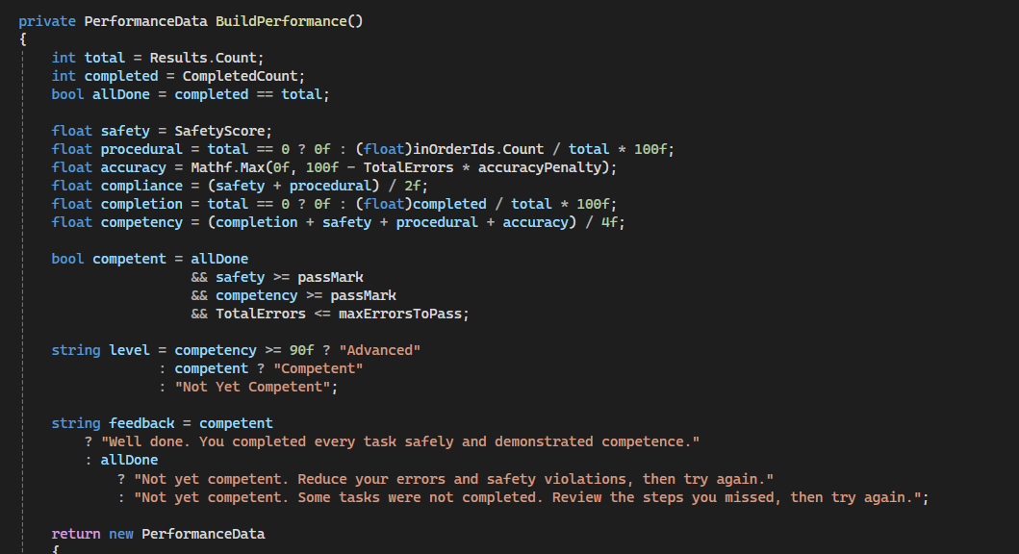

Evidence output - The EvidenceSaver script reads the results screen, builds a pdf with a small custom class (Evidence PDF), emails it through the Apps Script web app.

Scene management - The MenuNavigation script loads scenes in the background behind a loading screen. Every scene load must rest the scene and all activities. Only the logged-in user stays until logout.
Sound - A SoundManager with an audio mixer controls effects and ambience volume. It plays pickup, drop, machine, correct, wrong and complete sounds.

Skill Proofs runs on the Meta Quest 2 and talks to the Firebase directly.
Part | Technology | Role
VR client | Unity 6, C#, XR Interaction Toolkit | Scenes, interactions, activity tracking, scoring and user interface
Authentication | Firebase Authentication | Email and password sign-up and login. Firebase hashes the passwords.
Database | Cloud Firestore | Stores users, simulations and a performance record for every session
Email service | Google Apps Script web app | Receives the evidence and sends an HTML email to the user
Local storage | Quest device storage | Saves video evidence when recorded
Recording | Liv creators kit | Allows apps to have a recording feature.
B. Testing Approaches and Results
Three testing approaches were used. Functional testing: each feature was tried with correct input and with wrong input, such as the wrong object in a socket, a test switch used too early and wiring started with the breaker ON. Device and platform testing: features were first checked in the XR Device Simulator on the laptop, then built and run on the Meta Quest 2 to confirm they work on the real headset. Error-handling testing: each mistake was checked to see that the right sound, effect and error or safety record was produced.
Table 1 shows the main test cases and their results.
Test | Input or action | Expected result | Result
Sign up | Valid name, email and password | Account is created, then the login screen opens | Pass
Login and logout | Valid account, then Logout | Simulation menu opens and profile shows name, ID and email; logout returns to login | Pass
Wrong object in socket | Place a wrong object in an XR Socket Interactor | Socket refuses it; the task stays incomplete | Pass
Remove a component | Complete an activity, then take a part out | Activity stops counting as complete | [CONFIRM]
Test too early | Flip the test switch before all tasks are done | Sparks and wrong sound; one error is recorded | [CONFIRM]
Breaker still ON | Start wiring with the breaker ON | Sparks and sound; safety violation recorded | [CONFIRM]
Evidence email | Press Save Evidence on the results screen | PDF is built and the email arrives for each signed-in account | Pass
Scene restart | Restart the simulation, then use sockets | Scene and all activities reset and sockets work again | [CONFIRM]
Table 1: Main test cases and results.
Results and defects found. The simulator and the headset did not always behave the same. Two problems only showed on the Quest 2: the sockets stopped working after the simulation was restarted, and the password fields showed plain text instead of hidden characters. The first was fixed by resetting the scene and all activities on every scene load. The second is handled by making the keyboard script hide password input on any headset. [CONFIRM both fixes are done before submitting.]
[Screenshot: a failed test, such as sparks and the wrong sound, and the error shown on the results screen]
C. Code Quality Practices
One source of truth. SessionTracker is the only script that calculates results, so scores cannot disagree between screens.
Reusable, inspector-driven scripts. ActivityTrigger groups tasks by activityID, and ErrorTrigger and the test scripts take their settings in the Inspector. The same script works in every scene, so no code is copied.
Separate responsibilities. Each script has one job: SoundManager for audio, MenuNavigation for scenes, EvidenceSaver for the PDF and email, and DatabaseManager for Firestore. The Scripts folder is split into Managers, Menu Navigation and Player.
Shared behaviour in one place. All sounds go through SoundManager and its audio mixer, and grab and drop sounds are shared by every XR Grab Interactable.
Safe handling of user data. Passwords are handled by Firebase Authentication and hashed there, so the app never stores them. The PDF is built by a small custom class with no extra libraries, which keeps the build light for the Quest 2.
Version control. The project is kept in a GitHub repository, and the README explains the setup and the project structure.

