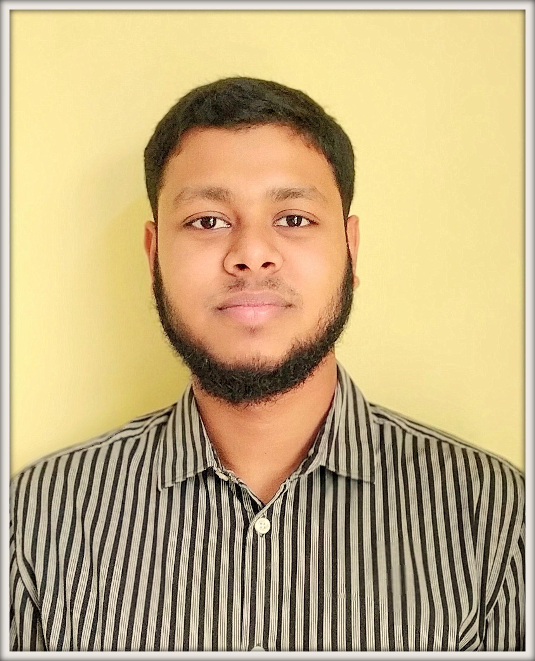**Towfiqul Islam**

+8801823923023 || [towfiq.106@gmail.com](mailto:towfiq.106@gmail.com) || [towfiqul@inflack.com](mailto:towfiqul@inflack.com)

<https://github.com/laziestcoder>

<https://stackoverflow.com/users/6688908/laziestcoder>

# 

# Professional Experience

## Solution Engineer, bKash Limited (Partner Team)

***bKash*** is a mobile financial service in Bangladesh operating under the authority of Bangladesh Bank as a subsidiary of BRAC Bank Limited. This mobile money system started as a joint venture between BRAC Bank Limited, Bangladesh and Money in Motion LLC, United States of America.

**Key Responsibilities**

* **Main Responsibility: Analyzing Problems** and **Designing Solutions** with **bKash Developers** representing my company.
* **Coding:** Implementation of **Solution** using specific **programming stack**.
* **Requirement analysis:** Analysis of the requirements & **developing logic**.
* **Developer end testing**: Through verification of output against requirements.

## Software Engineer, Inflack Limited (Current)

***Inflack***, a software consultancy company works both on big scale government & private projects. Inflack operates with the vision at its core to achieve the highest bar on customer collaboration.

**Key Responsibilities**

* **Coding:** Conversion of the requirements into production code.
* **Requirement analysis:** Analysis of the requirement & stakeholder communication.
* **Developer end testing**: Through verification of output against requirements.
* **Cultural advocacy:** Promote company norms & values to both employee & customers.

**Work Highlights**

### [**TAXSENSE**](http://www.taxsensebd.com/)

[A software based on Tax Calculation and Tax Report Generator for Ahkam and Associates Business Limited.](http://www.taxsensebd.com/)

***Technologies***​: PHP (Laravel), Docker, JQuery, MySQL.

### [**HR ACR**](http://acr.ict.inflack.com/)

Application developed for Ministry of ICT for generating Annual Confidential Report of employees.

***Technologies​***: PHP (Laravel), Docker, JQuery, MySQL.

### [**IMS**](http://demo.eti.inflack.com/login)

A software called Inventory Management System for Electoral Training Institute for managing different types of product, stock, purchase and tracking the distributed items.

***Technologies​***: PHP (Laravel), Docker, JQuery, MySQL.

# Skills

|  |  |  |  |  |  |  |  |  |
| --- | --- | --- | --- | --- | --- | --- | --- | --- |
| C/C++ | PHP | JAVA | Docker | Bash | GIT | Laravel |  |  |
| MySQL | JavaScript | JIRA | JQuery | Spring Boot | Postman | Unix |  |  |

# Other Project and Activities

[ITMS](http://itms.herokuapp.com/)

Transportation Management System for IIUC as my final year project which handles the hassles regarding transportation system.

***Technologies***​: PHP (Laravel), XAMPP, JQuery, MySQL

[BDT_TMS](https://github.com/laziestcoder/BDTTMS)

Bangladesh Tour and Travel Management System, a solution for Bangladeshi Tourist and Travelers.

***Technologies***​: PHP, OOP, XAMPP JQuery, MySQL

# Awards & Achievements

## Team Award as Coach:

* IIUC IUPC 2017, my team CJC_TEAM_1971 Ranked [2nd Position](https://drive.google.com/open?id=1TC8-AII5ER3ntrIl0wB3tU1JNtoU11VA). <https://goo.gl/DJnuAy>
* EDU Programming Contest 2018 , my team CJC_TEAM_1971 Ranked [5th position](https://drive.google.com/open?id=1sg0KEhFqm9TZGdn_XwJFlS-bBWKRP8VN)***.*** <https://goo.gl/JTPNuu>

## ACM Profiles:

* **5th** Position on **CSE Week Programming Contest 2016.** <https://algo.codemarshal.org/contests/cseweek-2016/standings>
* Participated in divisional onsite contest: *IIUC IUPC 2015*,*2016*, *USTC IUPC 2016* Solved **500+** problems in various online judge.
* Virtual Judge ID: **UVA**: [*448714*](https://uhunt.onlinejudge.org/id/448714), **CodeForces**: [*laziestcoder*](http://codeforces.com/profile/laziestcoder)*,*  **HackerRank**: [*Laziest_Coder*](https://www.hackerrank.com/Laziest_Coder)

# Education

|  |  |  |
| --- | --- | --- |
| B.Sc. Computer Science & Engineering ‘19 | HSC ‘13 | SSC ‘11 |
| Int’l Islamic University Chittagong | Govt. City College Chittagong | Govt. Muslim High School Chittagong |

# Personal Information

* **Father’s Name:** Karimul Islam
* **Mother’s Name:** Salina Akter
* **Nationality:** Bangladeshi
* **Present Address:** House-18, Road-23, Pallabi, Mirpur-11.5, Dhaka-1216
* **Permanent Address:** House-106, Road-Kobi Nazrul Islam, Sadarghat, Chittagong-4000