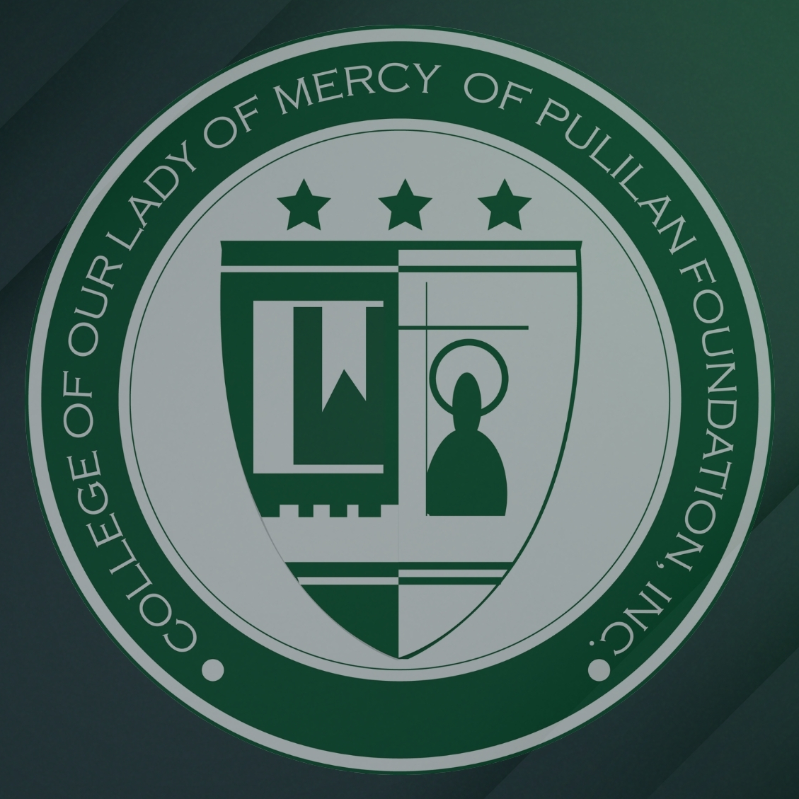
COLLEGE OF OUR LADY OF MERCY OF PULILAN FOUNDATION, INC.
Web Systems Development — Final Examination
SYSTEM DOCUMENTATION
Evaluation Rubric
Resume & Portfolio Website Project
Final Exam Requirement • Total: 100 Points
For evaluating the written documentation submitted alongside the resume/portfolio website
Student: Justine Cedric M. Orido
Section: BSIT 4-TaskUs
Project Title: TenTen’s
Instructor: Sir Michael Espiritu

Purpose and Scope
Purpose
This project is a personal resume and portfolio website created for the information technology student, Justine Cedric M. Orido. It is mainly designed to be utilized as a single professional digital hub to display my abilities, certificates and projects to potential employers, internship coordinators and instructors. Instead of sending them bits and pieces of pdf files and code snippets, a single live URL presents a fully interactive, comprehensive profile viewable to anyone. The design direction – dark, minimal, editorial, with gold accent – was purposefully chosen intentionally and professionally looking, instead of using a template for default. For a web development applicant, this site also double duty as a live work sample of basic frontend skills, including semantic HTML, responsive CSS layout and basic accessibility practices. The finished website is hosted on Vercel, so that single live URL is publicly reachable without running anything locally.

Scope
The website is developed as a single page with five sections linked with anchors, containing About (introduction, skills and statistics), Certifications (8 Certifications from Cisco Networking Academy and Wadhwani Foundation), Projects (MediMate, Attendance Tracking System and Aim Shooting Game), Education (Senior High School STEM and BSIT) and Contact (email and downloadable Resume) respectively. The navigation bar at the top of the page links to all sections and it is sticky so that it remains visible while scrolling through the page.

Limitations
The system is on purpose a static frontend application: there is no backend database, no user authentication, no server-side contact form (the contact section is a mailto: link instead). The site is a single HTML file with embedded CSS, therefore the content updates have to be made directly in the source code (not through a Content Management System). Lastly, the project links are limited to completed work only, projects still in development are not displayed.

Expected Documentation Structure
A quick pre-grading reference — not separately scored, but every unchecked item should surface as a gap somewhere in the category scores below.
- Title Page | - Site Map / System Structure
- Introduction / Background | - User Guide with Screenshots
- Objectives | - Development Process Summary
- Scope and Limitations | - Challenges and Solutions
- System Features Overview | - Conclusion and Recommendations
- Technology Stack / Tools Used | - References / Appendices

1. Introduction & Project Overview — 15 pts
Score | Criteria
14–15 Excellent | Clearly explains the purpose of the website, the motivation behind design/content choices, specific objectives, and a well-defined scope and limitations.
10–13 Good | Introduction and objectives are present and clear, but scope/limitations are vague or only briefly mentioned.
6–9 Fair | Introduction is generic or too brief; objectives are unclear or copied from a template with little customization.
0–5 Poor | No clear introduction or objectives; reader cannot tell what the project is meant to accomplish.
Purpose of the Website
This is a personal resume and portfolio website of Justine Cedric M. Orido, an Information Technology student taking Web System Development. The point of the site is to provide potential employers, internship coordinators and instructors with a single, shareable URL presenting my profile, skills, certifications, projects and contact information without forcing them to open multiple scattered files or request my resume via email. It is meant to be read in about thirty seconds by someone who decides whether they want to take a closer look.
Project Background
The design direction – dark, minimal, editorial, with a single gold accent color – was selected intentionally. Most student portfolio sites utilize bright templates with stock imagery that immediately makes them look like they could be any other. A dark color palette with serif headings and limited animation reads as intentional, not borrowed, and ensures attention is on the content, not the decoration.
The same applies to the content choices. Every project card mentions the technology stack and describes what I personally built, since the number one failure of a student portfolio is to present group work as individual work. The certifications are presented with issuing organization and date, not just a title, so that a reader can verify them. The order of sections – About, Certifications, Projects, Education, Contact – follows the path a recruiter would read: identity first, then proof of skill, then proof of work, then credentials, then a way to get in touch.
For an applicant to a web development position specifically, the site serves also as a live work sample: showcasing semantic HTML, structured CSS, responsive layout, accessibility rudiments, and deployment – precisely what the job requires.
Objectives
1. Present a complete professional profile – name, role, location and short intro – within the first screen so a visitor knows who I am without scrolling.
2. Showcase at least 3 real projects, with a few sentences description, technology stack used, and my personal contribution stated clearly.
3. Provide a list of verifiable certificates, with issuing organizations and dates, in a format where a recruiter can skim through them quickly.
4. Add a downloadable resume link (PDF) to the navigation bar and also to the contact section.
5. Deliver a fully responsive, accessible website that displays properly at mobile, tablet and desktop widths, with keyboard-navigable links and descriptive alternative text for images.
6. Deploy the site to a public URL on Vercel, so it can be shared as part of job applications and assessed without the need to run it locally.
Scope and Limitations
The website has five principal sections, in this order:
• About – introduction, list of skills, statistics and availability status.
• Certifications – eight certificates from Cisco Networking Academy and Wadhwani Foundation, with date, issuer and a brief description.
• Projects – three projects (MediMate, Attendance Tracking System, and Aim Shooting Game), each with a project description, technology stack, and project imagery.
• Education – Senior High School STEM strand and BS in Information Technology.
• Contact – email link, downloadable resume, and professional social links.
A sticky navigation bar links to all five sections and stays visible while scrolling. The site is publicly deployed and responsive on mobile, tablet, and desktop widths.
Limitations. By design, the site is static: there is no backend, no database, no user accounts. It uses no framework and no build tool – it is a single hand-written HTML file with embedded CSS, but content updates involve editing the source file directly. Project links are only to projects I have actually completed; there are no projects under development. The contact section has a mailto: link rather than a submitted contact form, so there is no server-side message handling. There is also no dark/light mode toggle or per-project case-study pages, though both are flagged for future improvement in the Conclusion and Recommendations.

2. System Features & Functionality Description — 15 pts
Score | Criteria
14–15 Excellent | Every major section/feature of the actual website (About, Skills, Projects, Contact, resume download, etc.) is described accurately and in enough detail that someone who has never seen the site understands what it does.
10–13 Good | Most features are described accurately; one or two are mentioned only briefly.
6–9 Fair | Descriptions are vague, generic, or only partially match what the website actually contains.
0–5 Poor | Feature descriptions are missing, or do not match the delivered website at all.

The website is a single-page application consisting of a persistent navigation bar, five anchored content sections, and a footer. The features below are listed in the order a visitor encounters them when scrolling from top to bottom. Every item described here exists on the live deployed site.
1. Sticky Navigation Bar
A fixed header that stays visible at the top of the viewport while the visitor scrolls. It contains three elements arranged horizontally: the site logo (Ten.Ten’s, with the period rendered in the gold accent color), a list of five anchor links (About, Certifications, Projects, Education, Contact), and a gold-outlined "Résumé ↓" button. Clicking any link scrolls smoothly to the corresponding section without reloading the page. On screens narrower than 860px the link list is hidden to preserve layout, but the logo and the résumé button remain visible and functional at all widths.
2. Hero / Landing Section
The first screen a visitor sees, containing no buttons — its only job is to establish identity before the visitor scrolls. It displays a large serif headline reading "Justine Cedric / M. Orido." with the second line italicized in gold, a subtitle identifying the field ("Information Technology"), a location line ("Based in the Philippines") preceded by a horizontal gold rule, a short italic statement of approach, and a "Scroll ↓" prompt at the bottom.
3. About Section
A two-column layout on desktop that collapses to a single column on mobile. The left column holds a portrait image with a subtle gold radial glow behind it. The right column holds a name line, two paragraphs of self-introduction, a skills subsection, a statistics row, and an availability badge.
A. Skills Subsection — A wrapping row of eight outlined pill-shaped tags: HTML5, Programming, JavaScript, Responsive Design, Git & GitHub, UI/UX Basics, Accessibility, and VS Code. Each tag is outlined rather than filled so the row stays visually quiet against the surrounding text.
B. Statistics Row — Three stat blocks separated from the text above by a horizontal rule: "3 — Projects built," "5+ — Certifications," and "2027 — Graduating." Each number is rendered in the large serif display font in the gold accent color, with a small uppercase label beneath it.
C. Availability Badge — A pill-shaped indicator containing a small pulsing green dot and the text "Available for opportunities," communicating current status at a glance.
4. Certifications Section
A two-column card grid on desktop that collapses to a single column on mobile, containing eight certification cards. Each card shows a gold-tinted badge icon on the left; on the right it shows the year in uppercase gold text, the certificate title in the serif font, the issuing organization (Cisco Networking Academy or Wadhwani Foundation), and a one-to-two-sentence description of the topics the certificate covers. Hovering a card highlights its border in a dimmed gold and lifts it two pixels, providing clear interactive feedback.
5. Projects Section
A three-column card grid on desktop that collapses to a single column on mobile, containing three project cards. Each card has three parts: a fixed-aspect-ratio image area at the top (with object-fit: contain and a white background so logos of varying proportions display fully without cropping), a body containing the project role in uppercase gold text, and a description of what the project does and what I personally built. Below the description is a wrapping row of outlined technology tags, and where applicable, a row of gold text links to a live demo and/or source code. Cards share the same hover behavior as the certification cards.
6. Education Section
A two-column card grid on desktop that collapses to a single column on mobile, containing two education cards. Each card shows the date range in uppercase gold, the program title in the serif font, the institution name in muted text, and a short description. Card one covers Senior High School (STEM strand) at Baliwag Polytechnic College; card two covers the BS in Information Technology program at the College of Our Lady of Mercy of Pulilan Foundation, Inc.
7. Contact Section
A centered closing section with a large headline, a short availability statement, and two action buttons side by side. The primary button ("Email me") is filled with the gold accent color and opens the visitor's default mail client via a mailto: link. The secondary button ("Download résumé") is outlined in gold and downloads the resume PDF. The section repeats the resume download already available in the navigation bar, so the visitor never has to scroll back up to reach it.
8. Resume Download
A downloadable PDF resume is reachable from two independent places — the navigation bar button and the contact section button — so it is available both at first arrival and at the end of the page. Both links use the download attribute.
9. Footer
A minimal footer containing the copyright notice on the left and three text links on the right: LinkedIn, GitHub, and Email. It closes the page without introducing new navigation or content.
10. Responsive Layout
Every multi-column block reflows to a single column at defined breakpoints (768px for card grids, 860px for the navigation link list). There is no horizontal scrolling at any viewport width down to 320px. Typography scales fluidly using clamp(), so headings remain proportionate across screen sizes without separate mobile font rules.
11. Accessibility Features
Semantic HTML landmarks (header, nav, main, section, footer) structure the page for screen readers. Every content image carries descriptive alt text, navigation links carry aria-label attributes, all interactive elements show a visible focus outline on keyboard navigation, and a prefers-reduced-motion media query disables transitions and smooth scrolling for visitors who have requested reduced motion at the operating-system level.

3. Technical Specifications & Tools Used — 15 pts
Score | Criteria
14–15 Excellent | Clearly lists languages, frameworks/libraries, development tools, and the hosting/deployment platform used, with a brief explanation of why each was chosen.
10–13 Good | Tools and technologies are listed accurately but with little or no explanation of why they were chosen.
6–9 Fair | Technical specifications are incomplete or listed without connecting them to how they were actually used in the project.
0–5 Poor | No technical specifications provided, or the list does not match the technologies actually used in the website.

The website is a static frontend project written in HTML5 and CSS3 with AI-assisted code. It uses no JavaScript, no framework, no build step, and no external libraries. This was a deliberate choice for a portfolio site of this size: fewer dependencies mean faster loading, less that can break, and a source file that anyone can inspect. The tools used, why each was chosen, and how each was used in this project are summarized below and detailed in the table.
• Languages: HTML5 (structure) and CSS3 (styling, layout, and hover effects).
• Frameworks / libraries: None, by design. CSS Grid, custom properties, and clamp() are native CSS features.
• Development tools: Visual Studio Code (editor), Claude (AI assistant for code review), Git and GitHub (version control), and Microsoft Edge DevTools (testing).
• Hosting / deployment: Vercel, which serves the finished static site at a public URL.
Category | Tool / Technology Used | Why It Was Chosen | How It Was Used in This Project
Markup / Structure | HTML5 | Semantic elements make the document structure readable to browsers and screen readers without extra work, satisfying the accessibility requirement directly. | The page is structured with header, nav, main, five section elements, and footer. Each section is identified with an id for anchor navigation and an aria-labelled by pointing to its heading.
Styling | CSS3 (embedded in a single <style> block in the document head) | A single embedded stylesheet keeps the whole site portable as one file with no external requests, which means faster load times and no broken-stylesheet risk. | All layout, typography, color, and hover states are defined in one stylesheet block.
CSS Architecture | Native CSS Custom Properties (:root variables) | Custom properties centralize the palette and spacing values, so the accent color or background can be changed in one place instead of being hunted across dozens of rules. | Core variables (--bg, --surface, --border, --text, --muted, --accent, --accent-dim) drive every color in the site. Changing --accent alone recolors all links, tags, section numbers, and hover states.
Responsive Layout | CSS Grid and clamp() | Grid with repeat(auto-fit) and explicit breakpoints handles the card layouts without duplicating rules; clamp() makes typography and padding scale fluidly between screen sizes without separate mobile styles. | Card grids use grid-template-columns: repeat(3, 1fr) on desktop and collapse to 1fr below 768px. Typography uses clamp(2.25rem, 8vw, 6rem) for the hero and clamp(1.25rem, 5vw, 4rem) for section padding.
Interactivity | Native CSS only — no JavaScript | Smooth scrolling and hover feedback are both achievable in pure CSS, so adding a JavaScript file or library would increase load time for no functional gain on a static site. | scroll-behavior: smooth on html provides anchor-link scrolling. transition rules on cards, buttons, and nav links provide hover feedback. No <script> tag exists anywhere in the source.
Icons / Favicon | Inline SVG data URI (emoji favicon) | An inline data URI favicon requires no image file, no network request, and no favicon folder — it works the moment the HTML file loads. | The <link rel="icon" href="data:image/svg+xml,..."> tag in the <head> embeds the favicon directly in the markup.
Fonts | System font stack (Georgia + system sans-serif) | Avoiding external font requests means the site renders instantly and remains fully readable on slow connections. | Georgia is used for display elements (headings, name, section titles); the -apple-system, BlinkMacSystemFont, 'Segoe UI', Roboto stack handles body copy. No Google Fonts or font files are loaded.
Version Control | GitHub | Version control tracks changes across build iterations, and a public repository is itself a signal of collaborative-development readiness. | The source file was committed incrementally to a GitHub repository; the repository is linked from the site footer.
Hosting | Vercel | Vercel serves a static HTML file directly with no build configuration, provides a public URL with HTTPS, and delivers pages through a global CDN, so the portfolio can be shared and assessed without running it locally. | The finished project was deployed to Vercel, which serves index.html at the public URL used in job applications. Content updates are made in the source file and redeployed.
Code Editor | Visual Studio Code | VS Code's built-in live preview and file management make it fast to iterate on markup and CSS before checking the result in a browser. | All HTML and CSS was written and edited in VS Code.
Testing | Microsoft Edge (DevTools) | Edge is the default browser on the machine used for development and provides the Device Toolbar for viewport resizing and a Console tab for error checking, so testing required no additional installs. | The site was tested at mobile, tablet, and desktop widths using Edge's Device Toolbar, and the Console tab was checked on every section for errors.
AI Assistant | Claude and DeepSeek | AI-assisted coding speeds up writing and checking markup and CSS, but every suggestion has to be understood and verified by the developer before it is used. | Used to review the HTML and CSS structure, catch unclosed tags and nesting errors (such as the Education card bug) and check accessibility attributes. Every suggested change was read line by line and manually applied.

4. System Design Documentation — 10 pts
Score | Criteria
9–10 Excellent | Includes a site map or structural diagram of the website, and explains the reasoning behind layout, color palette, and typography choices.
6–8 Good | Includes a basic site structure overview or some design rationale, but not both.
3–5 Fair | Design documentation is thin — a single sentence or a design element listed with no explanation.
0–2 Poor | No system design documentation included at all.
Site Map / System Structure
The website is a single-page document. Rather than branching into separate HTML files, all content lives in one index.html and is divided into five anchored sections reached through the persistent navigation bar. The diagram below shows the structure and the order in which a visitor moves through it.
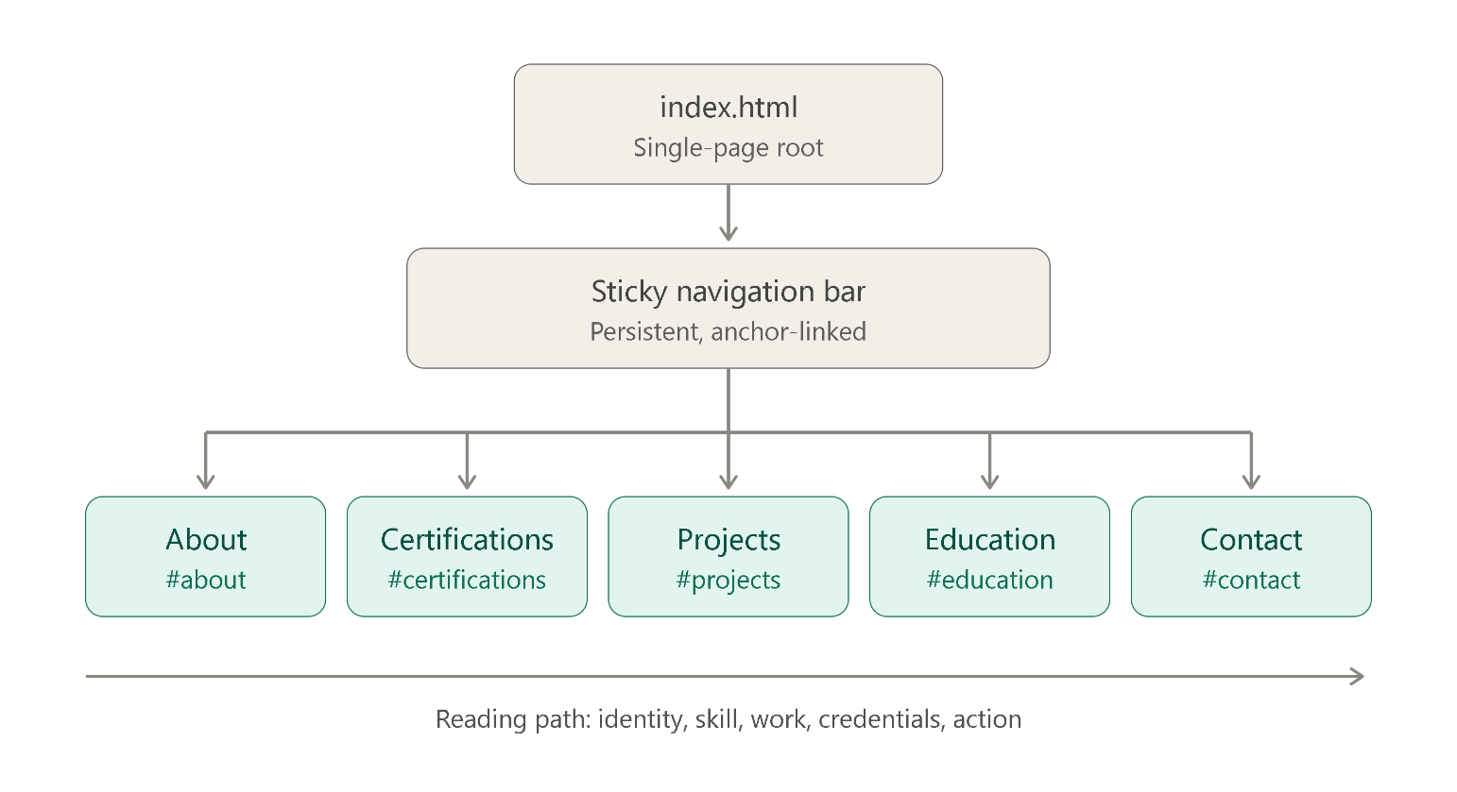
Figure 1: Site map / structure diagram of the website
Text representation of the structure:
index.html
│
├── Sticky Navigation Bar
│ ├── Logo (Ten.Ten’s) → scrolls to top
│ ├── About → #about
│ ├── Certifications → #certifications
│ ├── Projects → #projects
│ ├── Education → #education
│ ├── Contact → #contact
│ └── Résumé button → downloads PDF
│
├── Hero Section (no anchor — entry point)
│
├── /01 About Section
│ ├── Portrait image
│ ├── Introduction paragraphs
│ ├── Skills tags
│ ├── Statistics row
│ └── Availability badge
│
├── /02 Certifications Section
│ └── 8 certification cards (2-column grid)
│
├── /03 Projects Section
│ └── 3 project cards (3-column grid)
│
├── /04 Education Section
│ └── 2 education cards (2-column grid)
│
├── /05 Contact Section
│ ├── Email button (mailto:)
│ └── Résumé download button
│
└── Footer
├── Copyright notice
└── LinkedIn · GitHub · Email links
Section Order and Layout
The five sections are ordered — About, Certifications, Projects, Education, Contact — to follow a recruiter's reading path rather than a builder. Identity comes first, because a visitor needs to know who they're looking at before anything else matters. Proof of skill (certifications) follows, then proof of work (projects), then formal credentials (education), and finally a way to make contact. Placing Contact last is deliberate: the closing section is the natural moment for a call to action, and repeating the résumé download there means the visitor never has to scroll back up to reach it. A sticky navigation bar sits above all of this so the visitor can jump to any section at any time without losing their place.
The layout uses a centered container capped at 1200px with fluid horizontal padding (clamp(1.25rem, 5vw, 4rem)), which keeps lines of text at a comfortable reading length on wide monitors while keeping content from touching the edges on phones. Multi-column blocks use CSS Grid and collapse to a single column below 768px. The hero is intentionally sparse — no buttons, no images — because its only job is to state a name and a field clearly enough that the visitor keeps scrolling.
Color Palette
The palette is built on three neutral tones and one accent: #0a0a0a for the page background (near-black), #141414 for card surfaces, #a3a3a3 for muted body text, and #e8b44a for the gold accent used on links, tags, section numbers, and hover states. Body text is #f5f5f5 on #0a0a0a, which is a contrast ratio well above the WCAG AA minimum, so readability is not traded away for style.
The dark background was chosen for three reasons. First, it distinguishes the site from the bright default-template look that most student portfolios share — the design rubric explicitly rewards a site that looks intentional rather than unmodified. Second, it makes the single gold accent function as a real visual signal: because gold is the only saturated color on the page, it reliably draws the eye to whatever matters — a section number, a link, a hover state — without competing with anything else. Third, gold-on-dark reads as considered and editorial rather than playful, which suits a professional portfolio.
Typography
Two typefaces are used throughout: Georgia, a serif, and the system sans-serif stack. Georgia is reserved exclusively for display elements — the hero name, section titles, card titles, and the italic pull quote — which gives those elements an editorial, deliberate weight. The system sans-serif handles everything that needs to be read quickly: body copy, navigation links, tags, labels, and buttons. The serif/sans pairing creates hierarchy without needing multiple weights or external font files, so the site loads with zero font requests and renders instantly.
Typography is set with clamp() so it scales fluidly rather than jumping between breakpoints. The hero headline runs from 2.25rem at phone width to 6rem on a large desktop; section padding scales from 4rem to 7rem. This keeps headings proportionate on every screen and removes the need to write separate mobile font rules.
Spacing and Hierarchy
Every section shares the same shell — a top border, a numbered header (/01, /02, …), and a title — which makes the page read as a consistent document rather than a stack of unrelated blocks. Cards across all three grid sections share a common visual language: the same border, the same corner radius, the same hover behavior (gold border highlight plus a two-pixel lift). Consistency was treated as a design goal in itself, because the design rubric's top bracket rewards "consistent typography and clear visual hierarchy" over novelty.

5. Development Process & Challenges — 15 pts
Score | Criteria
14–15 Excellent | Describes the actual steps taken to build the site (planning, building, testing, deployment) and at least one genuine challenge encountered, with a clear explanation of how it was resolved.
10–13 Good | Describes the general process taken, but challenges are described only briefly or generically (e.g., “it was hard but I fixed it”).
6–9 Fair | Process description is vague or reads as an afterthought; no real challenge or resolution is described.
0–5 Poor | No development process or challenges section included.
Development Process Summary
The site was built in six stages, beginning with content and materials rather than code. Each stage produced something usable before the next began, so there was never a point where the page was broken and unviewable.
1. Compiling Certificates, Creating the Resume, and Gathering Inspiration (Day 01)
Before writing any code, I did the groundwork that the site would eventually display. First, I gathered and organized my certifications — collecting the actual certificates from Cisco Networking Academy and Wadhwani Foundation, confirming each title, issuing organization, and date, and writing a short description of what each one covered. This step mattered because the Certifications section would be judged on accuracy; listing a certificate with the wrong issuer or year would be worse than not listing it at all.
Next, I created the resume as a PDF, since the site would need a downloadable file from the very start. Writing the resume also forced me to decide what to include in the portfolio itself — the two documents needed to tell the same story, or an employer comparing them would notice the mismatch.
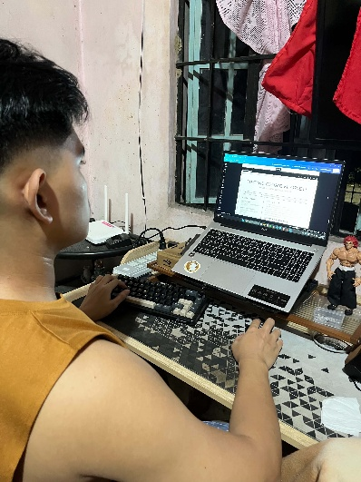
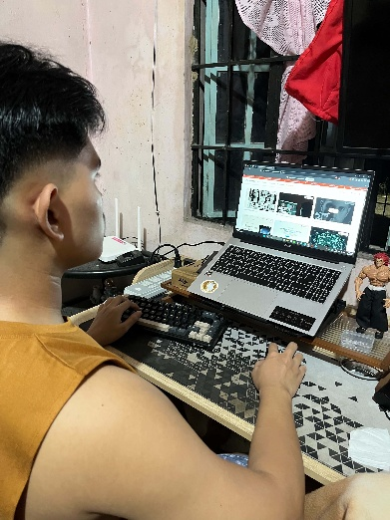
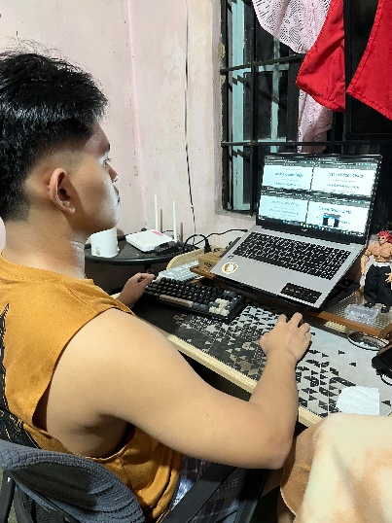
Finally, I looked at existing portfolio websites for inspiration. I reviewed several developer and designer portfolios to see how they ordered their sections, how much text they put on each card, and how they handled navigation on a single page. I deliberately avoided copying any single site; instead, I noted what worked across several of them — a short hero, a scannable project grid, a resume available from the top — and used those observations to plan my own section order and layout before opening a code editor.

Figure 2: Attachments Gathering
2. Planning and Structuring the Content (Day 02)
With the materials in hand, I decided on a single-page site with anchor links rather than a multi-page site, because a recruiter scanning a portfolio should not have to click through several pages to find a project. I settled on five sections — About, Certifications, Projects, Education, Contact — and sketched the card layouts on paper before writing any code.

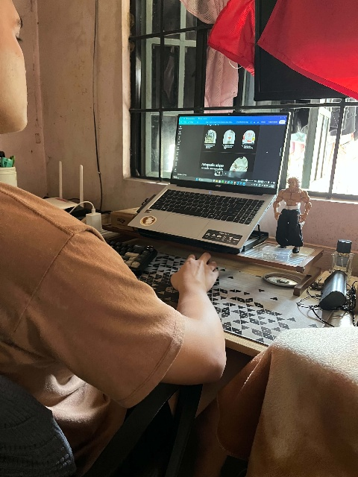
Figure 3: Project Structuring
3. Building the Semantic HTML Skeleton (Day 02)
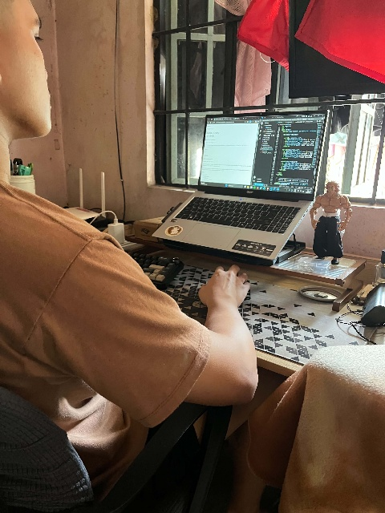
I wrote the markup first, with placeholder text inside each section: header for the navigation bar, main containing five section elements, and footer at the bottom. Each section was given an id matching its navigation link. Building structure before styling meant the page was already navigable and readable before a single line of CSS was written, which made later layout bugs much easier to isolate.
Figure 4: HTML Skeleton

4. Styling and Establishing the Visual Identity (Day 03)
CSS was added section by section, starting with the custom properties in :root so that every color on the page came from a single set of variables. The navigation bar and hero were styled first because they set the visual tone for everything below. Typography was set with clamp() from the start, so the page scaled fluidly between screen sizes without needing separate mobile font rules later.
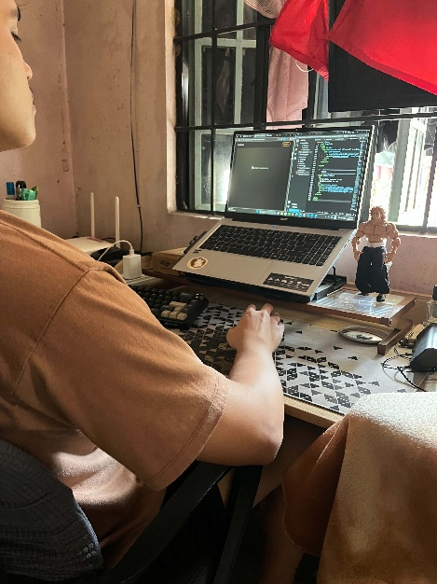
Figure 5: Design & Layout Application

5. Adding Real Content and Images (Day 03)
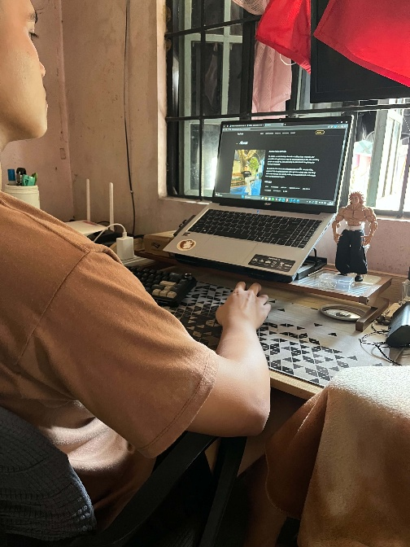
Placeholder text was replaced with the real content gathered in Stage 1 — the project descriptions, the eight certification entries, and the education history. Images were added to the About and Projects sections. This stage surfaced the layout problems described below, since real images and real text lengths behave differently from the short placeholders used during the skeleton stage.
Figure 6: Adding Attachments

6. Testing in Microsoft Edge (Day 03)
Testing was done in Microsoft Edge using its DevTools. I used the Device Toolbar to resize the page to mobile, tablet, and desktop widths and checked each section for horizontal scrolling or overlapping elements. I clicked every navigation link to confirm the anchor targets were correct, and opened the Console tab on each section to check for errors. Several of the fixes described below came out of this stage.
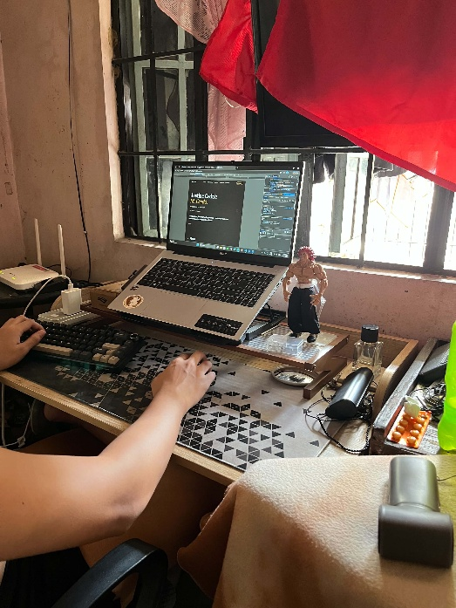
Figure 7: Testing with DevTools
7. Deploying to Vercel (Day 04)
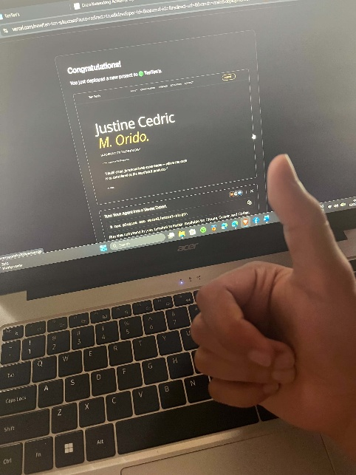
After testing, I deployed the site to Vercel so it could be reached from a public URL instead of only from my own machine. Because the site is a single static HTML file with no framework and no build step, no build command or special configuration was needed — Vercel simply serves the file. Once deployed, I opened the live page on a phone to confirm it displayed and worked outside my local preview, which is the same URL I can now include in job applications.

Figure 8: Deployment

Challenges and Solutions
Challenge Encountered | How It Was Solved
The two Education cards rendered as a single merged container. The layout broke because the first card's description paragraph was missing a closing </p> tag. The browser kept the paragraph open, and the second <article> element was swallowed inside it — so instead of two separate cards, the page showed one oversized box containing both. | I traced the problem back to the markup rather than the CSS, found the missing </p>, and closed every tag in that section properly — description, then card, then a clean second card. The key lesson was that a layout bug is not always a CSS bug: when an element swallows its neighbor, the first thing to check is whether a tag was left open.
Project images were being cropped inside their containers. The default image behavior stretched or cut off logos at the edges, so some project logos did not display fully. | I changed the image to object-fit: contain so it scales to fit within its container without being cropped, and set a fixed aspect-ratio on the image area so the cards kept a consistent height. I also added a white background and internal padding so transparent or oddly-shaped logos displayed fully.
The portrait image disappeared after deploying to Vercel. The site worked correctly when previewed locally, but once it was live, the portrait in the About section showed as a broken image. The cause was that the image file was stored only in a local folder on my computer and had never been committed to the GitHub repository — so when Vercel pulled the project from GitHub to build the live site, the image simply wasn't there. Vercel can only deploy files that exist in the repository it's connected to. | I uploaded the missing image file to the GitHub repository alongside the HTML file, then deleted the current deployment on Vercel, re-imported the project from the updated repository, and re-deployed. The portrait now loads correctly on the live site because the image file and the HTML that references it are both in the same repository. The lesson: Vercel deploys what's in GitHub, not what's on my local machine — so every asset the site needs (images, fonts, PDFs) must be committed to the repository, not just the code.

6. User Guide (Navigation with Screenshots) — 15 pts
Score | Criteria
14–15 Excellent | Step-by-step walkthrough of the website with clear, properly labeled screenshots, detailed enough for someone unfamiliar with the site to navigate it independently.
10–13 Good | Screenshots are present and mostly clear, but instructions are brief or a step is missing.
6–9 Fair | Screenshots are low quality, unlabeled, or do not match the current version of the website.
0–5 Poor | No screenshots or navigation instructions included.

Step 1 — Landing. The site opens on the hero section, showing the name "Justine Cedric M. Orido.", the field of study, and a short statement of approach. The sticky navigation bar at the top lists the five sections.
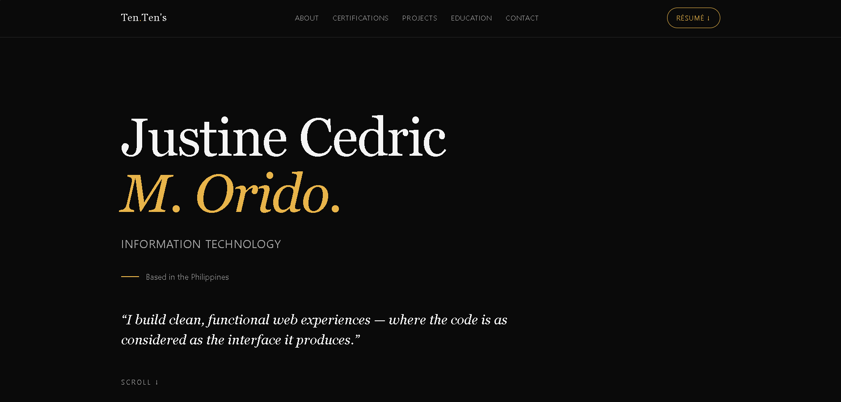
Figure 9: Homepage / Landing Section
Step 2 — About and Skills. Click About in the navigation bar (or scroll down). This section introduces me, lists my skills as tags, shows a statistics row, and displays the availability badge. The navigation bar remains fixed at the top throughout.
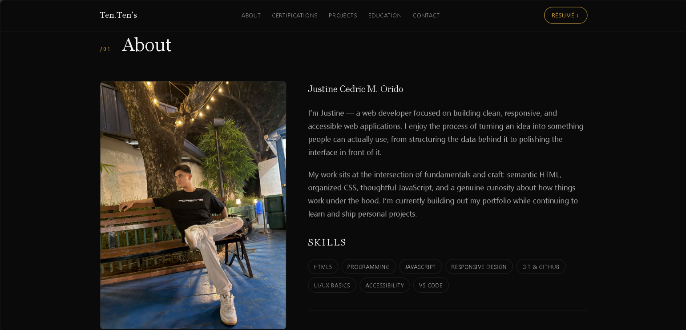
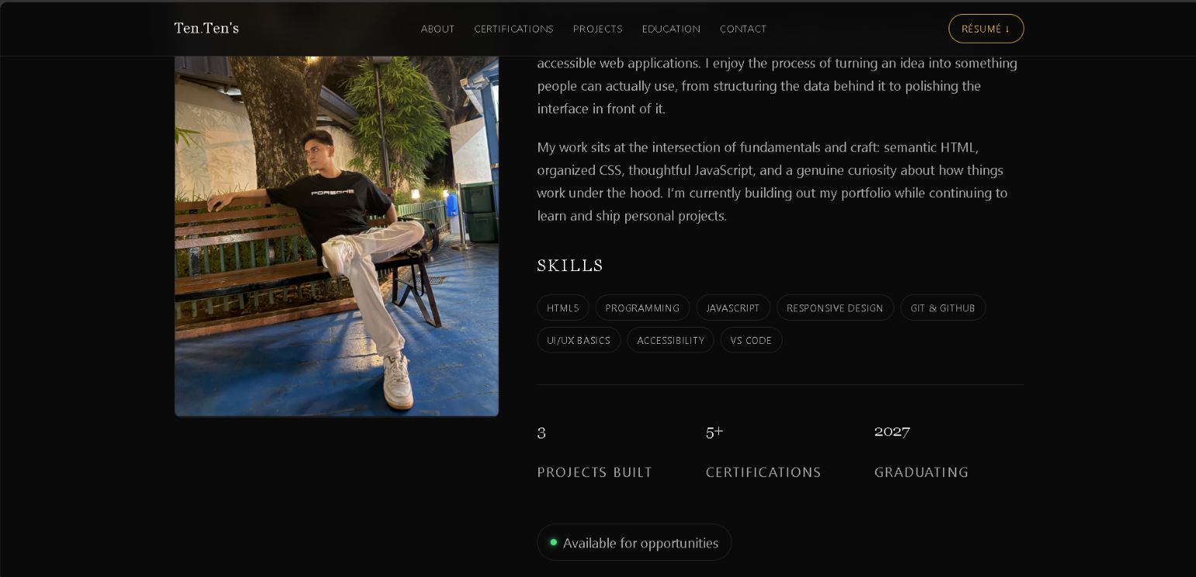
Figure 10: About / Skills Section
Step 3 — Certifications. Click Certifications to jump to the card grid. Each card shows the year, the certificate name, the issuing organization, and a short summary of the topics covered.
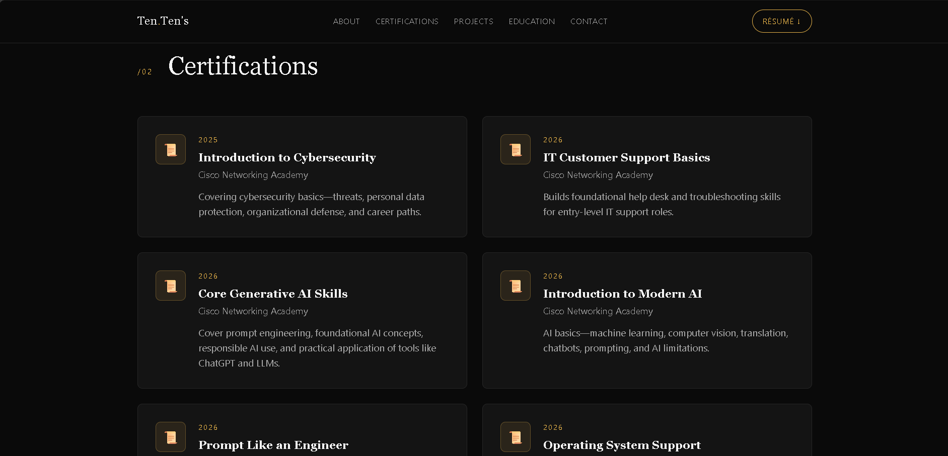
Figure 11: Certifications
Step 4 — Projects. Click Projects to view the three project cards. Each card contains an image, a role line, a description, technology tags, and — where available — links to a live demo and source code. Hovering over a card highlights its border.

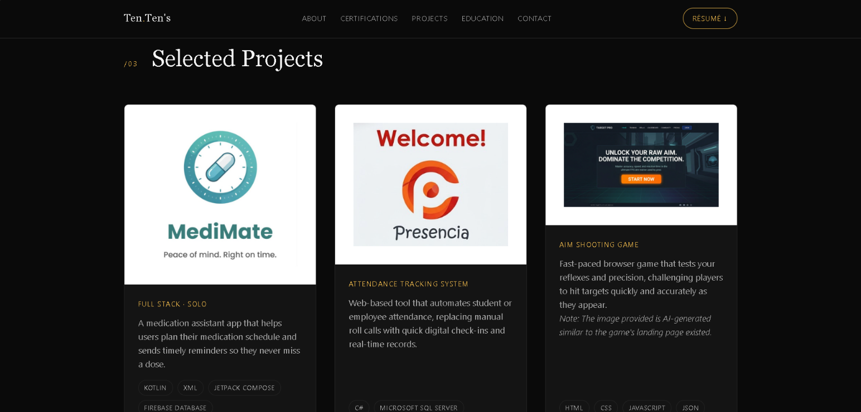
Figure 12: Projects Section
Step 5 — Education. Click Education to see the two education cards: Senior High School (STEM strand) and the BS in Information Technology program, each with institution and description.
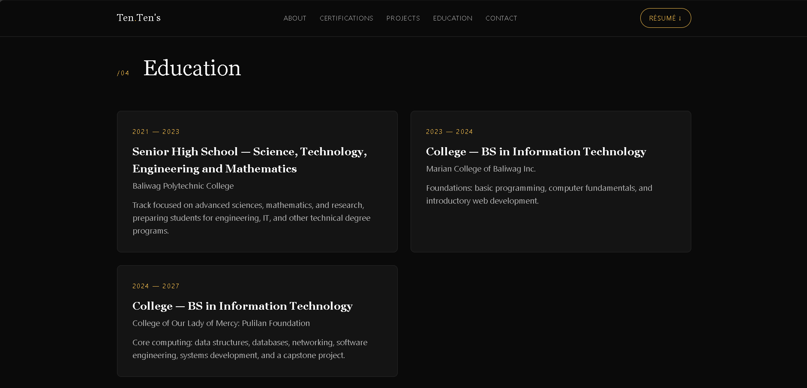
Figure 13: Education

Step 6 — Contact and Résumé Download. Click Contact to reach the closing section. Press Email me to open your mail client with the address pre-filled, or press Download résumé to save the PDF. The same résumé is also always available from the navigation bar button.
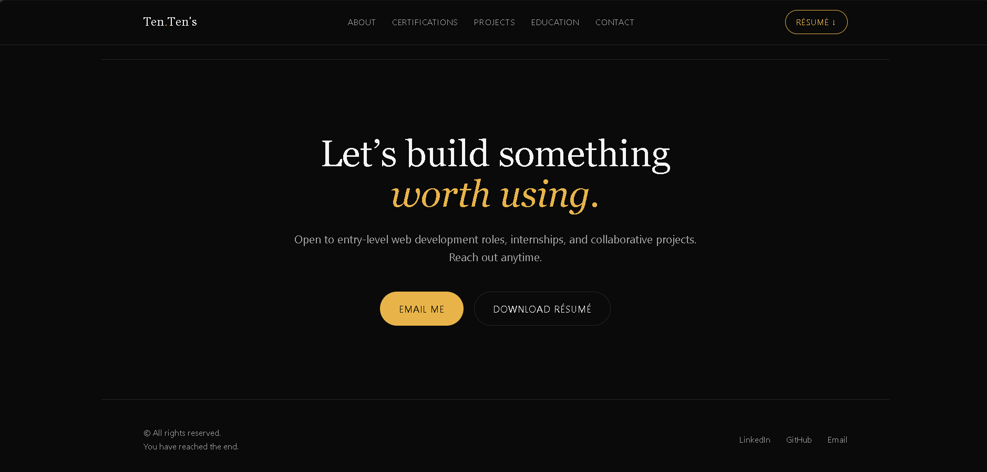Figure 14: Contact

7. Conclusion, Reflection & Recommendations — 10 pts
Score | Criteria
9–10 Excellent | Thoughtful reflection on what was learned, an honest self-assessment of the finished website, and specific, realistic recommendations for future improvement.
6–8 Good | Conclusion is present and reasonable but fairly generic; recommendations are vague (e.g., “add more features”).
3–5 Fair | Conclusion restates the introduction with little genuine reflection.
0–2 Poor | No conclusion or reflection included.

The hardest part of putting this portfolio together wasn't the visual design, it was what to include and how to present it honestly. The layout came together pretty quick, figuring out how to describe each project so it reflected my personal contribution took much longer. I'm most proud of two things: The projects section, where each card now clearly names the stack and scope. And the fact that the site is actually deployed and works on a phone – not just in a local preview.

The big technical takeaway was: write structure before styling. Some of my biggest bugs—the merged education cards, the mobile overflow—were not CSS bugs at all. They were markup bugs that CSS was concealing. Validating the HTML before I wrote a single style would have saved me an entire round of debugging.

An honest self-assessment. The site is clean, responsive and usable at a basic accessibility level, but it is a static brochure at the moment. No form to contact, no dark/light toggle, no filter on the lists of projects and certificates, features that will gain relevance as the number of entries increases.

If I had more time, I would add, in priority order: (1) access to my project repos again, and a link on each project card so clicking it opens the live project or its source; (2) a light/dark toggle based on CSS custom properties, the dark palette being a strong default but not everyone's choice; and (3) automated accessibility checks in the deployment pipeline, so contrast and alt-text regressions are caught before they reach the live site.

8. Documentation Quality & Presentation — 5 pts
Score | Criteria
5 Excellent | Well-organized, consistently formatted, free of spelling/grammar errors, with properly labeled figures/tables and a logical section order.
3–4 Good | Generally well-organized with minor formatting inconsistencies or a few typos.
1–2 Fair | Noticeably disorganized, or contains frequent spelling/grammar errors that affect readability.
0 Poor | Difficult to read or follow; looks assembled at the last minute.

Scoring Summary Sheet
Category | Points Possible | Score
Introduction & Project Overview | 15
System Features & Functionality Description | 15
Technical Specifications & Tools Used | 15
System Design Documentation | 10
Development Process & Challenges | 15
User Guide (Navigation with Screenshots) | 15
Conclusion, Reflection & Recommendations | 10
Documentation Quality & Presentation | 5
TOTAL | 100

Suggested Grade Bands
Score | Grade Interpretation
90–100 | Excellent — comprehensive, professional documentation, ready to hand off to a real client or employer.
75–89 | Very Satisfactory — solid documentation covering all major sections with only minor gaps.
60–74 | Satisfactory — meets the minimum requirements but has noticeable gaps in depth, accuracy, or clarity.
Below 60 | Needs Improvement — significant sections are missing, inaccurate, or unclear; does not adequately document the system.

