**Problem and Background:**

To tackle climate change we need to change many aspects of our life and eating pattern is one of them. The following image (<https://www.nature.com/articles/d41586-019-02409-7>) highlights that a reduction in animal meat consumption and, in the long term, a reduction in animal products consumption is key in mitigating CO2. One step to increase plant over animal products consumption is to increase the number of Vegetarian/Vegan restaurants, which will be the task in my project.

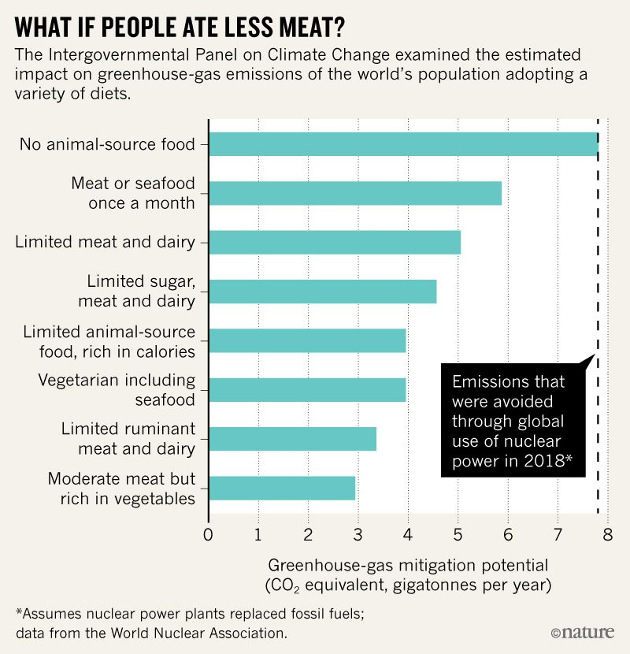

**What kind of data and how I use it:**

In my project I will take New York locational data (<https://ibm.box.com/shared/static/fbpwbovar7lf8p5sgddm06cgipa2rxpe.json>) and Toronto locational data (<https://en.wikipedia.org/wiki/List_of_postal_codes_of_Canada:_M>) to analyse the amount of restaurants in those two cities respectively. The data comes from the Foursquare locational database. Furthermore I will analyse how many Vegetarian/Vegan restaurants they have, where they are and how high the percentage is. With this, interested people can open up new businesses.