#include<iostream>

#include<graphics.h>

#include<math.h>

using namespace std;

class transform

{

public:

int m, a[20][20], c[20][20];

int i, j, k;

public:

void object();

void accept();

void operator\*(float b[20][20])

{

for (int i = 0; i < m; i++)

{

for (int j = 0; j < m; j++)

{

c[i][j] = 0;

for (int k = 0; k < m; k++)

{

c[i][j] = c[i][j] + (a[i][k] \* b[k][j]);

}

}

}

}

};

void transform::object()

{

int gd, gm;

gd = DETECT;

initgraph(&gd, &gm, NULL);

line(300, 0, 300, 600);

line(0, 300, 600, 300);

for (i = 0; i < m - 1; i++)

{

line(300 + a[i][0], 300 - a[i][1], 300 + a[i + 1][0], 300 - a[i + 1][1]);

}

line(300 + a[0][0], 300 - a[0][1], 300 + a[i][0], 300 - a[i][1]);

for (i = 0; i < m - 1; i++)

{

line(300 + c[i][0], 300 - c[i][1], 300 + c[i + 1][0], 300 - c[i + 1][1]);

}

line(300 + c[0][0], 300 - c[0][1], 300 + c[i][0], 300 - c[i][1]);

int temp;

cout << "Press 1 to continue";

cin >> temp;

closegraph();

}

void transform::accept()

{

cout << "\n";

cout << "Enter the Number Of Edges:";

cin >> m;

cout << "\nEnter The Coordinates :";

for (int i = 0; i < m; i++)

{

for (int j = 0; j < 3; j++)

{

if (j >= 2)

a[i][j] = 1;

else

cin >> a[i][j];

}

}

}

int main()

{

int ch, tx, ty, sx, sy;

float deg, theta, b[20][20];

transform t;

t.accept();

cout << "\nEnter your choice";

cout << "\n1.Translation"

"\n2.Scaling"

"\n3.Rotation";

cin >> ch;

switch (ch)

{

case 1:

cout << "\nTRANSLATION OPERATION\n";

cout << "Enter value for tx and ty:";

cin >> tx >> ty;

b[0][0] = b[2][2] = b[1][1] = 1;

b[0][1] = b[0][2] = b[1][0] = b[1][2] = 0;

b[2][0] = tx;

b[2][1] = ty;

t \*b;

t.object();

break;

case 2:

cout << "\nSCALING OPERATION\n";

cout << "Enter value for sx,sy:";

cin >> sx >> sy;

b[0][0] = sx;

b[1][1] = sy;

b[0][1] = b[0][2] = b[1][0] = b[1][2] = 0;

b[2][0] = b[2][1] = 0;

b[2][2] = 1;

t \*b;

t.object();

break;

case 3:

cout << "\nROTATION OPERATION\n";

cout << "Enter value for angle:";

cin >> deg;

theta = deg \* (3.14 / 100);

b[0][0] = b[1][1] = cos(theta);

b[0][1] = sin(theta);

b[1][0] = sin(-theta);

b[0][2] = b[1][2] = b[2][0] = b[2][1] = 0;

b[2][2] = 1;

t \*b;

t.object();

break;

default:

cout << "\nInvalid choice";

}

getch();

return 0;

}

OUTPUT:

Translation

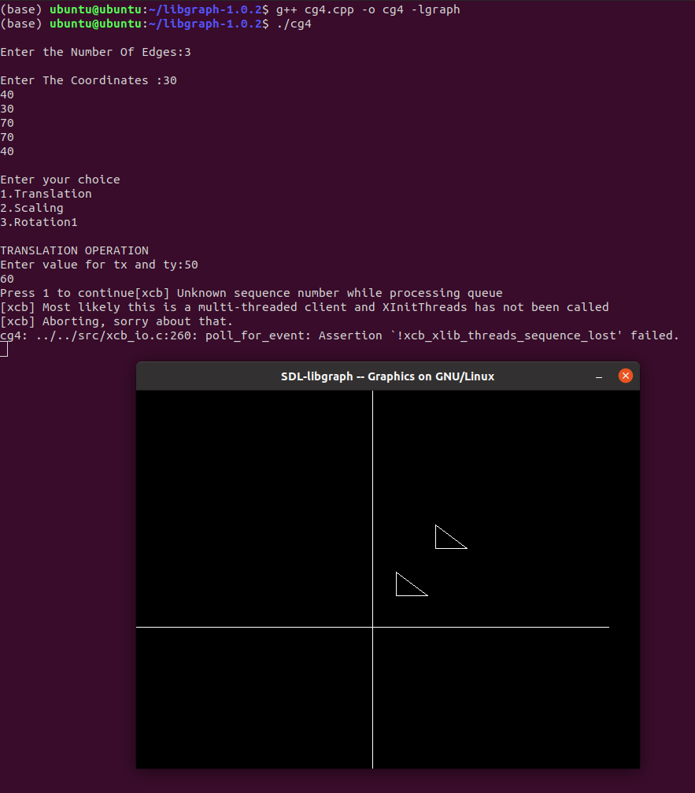

Scaling

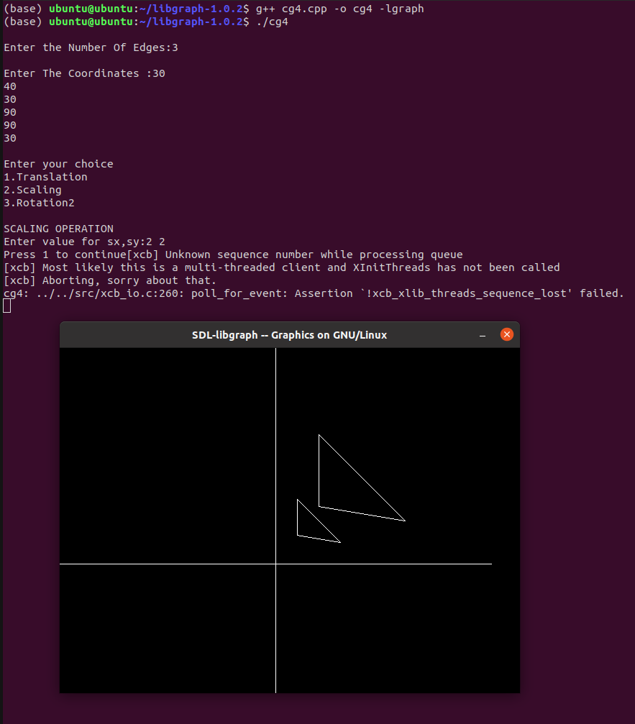

Rotation

