**Introduction**

The Hotel Management System API is designed to manage room categories and check their availability. This API is built using ASP.NET Core 8 and uses MongoDB as the database. The API supports CRUD operations for room categories and availability checks.

**API Endpoints**

Room Endpoints:

1. Get all rooms

* URL: GET /api/Room
* **Response**

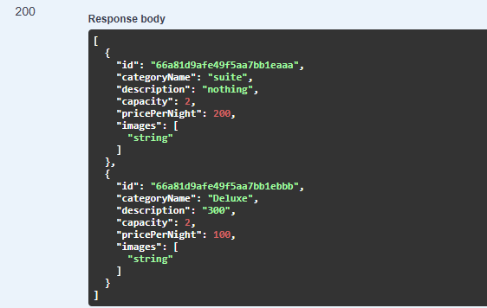

1. Get a specific room

* Get a specific room

1. Create a new room

* **URL:** POST /api/Room

1. Update an existing room

* **URL:** PUT /api/Room/{id}

1. Delete a room

* **URL:** DELETE /api/Room/{id}

Availability Endpoints:

* Get All availabilities
* **URL:** GET /api/Availability
* Check availability for specific dates
* **URL:** POST /api/Availability/check
* Create new availability
* **URL:** POST /api/Availability
* Update an existing availability
* **URL:** PUT /api/Availability
* Delete an availability
* **URL:** DELETE /api/Availability/{roomId}/{checkIn}/{checkOut}

**Code Structure**

* **Models:** Contains the data models (Room, Availability).
* **Services**: Contains the interfaces and implementations for data access services (IAvailabilityService, AvailabilityService, IRoomService, RoomService).
* **Controllers**: Contains the API controllers (RoomController, AvailabilityController).
* **Configuration**: Contains configuration settings for MongoDB.

**future features**

potential future features that could enhance the system:

1. Customer Model : to manage customer details

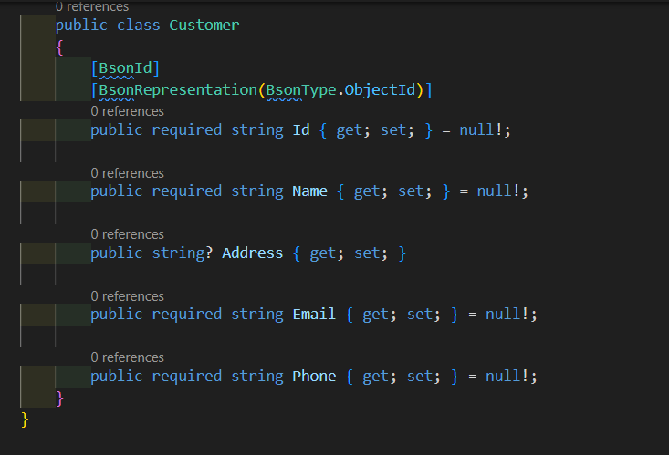

1. Booking Model : to manage room reservations

