Taller 5 AREP  
Infrastructure as Code: AWS-CLI Primer Workshop

Santiago Gualdrón Rincón

**Prerequisites**

1. Install the AWS-CLI application.
2. Configure the AWS-CLI application:

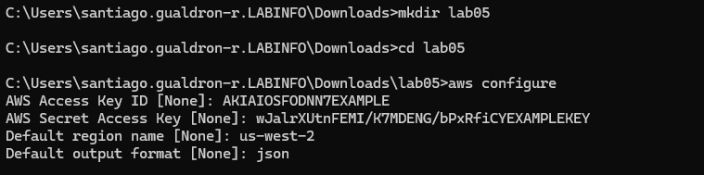

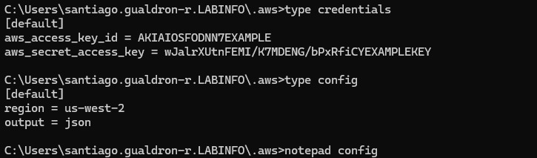

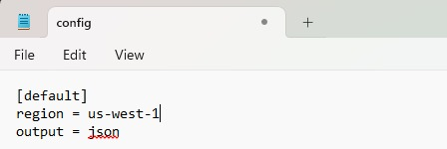

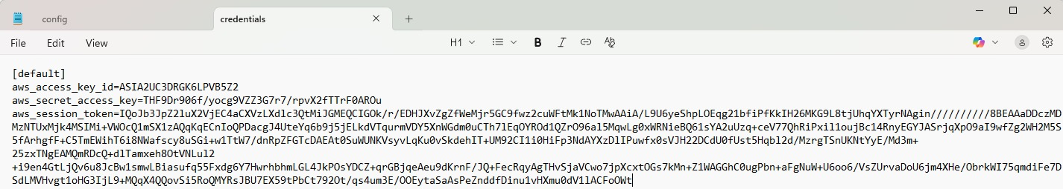

**Step 1: Create a Key Pair for EC2**

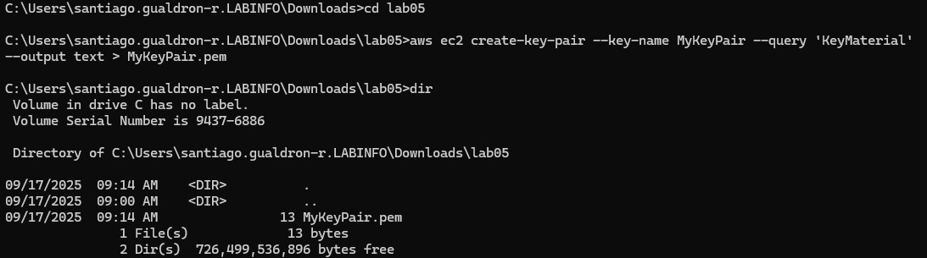

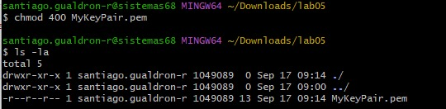

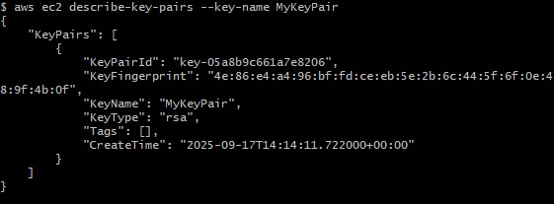

**Step 2: Create a Security Group**

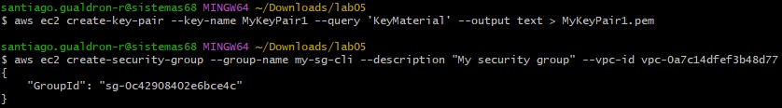

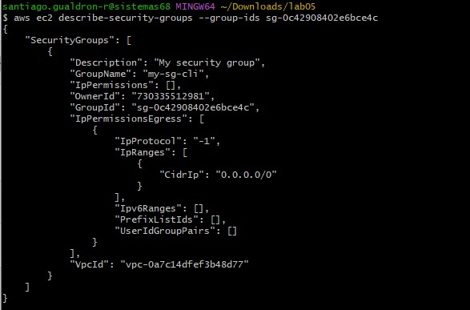

**Add Ingress Rules**

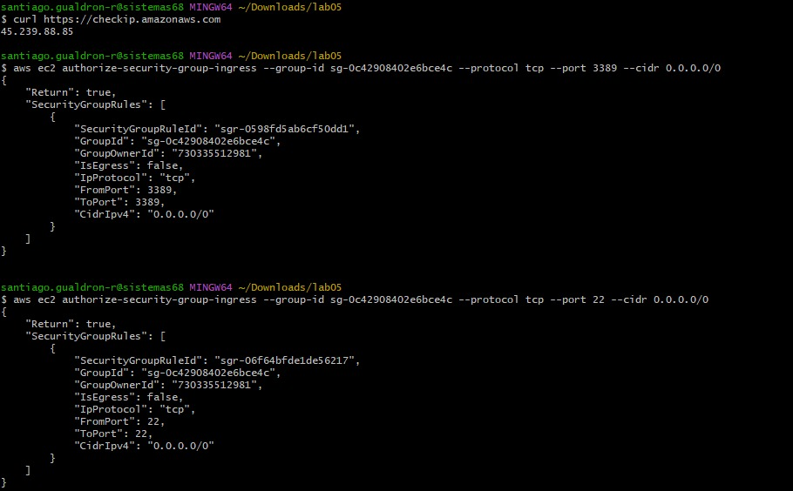

**Step 3: Create the Instance**

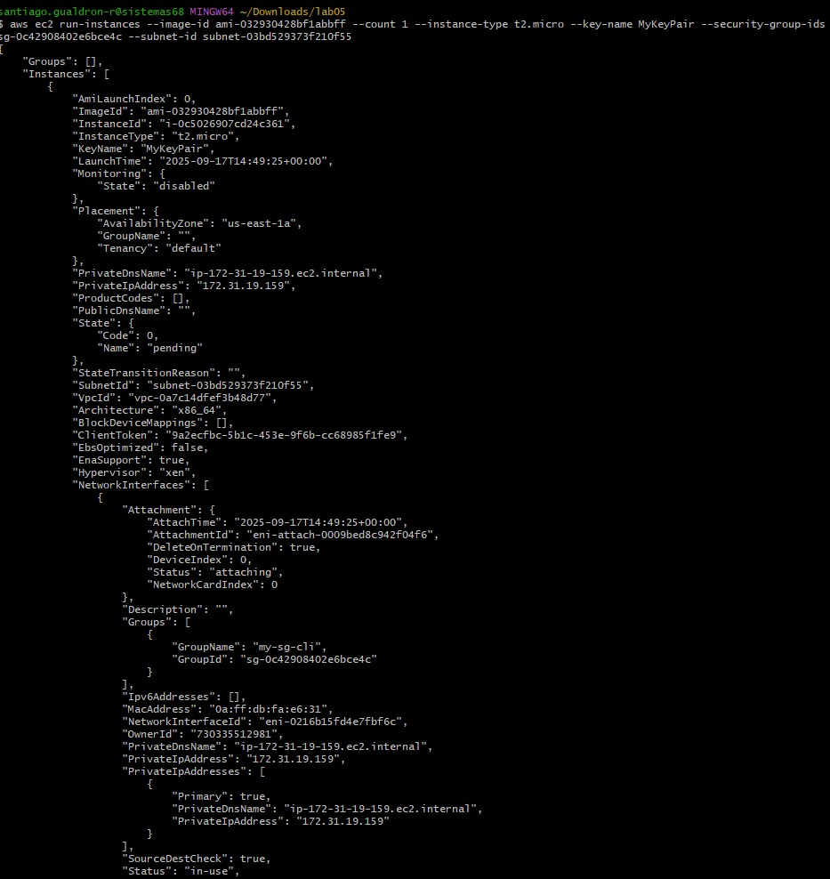

**Step 4: Connect to the Instance**

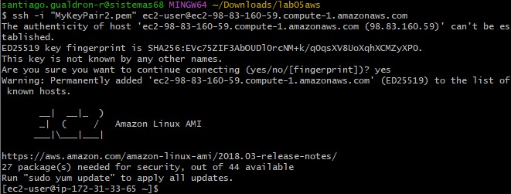

**Step 5: List Your Instances** and **Step 6: Clean Up**

