

Lab-Mid

Software Test



May 24, 2024

Waleed rashid

CFG:

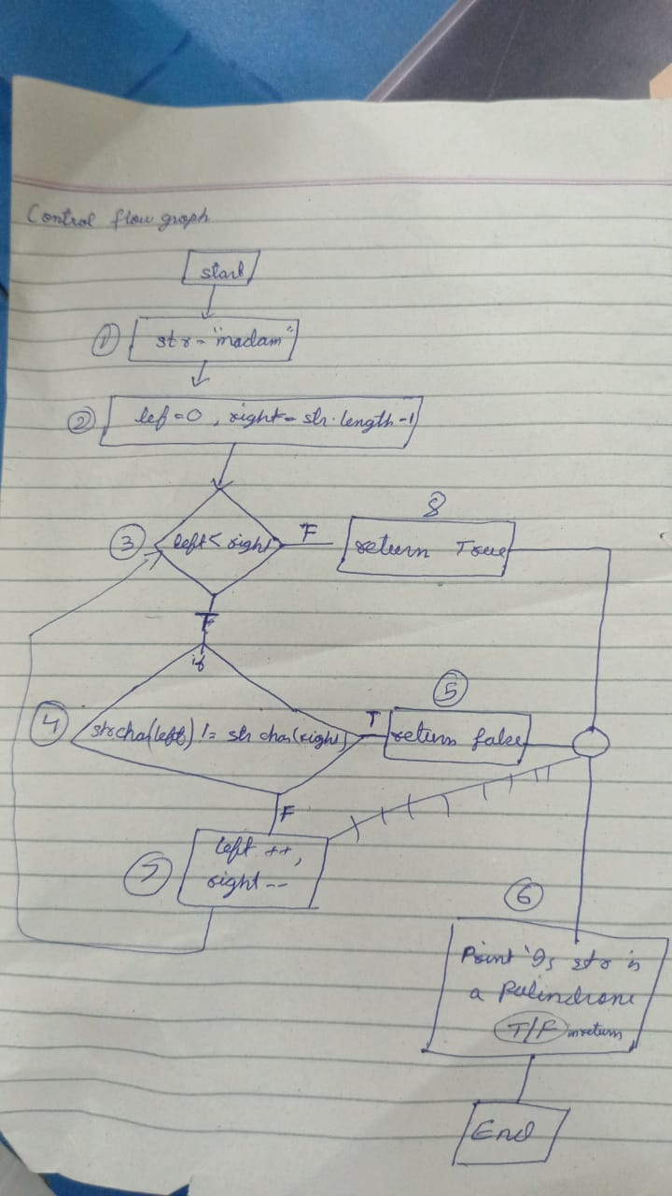

* Path:

1. 1,2,3,8,6
2. 1,2,3,4,5,6
3. 1,2,3,4,7,3,8,6

* Test cases:

|  |  |  |  |
| --- | --- | --- | --- |
| T-id | Path | Input data | Output data |
| 01 | 1,2,3,8,6 | STR=””  ‘EMPTY STRING’ | Return TRUE Palindrome |
| 02 | 1,2,3,8,6 | str:”a” | Return TRUE true Palindrome |
| 03 | 1,2,3,4,5,6 | STE=’apple’ | Return FALSE |
| 04 | 1,2,3,4,7,3,8,6 | STR=’race car’ | Return TRUE |

Test file link:

https://github.com/Waleed-070/software-testing/commit/7dcbce239a157db14568a2f98df4aebfb3f5972d