**Name: ALLISON ALBAN PEREIRA**

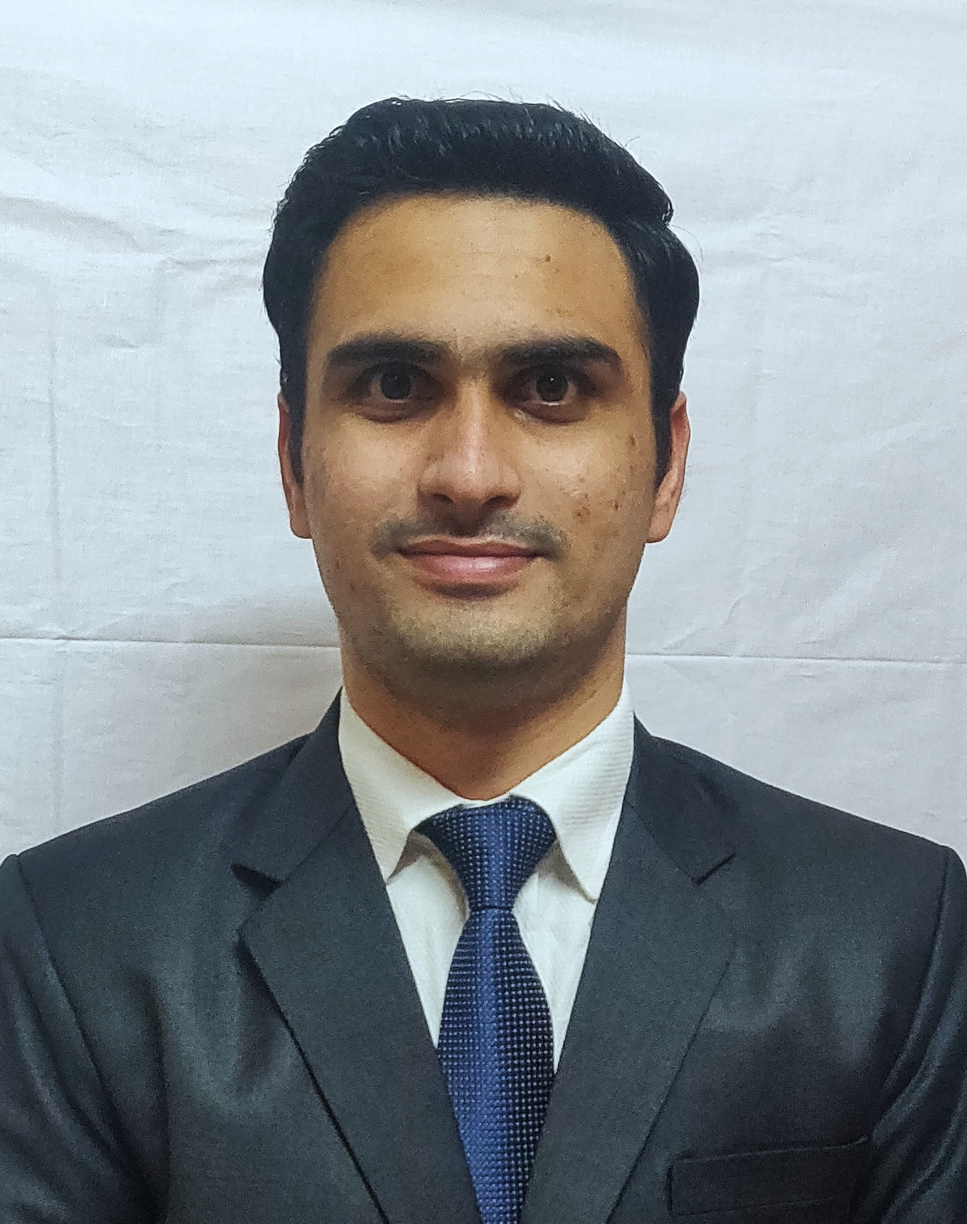

|  |  |  |  |
| --- | --- | --- | --- |
| **Email ID:** allisonpereira44@gmail.com |  | **Contact No.-** 8779724727/  9545829287 |  |
| **LinkedIn ID:** <https://www.linkedin.com/in/allison-alban-pereira-5b56a1123/> |  | **DOB:** 25th April 1996 |  |
| **Address:** KHARBHAT SALOLI, BANGLI NAKA, VASAI WEST, DIST. PALGHAR - 401201. |  | | |

**Master of Management Studies (MARKETING)**

|  |  |  |  |  |  |
| --- | --- | --- | --- | --- | --- |
| **Academic Qualifications** | | | | | |
| **Qualification** | **Specialization** | **Board / University** | **Institute Name** | **Year of Passing** | **% / CGPA** |
| MMS YEAR II | MARKETING | MUMBAI UNIVERSITY | ST. FRANCIS INSTITUTE OF MANAGEMENT & RESEARCH (SFIMAR) | 2021 | 65.50% |
| MMS YEAR I | MARKETING | MUMBAI UNIVERSITY | ST. FRANCIS INSTITUTE OF MANAGEMENT & RESEARCH (SFIMAR) | 2020 | 65.18% |
| Graduation | COMMERCE (BCOM) | MUMBAI UNIVERSITY | ST. GONSALO GARCIA COLLEGE | 2016 | 58.42% |
| Grade XIIth | COMMERCE | MAHARASHTRA BOARD | ST. THOMAS BAPTISTA JR. COLLEGE | 2013 | 54.33% |
| Grade Xth | - | MAHARASHTRA BOARD | ST. AUGUSTINE’S HIGH SCHOOL | 2011 | 70.91% |

|  |  |  |
| --- | --- | --- |
| **Work Experience Total: 33 months** | | |
| **FEDEX EXPRESS TRANSPORTATION AND SUPPLY CHAIN**  8th Floor, Unit No 801, Boomerang, Wings A & B1,  Chandivali Rd, Near Chandivali Studio, Andheri East,  Mumbai, Maharashtra 400072 | | October 2016 – July 2019 (33 months) |
| **Designation 1** (Month Year – Month Year) | * Handling billing queries for manual and automation cases. * To verify and validate the account number in C2 screen. * Verifying and matching the information of each field in GREEN Error Correction system with the same field or details completed by Customer on the paper copy or EMEA Imaging for Ship to Collect System (EIStC) for Image copy of Air waybill. * Helping Cash Apps team in releasing CAPS. * Received BRAVO ZULU Award for reconciling the TDS for FY 2012& 2013 and supporting FedEx to claim pending Tax funds. * Received letter of appreciation for achieving productivity with zero errors and also for supporting the Cash Applications team during closing week. | |

|  |  |  |
| --- | --- | --- |
| **Internships and Major Projects** | | |
| **JoyfulEncounters Technology Solutions Inc. (JETSDIGITAL)**  **30 Elm Drive East,**  **Mississauga, ON,**  **Canada, L5A 4C3** | | May 2020 – July 2020 (2 months) |
| **Area of Internship** | * Plan and Execute Social Media Marketing strategy for a new Digital Marketing agency and to be launched Online Career Portal * Build Social Media agency templates and client documentation * Grow and expand company social media presence on platforms including Facebook, LinkedIn, Twitter, and Instagram * Research and monitor activities of company competitors using company provided tools and techniques * Create and distribute engaging written or graphic content in the form of e-newsletters, video and blog content and social media messages | |
| **Project Name** | * A Study on Social Media Marketing Strategies to Identify and Attract New Customers. * Prepare questionnaire, collect responses and understand which social media sites can help the company to grow its presence in the market. | |

|  |  |
| --- | --- |
| **Certifications** | |
| **Certificate Name** | * Power BI (2021) * Tableau (2021) * Tally Erp 9 (2015) * Ms-CIT (2016) |

|  |  |
| --- | --- |
| **Extra-Curricular Achievements and Activities** | |
| **Sports** | * Ranked 9th in Cross Country race in School. * Participated in Inter College Football competition. |

|  |
| --- |
| **Areas of Interest** |
| * Playing Badminton, Cricket & Football. * Love Drawing and art. |