**RESUME**

**Name :** **Sri AVIJIT PAUL**

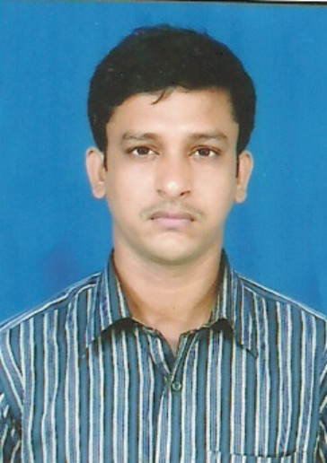

**Father’s Name :** Sri Nirmal Paul

**Permanent Address :**  33/6 Murari Pukur Road, B.R.S.-XI,

Block-6, Flat-24, Kolkata – 700 067.

**Date of Birth :** 17th September, 1980

**NATIONALITY :** Indian

**RELIGION :** Hinduism

**CASTE :** General

**CONTACT NO. :** 9163211790

**EMAIL ID :** avijtpl@gmail.com

**Educational Qualification :**

* Passed 1st Division in Madhyamik Pariksha from “Scottish Church Collegiate School” under W.B.B.S.E in 1998.
* Passed P Division in Higher Secondary Examination from “Oriental Seminary School” under W.B.C.H.S.E in

**Technical Qualification :**

Passed Printing Technology in 2008.

(Diploma Engineering in Printing) from “The Regional Institute of Printing Technology”,

Govt. of W.B., Jadavpur, Kolkata – 700 032

**Extra Qualification :**

* Completed Apprientice Training in Trade Plate Maker from “TheTimes of India” under National Council for Vocational Training, Govt. of India.

**Working Experience :**

* Worked in “The Times of India” in Plate Making Department as a Plate Maker from 2003 to 2005.
* Worked as a executive at Barnana Prakashani Press from October 2005 to March 2008.
* Worked as a JUNIOR EXECUTIVE (PRODUCTION) in “Darpan Publications Pvt. Ltd.” Kolkata, working area at Orient 30 machine since April 2008 to October 2010.
* Working in HT Media Ltd. Kolkata & New Delhi Greater Noida as a PRODUCTION EXECUTIVE from 2010 to 2017.
* Working at Satyajug Press Kolkata from November 2017 to August 2018 .
* Now working at Divya Bhaskar (Ahmedabad) as a Sr. Management Associate in Production.

Job Responsibility:

* Working at TKS and colorman machine(Man Roland),Greater Noida press (Delhi).
* Worked at STAR LINE M/C-S30, Newsline S-30, Cityline Express Machine at kolkata press.
* Now working at KBA Machine & HIGHLINE Machine.
* Handling shift supervising and administrative work also.
* Check the quality of printing and operations, control manpower in a shift.
* Check the wastage control and take care safety rules also.
* Have end to end responsibility for the production, operations & recruitment also.
* Also supervising maintenance team for daily basic maintenance report.
* Control & supervise all production contract activity & report the job status periodically to direct production manager on official issue with solution require for maintaining production progress.
* Ensuring collaboration between different staff & different department.
* Planning & organizing production schedule daily on timely.

**Total Working Experience : 15 Years**

.

**Declaration :**

I Mr. Avijit Paul, S/o Sri Nirmal Paul hereby declare that the above furnished details are true to the best of my knowledge and belief.

I hope you will consider my case favourably

Avijit Paul