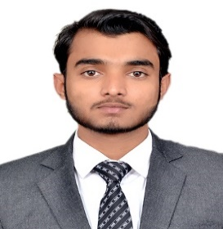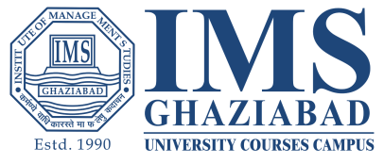

Address: 250, Luhari, Jhajjar, Haryana-124108, Mobile No.: 9568607068 I Email-Id:s.arjun0707[@gmail.com](mailto:varnita.goyal@gmail.com)

LinkedIn ID: http://linkedin.com/in/arjun-singh-362361194

ARJUN SINGH

|  |  |  |  |
| --- | --- | --- | --- |
| **career Objective** |  | To secure a position as a public relations/marketing professional in order to utilize my administrative, marketing, and interpersonal skills with accuracy and efficiency while maintaining a motivated, productive and goal oriented environment for the entire professional team on board. | |
| **Skills & Abilities** |  | * Working knowledge of Advance Excel * Collecting, Organising and Analysing information * Persuading and Negotiation Skills * Developing Digital Footprints | |
| **EDUCATION** |  | * MIB (2019-2021) IMS Ghaziabad, University Courses Campus (PGD-Marketing) * B.A (2015-2018) Arts Faculty, Delhi University. * XII (2013-2014) Jeevan Jyoti Public School, Sondhi, Jhajjar, Haryana * X (2011-2012) Gyan Deep Sr. Sc. School, Khakhana (Jhajjar) | |
| **Internships and projects** |  | * Worked as a Marketing and Business Development for two month (May-2020 to july-2020) internship in Shavsi Global Services. | |
| **WORKSHOpS** |  | * Workshop on ‘Statistics using Excel’ to learn the use of statistical tools in Excel. * Workshop on ‘Start-up and New Venture Creation’ at IMSUC Campus, Ghaziabad. * Workshop on How MCA work to get common information about a company. * Workshop on ‘Digital Foot Printing’ to understand Traceable Digital Activities on the internet in October 2019. * Workshop on ‘Finance for Non –Finance’ in January, 2020. | |
| **industry & academia participatioNs** |  | * Managed Blood Donation Camp in IMSUC, Ghaziabad organized by Rotary Club Sahibabad. * Organized ‘LOKTANTRA’ to get clarity about Indian political environment. * Visited Coca-Cola Moon Beverage Private Ltd., in August-2019. * Visited to Parle Agro Private Ltd, in September-2019. * Visited to Yakult Danone India Private Limited. Bahadurgarh, in March-2020. * Attended national seminar on “Indian financial system: Tactical Issues, Challenges and Scope’’ in October, 2019. * Attended national conference on Business Transformation through Sustainability, Entrepreneurship and Digitalization in Nov 2019. * Attended various Guest lecture to know about contemporary Business Environment and the role of Digitalisation. | |
|  |  | |