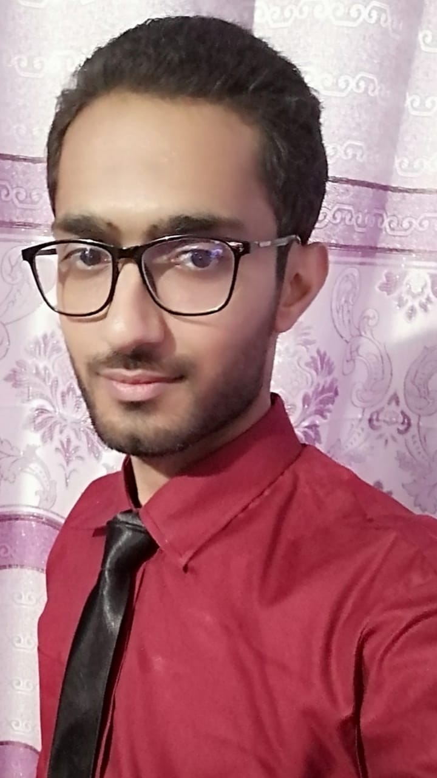

Contact

**Address:**

J/254 Ghosia Colony Near Central Jail, Karachi

**Phone:**

0336-2204230

**Email:**

uunerk1@gmail.com

Languages

English

Urdu

ARSALAN SALEEM

Summary

Configuration & Installation of Analog & Digital CCTV. Cameras.Troubleshoot cameras, DVRs, NVRs, and other hardware Provide technical support to end users regarding software and hardware related issues.Knowledge of multiple types of CCTV systems, Multiple years of experience in CCTV installation. Tested all installations and setups to make sure they worked.

Skill Highlights

|  |  |
| --- | --- |
| * Project management * Strong decision maker * Complex problem solver | * Hardworker * Innovative * Service-focused |

Experience

* **CCTV Technician in Regent Plaza Hotel (2014 to 2020)**
* **CCTV Technician in United Technologies (2013 to 2014)**
* **Assistant NICU in Osmania Hospital (2011 to 2013)**

Education

Matric (Computer Science) Karachi Board

Certifications

Diploma in Information Technology