# **Dharamvir**

# West Delhi-110027, Delhi, India

+91-8860012516

mathurdharamveer100@gmail.com

# Senior Executive(Operations)

**Over 14+ years of experience with 13+ years of experience in Av i a t io n .**

Handling 60+ Team Members supporting multicultural clients.

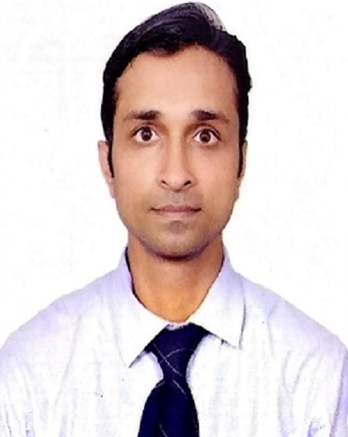

**ACADEMIC QUALIFICATION**

* Passed 10th from C.B.S.E. board.
* Passed 12th from C.B.S.E. board.
* Graduate from Delhi University In B.COM Pass.
* Diploma in Aviation and Hospitality Management from AHA Rajouri Garden New Delhi
* Web Designing Course from Sewa Bharti

EXPERIENCE

**HOLISOL LOGISTICS PVT. LTD.(Supply Chain Management)**

March, 2021 - PRESENT

* Creating E-Way Bills ,Challan, good knowladge of the ULMS and ULMS2.
* Looking after customer complaints and resolve the same in timely manner.
* Weekly performance reviews with Team Leaders and supervisors.
* Create performance improvement plan for bottom quota agents.
* Goal setting with Team leaders .
* Responsible for Improving Customer Satisfaction and process Enhancements, working closely with Quality/Training Teams.
* Managing day-to-day operations, client/ customer management and assuring quality assurance.
* Develop & Help Team leaders drive.
* Weekly/Monthly/Quarterly reporting & dashboards to track progress against quota & scorecard metrics.
* Maintain a deep understanding of our products and industry knowledge to be able to speak with customers about the most relevant features/functionality for their specific needs.
* Work closely with HR, Finance and IT to ensure all laid down policies & processes are followed.
* Identifying productivity and process improvement opportunities to ensure that service and quality levels are met.
* Identifying and managing performance parameters within the team at individual levels .

## Team Leader Operations

* Managing teams members handling.
* First point of contact for respective Team members
* Training Agents for better customer experience and process efficiency.
* Work closely with all the Support Functions to ensure all laid down policies & processes are followed.

# SKILLS

## People Management, MS Powerpoint ,

**MS Excel.**

**Trainings:**

* Attended training of seven standards of customer services organized by AIR FRANCE at AIR FRANCE office.
* Attended computerized Based Training for Check-in and dangerous Goods Regulations.
* Attended Documentation training at AIR FRANCE office.
* Attended ULMS Training for creation of oreders , Bins Adjustment , Bins transfer etc…
* Attended Training for creating E-WAY BILLS on Goverment web site.

# LANGUAGES

* English, Hindi

# EXTRA-CURRICULAR

* Started Yoga and Morning Walk
* Delivery & management of all customers and operations need.
* Ensuring continuous improvement in Service Delivery
* Continuously drive and improve Efficiency and Employee metrics within the team
* Adherence to SLAs along with data integrity and reporting
* Constantly working on maximizing direct customer satisfaction.
* Analyzing & identifying training needs to improve customer interaction

**Indigo Airline**

Mar 2017-JUL 2021

* Operations in charge of Arrivals and Departures.
* Worked in QRT department as a QRT coordinator.

**Air India Sats**

Nov 2013-Feb 2017

* Worked as a Duty Officer for **Emirates Airlines , Air Mauritius** and **Mahan Air.**
* Operations in charge of all areas in Arrivals and Departures.
* Used to make roaster of 60+ staff and daily allocating staff in all areas to make flight operation smooth and hassle free.

**Cambata Aviation Pvt. Ltd.**

Dec 2008-Oct 2013

* Worked with **CAMBATA Aviation Pvt. Ltd.** as a arrivals and departure coordinators for Virgin Atlantic, Malaysia Airlines, China Southern, China Eastern, Aeroflot, Qatar, Uzbekistan. Also coordinated non schedule flights.
* Worked with **Air France KLM Royal Dutch Airlines** under the payroll of **CAMBATA Aviation Pvt. Ltd.** Since 01 Nov 2008 till 01 Sep 2012 as Coordinator.
* Worked with **CAMBATA AVIATION PVT LTD** as a SUPERVISOR. In charge Mishandled Baggage Services, handling mishandled baggage customers for **Air France KLM & Delta airlines**, liaising with the claims department for settlement of passenger’s claims, attending & replying to their complaints.
* Under the Payroll of **DELHI AIRPORT SERVICES Pvt. Ltd.** Since 18th Dec.2007 to till 30th Oct 2008.

**Delhi Airport Services Pvt. Ltd.**

Dec 2007- Oct 2008

* Worked with **KLM Royal Dutch Airlines** as Customer Care Executives

**Omnia Bpo Services(Indian Airlines)**

Jul 2007 - Oct 2008

* Provided Help to customer with their Flight reservation for **Indian AirLines** and assisting them with flight check in and seat assignment.