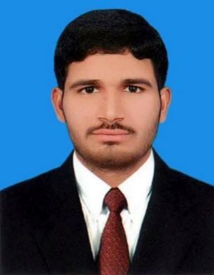**SHAHID YOUSAF**

Near awais market khiali adda gujranwala.

03206005041

Email: shahidyousaf82@gmail.com

**Educational Record:**

2018 to 2020 Mphil physical chemistry CGPA = 3.92/4

The university of lahore

2015 to 2017 M.Sc. Chemistry Grade: A

Punjab University Lahore.

2013 to 2015 B.Sc. (Che, Math, Phy) Grade:B

Punjab University Lahore.

2011 to 2013 F.Sc. Pre Engineering Grade: A

Govt. satellite town college Gujranwala.

2009 to 2011 Matriculation in Science Grade: A

Govt. high school khiali by pass.

**Academic Project:**

Nanoparticles synthesis (master degree research)

Synthesis and characterization of Sm doped TiO2 Nanoparticles

* **Vitamin C:(** Bachelor degree research)

Find out the concentration of vitamin C in fruit juices by titration method.

**Experience:**.

2018 to 2019 Lecturer in Punjab Group of Colleges Qila Didar singh

campus.

2019 to Till date Lecturer at PUNJAB GROUP OF COLLEGES GUJRANWALA

**Extra-Curricular:**

* Attended “Chemistry Graduates: Opportunities & Challenges” seminar in UOL.
* Attended the symposium of chemistry dept.
* Attended the seminar of traffic police.

**Other Skills:**

* MS Office
* Window installation.
* Player of badminton.
* Function Organizer

**Laptop achiever core i7-7th generation.**

**2 Time scholarships.**

**Languages:**

* Urdu
* English
* Punjabi