

**Task no : 1**

**Name = Muhammad waleed**

**Roll no = SU92-BSSEM-F22-105**

**Section = 5B**

**Course = Computer Network**

**Date = 20-sep-2024**

**Submitted by = Sir Rasikh Ali**

# Lab 1

**Introduction to Packet Tracer:**

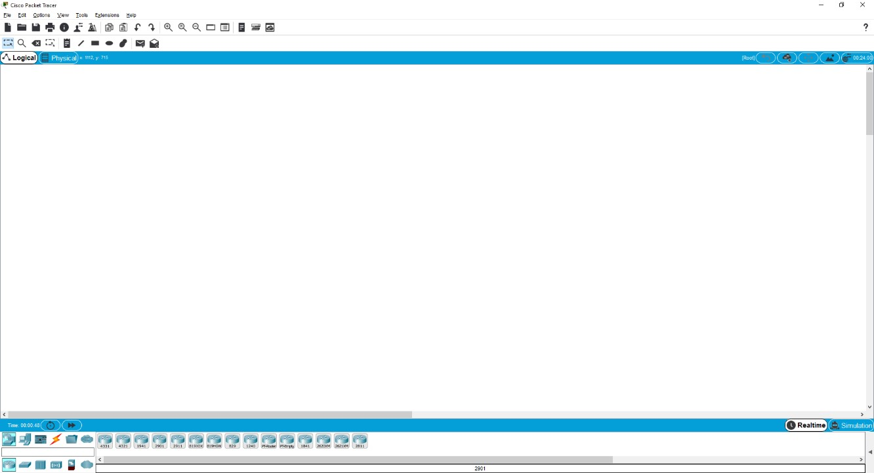

* Packet Tracer is a powerful router simulator created by Cisco Systems. It provides virtual interfaces to interact with physical environment.
* The purpose of Packet Tracer is to offer students and teachers a tool to learn the principles of networking as well as develop Cisco Technology specific skills.
* Packet Tracer is a simple Drag & Drop simulator that provides user-friendly environment.
* One of the biggest advantage of packet tracer is that when implementing a large scale of network in a physical environment it helps to establish the whole scenario in the simulator.
* Packet Tracer creates **.pkt & .pka** Extension when saving files.
* Packet Tracer **Include Routers, Switches, Hub, Servers, End Devices, Firewalls, And Multi user environment support**, so one can easily perform a large activity with its group members or partners on two computers. After completing of an activity both can merge a single Lab in one activity.

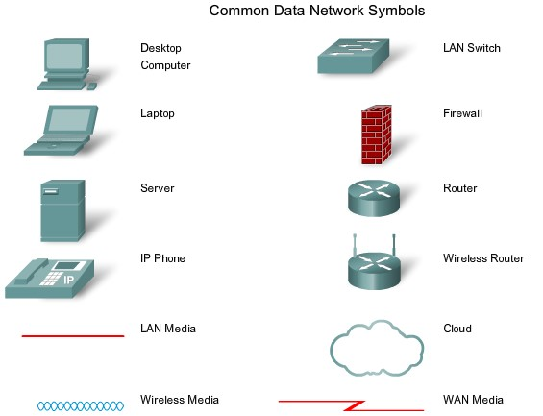

**Difference Between End & Intermediate devices:**

**Intermediary devices:**

A device that connects directly to end user devices or provides end user routing to other networks. For instance, a router is an example of intermediary devices Intermediary devices connect the individual hosts to the network and can connect multiple individual networks to form an internet-work.

**End Devices**

The network devices that people are most familiar with are called end devices. These devices form the interface between the human network and the underlying communication network. Some examples of end devices are: • Computers (work stations, laptops, file servers, web servers)

* Network printers
* VoIP phones
* Security cameras
* Mobile handheld devices (such as wireless barcode scanners, PDAs)

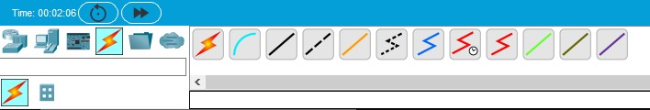

Selecting Connection Type

**Difference between Twisted Pair & Unshielded Twisted Pair:**

**Twisted pair:** **Twisted pair** cabling is a type of wiring in which two conductors (the forward and return conductors of a single circuit) are twisted together for the purposes of canceling out electromagnetic interference (EMI) from external sources.

**UTP**: is a four –pair medium used in verity of networks. UTP does not require te fixed spacing connection that is necessary with coaxile type connection. UTP is also finding increasing use in video applications, primarily in security cameras. Many middle to high-end cameras include a UTP output with setscrew terminals. This is made possible by the fact that UTP cable bandwidth has improved to match the baseband of television signals

**Symbols of Cable Type:**

**Console Cable (used to connect with a router)**

**Straight Through Cable (Used to Connect Different Devices**

**Copper Crossover cable (Used to connect with the same devices)**

 **Fiber (used in WAN environment)**

 **Phone (used in VOIP Phone)**

 **Coaxial cable (used in WAN emulation)**

 **Serial DCE Cable (Used in WAN links where clock rate is required)**

 **Serial DTE Cable (used in WAN link where clock rate is not required)**

**Task 1;**

What is the difference between all the routers, and when to use them (mentioned in cisco packet tracer)

***Answer :***

***Difference Between Routers and When to Use Them***

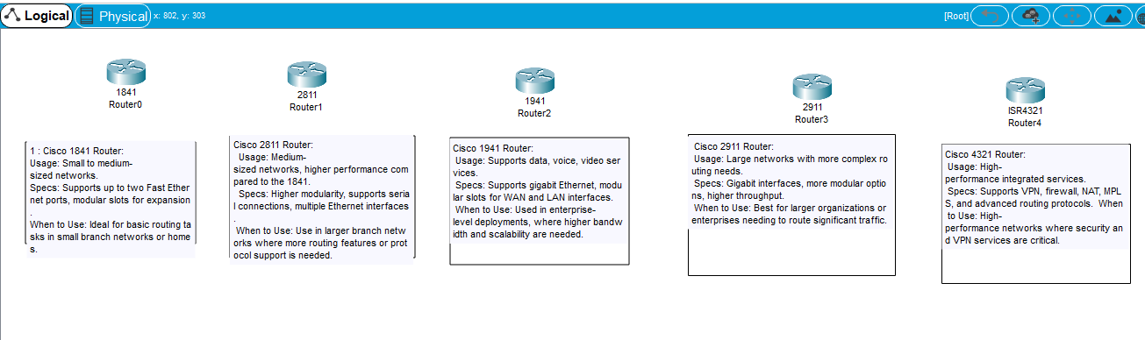

**Task 2;**

What is the difference between all the switches, and when to use them (mentioned in cisco packet tracer)

***Answer :***

***Difference Between Switches and When to Use Them***

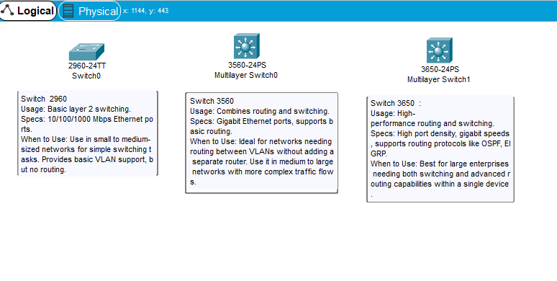

**Task 3;**

What is the difference between all the connection wires, and when to use them (mentioned in cisco packet tracer)

***Answer :***

***Difference Between Routers and When to Use Them***

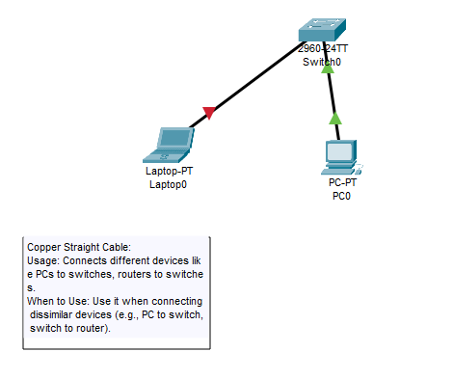



**Copper Crossover Cable**:

* **Usage**: Connects similar devices, such as switch-to-switch or router-to-router.
* **When to Use**: Used for directly connecting two similar networking devices for communication.

**Console Cable (used to connect with a router)**

* **Usage**: Used for direct connection to a device’s console port.
* **When to Use**: For initial configuration or troubleshooting of a router or switch by connecting a PC or terminal to the device.

 **Fiber (used in WAN environment)**

* **Usage**: For long-distance connections with high bandwidth.
* **When to Use**: Use between switches or routers when dealing with long distances and high-speed data transmission (typically for enterprise or data center networks).

 **Coaxial cable (used in WAN emulation)**

* **Usage**: Rare in modern networks but can simulate older networks or specific devices.
* **When to Use**: Used in older LAN setups, like cable internet or certain legacy systems.