

**Task no : 2**

**Name = Muhammad waleed**

**Roll no = SU92-BSSEM-F22-105**

**Section = 5B**

**Course = Computer Network**

**Date = 20-sep-2024**

**Submitted by = Sir Rasikh Ali**

*Lab 2*

# Establish Connectivity between End Devices

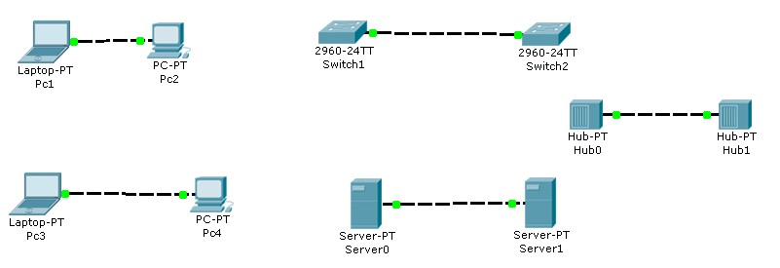

1. Drag & Drop All the END devices & Intermediary devices
2. Connect these Devices with Copper Cross over cable
3. After establishing the connectivity between all the devices check that all devices must be Showing GREEN signal

# Establish Connectivity A Client & Switch

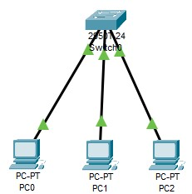

1. Drag & Drop All the END devices & Network device (switch)
2. Connect these Devices with Straight through cable
3. After establishing the connectivity between all the devices check that all devices must be Showing GREEN signal

# Establish Connectivity Between End Devices & Switch & Router

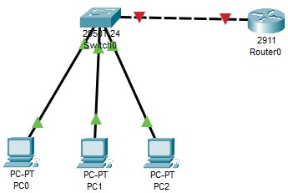

1. Drag & Drop All the END devices & Network device (switch & router)
2. Connect these End Devices with Switch using Straight through cable
3. Connect the Switch with Router using Copper Crossover cable
4. After establishing the connectivity between all the devices check that all devices must be Showing GREEN signal (except router to switch)
5. Click on router and go to config and open the port which is in use (GigabitEthernet0/0 or 0/1 or 0/2)

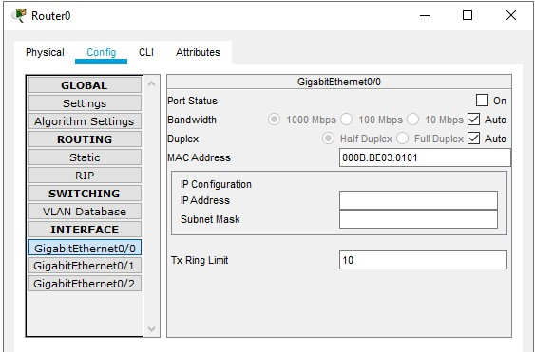

1. Click on the “Port Status” and turn it on.
2. After turning it on the connectivity between all the devices must be Showing GREEN signal

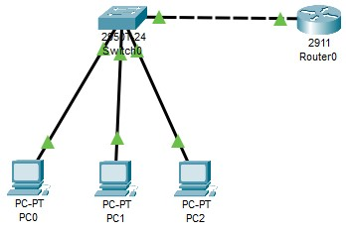

*Lab 2 - Task*

**Task 1;**

Why are we using 2911 router and not the others?

**Answer :**

The Cisco **2911 router** is part of the **Integrated Services Router (ISR) G2** family, designed for enterprise branch offices and medium-to-large networks. Here are some reasons why you might choose the 2911 router over other models like the 1841 or 1941:

***Performance and Scalability****:*

* **2911 Router** supports higher throughput and can handle more traffic compared to the lower-end models like the **1841** and **1941**.
* It provides **3 integrated 10/100/1000 Gigabit Ethernet ports** and has **modular slots** that can be expanded as the network grows.

**Advanced Features**:

* The **2911** offers advanced features such as support for **voice, video, VPN, MPLS, and security services** like firewall and encryption.
* This makes it suitable for **multi-service networks** where not just data but voice and video traffic needs to be routed efficiently.

***Not Use Other Routers :***

* **1841 Router**: Lacks performance and scalability, limited to smaller, less complex networks with fewer advanced features.
* **1941 Router**: Offers better performance than the 1841 but still lacks the modularity, advanced services, and scalability needed for larger, more complex networks.
* **ISR 4321**: Could be a great option for even larger networks with more demanding needs, but it may be overkill for some medium-sized networks.

**Task 2;**

Why are we using 2950T or 2960 switch and not the others?

**Answer :**

Both the **Cisco 2950T** and **Cisco 2960** are commonly used **Layer 2 switches** designed for small to medium-sized networks. Here’s why you might choose one of these models:

**Cisco 2950T**:

* It is a **layer 2 switch** that provides basic switching functionality at a relatively low cost.
* It supports **10/100 Mbps Fast Ethernet** ports, making it suitable for small networks or lab setups.
* Great for environments that don’t require gigabit speeds or advanced features like routing.
* **Cisco 2960**:
* This is a more modern **Layer 2 switch** compared to the 2950T, with support for **10/100/1000 Mbps Gigabit Ethernet**.
* It provides better performance, especially when you have devices requiring **higher bandwidth** or newer technology.
* It supports **VLANs, port security, QoS**, and **basic management features**.
* Great for medium-sized enterprises where gigabit connectivity is required, but you don't need full Layer 3 functionality (routing).

**Not Use Other Switches :**

* **Cisco 2960 vs. Cisco 3560**: The **3560** is a **Layer 3 switch** that also supports routing between VLANs. If you don’t need routing at the switch level or want to separate switching and routing functions, a **2960** will be simpler and cost-effective.
* **Cisco 3650**: This is a **multilayer switch** with advanced features for larger enterprises. It's better suited for more complex networks requiring high performance and scalability.
* **Cisco 9200 Series**: This is a high-performance switch with more advanced features, which may be overkill for smaller setups or basic switching needs.

# Task 3;

Design the network of "Lab-7" or “Lab-8” (2-3 rows of computers) Use: Switch, Router, & End-Devices like Laptop/PC

**Answer :**

