

**Task no : 4**

**Name = Muhammad waleed**

**Roll no = SU92-BSSEM-F22-105**

**Section = 5B**

**Course = Computer Network**

**Date = 20-sep-2024**

**Submitted by = Sir Rasikh Ali**

**Assigning IP Address to a Network (with Server / DHCP)**

1. Make a network similar to this and open the Server settings.

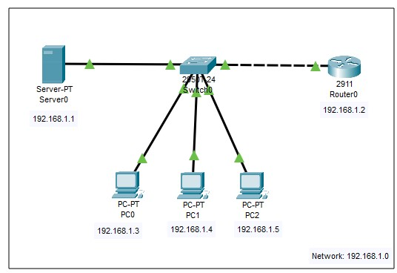

1. Open desktop and go to IP Configuration

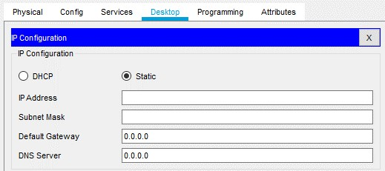

1. In the “IP Address” field, type the following IP address: **192.168.1.1** and click enter, it’ll automatically add a relevant subnet mask and in the “Default Gateway” type the IP Address of the router, or enter an IP Address which you’ll then give to the Router (**192.168.1.2**).

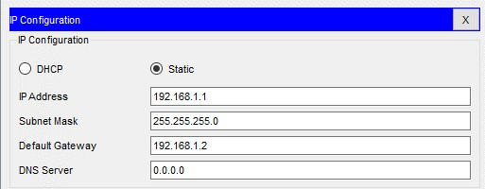

1. Now, go to the “Services” tab and open “DHCP”, here Click on the “serverPool” from list below

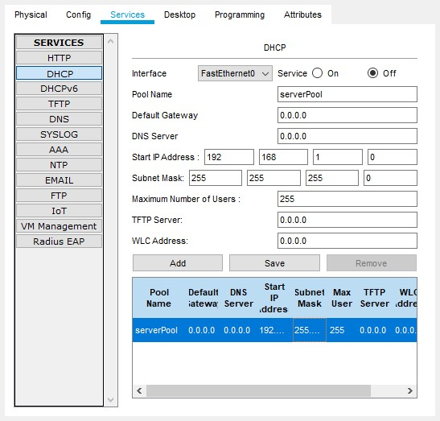

1. Now, just change the “Default Gateway” from 0.0.0.0 to the IP Address which is preserved to be set to Router / Router’s IP (**192.168.1.2**) and Click on “ON” button for “Service” and click on Save and close it.

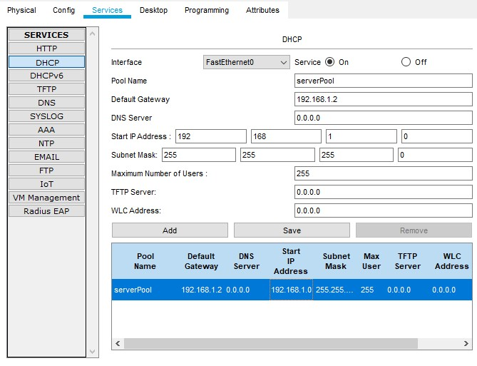

1. Hover over the Server to double-check if the IP and Gateway is assigned or not.

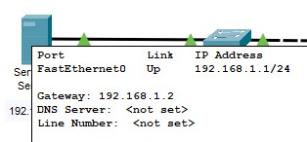

1. Now, Assign the Router’s IP (**192.168.1.2**) if you haven’t already (follow previous steps of assigning IP to router)
2. Now, click on the end device (PC/Laptop) and open its setting and go to “desktop”.

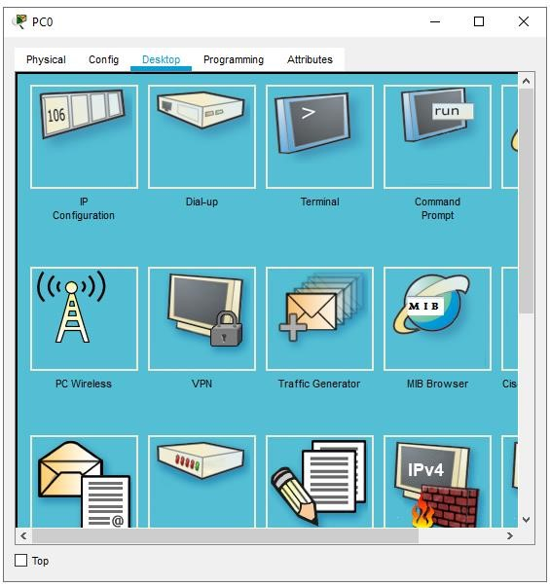

1. From here, open the first option “IP Configuration”

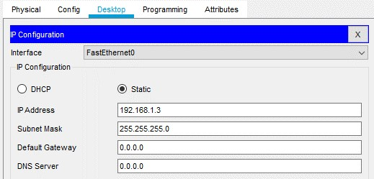

1. Now, in here, just click on DHCP and let the **“Magic Begin”** It’ll automatically assign an IP

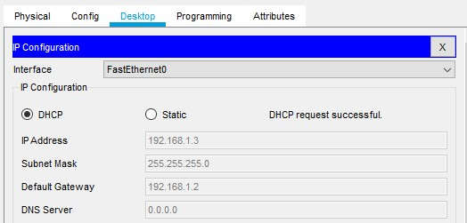

1. Then do the same (Step 8 to 10) for all the End Devices.
2. Afterwards, you can check if the IP is assigned to devices, (either by hover, or command prompt)

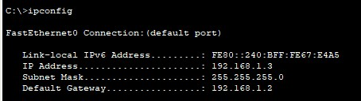

1. Now to check if we can transfer message between end-devices or not, just open any end-device and open its Command Prompt, and type “**ping**” and afterwards type the **ip-address** of **target device**.

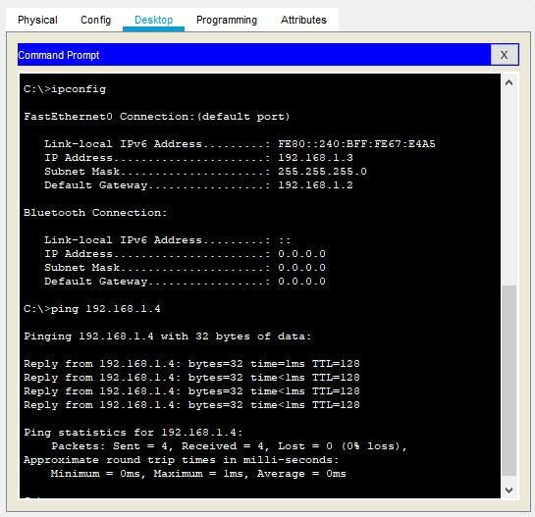

1. As there is **0% loss** that means, the connection was successful and message was sent successfully.

*Lab 4 - Task*

**Task 1;**

Design the network of "Lab-7" or “Lab-8” (2-3 rows of computers)

Use: Server, Switch, Router, & End-Devices like Laptop/PC

Assign them IP Address (Dynamically/DHCP) of any Network (or you can use network **192.168.1.0**)

