**Computer Networks Rasikh Ali**



**Task no : 7**

**Name = Muhammad waleed**

**Roll no = SU92-BSSEM-F22-105**

**Section = 5B**

**Course = Computer Network**

**Date = 11-oct-2024**

**Submitted by = Sir Rasikh Ali**

# Lab 7

**Assigning IP Address to a Network (Dynamically/DHCP, using Command)**

1. Repeat Steps **“1”** to **“8”** from Lab 6, After that stay in CLI, in “**router(config)#**”.

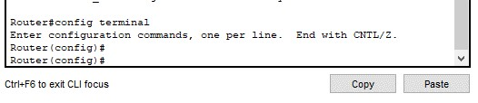

1. Write commands:
   1. ip dhcp excluded-address [start ip address] [end ip address] like: ip dhcp excluded-address 192.168.1.2 192.168.1.10

(optional command, if you want to keep some IP Addresses separate, not to be assigned by DHCP)

* 1. ip dhcp pool [CustomPoolName] like: ip dhcp pool Network192
  2. network [NetworkID] [Subnet Mask] like: network 192.168.1.0 255.255.255.0
  3. default-router [Router IP Address] like: default-router 192.168.1.1

(This was assigned in “**Lab 6**” content)

* 1. Lastly, to exit from this “router(dhcp-config)#” just type “**exit**”

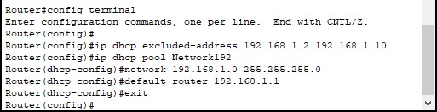

1. Now, configure IP addresses to be DHCP, like we did in “**Lab-4, Step 8 to 10**” and afterwards hover over the PCs to check if the IP is configured or not

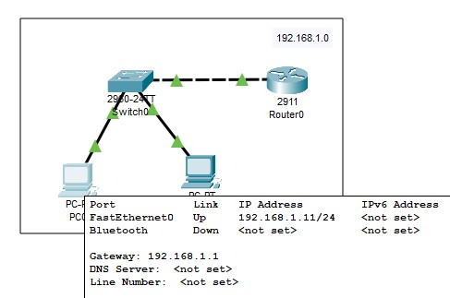

1. Now, to check connection between PCs and Router, execute “**ping**” & “**telnet**” commands

**Computer Networks Rasikh Ali**

# Lab 7 - Task

**Task 1;**

Design network of "Lab-7" or “Lab-8” (2-3 rows of computers) Use:

* Switch (1)
* Router (1)
* End-Devices like Laptop/PC

Assign IP Address (167.158.15.0) using Command for Router. And Dynamically (DHCP-Router) for End-Devices

