**Computer Networks Rasikh Ali**



**Task no : 8**

**Name = Muhammad waleed**

**Roll no = SU92-BSSEM-F22-105**

**Section = 5B**

**Course = Computer Network**

**Date = 10-oct-2024**

**Submitted by = Sir Rasikh Ali**

Lab 8

## Assigning IP Address to 2 Networks (Dynamically/DHCP, using Command)

1. Create the following (2 switches means, 2 networks, connected to same router);
   * **1 router**
   * **2 switches**
   * switches connected to some devices

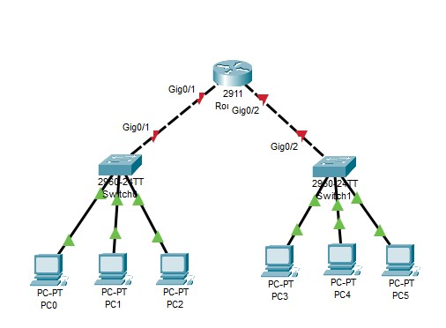

1. Repeat all the steps from **Lab 7**, for both the Networks:

**Computer Networks Rasikh Ali**

# Lab 8 - Task

## Task 1;

Design network of "Lab-7" and “Lab-8” (2-3 rows of computers) Use:

* Switch (2)
* Router (1)
* End-Devices like Laptop/PC

Given IP Address (167.158.15.0), Create 4 Subnets from this given IP Address and use the “2” Subnets in the 2 networks connected to Router, using Command for Router. And Dynamically (DHCP-Router) for End-Devices

