

LAB # 14

Complex Computing Activity

Submitted To: Sir Hamza Farooqui

Student Name: Muhammad Waleed Kamal
Department: Artificial Intelligence
Roll No.: 23-AI-36
Section: A2

Report of Complex Computing Activity

Apple Detection Model for Sorting using YOLOv8m

Table of Contents
No. | Topic
1 | Introduction
2 | System Architecture & Pipeline
3 | Model Design & Training
4 | Model Evaluation & Results
5 | Deployment & Visualization
6 | Integrated Lab Concepts
7 | Challenges & Limitations
8 | Ethical & Fairness Considerations
9 | Setup & Run Instructions
10 | Conclusion
11 | Presentation & Demonstration

Introduction
Automation in agriculture has become essential to improve productivity, reduce labor costs, and ensure consistent quality control. One of the key challenges in fruit processing industries is accurate and fast sorting of fruits based on quality and type, which traditionally requires significant human involvement and is prone to error.
This project presents an Automated Apple Detection and Classification System capable of identifying and sorting four different apple categories:
- Red Apples
- Green Apples
- Used Apples
- Rotten Apples
The system is designed for agricultural and industrial environments where human interaction is involved, enabling automatic analysis and sorting through a machine based vision system. The project leverages computer vision and deep learning, using the YOLOv8 object detection model, to perform real time detection with high accuracy and smooth performance, including mobile deployment.

System Architecture & Pipeline
The overall system architecture of the automated apple detection and sorting system follows a structured end to end machine learning pipeline. The process begins with the collection of apple images from real agricultural environments. These images are then annotated using Roboflow, where bounding boxes are created for each apple type. After annotation, data augmentation techniques are applied to increase dataset diversity and improve model generalization. The augmented dataset is split into training, validation, and testing sets. The training phase is
conducted using the YOLOv8m object detection model on Google Colab with GPU acceleration. Once training is complete, the model is evaluated using standard detection metrics. Finally, the trained model is deployed through Ultralytics Hub, enabling mobile based detection and smooth real time visualization.
The pipeline takes apple images captured as input. These images are processed through a deep learning based object detection and classification model that identifies the apple type present in each image. The output of the system consists of bounding boxes drawn around detected apples along with their corresponding class labels. The final

Image Collection
Data Annotation (Roboflow)
Data Augmentation

Train / Validation / Test Split
YOLOv8m Model Training (Google Colab GPU)

Model Evaluation
Deployment (Ultralytics Hub) Hub)

Mobile Detection & Visualization
Fig: Apple Detection System Workflow
deployment enables mobile friendly inference with smooth graphical visualization, making the system suitable for practical use in agricultural settings.
Dataset Description & Preprocessing
The initial dataset used for this project consisted of approximately 100 original apple images collected from real world scenarios. These images captured a variety of conditions, including changes in lighting, different background environments, multiple apple types appearing in a single image. This diversity was important to ensure that the trained model could generalize well to practical environments.
For annotation, the Roboflow platform was used to label the dataset. Bounding box annotations were created for four distinct apple classes: Red Apple, Green Apple, Used Apple, and Rotten Apple. This labeling process enabled the model to learn both object localization and classification simultaneously.
To improve model robustness and reduce overfitting caused by the limited dataset size, several data augmentation techniques were applied. As a result of augmentation, the dataset size increased to approximately 260 images. Out of these, around 240 images were used for training, while 10 images each were reserved for validation and testing purposes. This dataset split ensured proper evaluation of the model’s learning and generalization capability.

Annotation
- Tool used: Roboflow
- Annotation type: Bounding box annotations
- Classes:
- Red Apple
- Green Apple
- Used Apple
- Rotten Apple

Data Augmentation
To improve generalization and avoid overfitting, data augmentation was applied:
- Flip: Horizontal, Vertical
- 90° Rotate: Clockwise, Counter-Clockwise, Upside Down
- Crop: 0% Minimum Zoom, 27% Maximum Zoom
- Rotation: Between -14° and +14°
- Grayscale: Apply to 24% of images
- Hue: Between -23° and +23°
- Brightness: Between -24% and +24%
- Exposure: Between -0% and +0%
Model Design & Training
The YOLOv8m model was selected for this project due to its lightweight architecture and high inference speed. The model is part of the Ultralytics YOLO framework and is specifically optimized for real time detection on edge devices and mobile platforms. Its efficiency makes it well suited for agricultural automation systems where fast and accurate predictions are required.
Model training was carried out on Google Colab, utilizing free NVIDIA T4 GPU resources to accelerate the training process. This environment provided the computational power necessary for deep learning while remaining cost effective. The model was trained using an image size of 640 × 640 pixels over 100 epochs. Throughout training, the model optimized multiple loss components, including bounding box loss, classification loss, and objectness loss which will discuss below. Model performance was continuously monitored using validation metrics to ensure stable learning and prevent overfitting.

Hyperparameters
Parameter | Value
Image Size | 640 × 640
Epochs | 100
Model Variant | yolov8m

Model Evaluation & Results
The trained model demonstrated strong performance across most apple categories. Rotten apples and used apples were detected with very high accuracy, as these classes possess distinct visual characteristics that are easily recognizable by the model. Red apples were detected with moderate accuracy, while green apples showed slightly lower accuracy compared to red apples.
These results indicate that color similarity and lighting variations played a significant role in misclassification, particularly between red and green apples. Additionally, class imbalance within the dataset contributed to the reduced performance for green apples. Model evaluation was performed using standard object detection metrics such as precision, recall, and mean average precision (mAP), along with visual inspection of bounding boxes to qualitatively assess detection performance.
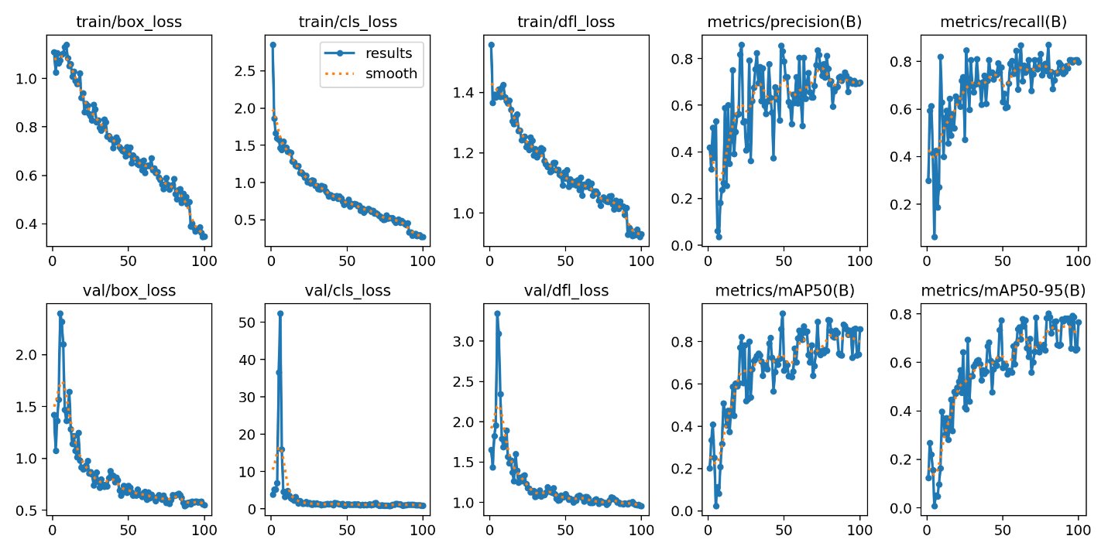
- Results of all the losses along with precision, recall and mean average precision(mAP)
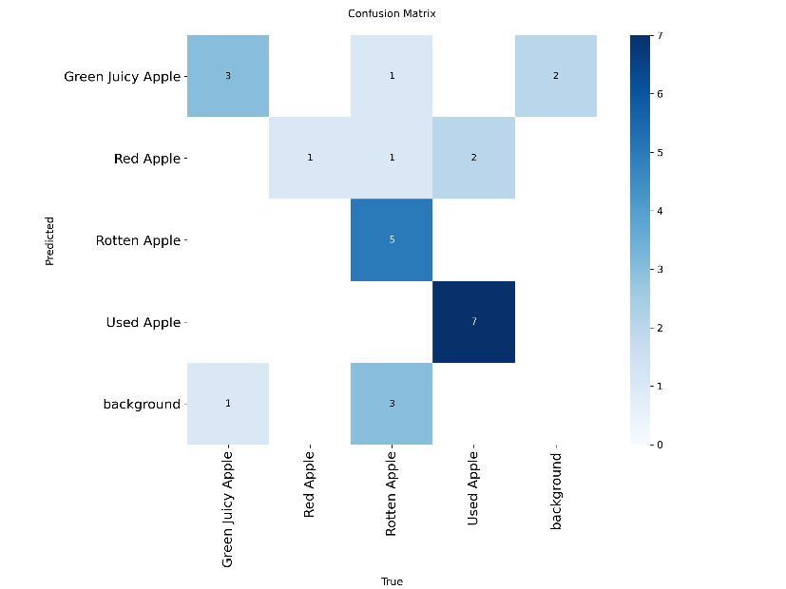
- Confusion Matrix
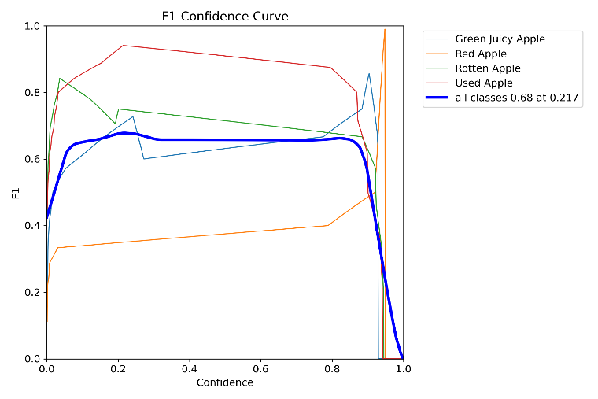
- BoxF1_curve
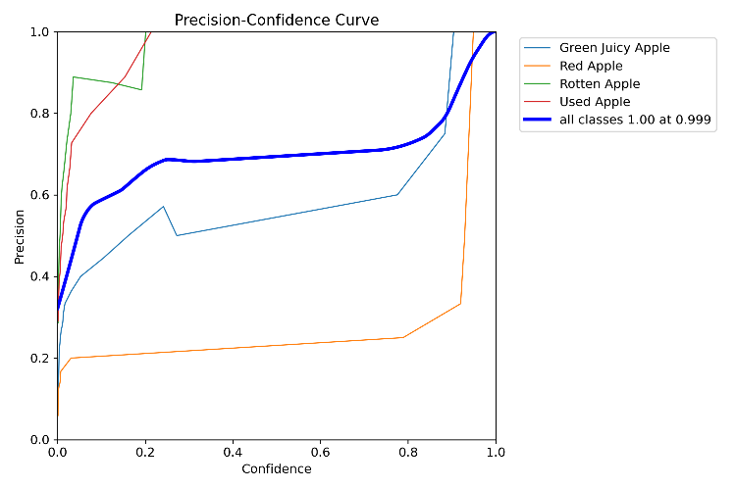
- BoxF1_P

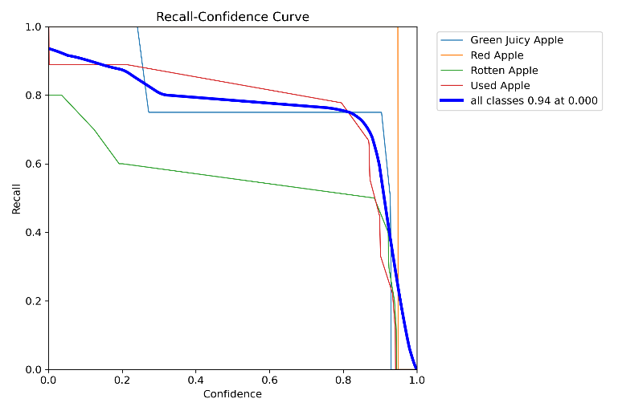
- BoxF1_R
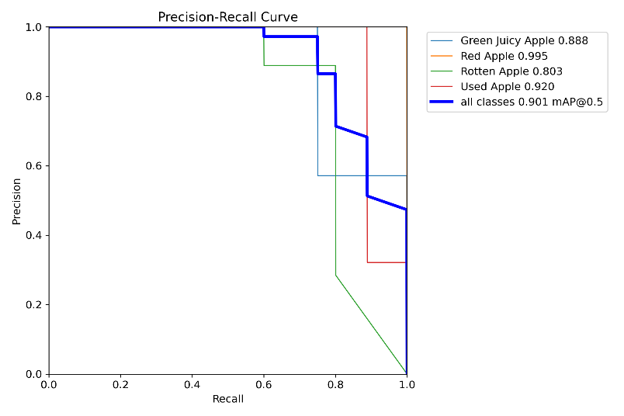
- BoxF1_PR

Deployment & Visualization
After training and evaluation, the model was uploaded to Ultralytics Hub to enable deployment and cloud based inference. The model was further retrained and optimized using Google Colab before deployment. Ultralytics Hub provided an efficient platform for managing the model and enabling easy access for inference across devices.
For mobile deployment, the Ultralytics mobile interface was used to perform real time apple detection. The deployed system allows users to detect apple types directly on a mobile device with smooth graphics and fast response time. This mobile based visualization makes the system highly practical for on field agricultural use and real time quality assessment.

Integrated Lab Concepts
This project integrates multiple machine learning lab concepts:
Lab Concept | Implementation
Data Collection | Real-world apple images
Data Augmentation | Image transformations
CNNs | YOLOv8 deep convolutional layers
Object Detection | Multi-class apple detection
Model Evaluation | Precision, Recall, F1-score, mAP
Deployment | Ultralytics Hub & Mobile inference

Challenges & Limitations
One of the main challenges encountered during the project was the limited size of the dataset, which restricted the model’s learning capacity for certain classes. Class imbalance further affected performance, particularly for green apples. Additionally, similar visual features between red and green apples, combined with varying lighting conditions, introduced classification difficulties. Furthermore, while the system performs well in controlled conditions, additional tuning and data collection would be required for large scale industrial deployment.

Ethical & Fairness Considerations
The proposed system is designed to reduce repetitive human labor in agricultural sorting processes while not completely replacing workers. Instead, it serves as a supportive tool to improve efficiency and consistency. The dataset used does not include any personal or sensitive information, ensuring privacy and ethical compliance. Fair classification across all apple categories was encouraged through balanced data augmentation to minimize bias.

Setup & Run Instructions
To set up the environment, the required libraries can be installed using pip, including Ultralytics and Roboflow. Model training can be performed using the YOLO training command with the YOLOv8m model, custom dataset configuration file, and specified training parameters such as image size and number of epochs. For inference, the trained model can be used to detect apple types in new images using the YOLO prediction command. GPU support is recommended for training and evaluation and a mobile device is required for Ultralytics Hub based detection.
- Environment Setup
pip install ultralytics roboflow
- Training Command
yolo task=detect mode=train model=yolov8m.pt data=data.yaml epochs=100 imgsz=640
- Inference
yolo task=detect mode=predict model=best.pt source=image.jpg
- Hardware Requirements
- GPU recommended (Google Colab)
- Mobile device for Ultralytics Hub detection

Conclusion
This project successfully demonstrates the development of a complete and complex machine learning system, integrating data collection, preprocessing, deep learning model training, evaluation and real world deployment. The automated apple detection and sorting system shows strong performance particularly in identifying defective apples and provides a scalable foundation for agricultural automation. Future enhancements include expanding the dataset, improving color based classification accuracy and integrating the system directly with physical sorting machinery for fully automated operation.

Presentation & Demonstration
The demonstration video of the project has been uploaded to the GitHub repository under the filename “Video_of_Apple_Detection_Model_from_Mobile.mp4”, showcasing real time apple detection and classification performed through the Ultralytics mobile interface with smooth visualization and accurate bounding box predictions.
Github Link: https://github.com/Waleed8001/Machine-Learning-Projects-and-Assignments/tree/main/Apple_Detection_Model
Demo Link: https://drive.google.com/file/d/1UkGo4wmlqRcaTlwrRaCCPBFPYVkLumrl/view?usp=sharing

-----------------------------------------------------------The End----------------------------------------------------------

