SMART PARKING PLATFORM
Project Management Plan
WE ARE Software Corp.
CIS 4374 – Information Systems Project Management
Section 19148
Made by:
Waleed Mohamed
Instructor:
Dr. Otto Dobretsberger
Version 1.0
09/10/2026

Existing Software Landscape
The smart parking industry already has so many popular platforms that help drivers find, reserve, and pay for parking everything you need to get the job done. Three well known examples that I decided to go for are ParkMobile, SpotHero, and ParkWhiz. Each platform makes parking a bit easier, but they offer different features and focus on different needs, so each one is a bit different. Looking at these already existing platforms can help us understand what is already available and find ways for our Smart Parking Platform to be different and way more useful, and that is the goal for us to learn from their mistakes.

1.1ParkMobile
ParkMobile is one of the most popular parking apps in the United States. The main goal of the app is to make paying for parking easier and faster so that people don't waste their time. Instead of using a parking meter or kiosk, drivers can enter the parking zone number, choose how long they want to park, and pay directly from their phone, so it is pretty nice and convenient for anyone using it. The app can also send alerts when a parking session is close to ending, and in some locations, users can add more time without going back to their car, and that is easily one of their better features in my opinion. ParkMobile also allows drivers to reserve parking ahead of time for places such as garages, airports, concerts, and sporting events, so the people would not stress.
One of ParkMobile's biggest strengths is that they know how to combine several useful parking features into one app, and that is why they are that big. It is also available in many cities across the country, which makes it convenient for people who like to travel. Our Smart Parking Platform would use some similar ideas, such as mobile payments and reservations because they are great, but it would focus more on showing real time parking space availability and giving parking operators tools to track occupancy and manage their parking areas and I think this will make us stand out. Because anytime I use these types of apps, I always have this problem.

1.2 SpotHero
SpotHero is another popular parking platform that I decided to go for, and this one focuses mainly on helping drivers find and reserve parking before they arrive at their destination, so it is more for convenience which is what we like more than anything. Users can search for parking near where they are going, compare different locations and prices, and then pay for a parking spot through the app or website, which is what makes them so popular because they can do all of that before leaving the house, and the users love that a lot. SpotHero can be used for so many things like for example normal hourly parking, airports, events, and even monthly parking, so they offer a lot of different places so people from all over can use them. After making a reservation, the user gets a prepaid parking pass that tells them how to enter the parking location, so they don't have to spend an hour trying to figure it out. Depending on the garage or lot, this could include scanning a QR code, showing the pass to an employee, or using a license plate number, but those are usually a bit more rare.
One of SpotHero's biggest strengths is how easy it makes it to plan parking ahead of time. Like I said before, this feature is really important because we always try to save some time. Instead of driving around looking for an open garage and hoping the price is good, users can compare their options before they even leave, and that is amazing because they get to save so much time and effort. SpotHero also works with parking operators and gives them tools to manage prices, reservations, and parking availability. Our Smart Parking Platform would have some similar features, but we want to put more focus on real-time parking information, navigation, and giving drivers and parking operators one complete system to use.

1.3 ParkWhiz
ParkWhiz is another parking platform that allows drivers to find and reserve parking before they even reach their destination. Users can search for any information, for example, address, event, or location, and then compare nearby garages and parking lots based on price and location, so it is pretty similar to the other two we talked about but still really good. Once they find a parking option they like, they can choose the date and time, pay online, and receive a digital parking pass, so it is nice and easy for the user to use, and simplicity is usually always better and so that you don't lose the paper ticket. This can save drivers so much time because they already know where they are going to park instead of searching for a spot for a long time after they arrive because no one likes to do that. ParkWhiz also provides information about the parking location, such as directions, restrictions, and available features, and that part is my favorite thing about this app because they just give you all the information you need to make your life a bit more simple.
One of ParkWhiz's biggest strengths is how simple the reservation process is, I feel like it is more simple than the other two apps that I talked about. Being able to compare prices and pay before arriving can be very useful, especially when parking for concerts, sporting events, airports, or busy areas because it can get pricy. Our Smart Parking Platform would use all of these similar ideas, but our main goal would be to bring more parking features together in one system and focus heavily on real time parking information for both drivers and parking operators so that we can stand out the most, and that is the goal to show people that they should use our app.

1.4 How Our Smart Parking Platform Will Be Different
After looking at the three apps I chose, ParkMobile, SpotHero, and ParkWhiz, it is pretty clear that all three platforms already make parking easier in different ways because I already talked about all three examples. They let the users find parking, make payments, and, in many cases, reserve a parking spot ahead of time, so they have a lot of nice features. Our Smart Parking Platform will use some of these same useful ideas, but the goal is to bring more of the parking experience together into one system so we can build on top of what is actually working.
One of the main focuses of our platform will be real-time parking availability because the users love that. Drivers will be able to see available parking spaces on an interactive map, reserve a spot, pay through the platform, and use navigation to reach the parking location to make it nice and easy. Users will also be able to view their reservation history and receipts and receive notifications about their parking session, and I feel like the users will like these extra features because a lot of apps do not show that.
The platform will also focus on the parking operators and not only the drivers. Operators will have their own dashboard where they can manage parking spaces, view occupancy information, and look at analytics about how their parking areas are being used, and this will make everything just so much more efficient. By combining all of these amazing tools for both drivers and parking operators, our goal is to create one platform that makes the entire parking process easier to manage.

2.0 Vision and Scope
WE ARE Software Corp., a software development company that works on creating different types of technology solutions for businesses and their customers. Our job is to make the life of our users easier. Our company has an amazing team filled with developers, designers, testers, and project managers who work together to plan and build software for anyone to use without struggle so we can save them more time. For this project, we have unlimited resources and budget, which gives our team the ability to focus on creating the best system possible so we can satisfy all of our amazing users, instead of stressing to stay within the budget. Our goal as a company is to create software that is useful, easy to understand, and solves real problems that people deal with on a daily basis.
Our company acquired the Smart Parking Platform project because there is a need for a better and easier way for drivers to find and manage parking, because we understand that parking has always been a huge problem for a long time and it is time for someone to step in and fix the problem at hand. Drivers can spend a lot of time just searching for an open parking space, especially in busy areas, and this can cause traffic, frustration, and wasted time; all of these bad things just ruin the user's mood. Parking operators also need better ways to keep track of their parking spaces and understand how their parking areas are being used because I used a lot of parking apps, and I'm not happy. Because of these problems, our company will plan and develop a smart parking platform that can help both drivers and parking operators.
The vision for the Smart Parking Platform is to create one system that makes parking easier from beginning to the very end. Drivers will be able to create an account, view available parking spaces in real time (not only the time when they checked in), find locations on an interactive working map, reserve parking, make digital payments, and receive directions to their parking location. They will also be able to see previous reservations and receipts and receive notifications about their parking. The main idea is to give drivers the information they need before they arrive so they do not have to waste as much time looking for an available space, because the more time we save for the users, the more it would show us that our app is actually useful.
The scope of the project will also include tools for parking operators. Operators will have access to a dashboard where they can manage parking information, view occupancy, and see analytics about how their parking areas are being used, and I am very firm on making this dashboard nice, simple, and effective. The platform will also connect with outside services when needed, such as payment and mapping services, because people always complain about these two topics. Overall, the project will focus on creating a system that connects drivers and parking operators and makes finding, reserving, paying for, and managing parking much easier; this will show the people that we are the best app to use.

3.0 Software Requirements Specification (SRS)
The Smart Parking Platform will be designed to make finding and managing parking so much easier for both drivers and parking operators; that is the goal we have in mind, just to make it nice and simple. The system will allow users to create an account, search for available parking spaces in real time, view parking locations on a map, reserve a parking spot instead of doing it last second, and make payments through the platform. We are doing all of that because we want to make it as simple as possible while giving them all the information they would need. Users will also be able to view their reservation history and receipts, receive notifications, and use navigation to help them reach their parking location.
The system will also provide amazing tools for parking operators so they can better manage their parking areas, and this part is very important because we need to make sure both sides are good not only for the people parking. Operators will be able to use a dashboard to manage parking information, check occupancy, and view analytics about how their parking spaces are being used, because they need all this information so we can make sure everyone can park effectively without wasting time. The platform will also work with outside services such as payment providers and mapping services. This part is also very important because I have seen lots of complaints online, especially about payment.

3.1 Use Cases
Use Case 1: Create Account
Actor: Driver
Precondition: User does not have an account already.
Steps: User enters their information.
Postcondition: Account is created.
Use Case 2: Log In
Actor: Driver
Precondition: User has an account.
Steps: User enters their login information.
Postcondition: User is logged into their account.
Use Case 3: Find Parking
Actor: Driver
Precondition: User is logged in.
Steps: User searches for parking.
Postcondition: Parking spots are shown in app.
Use Case 4: View Map
Actor: Driver
Precondition: Parking spots are available.
Steps: User opens the map.
Postcondition: Parking locations are shown to users.
Use Case 5: Reserve Parking
Actor: Driver
Precondition: A parking spot is available.
Steps: User chooses and reserves a spot.
Postcondition: Spot is reserved for them.
Use Case 6: Pay for Parking
Actor: Driver
Precondition: User chooses a parking spot.
Steps: User enters payment and pays.
Postcondition: Payment is completed.
Use Case 7: View Receipt
Actor: Driver
Precondition: User has made a payment.
Steps: User opens their receipt.
Postcondition: Receipt is shown for proof.
Use Case 8: View Past Reservations
Actor: Driver
Precondition: User has past reservations.
Steps: User opens reservation history.
Postcondition: Past reservations are shown to user.
Use Case 9: Get Notification
Actor: Driver
Precondition: User has an active parking session.
Steps: System sends a notification.
Postcondition: User gets the notification.

Use Case 10: Get Directions
Actor: Driver
Precondition: User chooses a parking location.
Steps: User opens directions.
Postcondition: Directions are shown to user.
Use Case 11: View Dashboard
Actor: Parking Operator
Precondition: Operator is logged in.
Steps: Operator opens the dashboard.
Postcondition: Parking information is shown.
Use Case 12: Manage Parking
Actor: Parking Operator
Precondition: Operator is logged in.
Steps: Operator updates parking information.
Postcondition: Information is updated.
Use Case 13: Check Occupancy
Actor: Parking Operator
Precondition: Operator is logged in.
Steps: Operator checks parking occupancy.
Postcondition: Occupancy is shown to user.
Use Case 14: View Analytics
Actor: Parking Operator
Precondition: Parking data is available.
Steps: Operator opens analytics.
Postcondition: Analytics are shown.
Use Case 15: Update Account
Actor: Driver
Precondition: User is logged in.
Steps: User changes their information.
Postcondition: Account is updated.

4.0 Work Breakdown Structure (WBS)
The Work Breakdown Structure below divides the Smart Parking Platform into a lot of smaller parts. This makes the project easier to organize and shows the main work that needs to be completed.
Level 1 | Level 2 | Level 3
1. Account and Access Management | 1.1 Driver Account | 1.1.1 Registration
 |  | 1.1.2 Login
 |  | 1.1.3 Profile Management
 | 1.2 Operator Account | 1.2.1 Operator Registration
 |  | 1.2.2 Operator Login
 |  | 1.2.3 Operator Profile Management
2. Parking Services | 2.1 Parking Search | 2.1.1 Real-Time Availability
 |  | 2.1.2 Interactive Map
 | 2.2 Parking Reservation | 2.2.1 Parking Selection
 |  | 2.2.2 Reservation Management
 | 2.3 Navigation | 2.3.1 Parking Location
 |  | 2.3.2 Directions
3. Payment and Records | 3.1 Payment Processing | 3.1.1 Digital Payment
 |  | 3.1.2 Payment Confirmation
 | 3.2 User Records | 3.2.1 Receipts
 |  | 3.2.2 Reservation History
4. Operator Management and Reporting | 4.1 Garage Management | 4.1.1 Parking Space Management
 |  | 4.1.2 Parking Information Management
 | 4.2 Monitoring and Reporting | 4.2.1 Occupancy Monitoring
 |  | 4.2.2 Analytics and Reports

5.0 Project Timeline and Gantt Chart
The Gantt chart below shows the main tasks for the Smart Parking Platform and how long each part should take.
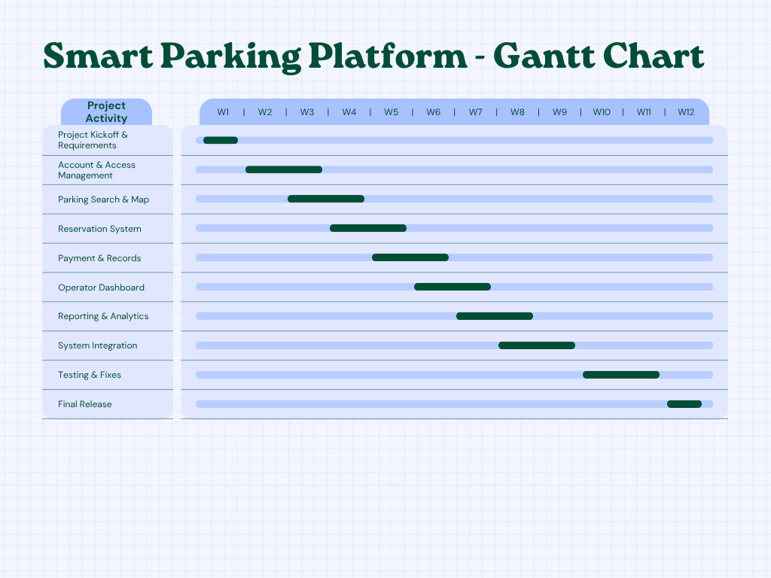

6.0 Agile/Scrum Backlog and Sprint 1
The Trello board below shows the product backlog for the Smart Parking Platform. The backlog includes a lot of items including; login, user interface, backend, and reporting requirements. A Sprint 1 backlog was also created to organize the first group of tasks that will be worked on.
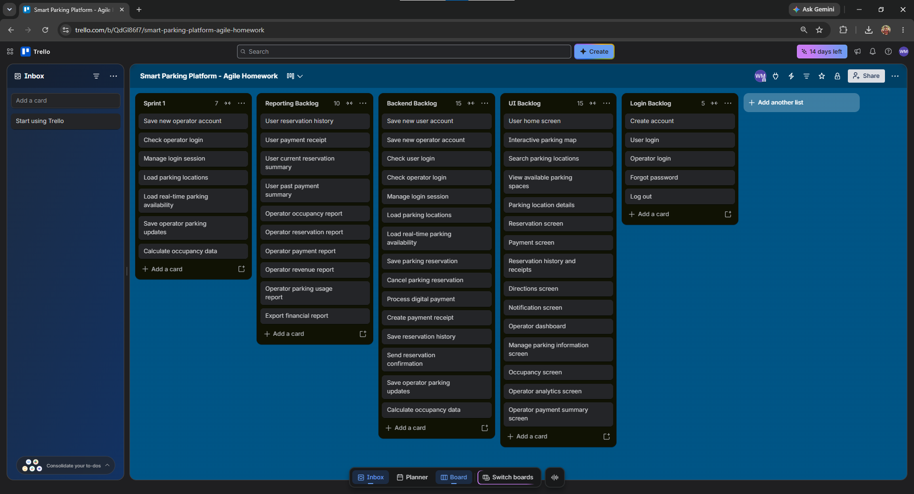

7.0 Risk Management

7.1 Technical Risks
- Parking availability data may not update correctly.
- The payment system may fail during a reservation.
- The map or GPS feature may give incorrect directions.
- The mobile app and operator system may have integration problems.

7.2 Schedule Risks
- Development tasks may take a lot longer than expected.
- Delays in one feature may affect other parts of the project.
- Testing and bug fixes may take way more time than planned.
- Team members may miss deadlines, causing the schedule to fall behind.

7.3 Financial Risks
- Development costs may be higher than expected.
- Payment processing fees may increase project expenses.
- Software, hosting, or map service costs may go over budget.
- The project may lose funding if costs become a bit too high.

7.4 People Risks
- A team member may leave the project before it is finished.
- Team members may have conflicts that slow down overall progress.
- Some team members may not have enough experience with certain tools.
- Poor communication may cause mistakes or duplicated work.

7.5 Risk Register
ID | Description | Probability | Impact | Owner | Response Strategy | Status/Notes
R1 | Parking availability data may not update correctly. | Moderate | High | Development Team | Mitigate | Open - monitor data accuracy
R2 | The payment system may fail during a reservation. | Moderate | High | Backend Team | Mitigate | Open - test payment processing
R3 | The map or GPS feature may give incorrect directions. | Low | Moderate | Development Team | Mitigate | Open - test map accuracy
R4 | The mobile app and operator system may have integration problems. | Moderate | High | Development Team | Mitigate | Open - test system integration
R5 | Development tasks may take longer than expected. | Moderate | Moderate | Project Manager | Mitigate | Open - monitor schedule
R6 | Testing and bug fixes may take more time than planned. | Moderate | Moderate | Testing Team | Accept | Open - allow extra testing time
R7 | Development costs may be higher than expected. | Moderate | High | Project Manager | Mitigate | Open - monitor project costs
R8 | Software, hosting, or map service costs may go over budget. | Low | Moderate | Project Manager | Accept | Open - review service costs
R9 | A team member may leave the project before it is finished. | Low | High | Project Manager | Mitigate | Open - keep project work documented
R10 | Poor communication may cause mistakes or duplicated work. | Moderate | Moderate | Project Manager | Mitigate | Open - hold regular team meetings

7.6 Communication Plan
Team/Audience | Meeting Cadence | Communication Method | Reporting Method
Development Team | Daily stand-up | Microsoft Teams | Task and progress updates
Testing Team | Weekly meeting | Microsoft Teams | Testing results and bug reports
Project Team | Weekly progress meeting | Microsoft Teams | Project progress report
Stakeholders | Monthly meeting | Teams or Email | High-level status report and the dashboard

