SQLServer Lab

Note: Use ITI DB

1. Create a view that displays student full name, course name if the student has a grade more than 50.
2. Create an Encrypted view that displays manager names and the topics they teach.
3. Create a view that will display Instructor Name, Department Name for the ‘SD’ or ‘Java’ Department
4. Create a view “V1” that displays student data for student who lives in Alex or Cairo.

Note: Prevent the users to run the following query

Update V1 set st_address=’tanta’

Where st_address=’alex’;

1. Create a view that will display the project name and the number of employees work on it. “Use Company DB”
2. Create index on column (Hiredate) that allow u to cluster the data in table Department. What will happen?
3. Create index that allow u to enter unique ages in student table. What will happen?
4. Using Merge statement between the following two tables [User ID, Transaction Amount]

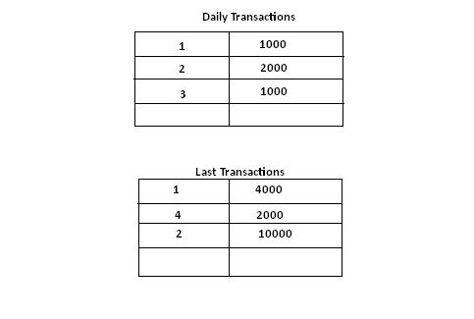

1. Try to Create Login Named(ITIStud) who can access Only student and Course tablesfrom ITI DB then allow him to select and insert data into tables and deny Delete and update