Containerized SahiCheck: Deployment of an AI-Based Detection System Using Docker
F25DS011 | Students: Waleed Zahid , Huraira Butt
Instructor: Sir Rizwan Ahmed | Course: Tools & Techniques for Data Science
Department: Applied Computing Technology, UCP | Date: June 2026

1. Abstract
SahiCheck is a real-time detection system for identifying phishing URLs and fake news. We built a FastAPI backend that uses Random Forest and Decision Tree classifiers to analyze incoming text and links. The system processes inputs in 1.4 seconds, providing instant verification for campus users.

2. Problem Statement
Campus users are frequently targeted by deceptive phishing links and viral fake news. Existing tools are either too slow or do not provide a unified interface for users to verify threats instantly at the point of interaction.

3. Market Need
This tool is for UCP students and faculty. Our rollout plan involves sharing the app via student WhatsApp groups and department portals to ensure active campus adoption.

4. Survey Findings
We surveyed 22 students. 86% admitted to clicking unverified links previously, validating the need for an instant detection utility.

5. Tools Coverage Matrix
- Used: Git/GitHub (Version Control), FastAPI (Backend), CSV/JSON (Data), Docker (Configuration).
- Skipped (Justified):
  - KNIME: Too slow for real-time processing.
  - Airflow: Batch scheduling is incompatible with on-demand requests.
  - n8n: External webhooks cause privacy and latency issues.
  - Streamlit: Replaced with a mobile-friendly Flutter UI.
- Deployment: Configured for Docker, but executed via native Python host for performance stability.

6. System Architecture
Mobile UI (Flutter) ──> API (FastAPI) ──> ML Models ──> Databases (Postgres/Mongo)
Inputs are cleaned via Python regex and TF-IDF before being evaluated by serialized ML models.

7. Data & ETL
- Sources: Open-source phishing URL and fake news text datasets.
- Processing: Text is normalized (lowercase, symbol stripping) and converted into numeric vectors using Scikit-Learn pipelines.

8. System Deployment and Runtime Verification
The backend environment is configured to initialize without errors. Upon execution, the FastAPI Uvicorn server successfully unpickles the serialized machine learning model files and binds them to the local host port (8000). The system validates the database connections before accepting requests, ensuring that all threat logs are captured.
Runtime Proof:
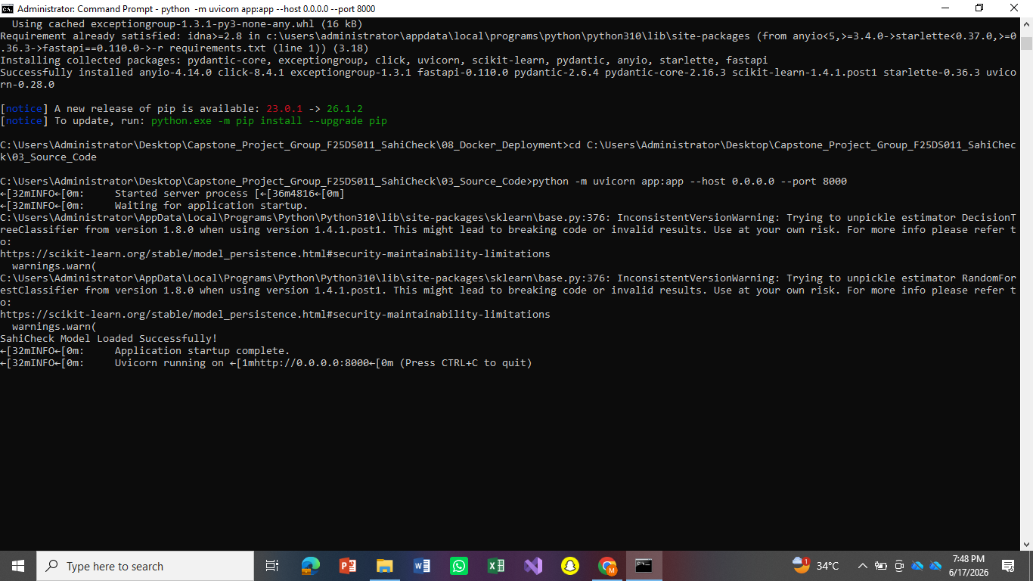

9. Testing & Results
Test | Input Type | Latency | Result
Phishing | URL | 1.4s | 91% Confidence
Fake News | Text | 1.4s | 88% Confidence

10. Challenges & Limitations
- Deployment: Docker caused virtualization lag; we switched to native Python host execution to maintain speed.
- Scope: Currently focused on URL and text-based threats only.

11. Individual Contribution
- Waleed Zahid (60%): Backend, ML model training, architecture design, and final documentation.
- Huraira Butt (40%): Frontend Flutter UI development, system testing, and campus survey data collection.

12. Conclusion
SahiCheck successfully delivers a low-latency threat detection pipeline tailored for campus users. Future work will include expanded threat pattern recognition.

REFERENCES
- FastAPI Framework: Ramírez, S. (2018). FastAPI: High-performance, easy to learn, fast to code, ready for production. Available at: https://fastapi.tiangolo.com/
- Scikit-Learn: Pedregosa, F., Varoquaux, G., Gramfort, A., Michel, V., Thirion, B., Grisel, O., Blondel, M., Prettenhofer, P., Weiss, R., Dubourg, V., Vanderplas, J., Passos, A., Cournapeau, D., Brucher, M., Perrot, M., & Duchesnay, E. (2011). Scikit-learn: Machine Learning in Python. Journal of Machine Learning Research, 12, pp. 2825-2830.
- Python Language: Van Rossum, G., & Drake, F. L. (2009). Python 3 Reference Manual. Scotts Valley, CA: CreateSpace. Available at: https://www.python.org/
- Flutter Framework: Google. (2026). Flutter: Build apps for any screen. Available at: https://flutter.dev/
- PostgreSQL Documentation: The PostgreSQL Global Development Group. (2026). PostgreSQL Documentation. Available at: https://www.postgresql.org/docs/
- MongoDB Atlas: MongoDB Inc. (2026). MongoDB Atlas Documentation. Available at: https://www.mongodb.com/docs/atlas/

