**Notes**

**Beautiful Soup:**

Beautiful Soup is a Python library that makes it easy to scrape information from web pages. It sits atop an HTML or XML parser and provides Pythonic idioms for iterating, searching, and modifying the parse tree.

**Environment Settings for Web Scraping:**

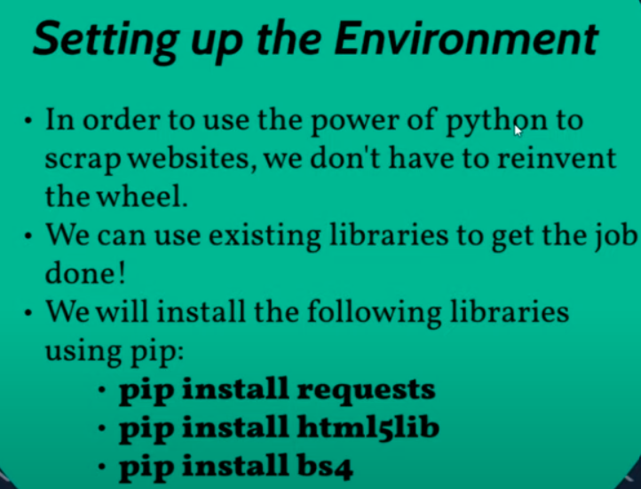

**Parser:**

A Python Parser is a program that takes input data (usually source code) and converts it into a structured format. The purpose of parsing in Python is to transform code into a machine-readable format, allowing for further processing and analysis.