# Index.html:

# Hikes.html:

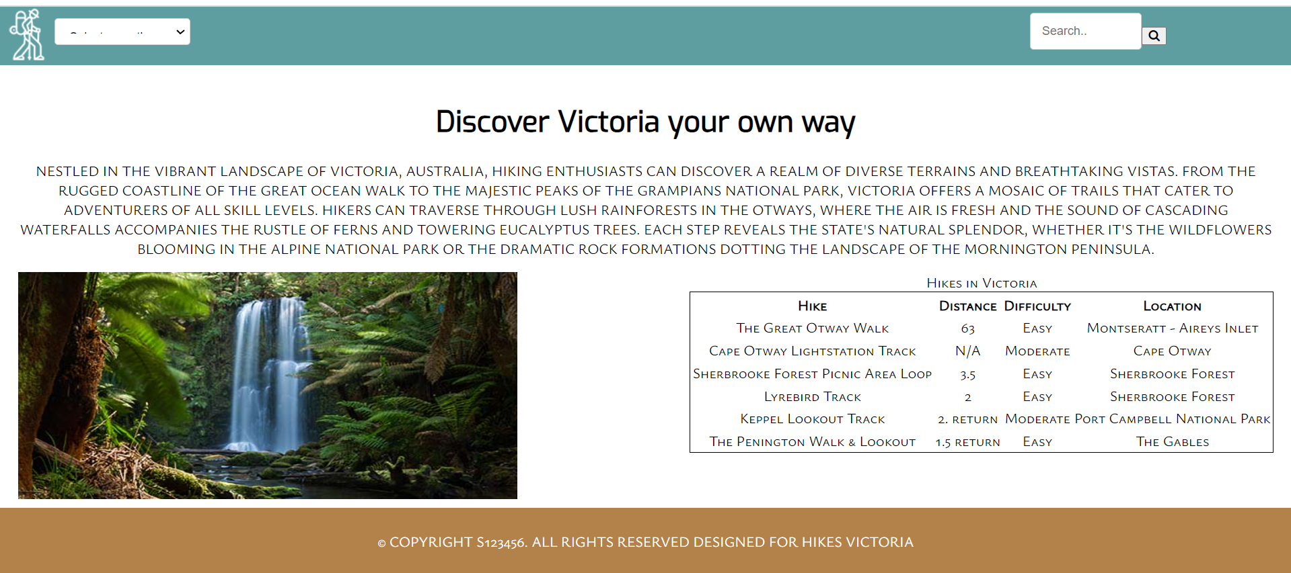

# Gallery.html:

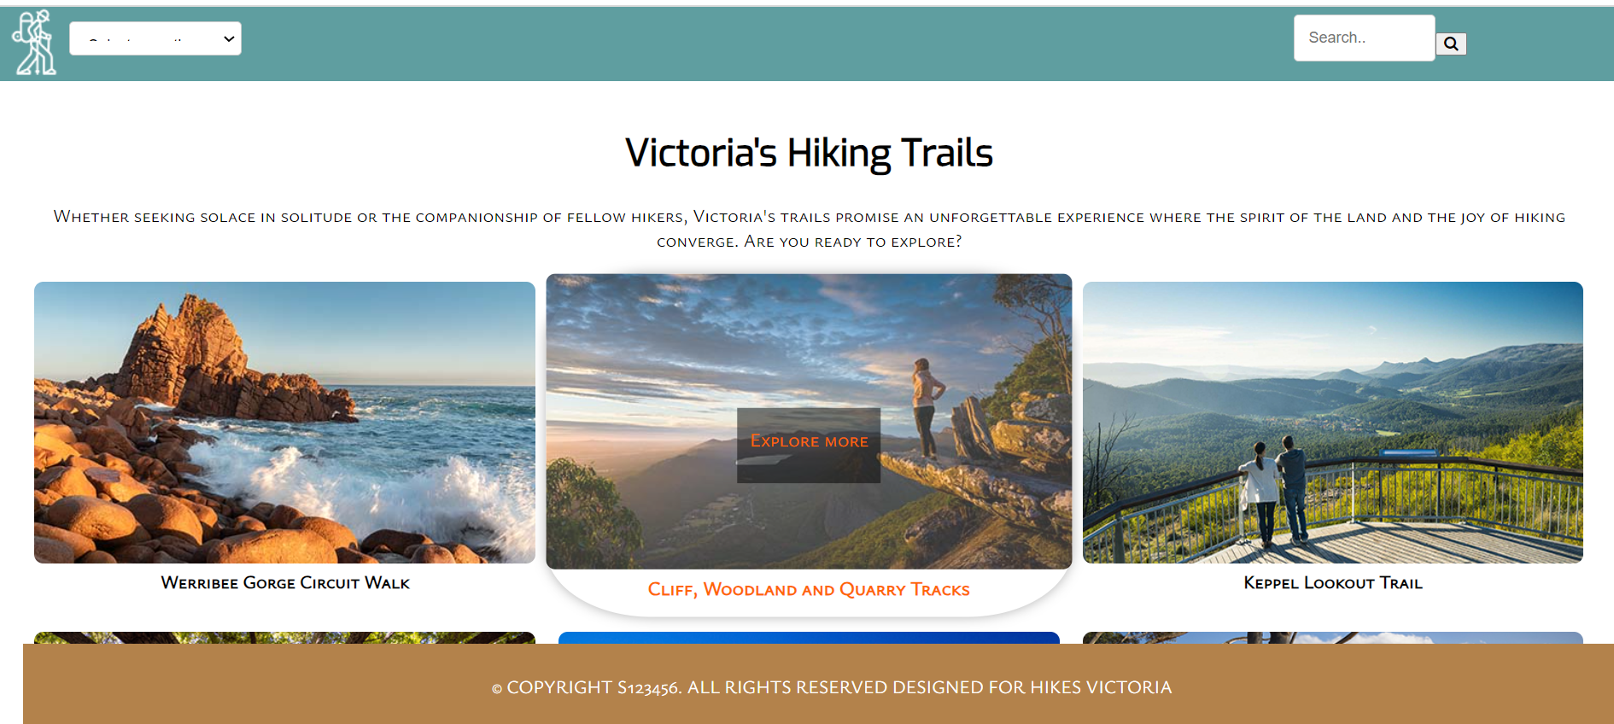

# Add.html:

