1. Chapter # 2: Analysis
2. 2.1 Existing systems
3. Existing graphics systems are extremely complicated and require a lot of coding knowledge to get going. Even though graphics application of the day are way too advanced and are very usable in their domains but one area in which they do not particularly shine is teaching new comers the basic of image processing by actually doing that. Applications like GIMP or other open source tools use extremely complicated algorithms and programming techniques that are next to impossible to grab for the new comers. Because of this reason many people do not pursue the field of image processing until later in their lives.
4. 2.2 Current system
5. The current application is a very simple application which can be edited by a high school student eager to learn about image processing. It is written to be easy to be understood by the programmers who have no previous programming experience at all. This serves less as a graphics application and more as a teaching tool to the students. Many extraordinary applications exist to do image processing that far outweigh the features in this tool but the entire purpose of this tool is to educate the young developers and push them to add new features as they so desire. Much of the exotic coding practices have intentionally been avoided as they add extra confusion and learning curve. It has been noted that such diversions eventually cause new comers to get bored and leave a project all togather.The User interface is minimalist and the developer chose this simple UI as a compromise to make the code as simple as possible.
6. 2.3 Objectives
7. The objectives of writing this application include
8. To make a tool to introduce image processing to new programmers
9. To make an extensible and modular software
10. To make a plug and play architecture
11. The tool is not meant to be used for real image processing
12. This tool motivates younger developer to the world or programming
13. 2.4 Project specifications
14. The project has been written in .net framework 4.5 and thud requires version 4.5 to be installed on the target machine. Other project specifications include
15. A Gui application written in C# 4.5
16. A windows based application
17. Development based training application
18. Meant for entry level introduction to image processing
19. Extensible and easy to understand
20. A training tool and not a production application
21. No install required
22. Open source under MIT License
23. A self guided study to the world of image processing
24. Further resources are provided as external links to the web
25. Concepts easily transferable to other languages/platforms
26. Easy to understand coding style
27. 2.5 MIT License
28. The MIT License (MIT)
29. Copyright (c) 2013 waleed khan
30. Permission is hereby granted, free of charge, to any person obtaining a copy   
    of this software and associated documentation files (the "Software"), to deal  
    in the Software without restriction, including without limitation the rights  
    to use, copy, modify, merge, publish, distribute, sublicense, and/or sell  
    copies of the Software, and to permit persons to whom the Software is  
    furnished to do so, subject to the following conditions:
31. The above copyright notice and this permission notice shall be included in  
    all copies or substantial portions of the Software.
32. THE SOFTWARE IS PROVIDED "AS IS", WITHOUT WARRANTY OF ANY KIND, EXPRESS OR  
    IMPLIED, INCLUDING BUT NOT LIMITED TO THE WARRANTIES OF MERCHANTABILITY,  
    FITNESS FOR A PARTICULAR PURPOSE AND NONINFRINGEMENT. IN NO EVENT SHALL THE  
    AUTHORS OR COPYRIGHT HOLDERS BE LIABLE FOR ANY CLAIM, DAMAGES OR OTHER  
    LIABILITY, WHETHER IN AN ACTION OF CONTRACT, TORT OR OTHERWISE, ARISING FROM,  
    OUT OF OR IN CONNECTION WITH THE SOFTWARE OR THE USE OR OTHER DEALINGS IN  
    THE SOFTWARE.
33. 2.6 Project specifications
34. The project includes the following specifications
35. Written in C# winforms 4.5
36. Visual studio 2012 professional IDE
37. Written on windows 7 professional
38. Tested on windows 7 and windows 8
39. 64 bit application but can easily be compiled as a 32 bit application
40. Menu driven interface
41. Very different from graphics processing application as it serves as different purpose
42. Uses very basic programming features
43. Exotic libraries and techniques have been avoided on purpose
44. Unit testing done using nuget package manager
45. Links to external resources are also provided for furthering the learning
46. 2.7 Proposed plan for implementation
47. The project started out as a simple C# winforms applications meant for line drawing and then later on other common features were added to application. The application will be deployed as no install required application which as easy as just copy and paste ability(Its called zero impact installation and removal).
48. 2.8 outcomes
49. The outcome of this project will be a simple and small application that is provided free of charge to anybody who wishes to learn image processing from the very beginning. The application requires 2.9MB of harddisk space and can be run on a modest machine by some one with no knowledge of software and particularly programming. The tool serves as a second step in advancing the programming capabilities of the person using the tool.
50. 2.9 Requirement analysis
51. The basic requirements for the application include
52. A windows based computer with atleast windows vista or later
53. Program has to be recompiled for 32 bit OS
54. .net framework 4.5
55. A good text editor or an IDE i-e Microsoft visual studio express
56. If testiing is a requisite a version of Visual studio higher than express is required
57. Atleast 512MB of RAM
58. 2.9MB of free harddisk space
59. .net framework must already be insalled and working
60. 2.10 Project Scheduling
61. The project worked on agile practices and was completed in a time period of month. New features were tested the time they were added to the main project as modules. All the phases of software production were carried out in a sequence small steps at a time, one feature was written completely and tested before moving to the second feature.
62. 2.11 Project dependencies
63. The project dependencies are as follows
64. Windows 7 professional operating system
65. .net framework version 4.5
66. Microsoft visual studio 2012 professional
67. nuget package manager
68. Libre office writer
69. 2.12 Scope
70. The project is meant to be a self paced training application which is very different from various other computer based training(CBT) modules present in the market. It is meant to be a very simple application which enforces development by actually doing it. This software has been written with the vision that programming can not be learnt untill one actually does it. The application can be extended to include other features related or not related to image processing but in small steps at a time. The project was supposed to be completed in very small time so the features are very few but new ones can be added without any complicated coding expertise.

2.13 Inputs/Outputs

The application is completely GUI based and there are no textual inputs and outputs. In this section screenshots of various features and their results will be shown.

1. File → quit

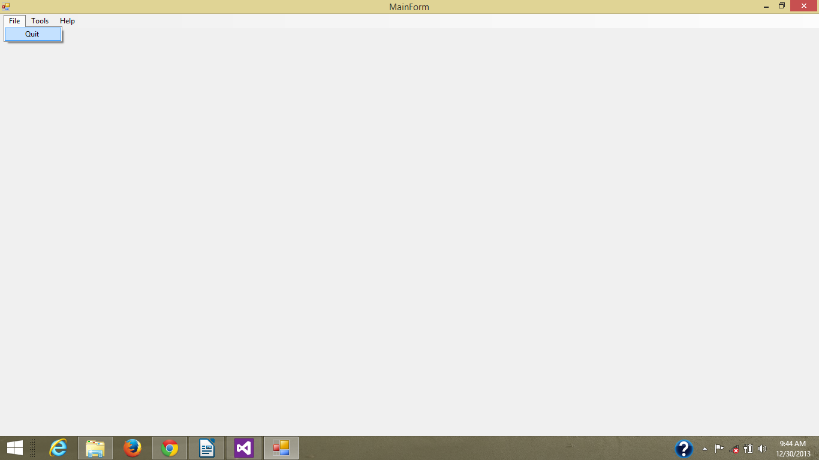

The application will exit if quit button is clicked

2. Tools → Compare

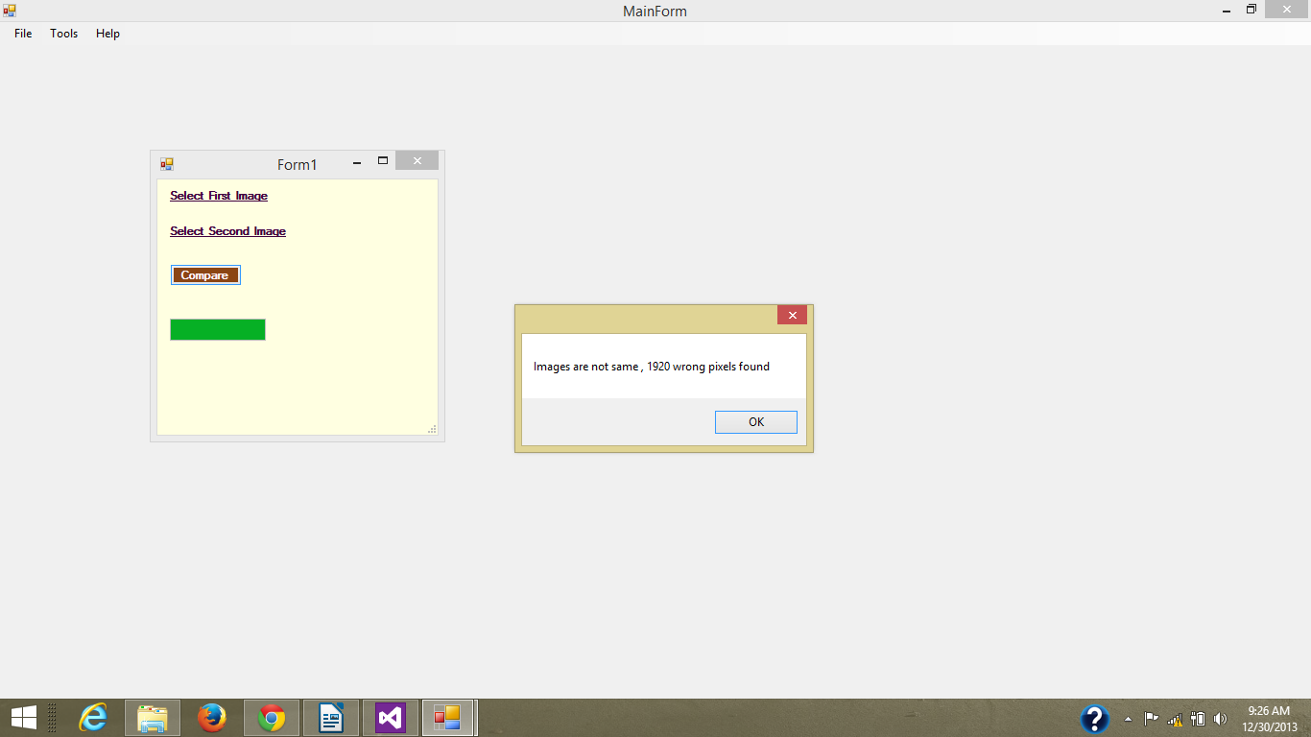

Compare command compares two images and shows the number of different pixels

3. Tools → Crop

Uncropped Image

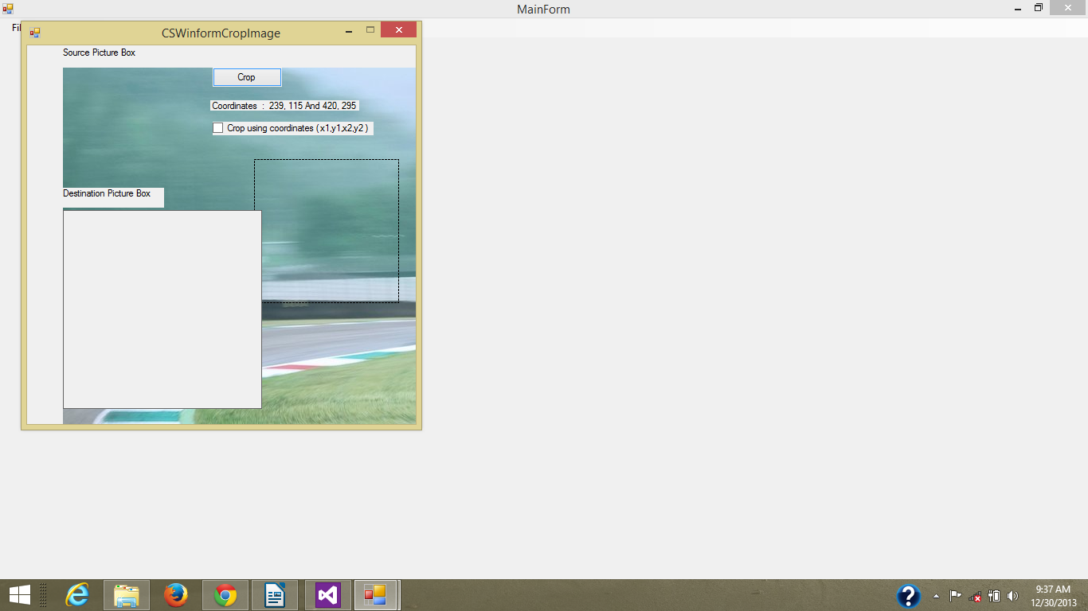

Cropped image shown in the picture box labelled destination picture box

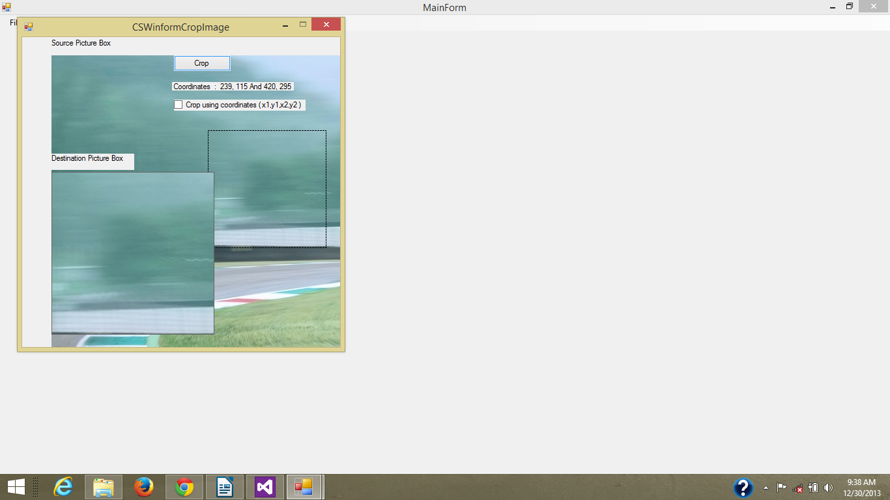

5. Tools → Freehand

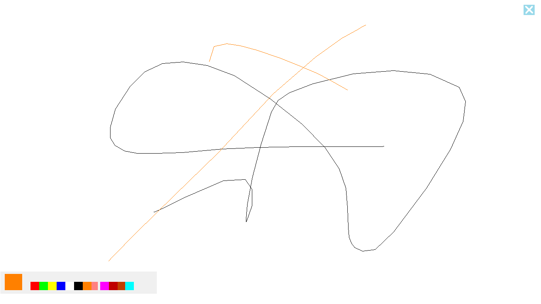

2.12 Harware requirements

The hardware requirements for the application are

* A computer with a color monitor and atleast 1GB RAM
* 2.9MB of free harddisk space
* A mouse or other pointing device
* A keyboard(optional)

2.12.1 Software requirements

* Windows vista or later 64 bit
* Microsoft visual studio express or other IDE(optional)
* Microsft .net framework 4.5
* nuget package manager

2.14 Feasibility study

2.14.1 Financial study

The application can be prepared in the minimalist resources and almost no financial requirements are needed, the application fits the budget of every one who has a computer but if the cost of software/hardware used in the project is taken in to account, it will be as follows

2.14.2 Technical feasibility

The software is technically not very complicated to write as it has minimalist feature even though it will take some coding profiecieny before all of the code base can be understood. The project is technically feasible as it can be written by one programmer using commonly available tools from micorosoft, but the knowledge of microst C#, .net framework, microsoft visual studio and image processing are a requisite.

2.14.3 Economic feasibility

The program can be easily run by a high school student or even elemtary school student on their computer and it requires no further costs to be operated. The time period the user is using the software as its intented purpose he/she will be learning how to write graphical applications with hands on training. If the user makes it through every module he/she will be technically able to say that he/she has knowledge of the C# language and image processing.

2.14.4 Social feasibility

The software tries to create a change in the social behaviour which is that programming is the art of super genius and great programmers are only born. This application tends to change that perception by providing a free software that is easy to modify and thus motivates ordinary people to learn programming. It is socially feasible as it does not try to interfere with minds of the people but it acts as a motivator to the society.

2.14.5 Operational feasibility

The software is very simple to use and has a very low learning curve for any one with access to a computer and eagerness to learn. It can be run by people of any age group just by double clicking the program, the source code is easy to understand but requires the effort from the user to learn the basics of C# and image processing. The greatest way to getting started with a technology is by using it. That is the entire purpose of making this application minimalist.