Chapter # 1: Introduction
1.1 The project is a simple image manipulation program written in C# using the visual studio 2012 professional IDE. The software has an easy to use and extensible interface unlike the popular graphics applications. The application contains all the navigation and tools in the menu bar at the top of the window. The technology used for the implementation was C# windows forms which is a tried and tested technology for developing GUI(graphical user interface) applications for windows platform. The version of .net framework used is 4.5 and the application has been tested on windows 7 and windows 8 but it will run on versions as old as windows vista.
1.2 Relevance to the course

The project does not relate directly to a course taught in the duration of the BS(CS) course but visual studio has been used as a tool of choice in developing applications for VB.NET and ASP.NET using C#.

1.3 Modules
The application contains various modules in the form of options in the menu bar. Every option is an independent piece of code that does not need the help of other modules. New features can be added to the project on the fly because of this plug and play capability and it also makes testing a bliss. Right now there are less than ten modules in the application but many more will be added in the future.
1.4 Methodology
The development methodology used in the project was incremental, new features were added as required and as new requirements became apparent. The tool began as a very simple single function application and later on other features were added and will continue to be added as time goes on. The tool is one day supposed to become a fully fledged graphics application which is easy to understand and extend. The developer believes in the power of the community to mature an application.

Chapter # 2: Analysis
2.1 Existing systems
Existing graphics systems are extremely complicated and require a lot of coding knowledge to get going. Even though graphics application of the day are way too advanced and are very usable in their domains but one area in which they do not particularly shine is teaching new comers the basic of image processing by actually doing that. Applications like GIMP or other open source tools use extremely complicated algorithms and programming techniques that are next to impossible to grab for the new comers. Because of this reason many people do not pursue the field of image processing until later in their lives.
2.2 Current system
The current application is a very simple application which can be edited by a high school student eager to learn about image processing. It is written to be easy to be understood by the programmers who have no previous programming experience at all. This serves less as a graphics application and more as a teaching tool to the students. Many extraordinary applications exist to do image processing that far outweigh the features in this tool but the entire purpose of this tool is to educate the young developers and push them to add new features as they so desire. Much of the exotic coding practices have intentionally been avoided as they add extra confusion and learning curve. It has been noted that such diversions eventually cause new comers to get bored and leave a project all togather.The User interface is minimalist and the developer chose this simple UI as a compromise to make the code as simple as possible.

2.3 Objectives
The objectives of writing this application include
To make a tool to introduce image processing to new programmers
To make an extensible and modular software
To make a plug and play architecture
The tool is not meant to be used for real image processing
This tool motivates younger developer to the world or programming
2.4 Project specifications
The project has been written in .net framework 4.5 and thud requires version 4.5 to be installed on the target machine. Other project specifications include
A GUI application written in C# 4.5
A windows based application
Development based training application
Meant for entry level introduction to image processing
Extensible and easy to understand
A training tool and not a production application
No install required
Open source under MIT License

A self guided study to the world of image processing
Further resources are provided as external links to the web
Concepts easily transferable to other languages/platforms
Easy to understand coding style

2.5 MIT License
The MIT License (MIT)
Copyright (c) 2013 waleed khan
Permission is hereby granted, free of charge, to any person obtaining a copy
of this software and associated documentation files (the "Software"), to deal
in the Software without restriction, including without limitation the rights
to use, copy, modify, merge, publish, distribute, sublicense, and/or sell
copies of the Software, and to permit persons to whom the Software is
furnished to do so, subject to the following conditions:
The above copyright notice and this permission notice shall be included in
all copies or substantial portions of the Software.
THE SOFTWARE IS PROVIDED "AS IS", WITHOUT WARRANTY OF ANY KIND, EXPRESS OR
IMPLIED, INCLUDING BUT NOT LIMITED TO THE WARRANTIES OF MERCHANTABILITY,
FITNESS FOR A PARTICULAR PURPOSE AND NONINFRINGEMENT. IN NO EVENT SHALL THE
AUTHORS OR COPYRIGHT HOLDERS BE LIABLE FOR ANY CLAIM, DAMAGES OR OTHER
LIABILITY, WHETHER IN AN ACTION OF CONTRACT, TORT OR OTHERWISE, ARISING FROM,
OUT OF OR IN CONNECTION WITH THE SOFTWARE OR THE USE OR OTHER DEALINGS IN
THE SOFTWARE.

2.6 Project specifications
The project includes the following specifications
Written in C# winforms 4.5
Visual studio 2012 professional IDE
Written on windows 7 professional
Tested on windows 7 and windows 8
64 bit application but can easily be compiled as a 32 bit application
Menu driven interface
Very different from graphics processing application as it serves as different purpose
Uses very basic programming features
Exotic libraries and techniques have been avoided on purpose
Unit testing done using nuget package manager
Links to external resources are also provided for furthering the learning
2.7 Proposed plan for implementation
The project started out as a simple C# winforms applications meant for line drawing and then later on other common features were added to application. The application will be deployed as no install required application which as easy as just copy and paste ability(Its called zero impact installation and removal).

2.8 outcomes
The outcome of this project will be a simple and small application that is provided free of charge to anybody who wishes to learn image processing from the very beginning. The application requires 2.9MB of harddisk space and can be run on a modest machine by some one with no knowledge of software and particularly programming. The tool serves as a second step in advancing the programming capabilities of the person using the tool.

2.9 Requirement analysis

The basic requirements for the application include
A windows based computer with atleast windows vista or later
Program has to be recompiled for 32 bit OS
.net framework 4.5
A good text editor or an IDE i-e Microsoft visual studio express
If testing is a requisite a version of Visual studio higher than express is required
At least 2GB of RAM
2.9MB of free harddisk space
.net framework must already be installed and working

2.10 Project Scheduling
The project worked on agile practices and was completed in a time period of month. New features were tested the time they were added to the main project as modules. All the phases of software production were carried out in a sequence small steps at a time, one feature was written completely and tested before moving to the second feature.

2.11 Project dependencies
The project dependencies are as follows
Windows 7 professional operating system
.net framework version 4.5
Microsoft visual studio 2012 professional
nuget package manager
Libre office writer

2.12 Scope
The project is meant to be a self paced training application which is very different from various other computer based training(CBT) modules present in the market. It is meant to be a very simple application which enforces development by actually doing it. This software has been written with the vision that programming can not be learnt untill one actually does it. The application can be extended to include other features related or not related to image processing but in small steps at a time. The project was supposed to be completed in very small time so the features are very few but new ones can be added without any complicated coding expertise.
2.13 Inputs/Outputs
The application is completely GUI based and there are no textual inputs and outputs. In this section screenshots of various features and their results will be shown.

- File → quit
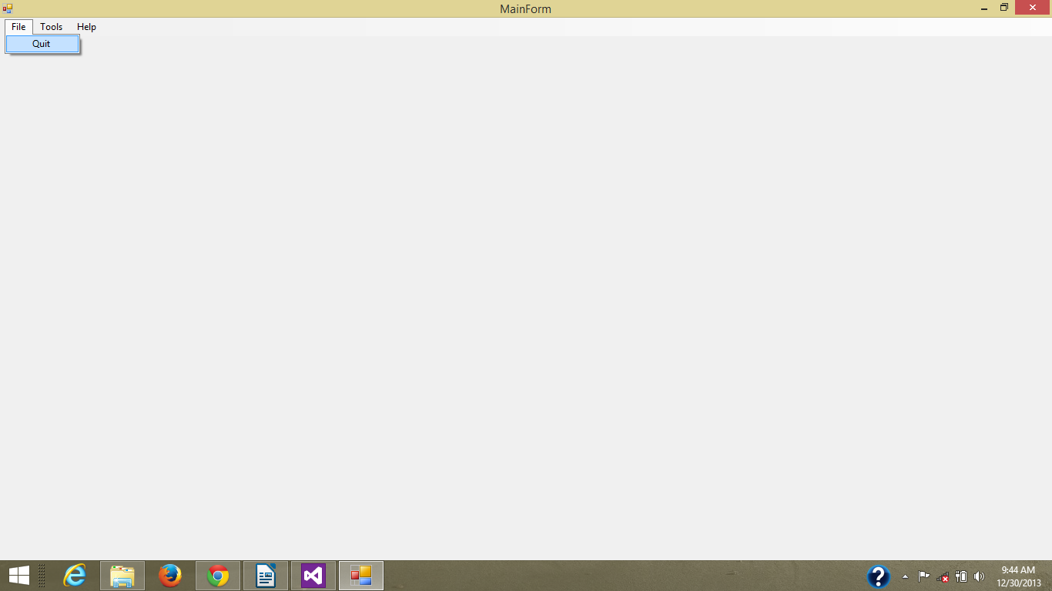
Figure c1
The application will exit if quit button is clicked

2. Tools → Compare
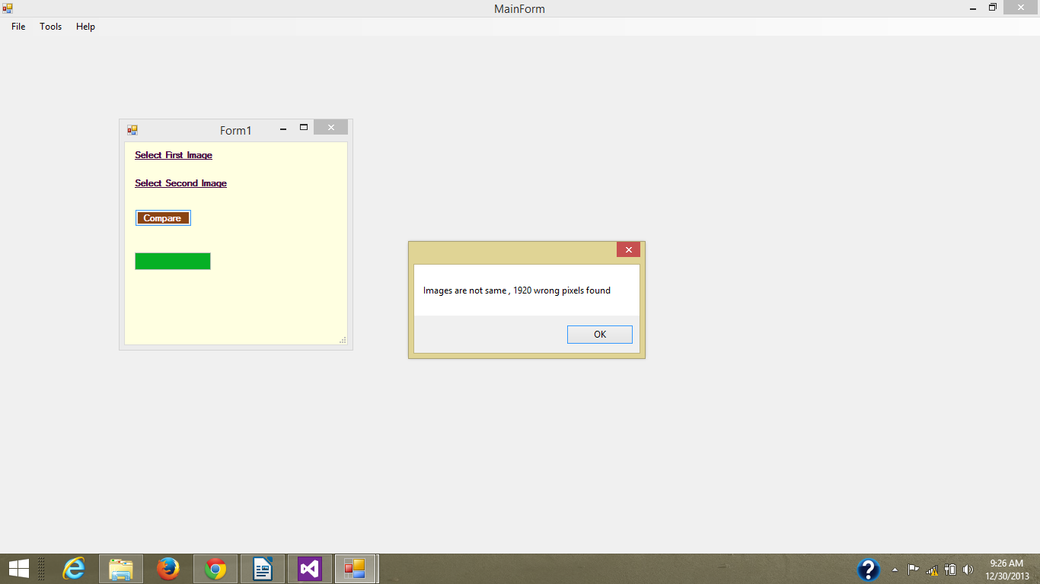
Figure c2
Compare command compares two images and shows the number of different pixels

3. Tools → Crop
Uncropped Image

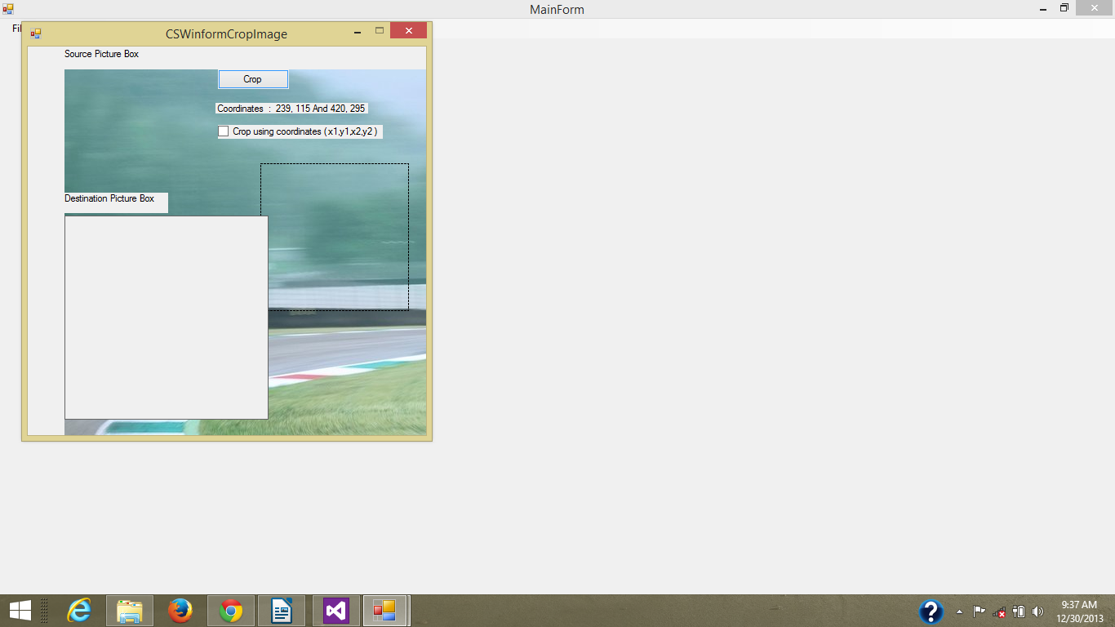
Figure c3

Cropped image shown in the picture box labeled destination picture box

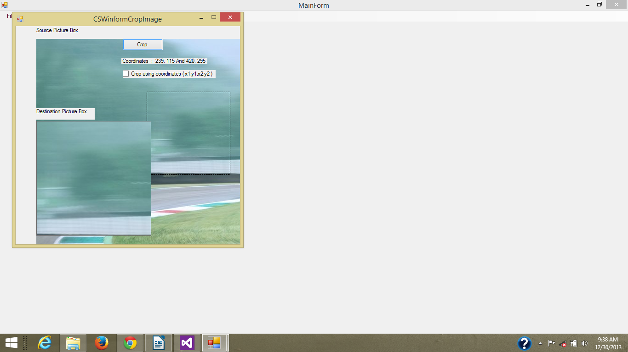
Figure c4

5. Tools → Freehand

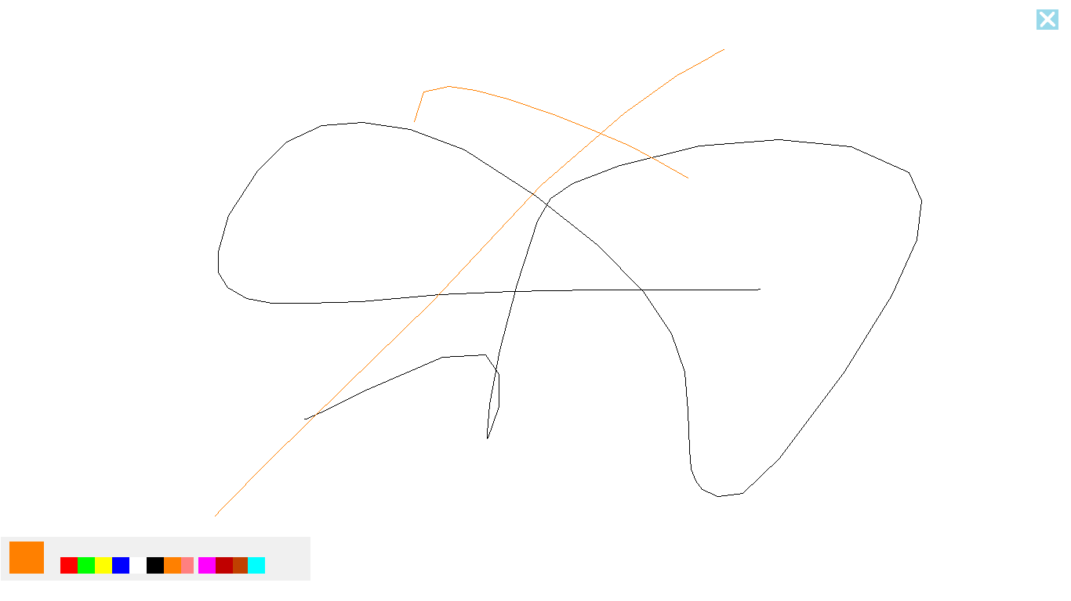
Figure c5

6. Tools → Grayscale → rotate
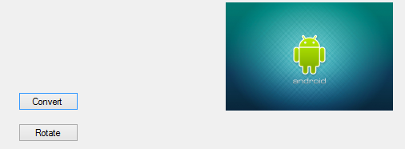

Figure c6
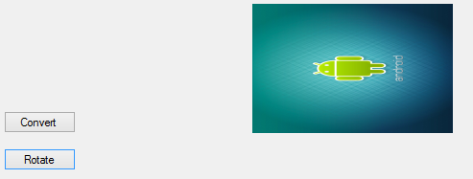

Figure c7

2.12 Harware requirements
The hardware requirements for the application are
- A computer with a color monitor and atleast 1GB RAM
- 2.9MB of free harddisk space
- A mouse or other pointing device
- A keyboard(optional)

2.12.1 Software requirements
- Windows vista or later 64 bit
- Microsoft visual studio express or other IDE(optional)
- Microsft .net framework 4.5
- nuget package manager

2.14 Feasibility study
2.14.1 Financial study
The application can be prepared in the minimalist resources and almost no financial requirements are needed, the application fits the budget of every one who has a computer but if the cost of software/hardware used in the project is taken in to account, it will be as follows

2.14.2 Technical feasibility
The software is technically not very complicated to write as it has minimalist feature even though it will take some coding profiecieny before all of the code base can be understood. The project is technically feasible as it can be written by one programmer using commonly available tools from micorosoft, but the knowledge of microst C#, .net framework, microsoft visual studio and image processing are a requisite.

2.14.3 Economic feasibility
The program can be easily run by a high school student or even elemtary school student on their computer and it requires no further costs to be operated. The time period the user is using the software as its intented purpose he/she will be learning how to write graphical applications with hands on training. If the user makes it through every module he/she will be technically able to say that he/she has knowledge of the C# language and image processing.

2.14.4 Social feasibility
The software tries to create a change in the social behaviour which is that programming is the art of super genius and great programmers are only born. This application tends to change that perception by providing a free software that is easy to modify and thus motivates ordinary people to learn programming. It is socially feasible as it does not try to interfere with minds of the people but it acts as a motivator to the society.
2.14.5 Operational feasibility
The software is very simple to use and has a very low learning curve for any one with access to a computer and eagerness to learn. It can be run by people of any age group just by double clicking the program, the source code is easy to understand but requires the effort from the user to learn the basics of C# and image processing. The greatest way to getting started with a technology is by using it. That is the entire purpose of making this application minimalist.

Chapter # 3: Design

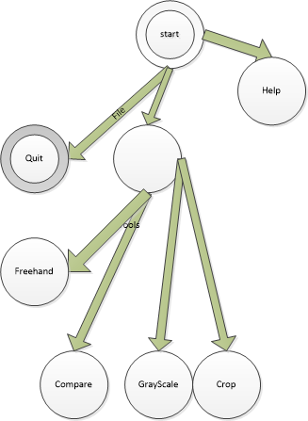

figure D1 state transition diagram

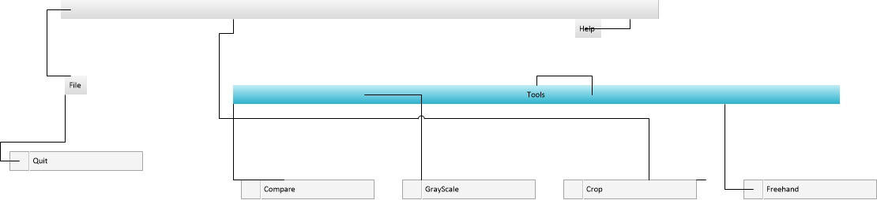

Figure D2 Wireframe diagram

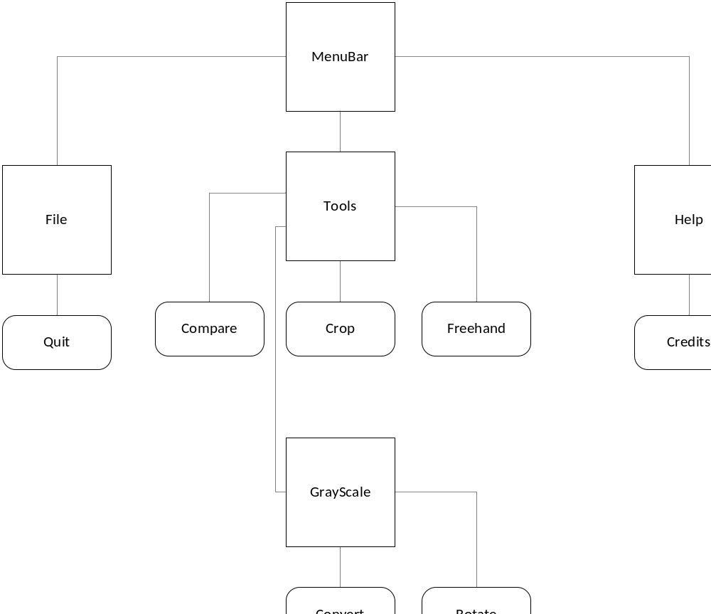

Figure D 3 program structure diagram

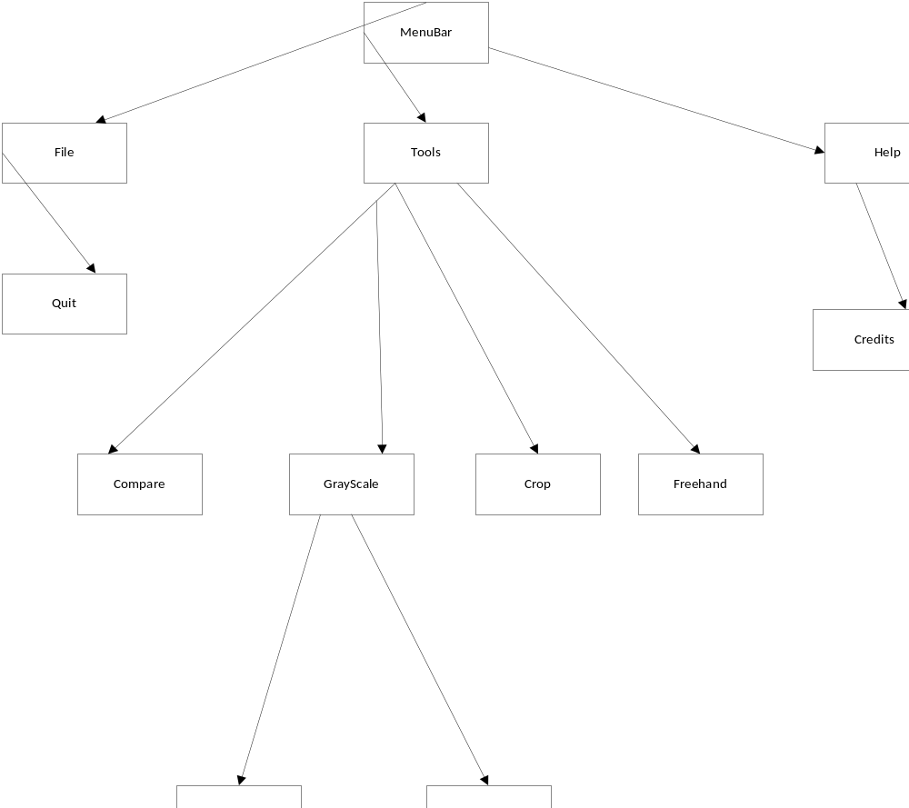

Figure D4 hierarchy diagram

Chapter # 4 Modules
4.1 Modules
The application consists of the following modules
- File
- Quit
- Tools
- Compare
- Grayscale
- Crop
- Freehand
- Convert
- Rotate

4.2 Technologies used
The following technologies were used in the production of the application
- .net framework
- C# windows forms
4.2.1 About .net framework
The .NET Framework is a technology that supports building and running the next generation of applications and XML Web services. The .NET Framework is designed to fulfill the following objectives:
To provide a consistent object-oriented programming environment whether object code is stored and executed locally, executed locally but Internet-distributed, or executed remotely.
To provide a code-execution environment that minimizes software deployment and versioning conflicts.
To provide a code-execution environment that promotes safe execution of code, including
- code created by an unknown or semi-trusted third party.
- To provide a code-execution environment that eliminates the performance problems of scripted or interpreted environments.
- To make the developer experience consistent across widely varying types of applications, such as Windows-based applications and Web-based applications.
- To build all communication on industry standards to ensure that code based on the .NET Framework can integrate with any other code.

- The .NET Framework consists of the common language runtime and the .NET Framework class library. The common language runtime is the foundation of the .NET Framework. You can think of the runtime as an agent that manages code at execution time, providing core services such as memory management, thread management, and remoting, while also enforcing strict type safety and other forms of code accuracy that promote security and robustness. In fact, the concept of code management is a fundamental principle of the runtime. Code that targets the runtime is known as managed code, while code that does not target the runtime is known as unmanaged code. The class library is a comprehensive, object-oriented collection of reusable types that you can use to develop applications ranging from traditional command-line or graphical user interface (GUI) applications to applications based on the latest innovations provided by ASP.NET, such as Web Forms and XML Web services.
- The .NET Framework can be hosted by unmanaged components that load the common language runtime into their processes and initiate the execution of managed code, thereby creating a software environment that can exploit both managed and unmanaged features. The .NET Framework not only provides several runtime hosts, but also supports the development of third-party runtime hosts.
- For example, ASP.NET hosts the runtime to provide a scalable, server-side environment for managed code. ASP.NET works directly with the runtime to enable ASP.NET applications and XML Web services, both of which are discussed later in this topic.
- Internet Explorer is an example of an unmanaged application that hosts the runtime (in the form of a MIME type extension). Using Internet Explorer to host the runtime enables you to embed managed components or Windows Forms controls in HTML documents. Hosting the runtime in this way makes managed mobile code possible, but with significant improvements that only managed code can offer, such as semi-trusted execution and isolated file storage.
- The following illustration shows the relationship of the common language runtime and the class library to your applications and to the overall system. The illustration also shows how managed code operates within a larger architecture.

4.2.2 .NET Framework in context

The following sections describe the main features of the .NET Framework in greater detail.

Features of common language runtime
The common language runtime manages memory, thread execution, code execution, code safety verification, compilation, and other system services. These features are intrinsic to the managed code that runs on the common language runtime.
With regards to security, managed components are awarded varying degrees of trust, depending on a number of factors that include their origin (such as the Internet, enterprise network, or local computer). This means that a managed component might or might not be able to perform file-access operations, registry-access operations, or other sensitive functions, even if it is being used in the same active application.

The runtime enforces code access security. For example, users can trust that an executable embedded in a Web page can play an animation on screen or sing a song, but cannot access their personal data, file system, or network. The security features of the runtime thus enable legitimate Internet-deployed software to be exceptionally feature rich.
The runtime also enforces code robustness by implementing a strict type-and-code-verification infrastructure called the common type system (CTS). The CTS ensures that all managed code is self-describing. The various Microsoft and third-party language compilers generate managed code that conforms to the CTS. This means that managed code can consume other managed types and instances, while strictly enforcing type fidelity and type safety.
In addition, the managed environment of the runtime eliminates many common software issues. For example, the runtime automatically handles object layout and manages references to objects, releasing them when they are no longer being used. This automatic memory management resolves the two most common application errors, memory leaks and invalid memory references.
The runtime also accelerates developer productivity. For example, programmers can write applications in their development language of choice, yet take full advantage of the runtime, the class library, and components written in other languages by other developers. Any compiler vendor who chooses to target the runtime can do so. Language compilers that target the .NET Framework make the features of the .NET Framework available to existing code written in that language, greatly easing the migration process for existing applications.
While the runtime is designed for the software of the future, it also supports software of today and yesterday. Interoperability between managed and unmanaged code enables developers to continue to use necessary COM components and DLLs.
The runtime is designed to enhance performance. Although the common language runtime provides many standard runtime services, managed code is never interpreted. A feature called just-in-time (JIT) compiling enables all managed code to run in the native machine language of the system on which it is executing. Meanwhile, the memory manager removes the possibilities of fragmented memory and increases memory locality-of-reference to further increase performance.

Finally, the runtime can be hosted by high-performance, server-side applications, such as Microsoft SQL Server and Internet Information Services (IIS). This infrastructure enables you to use managed code to write your business logic, while still enjoying the superior performance of the industry's best enterprise servers that support runtime hosting.

4.2.3 About windows forms

Windows Forms and Smart Client Applications

With Windows Forms you develop smart clients.Smart clients are graphically rich applications that are easy to deploy and update, can work when they are connected to or disconnected from the Internet, and can access resources on the local computer in a more secure manner than traditional Windows-based applications.
Building rich, interactive user interfaces
Windows Forms is a smart client technology for the .NET Framework, a set of managed libraries that simplify common application tasks such as reading and writing to the file system. When you use a development environment like Visual Studio, you can create Windows Forms smart-client applications that display information, request input from users, and communicate with remote computers over a network.
In Windows Forms, a form is a visual surface on which you display information to the user. You ordinarily build Windows Forms applications by adding controls to forms and developing responses to user actions, such as mouse clicks or key presses. A control is a discrete user interface (UI) element that displays data or accepts data input.
When a user does something to your form or one of its controls, the action generates an event. Your application reacts to these events by using code, and processes the events when they occur.
Windows Forms contains a variety of controls that you can add to forms: controls that display text boxes, buttons, drop-down boxes, radio buttons, and even Web pages. For a list of. If an existing control does not meet your needs, Windows Forms also supports creating your own custom controls using the UserControl class.
Windows Forms has rich UI controls that emulate features in high-end applications like Microsoft Office. When you use the ToolStrip and MenuStrip control, you can create toolbars and menus that contain text and images, display submenus, and host other controls such as text boxes and combo boxes.
With the Visual Studio drag-and-drop Windows Forms Designer, you can easily create Windows Forms applications. Just select the controls with your cursor and add them where you want on the form. The designer provides tools such as gridlines and snap lines to take the hassle out of aligning controls. And whether you use Visual Studio or compile at the command line, you can use the FlowLayoutPanel, TableLayoutPanel and SplitContainer controls to create advanced form layouts in less time.

Finally, if you must create your own custom UI elements, the System.Drawing namespace contains a large selection of classes to render lines, circles, and other shapes directly on a form.

4.3 C# Language

C# syntax is highly expressive, yet it is also simple and easy to learn. The curly-brace syntax of C# will be instantly recognizable to anyone familiar with C, C++ or Java. Developers who know any of these languages are typically able to begin to work productively in C# within a very short time. C# syntax simplifies many of the complexities of C++ and provides powerful features such as nullable value types, enumerations, delegates, lambda expressions and direct memory access, which are not found in Java. C# supports generic methods and types, which provide increased type safety and performance, and iterators, which enable implementers of collection classes to define custom iteration behaviors that are simple to use by client code. Language-Integrated Query (LINQ) expressions make the strongly-typed query a first-class language construct.
As an object-oriented language, C# supports the concepts of encapsulation, inheritance, and polymorphism. All variables and methods, including the Main method, the application's entry point, are encapsulated within class definitions. A class may inherit directly from one parent class, but it may implement any number of interfaces. Methods that override virtual methods in a parent class require the override keyword as a way to avoid accidental redefinition. In C#, a struct is like a lightweight class; it is a stack-allocated type that can implement interfaces but does not support inheritance.
In addition to these basic object-oriented principles, C# makes it easy to develop software components through several innovative language constructs, including the following:
- Encapsulated method signatures called delegates, which enable type-safe event notifications.
- Properties, which serve as accessors for private member variables.
- Attributes, which provide declarative metadata about types at run time.
- Inline XML documentation comments.
- Language-Integrated Query (LINQ) which provides built-in query capabilities across a variety of data sources.
If you have to interact with other Windows software such as COM objects or native Win32 DLLs, you can do this in C# through a process called "Interop." Interop enables C# programs to do almost anything that a native C++ application can do. C# even supports pointers and the concept of "unsafe" code for those cases in which direct memory access is absolutely critical.
The C# build process is simple compared to C and C++ and more flexible than in Java. There are no separate header files, and no requirement that methods and types be declared in a particular order. A C# source file may define any number of classes, structs, interfaces, and events.

4.4 .NET framework architecture

C# programs run on the .NET Framework, an integral component of Windows that includes a virtual execution system called the common language runtime (CLR) and a unified set of class libraries. The CLR is the commercial implementation by Microsoft of the common language infrastructure (CLI), an international standard that is the basis for creating execution and development environments in which languages and libraries work together seamlessly.
Source code written in C# is compiled into an intermediate language (IL) that conforms to the CLI specification. The IL code and resources, such as bitmaps and strings, are stored on disk in an executable file called an assembly, typically with an extension of .exe or .dll. An assembly contains a manifest that provides information about the assembly's types, version, culture, and security requirements.
When the C# program is executed, the assembly is loaded into the CLR, which might take various actions based on the information in the manifest. Then, if the security requirements are met, the CLR performs just in time (JIT) compilation to convert the IL code to native machine instructions. The CLR also provides other services related to automatic garbage collection, exception handling, and resource management. Code that is executed by the CLR is sometimes referred to as "managed code," in contrast to "unmanaged code" which is compiled into native machine language that targets a specific system. The following diagram illustrates the compile-time and run-time relationships of C# source code files, the .NET Framework class libraries, assemblies, and the CLR.
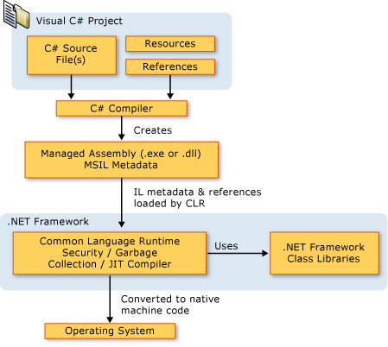
Language interoperability is a key feature of the .NET Framework. Because the IL code produced by the C# compiler conforms to the Common Type Specification (CTS), IL code generated from C# can interact with code that was generated from the .NET versions of Visual Basic, Visual C++, or any of more than 20 other CTS-compliant languages. A single assembly may contain multiple modules written in different .NET languages, and the types can reference each other just as if they were written in the same language.
In addition to the run time services, the .NET Framework also includes an extensive library of over 4000 classes organized into namespaces that provide a wide variety of useful functionality for everything from file input and output to string manipulation to XML parsing, to Windows Forms controls. The typical C# application uses the .NET Framework class library extensively to handle common "plumbing" chores.

Chapter # 5 Testing
5.1 About testing
Testing is the process by which software quality can be assured and requirements can be enforced, software written with tests are higher quality and contain lesser design bugs

5.2 unit testing
unit testing is the process of writing assertions and other tests in order to make sure the code performs the way it is supposed to for example if there is a function that does addition then test data will check to see if the addition of two known quantities is a known result e.g 2+2 should return 4 for the function to be correct. Testing is very essential to enforce requirements and produce high quality code. Applications containing user entered data can be unit tested and there exist different tools and method to test other types of applications.

5.3 Test driven development
One approach of unit testing promotes the idea of writing tests before any code is written and then writing code which will make these tests true, this way all the requirements can be forced in form of tests and one can not write code that breaks the requirements.

5.4 Testing with mock objects and fakes
Complex user controls and framework hierarchies need something other than unit testing in order to be tested, mock object are fake objects which emulate real objects and actions performed on them. Mocks or mock objects are used in situations where it would other wise be infeasible or even impossible to test an application. A part of application which needs testing can be simulated and tested alone, system supplied components are already tested by the vendor and do not need any further testing.

5.5 A tutorial on test driven development in visual studio 2012

Note:
Below is a tutorial published on the visual studio magazine by “Mickey gousset” on 07/09/2013 and the author of this document gives all the due credits to Mickey gousset.

There are various ways to build and test software. The specific process followed depends on a variety of factors, including the project itself, team members, project schedule and so on. One such process is termed Test-driven Development (TDD). In TDD, I develop test cases before I write any code. Once I have test cases in place, then I can build the appropriate functionality to make the tests pass.
This is a reverse of the standard coding model, where code is developed first, then tested. But this method has several benefits:
- The ability to tackle small aspects of the system initially, and evolve the system as the requirements evolve
- The tests act as documentation for the system
- The tests serve as a suite of regression tests, ensuring that future code changes don't break existing functionality
Visual Studio 2012 supports the concept of TDD through its unit testing framework. In this column, I'll walk through a simple example of using Visual Studio 2012, and its unit testing framework, to perform TDD. My scenario is building a windows class library for performing math functions, such as addition and subtraction.
To begin, create a blank solution in Visual Studio 2012 named ALM.UnitTestingExample. Add a new C# Windows Class Library project to the solution, and name it ALM.MathLibrary. This project will contain the code for performing the math functions. Now add a C# Windows Unit Test Project to the solution, and name it ALM.MathLibraryTests. A Test Project is a Visual Studio project that contains various tests, such as unit tests and web tests, and will contain the tests designed for the math library. Delete the Class1.cs file from the ALM.MathLibary project, and the UnitTest1.cs file from the ALM.MathLibraryTests project. Finally, add a reference to the ALM.MathLibrary project, from the ALM.MathLibraryTests project.
With the base solution now in place, I can start building the tests. This is a math library which will have functions for addition and subtraction. Right-click on the ALM.MathLibraryTests project, and select Add | New Item. Select the Unit Test object, and name it BasicMathFunctionsTest.cs. This creates a new class file to contain all tests related to basic math functions. Figure 1 shows what the base generated code for this class looks like.
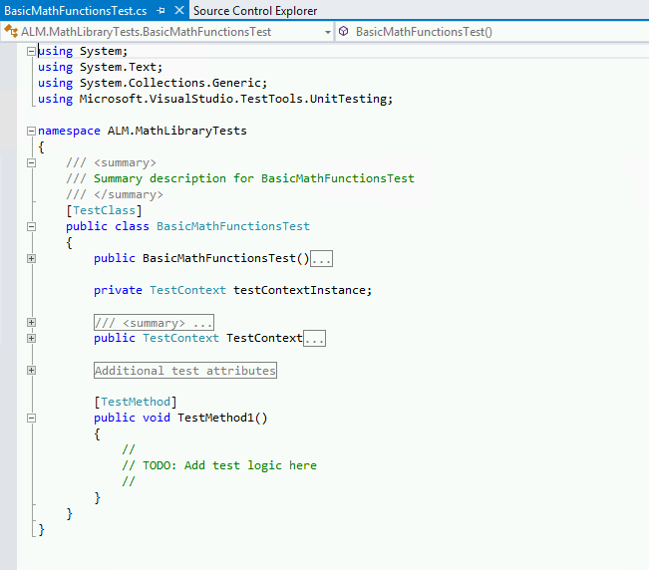

Figure 1. The base generated code for a unit test.
Notice the different attributes in the code. Above the class declaration is a [TestClass] attribute. This marks this class as a test class containing test methods, which allows the unit testing framework to pick it up. The generated code also created a sample test method for me, named TestMethod1. This method is also marked with an attribute, [TestMethod]. This attribute allows the testing framework to identify this method as a potential test that needs to be run. Rename TestMethod1 to be AddTest. Right-click on the solution in Solution Explorer and select Build Solution to verify the solution will build.
At this point I have a test project, with a test class and a blank test method. Just for fun, let's run this test and see what happens. Visual Studio 2012 has a window called Test Explorer for interacting and running unit tests. In Visual Studio, select Test | Windows | Test Explorer to open this window, shown in Figure 2.

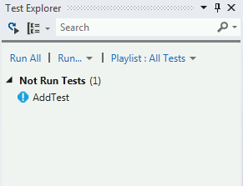

Figure 2. The AddTest Method, with test code added.
When the test project was compiled, the testing framework found the test class and method definitions, and displays the tests in the Test Explorer window. In this scenario, it knows this test has not been run yet, so it lists it under the Not Run Tests category. There are multiple options for running tests. I can right-click on a specific test and run just that test. I can run an entire category of tests. Or I can run all the tests listed in the Test Explorer. Click the Run All link to run all the tests. The solution will be built, and the test will run, with the results showing at the bottom of the test window. In this scenario, the test will pass, as there's no actual test to run. Notice also that the test was moved to the Passed Tests category in Test Explorer.
Now let's build an actual test. As Figure 3 shows, I've added code to the AddTest method.
Figure 3. The AddTest Method, with test code added.
For this test, I'm instantiating a class called BasicMathLibrary. I'm going to be testing the Add function of the library, so I specify the expected value, then make a call to the Add method. Finally, I use the Assert.AreEqual method to check whether or not the expected value matches the actual value returned from the Add method. However, if I build the solution, the build will fail (obviously) because I haven't created the BasicMathLibrary class or the Add method. So, following test-driven development principals, I should create the class and the method, as shown in Figure 4.
Figure 4. The created class and method, based off the test code.
Notice how I've created the BasicMathLibrary class and the Add method, but haven't built any functionality yet for the Add method. Instead, I am throwing a NotImplementedException exception. This allows me to quickly stub out methods without adding actual logic, to allow my solution and tests to compile.
With the class and method stubbed out, build the solution again. At this point, the solution should compile correctly. Go back to the Test Explorer and click the Run All link. The AddTest will run, and this time will fail, as shown in Figure 5.
Figure 5. The Test Explorer window, showing that the AddTest test has failed.
Figure 5 shows the AddTest unit test failed, and gives me details around the failure. In this instance, it tells me that the method or operation isn't implemented, which is what was expected. From here, I can go back to the Add method, implement the appropriate code, then re-run the test. Once that test passes, I create the next unit test, and then go through the same process as outlined earlier.
TDD is a proven methodology for building software that helps ensure the source code is thoroughly unit tested. And Visual Studio 2012, with its unit testing framework, provides the ability to easily implement test-driven development in an organization. In Part 2 of this column, I will continue to build off this example, and show in more detail how to use the unit test framework in Visual Studio 2012

In Part 1 of this column, I defined test-driven development (TDD), why it's important, why it's a successful development methodology, and the basics of how to implement TDD using the unit testing framework in Visual Studio 2012. In this column, I'm going to continue to build off the example code in Part 1, and continue to dive into the unit testing framework in Visual Studio 2012, specifically the different features provided by Test Explorer to help with the testing process.
When I left off last time, I'd created the stub code for the Add method and run the unit test for the method. The test failed because the code hadn't been implemented yet. This implies that I need to implement the actual method. I can add the following line of code to the method to implement the logic:
return (p1 + p2);
Open the Test Explorer window, and click the Run All link to run all the unit tests. The solution will compile and the tests will run. This time the test will pass, as expected.
Let's dive into the Test Explorer window in more detail. The Test Explorer window is my interface into the unit tests in my solution. The Test Explorer window, by default, groups my tests into multiple categories, such as Failed Tests, Not Run Tests and Passed Tests. This lets me easily see new tests that have been created but not yet executed, so I can run just those tests in a test run. To see this, add a new test method, SubtractTest, to the BasicMathFunctionsTest class, as shown in Figure 1.
Figure 1. The SubtractTest test method.
As can be seen in Figure 1, a new method was added to the BasicMathFunctionsTest.cs class, called SubtractTest. If I compile the solution, the unit test framework will pick up on the new test method and add it to the Test Explorer window under the Not Run Tests category, as shown. This provides a quick and easy way to see what new tests are available.
Notice how the method currently contains one line of code, Assert.Inconclusive(). If I just create the test method without any code and run it, it would pass. While this is perfectly valid, it doesn't help me identify any test stub methods I might have created, i.e. test methods where I just created the shell of the method, with the intention of adding the actual test code later. Adding an Assert.Inconclusive() call to any unfinished test method will cause that test method to show up as skipped in the Test Explorer window (Figure 2). Any methods showing up as skipped would indicate test methods that need to be modified/created.

Figure 2. Tests that need to be implemented will show up as skipped in Test Explorer.
The Test Explorer window can be used to organize tests into Test Playlists. Right-click on a test, and select Add to Playlist | New Playlist to create a new playlist file. This creates an XML file with a .PLAYLIST extension, containing the names of all the tests in that playlist. I can now select the Playlist drop down box in the Test Explorer window and select the created playlist. This will display in Test Explorer only the tests contained in the playlist. To see all the tests available in a solution, click the Playlist drop down box again and select All Tests.
By default, the tests in Test Explorer are arranged by test outcome, such as passed, failed or skipped. You can also arrange them by test class, test duration or test project.
Another methodology starting to appear is the idea of continuous testing. The idea is that I should be continuously testing my code as I build it. Visual Studio 2012 supports this by allowing me to automatically run my unit tests as part of my personal build process. Instead of building my solution and then opening Test Explorer and running my tests, I can have the tests run automatically as soon as I build the solution. This saves time, as well as providing immediate feedback on the build process. To do this, click the Run Tests After Build button in the top left of the Test Explorer.
The past two columns have delved into how to perform TDD using Visual Studio 2012, and a more in-depth look into the Test Explorer window. Visual Studio 2012 provides many more testing opportunities for TDD, from the use of other testing frameworks to the use of shims and fakes to help mock out code to test. All of these tools can be used to help create better-tested code.

About the Author
Mickey Gousset spends his days as a principal consultant for Infront Consulting Group. Gousset is lead author of "Professional Application Lifecycle Management with Visual Studio 2012" (Wrox, 2012) and frequents the speaker circuit singing the praises of ALM and DevOps. He also blogs at ALM Rocks!. Gousset is one of the original Team System/ALM MVPs and has held the award since 2005.

5.6 Code coverage
Not exactly a test but a similar approach to testing software for potential security flaws in a program, a technique known as “Code coverage” is used. Code coverage is done with automated tools and it checks to see whether all the paths in the executable have been exercised and whether all of the code points are reachable. Code coverage helps uncover design level flaws which might have been missed in the earlier phases. Microsoft visual studio 2012 has an extension called “code digger” which is an excellent tool for code coverage. Below is an introduction to code digger taken from the microsoft research site(www.research.microsoft.com)

Code Digger is a Microsoft® Visual Studio® 2012 and 2013 extension that analyzes possible execution paths through your .NET code. The result is a table where each row shows a unique behavior of your code. The table helps you understand the behavior of the code, and it may also uncover hidden bugs.

Overview
Through the new context menu item "Generate Inputs / Outputs Table" in the Visual Studio editor, you can invoke Code Digger to analyze your code. Code Digger computes and displays input-output pairs. Code Digger systematically hunts for bugs, exceptions, and assertion failures.
Out of the box, Code Digger only works on public .NET code that resides in Portable Class Libraries.
Under the hood, Code Digger uses the Pex engine and Microsoft Research’s Z3 constraint solver to systematically analyze all branches in the code, trying to generate a test suite that achieves high code coverage.
Code Digger is the first extension from the Pex team at Microsoft Research for Visual Studio 2012 and 2013. Stay tuned for future extensions that bring more aspects of the rich experience of the Pex Visual Studio 2010 Power Tools to the latest version of Visual Studio. If you have feedback for us, or bug reports, feel free to write an email to the Pex team at Microsoft Research. If you have used Pex before, let us know if you are missing a particular feature.

Chapter # 6 Implementation

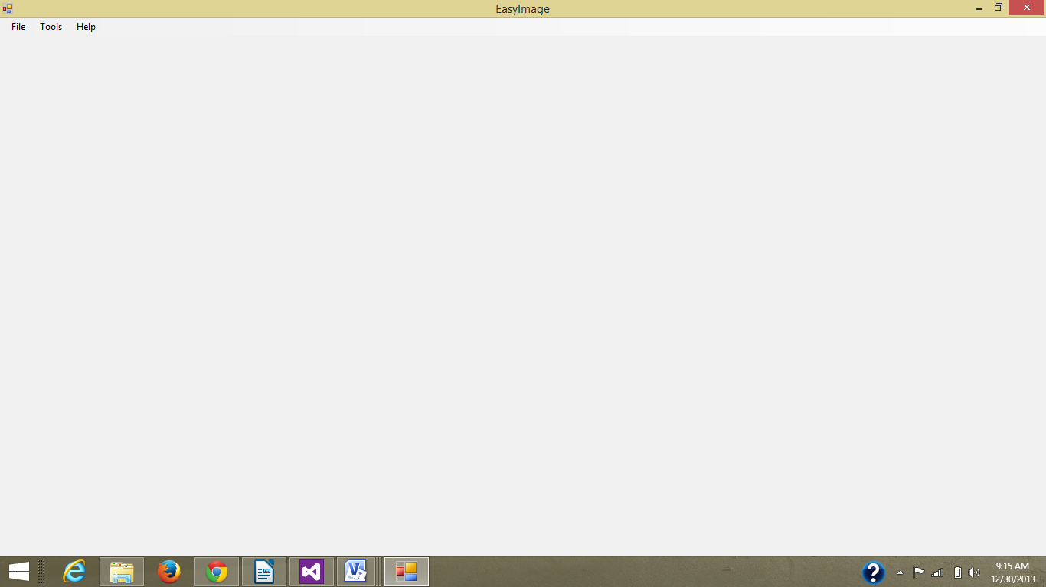

using System;
using System.Collections.Generic;
using System.ComponentModel;
using System.Data;
using System.Drawing;
using System.Text;
using System.Windows.Forms;

namespace ImageComparison
{
public partial class MainForm : Form
{
public MainForm()
{
InitializeComponent();
}

private void compareToolStripMenuItem_Click(object sender, EventArgs e)
{
Form fr = new Form1();
fr.ShowDialog();
}

private void grayScaleToolStripMenuItem_Click_1(object sender, EventArgs e)
{
Form fr = new GScale();
fr.ShowDialog();
}

private void cropToolStripMenuItem_Click(object sender, EventArgs e)
{
Form fr = new Crop();
fr.ShowDialog();
}

private void quitToolStripMenuItem_Click(object sender, EventArgs e)
{
this.Close();
}

private void freeHandToolStripMenuItem_Click(object sender, EventArgs e)
{
Form fr = new FreeHand();
fr.ShowDialog();
}

private void helpToolStripMenuItem_Click(object sender, EventArgs e)
{
MessageBox.Show("EasyImage by Waleed khan Contact@ netprodigy@hotmail.com for assistance ");
}

}
}

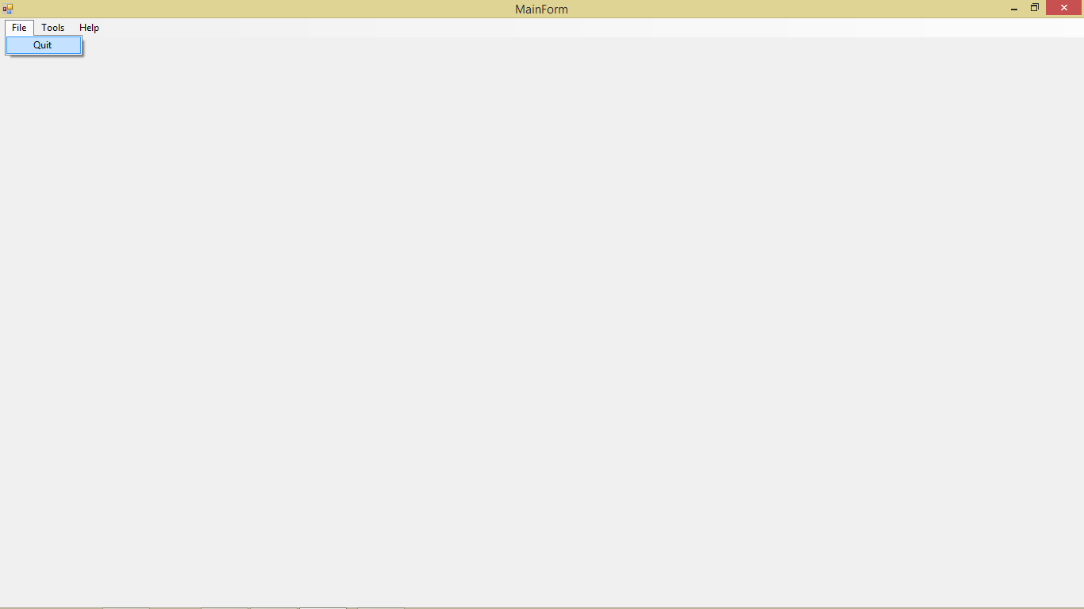
private void quitToolStripMenuItem_Click(object sender, EventArgs e)
{
this.Close();
}

using System;
using System.Collections.Generic;
using System.ComponentModel;
using System.Data;
using System.Drawing;
using System.Text;
using System.Windows.Forms;
using System.IO;

namespace ImageComparison
{
public partial class Form1 : Form
{
public Form1()
{
InitializeComponent();
}

static string fname1, fname2;
Bitmap img1, img2;
int count1 = 0, count2 = 0;
bool flag = true;

private void Form1_Load(object sender, EventArgs e)
{
progressBar1.Visible = false;
pictureBox1.Visible = false;
}

private void linkLabel1_LinkClicked(object sender, LinkLabelLinkClickedEventArgs e)
{
openFileDialog1.FileName = "";
openFileDialog1.Title = "Images";
openFileDialog1.Filter = "All Images|*.jpg; *.bmp; *.png";

openFileDialog1.ShowDialog();
if (openFileDialog1.FileName.ToString() != "")
{
fname1 = openFileDialog1.FileName.ToString();
}
}

private void linkLabel2_LinkClicked(object sender, LinkLabelLinkClickedEventArgs e)
{
openFileDialog2.FileName = "";
openFileDialog2.Title = "Images";
openFileDialog2.Filter = "All Images|*.jpg; *.bmp; *.png";

openFileDialog2.ShowDialog();
if (openFileDialog2.FileName.ToString() != "")
{
fname2 = openFileDialog2.FileName.ToString();
}
}

private void button1_Click(object sender, EventArgs e)
{
progressBar1.Visible = true;

string img1_ref, img2_ref;
img1 = new Bitmap(fname1);
img2 = new Bitmap(fname2);

progressBar1.Maximum = img1.Width;
if (img1.Width == img2.Width && img1.Height == img2.Height)
{
for (int i = 0; i < img1.Width; i++)
{
for (int j = 0; j < img1.Height; j++)
{
img1_ref = img1.GetPixel(i, j).ToString();
img2_ref = img2.GetPixel(i, j).ToString();
if (img1_ref != img2_ref)
{
count2++;
flag = false;
break;
}
count1++;
}
progressBar1.Value++;
}

if (flag == false)
MessageBox.Show("Images are not same , " + count2 + " wrong pixels found");
else
MessageBox.Show(" Images are same , " + count1 + " same pixels found and " + count2 + " wrong pixels found");
}
else
MessageBox.Show("can not compare these images");

this.Dispose();
}
}
}

public Bitmap RotateImage(Bitmap img)
{
var bmp = new Bitmap(img);

using (Graphics gfx = Graphics.FromImage(bmp))
{
gfx.Clear(Color.White);
gfx.DrawImage(img, 0, 0, img.Width, img.Height);
}

bmp.RotateFlip(RotateFlipType.Rotate270FlipNone);
return bmp;
}

private void button1_Click(object sender, EventArgs e)
{
Bitmap bmp = new Bitmap(pictureBox3.Image);
//MakeGrayscale(bmp);
pictureBox4.Image = MakeGrayscale(bmp);
}

private void btnRotate_Click(object sender, EventArgs e)
{
Bitmap bmp = new Bitmap(pictureBox3.Image);

pictureBox3.Image = RotateImage(bmp);

}

}

public static Bitmap MakeGrayscale(Bitmap original)
{
//make an empty bitmap the same size as original
Bitmap newBitmap = new Bitmap(original.Width, original.Height);

for (int i = 0; i < original.Width; i++)
{
for (int j = 0; j < original.Height; j++)
{
//get the pixel from the original image
Color originalColor = original.GetPixel(i, j);

//create the grayscale version of the pixel
int grayScale = (int)((originalColor.R * .3) + (originalColor.G * .59)
+ (originalColor.B * .11));

//create the color object
Color newColor = Color.FromArgb(grayScale, grayScale, grayScale);

//set the new image's pixel to the grayscale version
newBitmap.SetPixel(i, j, newColor);
}
}

return newBitmap;
}

using System;
using System.Collections.Generic;
using System.ComponentModel;
using System.Data;
using System.Drawing;

using System.Text;
using System.Windows.Forms;

namespace ImageComparison
{
public partial class FreeHand : Form
{
Graphics Graphic;//this class contains methods for drawing shapes and other stuff such as drawLine etc
Pen myPen = new Pen(Color.Black,1);
Point ep = new Point(0,0);
Point sp = new Point(0,0);
int k = 0;

public FreeHand()
{
InitializeComponent();
}
private void Form1_MouseDown(object sender, MouseEventArgs e)
{

sp = e.Location;
if(e.Button==MouseButtons.Left){
k = 1;
}

}

private void Form1_MouseMove(object sender, MouseEventArgs e)
{
if(k==1){
ep = e.Location;
Graphic = this.CreateGraphics();
Graphic.DrawLine(myPen, sp, ep);
}
sp = ep;

}

private void Form1_MouseUp(object sender, MouseEventArgs e)
{
k = 0;
}

private void red_Click(object sender, EventArgs e)
{
myPen.Color = red.BackColor;
pictureBox1.BackColor = red.BackColor;
}

private void green_Click(object sender, EventArgs e)
{
myPen.Color = green.BackColor;
pictureBox1.BackColor = green.BackColor;
}

private void yellow_Click(object sender, EventArgs e)
{
myPen.Color = yellow.BackColor;
pictureBox1.BackColor = yellow.BackColor;
}

private void blue_Click(object sender, EventArgs e)
{
myPen.Color = blue.BackColor;
pictureBox1.BackColor = blue.BackColor;
}

private void white_Click(object sender, EventArgs e)
{
myPen.Color = white.BackColor;
pictureBox1.BackColor = white.BackColor;
}

private void black_Click(object sender, EventArgs e)
{
myPen.Color = black.BackColor;
pictureBox1.BackColor = black.BackColor;
}

private void orange_Click(object sender, EventArgs e)
{
myPen.Color = orange.BackColor;
pictureBox1.BackColor = orange.BackColor;
}

private void pink_Click(object sender, EventArgs e)
{
myPen.Color = pink.BackColor;
pictureBox1.BackColor = pink.BackColor;
}

private void purple_Click(object sender, EventArgs e)
{
myPen.Color = purple.BackColor;
pictureBox1.BackColor = purple.BackColor;
}

private void maroon_Click(object sender, EventArgs e)
{
myPen.Color = maroon.BackColor;
pictureBox1.BackColor = maroon.BackColor;
}

private void brown_Click(object sender, EventArgs e)
{
myPen.Color = brown.BackColor;
pictureBox1.BackColor = brown.BackColor;
}

private void rubber_Click(object sender, EventArgs e)
{
myPen.Color = cyan.BackColor;
pictureBox1.BackColor = cyan.BackColor;
}

private void pictureBox2_Click(object sender, EventArgs e)
{
this.Close();
}

private void pictureBox2_MouseEnter(object sender, EventArgs e)
{
pictureBox2.Image = ImageComparison.Properties.Resources.cross2;
this.Cursor = System.Windows.Forms.Cursors.Hand;
}

private void pictureBox2_MouseLeave_1(object sender, EventArgs e)
{
pictureBox2.Image = ImageComparison.Properties.Resources.cross;
this.Cursor = System.Windows.Forms.Cursors.Cross;
}

private void Form1_Load(object sender, EventArgs e)
{

}

}
}

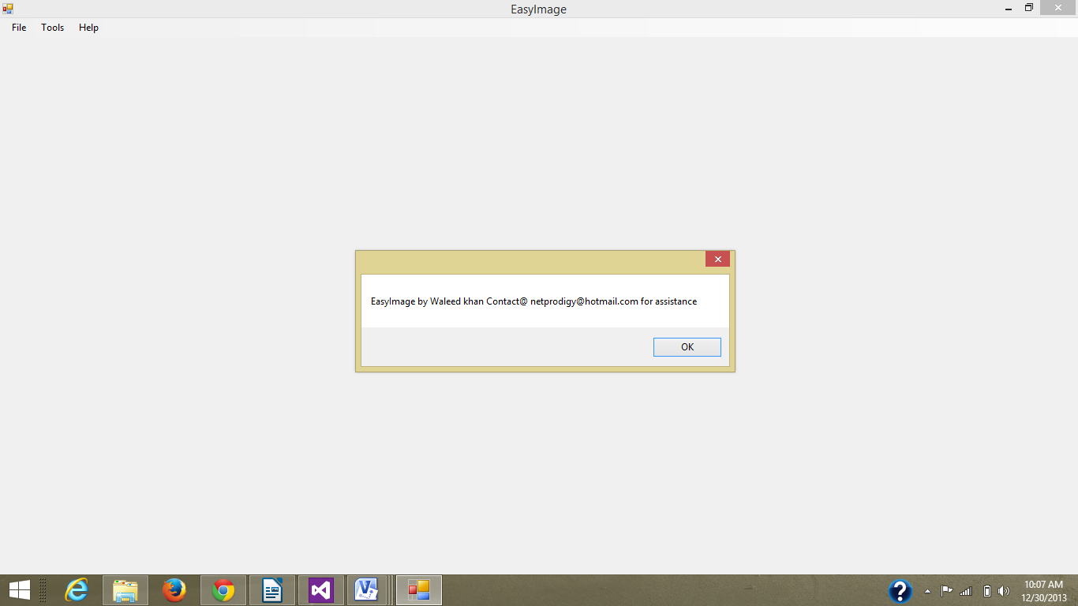
private void helpToolStripMenuItem_Click(object sender, EventArgs e)
{
MessageBox.Show("EasyImage by Waleed khan Contact@ netprodigy@hotmail.com for assistance ");
}

Chapter # 7 Maintenance
7.1Maintenance and environment
The application is very simple to maintaine and the environment is very intuitive, the application needs zero maintenance as it is a stand alone application with no backing data store or a web server. A few points must still be kept in mind for the maintenance of this application
- If the application is edited, make sure it points to right resources
- Make the new features consistent with the old ones
- Use a concise programming style
- Do not attempt to change a name for a control or function
- Try to put your code in a seperate namespace
7.2 Correction
In case of any errors try to revert to when the application was working, a better solution would be to check the error on the internet for more insight in to the process. You can check the function definitions, their arguments and how to use them on the MSDN site(http://www.msdn.com). Use meaningful variable so that it is easy to debug the application. Try to follow the modular strategy and try making new modules for new feature and not write code in a linear fashion. Last but not the least learn to use the build in debugger in Visual studio, that will greatly reduce your debugging time and add efficiency to your coding syle.

7.3 Adaption
The application can be adapted as per user needs but before doing that make sure that you are familiar with the basics of programming and coding conventions used in this application. The application takes a little time getting used to and after all image processing takes a bit longer, so before trying to adapt it try to learn it.

7.4 Enhancements
As EasyImage is an extremely simple and clamshell applications, almost endless enhancements are possible. Some of the enhancements that the user well aquantained with programming can do are as follows
- Use better algorithms
- Use performance oriented libraries
- For the best performance we suggest using the OpenCV(computer vision) library
- Windows presentation foundation can be used high quality user interface
- Use Model view presenter to test the application
- Learn the techniques of dependency injection
- Apply design patterns

7.5 Prevention
To prevent the new user from falling in to the scary world of programming bugs following should be kept in mind
- Only use the functions you are familiar with
- Do not try to implement unsupported or depreciated methods
- Make sure your development environment is up to date
- Check to see online if it is a known issue
- Try to learn before you apply
- Take small steps instead of one big step

Chapter # 8 Conclusion
8.1 In the conclusion I would like to say programming is an art like any other art and trying to approach it as a science is a mistake. Every art takes some time and patience to master. Only the utmost dedication and handwork turns art forms. Programming is one of those things which can not be learnt over night and requires considerable time before getting down the throat but once it does it stays there for a life time. In the last I will congratulate to all of those who came this far but the real learning has just begun. Trust your skills, eliminate your fears and be happy writing software.

Chapter # 9 Future recommendations
9.1 In future the software can be enhanced in several ways, some of additions which can be made are as follows
- Use better algorithms
- Add more sophisticated features
- Use hardware acceleration libraries like opencv, opencl etc
- The interface can be greatly improved

Chapter # 10 References
10.1 Books
The books used for this project and for the technologies inside it are
- Programming windows with C# 2nd edition by charles petzold
- .Net framework essentials by Thuan Thai and Hoang Q. Lam
- C# unleashed
- C# blackbook

10.2 Websites
Some useful websites are
- www.msdn.com
- www.stackoverflow.com
- www.dotnetcorner.com
- www.codeproject.com
- www.office.microsoft.com

10.3 Magazines
- Visual studio magazine
- Dr Dobbs journal

10.4 Courses
www.coursera.com contains a plethora of courses on various coding topics.

