Mountaineering :

Mountaineering is a sport that involves climbing, hiking,

traversing mountains.

# User Guide

|  |  |  |
| --- | --- | --- |
| Supervisor. | Miss Ifrah Haider | |
| Batch. | ACCP-2401C1 | |
| Group. | Group- C | |
| Serial No. | Enrollment Number | Student Name |
| 1. | Student1545798 | DANISH |
| 2. | Student1538843 | MUHAMMAD OWAIS KHAN |
| 3. | Student1545797 | MUHAMMAD WALI |
| 4. | Student1538835 | MUHAMMAD HUNAIN |

## 1. Welcome (Index.html)



Figure I: Welcome Page to Mountaineering

Mountaineering is the sport, hobby, or profession of climbing mountains, often involving technical skills, physical endurance, and a deep appreciation for nature and the outdoors. It encompasses a wide range of activities, from hiking and trekking in mountainous terrain to more advanced endeavours such as rock climbing, ice climbing, and alpine climbing. Mountaineering can involve ascending peaks, traversing ridges, navigating glaciers, and overcoming various challenges posed by high-altitude environments. It often requires specialized equipment, training, and knowledge of safety practices due to the inherent risks associated with climbing in rugged and remote landscapes.

1.

E-Project: Mountaineering

## 2. Layout Top



## 3. On Scroll Navbar



Figure 2. Upper Frame Interface

## 4. Dropdown Navbar



Figure 3. Dropdown navbar

### 2.1.1 Blog Section

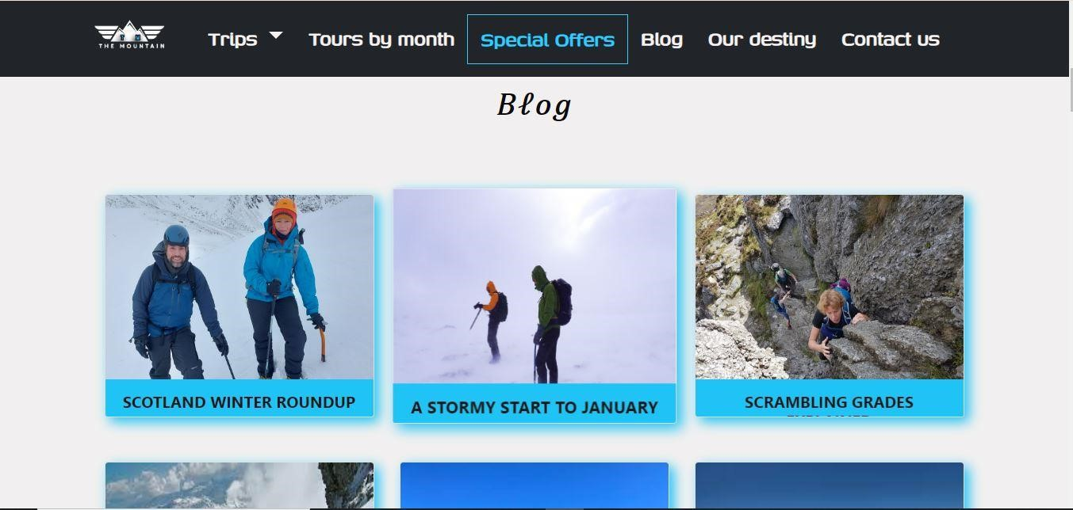

Figure 2: Blog

A blog section on a website refers to a dedicated area or page within a website where regularly updated articles, posts, or content pieces are published. This section typically features a collection of entries, organized chronologically or by topic, covering a range of subjects relevant to the website's theme, purpose, or audience interests.

The blog section serves various purpose including.

1. **Content Sharing:** It provides a platform for sharing informative, educational, entertaining, or promotional content with website visitors.

1. **Authority Building:** By consistently publishing high-quality content, the blog helps establish the website owner as an authority or thought leader in their industry or niche.

1. **Community Building:** A blog can foster a sense of community among readers who share common interests or concerns, leading to discussions, networking opportunities, and relationship-building.

### 3.1.1 Overview

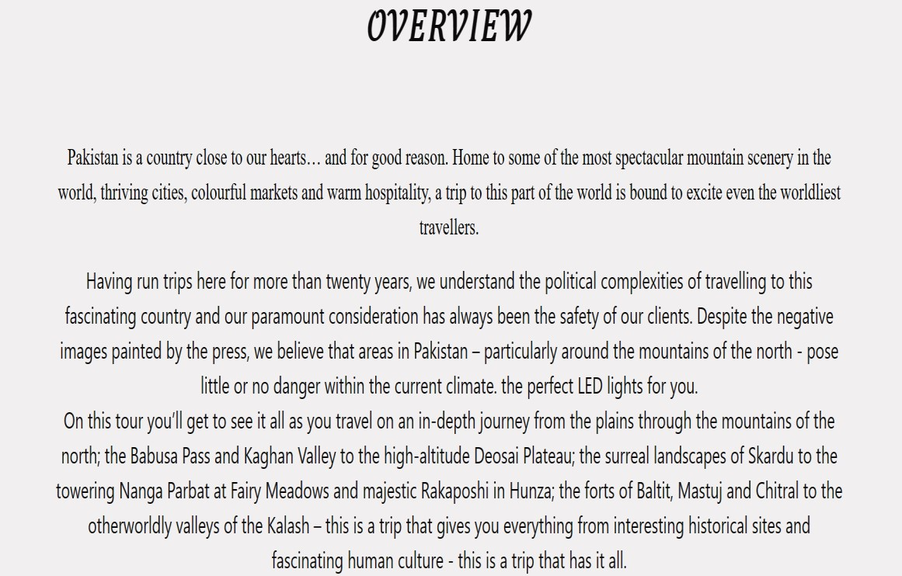

Figure 3: Overview

An overview website typically serves as a concise introduction or summary of a particular topic, product, service, organization, or concept. It aims to provide visitors with a quick understanding of the key features, benefits, and information related to the subject matter.

Here's a breakdown of the elements typically found on an overview website:

1. **Introduction:** The website starts with a brief introduction that highlights the main purpose or objective of the subject matter. This section may include a catchy headline, a short description, and possibly a welcome message.

1. **Additional Information:** Depending on the subject matter, additional information such as testimonials, case studies, FAQs, or relevant resources may be included to provide further context or address common questions.

Overall, an overview website serves as a starting point for visitors to learn about a topic or offering, providing them with a clear understanding of its key aspects and guiding them towards further engagement or action.

### 4.1.1 Gallery Section

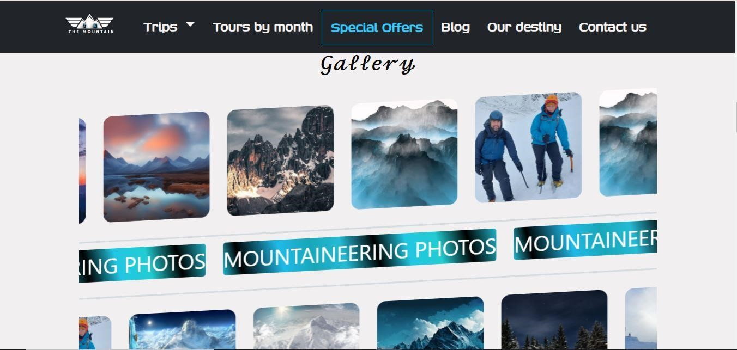

Figure 4: Gallery

A gallery section on a website refers to a dedicated area or page where collections of images, photographs, artwork, or multimedia content are displayed for visitors to view, appreciate, and interact with. This section is often utilized by individuals, businesses, artists, photographers, designers, and organizations to showcase their work, products, or visual content in an aesthetically pleasing and organized manner.

Here's a breakdown of the key components typically found in a gallery section on a website:

1. **Image Grid:** The primary feature of a gallery section is the image grid, where thumbnails or small previews of the images are displayed in a grid layout. This layout allows visitors to quickly browse through the collection and select specific images to view in more detail.

1. **Image Viewer:** Clicking on an image in the grid opens it in a larger viewer, providing visitors with a closer look at the image along with additional details or captions. This viewer may include navigation buttons or gestures for easy navigation between images.

1. **Categories or Filters:** Gallery sections often include categories or filters that allow visitors to sort or filter the images based on specific criteria, such as topic, style, date, or medium. This helps visitors find the images that are most relevant or interesting to them.

1. **Description or Captions:** Each image may be accompanied by a description, caption, or metadata providing context, information, or credits related to the image. This helps visitors understand the content of the images and learn more about the subject matter or creator.

1. **Navigation Controls:** Gallery sections may include navigation controls such as arrows, pagination, or swipe gestures to facilitate browsing through multiple pages or sections of the gallery.

1. **Interaction Features:** Depending on the website's functionality, visitors may have the option to interact with the images in various ways, such as liking, sharing, commenting, or saving their favourite images.

1. **Responsive Design:** A well-designed gallery section should be optimized for various devices and screen sizes, ensuring that the images are displayed correctly and the user experience remains seamless across desktops, tablets, and smartphones.

Overall, a gallery section on a website serves as a visually compelling showcase of images or visual content, allowing creators to highlight their work and engage with their audience in a visually appealing manner.

### 5.1.1 About Us

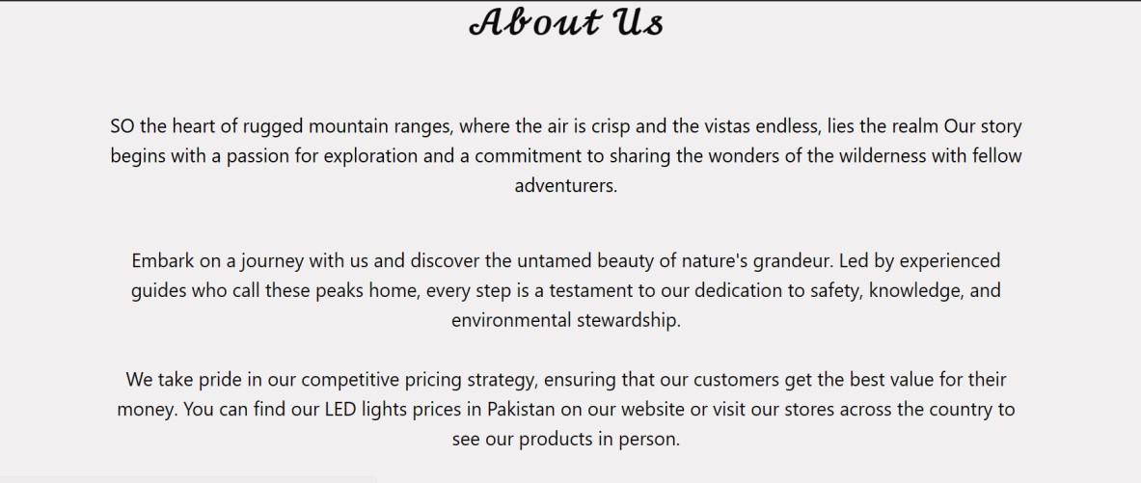

Figure 5: About Us

An "About Us" page on a website is a crucial component that provides visitors with information about the website owner, organization, company, or individual behind the website. It offers insights into the history, mission, values, team members, and other relevant details that help establish credibility, build trust, and foster a connection with visitors. Here's a breakdown of what an effective "About Us" page typically includes:

### 6.1.1 Book Now

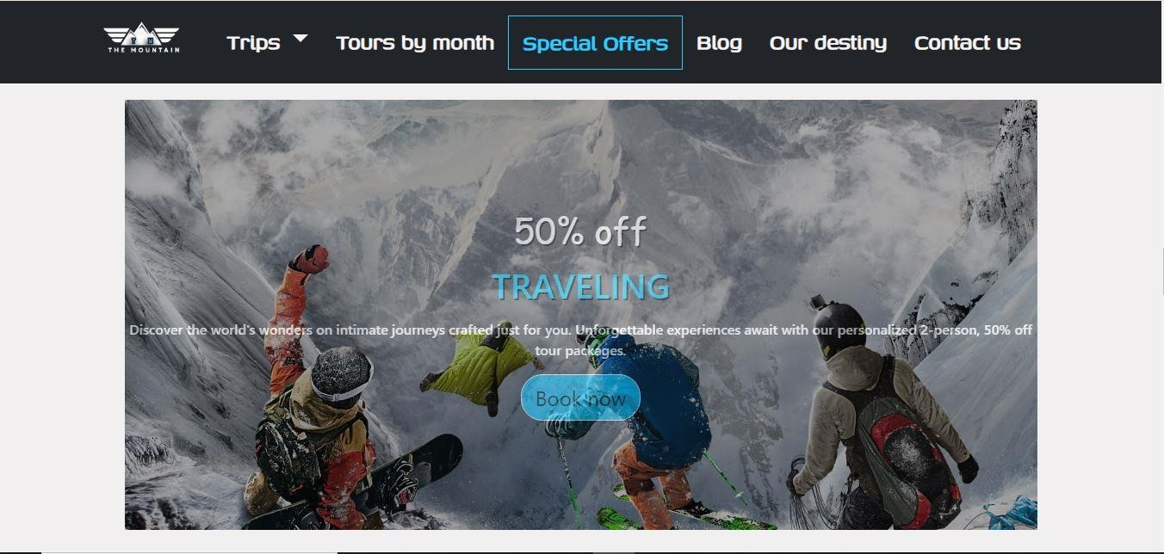

Figure 6: Book Now

A "Discount and Book Now" section on a website typically refers to a dedicated area or feature that offers promotional discounts, deals, or special offers to encourage visitors to book or make a purchase. This section is commonly found on websites related to travel, hospitality, accommodation, events, activities, and various other products or services. Here's a breakdown of what this section may include:

1. **Discount Offers:** The section displays current discounts, promotions, or deals available to website visitors. These discounts may include percentage discounts, cashback offers, package deals, or limited-time offers.

1. **Booking Options:** Visitors are presented with options to book or make a reservation directly through the website. This could involve a booking form where visitors can input their details, select dates, choose options, and complete the booking process online.

1. **Terms and Conditions:** Important information regarding the terms and conditions of the discounts or offers, including validity periods, eligibility criteria, restrictions, and cancellation policies, may be provided to ensure transparency and clarity for visitors.

1. **Visuals and Descriptions:** Engaging visuals, such as high-quality images, graphics, or videos, accompanied by compelling descriptions, highlight the benefits and features of the discounted products or services, enticing visitors to take advantage of the offers.

1. **Trust Signals:** Incorporating trust signals, such as customer reviews, ratings, trust badges, or secure payment icons, helps build credibility and reassures visitors that their booking transactions are safe and reliable.

Overall, a "Discount and Book Now" section serves as a powerful marketing tool to attract visitors, stimulate bookings, and drive conversions by offering enticing discounts and facilitating the booking process directly on the website.

### 7.1.1 Dates & Price

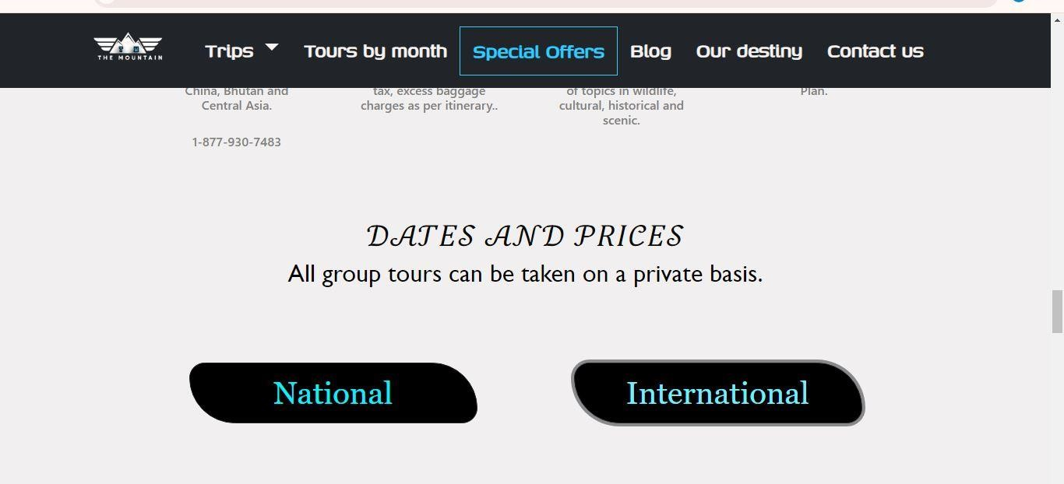

Figure 6: Dates & Price

A "Dates and Price" section on a website typically refers to a dedicated area or feature that provides visitors with information about available dates, scheduling options, and pricing details for products, services, events, or bookings. This section is commonly found on websites related to travel, accommodation, event planning, ticketing, and various other industries where scheduling and pricing are essential considerations for visitors. Here's a breakdown of what this section may include:

1. **Availability Calendar:** The section may feature an availability calendar that displays dates, times, or slots when the product, service, or event is available for booking or reservation. This calendar allows visitors to view open dates and select their preferred timing.

1. **Pricing Information:** Clear and transparent pricing information is provided to visitors, including base prices, optional add-ons, discounts, taxes, fees, and total costs. This helps visitors understand the financial implications of their booking decisions.

1. **Special Offers:** If applicable, any special offers, discounts, promotions, or package deals are highlighted to incentivize visitors to make a booking. This could include early bird discounts, group rates, seasonal promotions, or limited-time offers.

1. **Cancellation and Refund Policies:** Important information regarding cancellation policies, refund procedures, rescheduling options, and any associated terms and conditions are provided to visitors to manage expectations and address potential concerns.

Overall, a "Dates and Price" section serves as a valuable resource for visitors to view availability, compare pricing options, and proceed with booking or reservation transactions directly on the website.

### 8.1.1 Contact Us

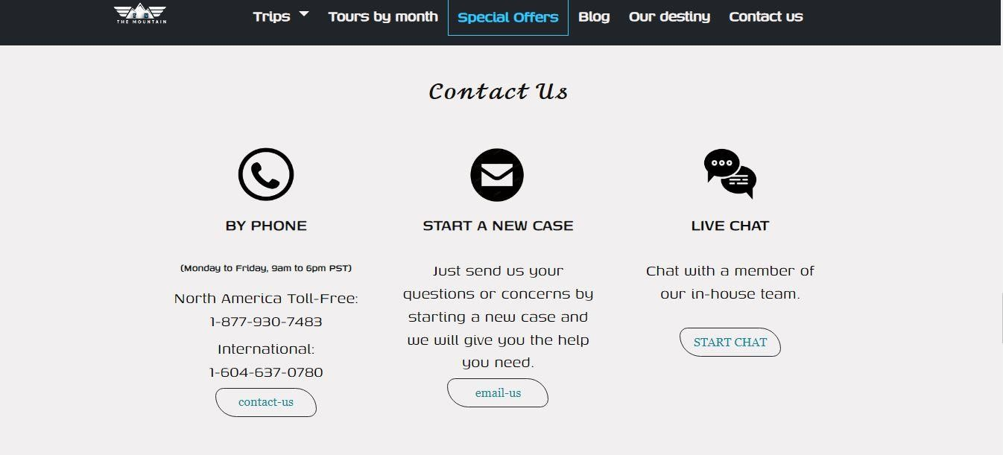

Figure 7: Contact Us

A "Contact Us" page on a website is a vital component that provides visitors with information and means to get in touch with the website owner, organization, or company. It serves as a bridge between the website and its visitors, enabling communication, inquiries, feedback, and support requests. Here's what an effective "Contact Us" page typically includes:

1. **Contact Information:** Clear and prominent contact details are displayed, including the company's name, physical address, phone number(s), email address(es), and possibly fax numbers or other relevant contact information. This allows visitors to choose their preferred method of communication.

1. **Contact Form:** A contact form may be provided, allowing visitors to send messages directly from the website. The form typically includes fields for the visitor's name, email address, subject, message, and any additional information required by the company. This form simplifies the communication process and helps streamline inquiries.

1. **Interactive Map:** An interactive map displaying the company's location can be included to provide visual context and help visitors find the physical address more easily. This map may be embedded from mapping services like Google Maps or created using custom mapping tools.

1. **Social Media Links:** Links to the company's social media profiles, such as Facebook, Twitter, LinkedIn, Instagram, or others, may be included to offer additional channels for communication and engagement. This allows visitors to connect with the company on various platforms.

1. **Privacy Policy and Data Handling:** Information about the company's privacy policy, data handling practices, and how visitor information will be used and protected is often included to reassure visitors about the confidentiality and security of their personal data.

1. **Accessibility Features:** Considerations for accessibility, such as providing alternative contact methods for visitors with disabilities, ensuring that contact forms are accessible to screen readers, and offering language translation options, may be implemented to ensure inclusivity.

Overall, a well-designed "Contact Us" page serves as a user-friendly gateway for visitors to reach out to the company, fostering communication, building trust.

## 9.1.1 FAQ’s

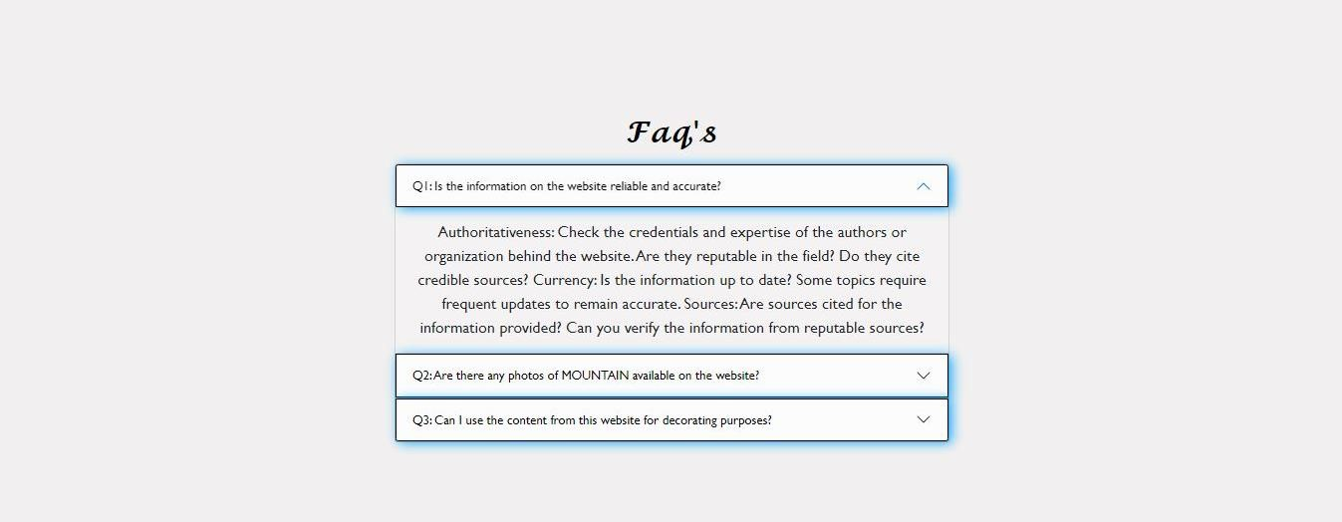

Figure 8: FAQ’s

A "FAQs" (Frequently Asked Questions) page on a website is a dedicated section that provides answers to common queries, concerns, or inquiries that visitors may have about the website, its products, services, policies, or other relevant topics. It serves as a valuable resource for users to find quick solutions to their questions without the need for direct communication with the website owner or customer support team.

### 10.1.1 Partners & Associations



Figure 9: Partners & Associations

"Partners and Associations" typically refers to a section on a website that provides information about the various organizations, companies, or entities with which the website owner or organization has established partnerships, collaborations, affiliations, or memberships. This section highlights the network of relationships and connections that the website owner has formed to enhance their offerings, credibility, and reach. Here's what this section may include:

Overall, the "Partners and Associations" section serves to showcase the website owner's network of relationships and highlight the collaborative efforts, affiliations, and credentials that contribute to the organization's success, credibility, and reputation within its industry or sector.

### 11.1.1 Reviews Section



Figure 10: Reviews

A "review" is an online platform that aggregates and publishes reviews, ratings, and opinions about products, services, businesses, or other entities. These websites serve as a resource for consumers seeking information and insights before making purchasing decisions. Review websites typically allow users to submit their reviews and ratings, which are then displayed publicly for others to read and evaluate.

### 12.1.1 Footer Section

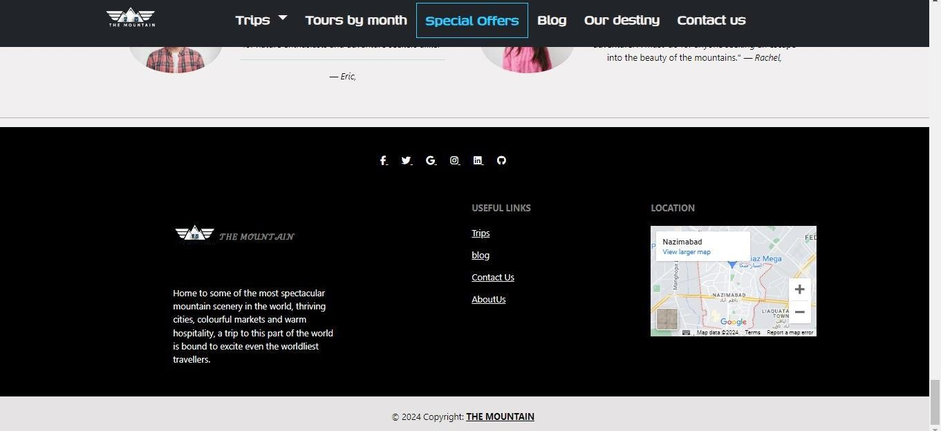

Figure 11: Footer

The website footer, also known as the bottom section or footer area, is a consistent element found at the bottom of web pages across a website. It typically contains important information, links, and functionality that are accessible from any page on the site. The footer serves multiple purposes, including navigation, branding, and providing essential information to visitors.

Here's what you might find in a website footer:

1. **Navigation Links:** Footer menus often include links to key pages of the website, such as the homepage, about us page, contact page, services or products, FAQs, blog, and legal pages like terms of service and privacy policy.

1. **Contact Information:** Important contact details, such as the company's physical address, phone number, email address, and links to social media profiles, may be included to provide visitors with multiple channels for communication.

1. **Copyright Information:** A copyright notice with the current year and the company's name asserts ownership of the website's content and protects against unauthorized use. It's often accompanied by a "All rights reserved" statement.

1. **Privacy Policy and Terms of Service:** Links to legal documents like the privacy policy and terms of service help ensure transparency and compliance with relevant laws and regulations governing user data and website usage.

1. **Site Map:** Some footers include a site map or link to a site map page, which provides a hierarchical list of all the pages on the website. This helps visitors navigate the website more easily and find specific content.

1. **Newsletter:** A website's newsletter or updates may be included. This allows the website owner to capture visitor email addresses for marketing purposes.

The footer is an important part of web design as it provides visitors with easy access to essential information and functionality, regardless of which page they are on. It contributes to the overall usability, accessibility, and professionalism of the website.

### 2.Welcome (TRIPS)

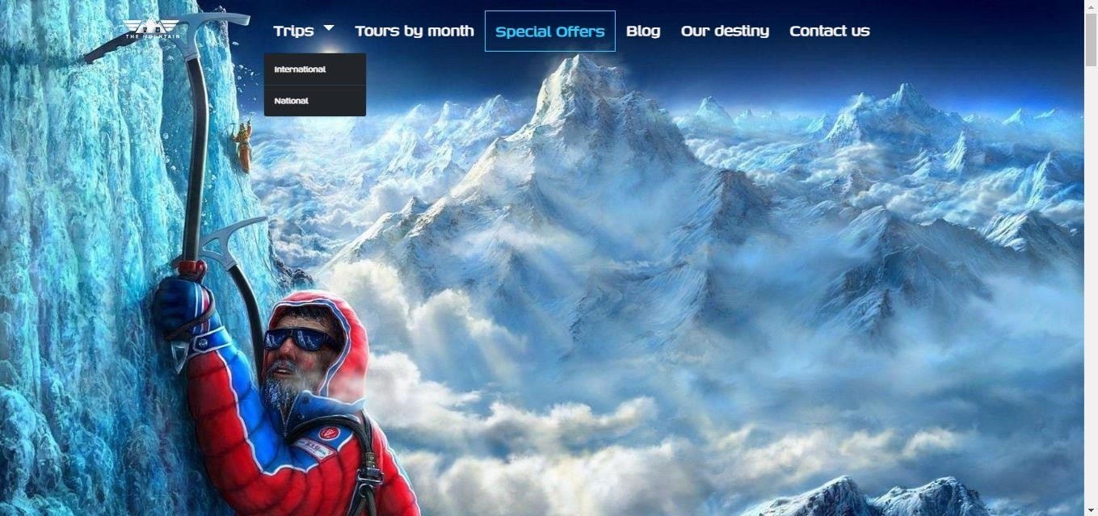

Figure 12: Trips

"Trips" typically refer to journeys or travels, often undertaken for leisure, exploration, adventure, relaxation, or cultural experiences. A trip involves leaving one's usual place of residence or work and traveling to a different location, whether it be a nearby destination, a distant city, a foreign country, or even an exotic locale.

#### 1.1.1 International Trips

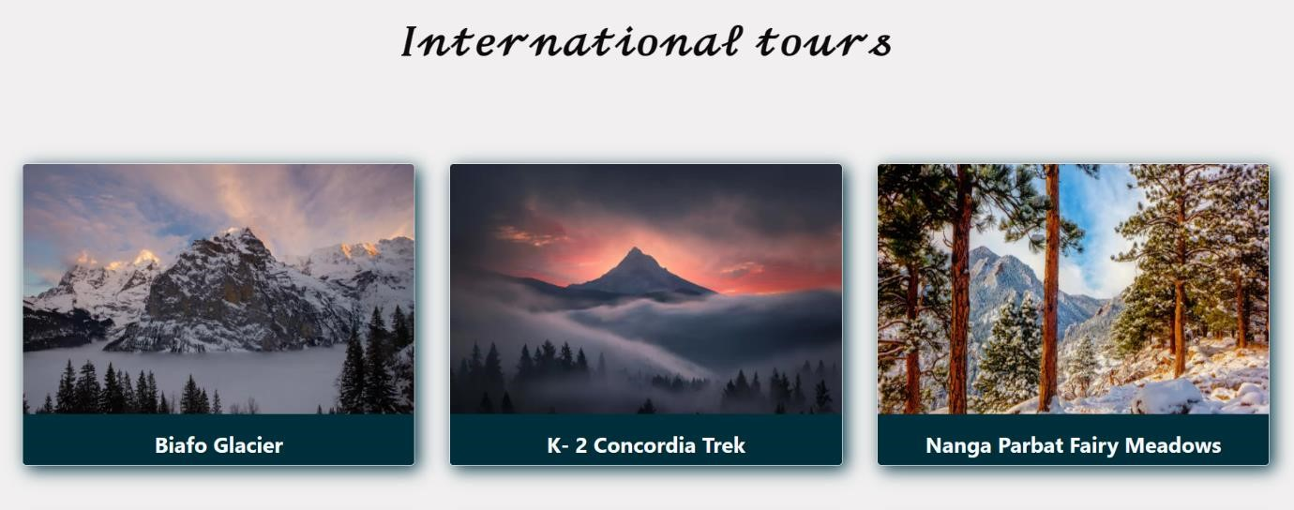

Figure 13: International Trips

International trips refer to journeys or travels that involve crossing national borders to visit destinations outside of one's home country. These trips typically involve traveling to foreign countries or territories, which may require additional planning, documentation, and considerations compared to domestic travel. Here are some key aspects of international trips:

1. **Passports and Visas:** Travelers usually need a valid passport to enter foreign countries, and in many cases, they may also need to obtain a visa or other entry permit depending on their nationality and the destination country's requirements. It's essential to research and obtain the necessary travel documents well in advance of the trip.

1. **Currency and Exchange Rates:** When traveling internationally, travellers may need to exchange currency to the local currency of the destination country. It's important to be aware of exchange rates, currency conversion fees, and have access to multiple payment methods, such as cash, credit cards, or prepaid travel cards.

1. **Language and Culture:** International trips often involve encountering different languages, cultures, customs, and traditions. It can be helpful to learn basic phrases in the local language, familiarize oneself with cultural norms and etiquette, and respect local customs and traditions while traveling.

1. **Health and Safety:** Travelers should be aware of any health risks or safety concerns in their destination country, including required vaccinations, health insurance coverage, potential hazards, and safety precautions. It's essential to stay informed and take necessary precautions to ensure a safe and healthy trip.

1. **Cross-Border Regulations:** International travellers should be aware of cross-border regulations, including customs and immigration requirements, duty-free allowances, prohibited items, and import/export restrictions. It's essential to comply with these regulations to avoid any legal issues or delays during international travel.

Overall, international trips provide opportunities for adventure, exploration, and cultural immersion, allowing travellers to discover new destinations, broaden their horizons, and create unforgettable experiences across borders and continents.

#### 2.1.1 National Trips

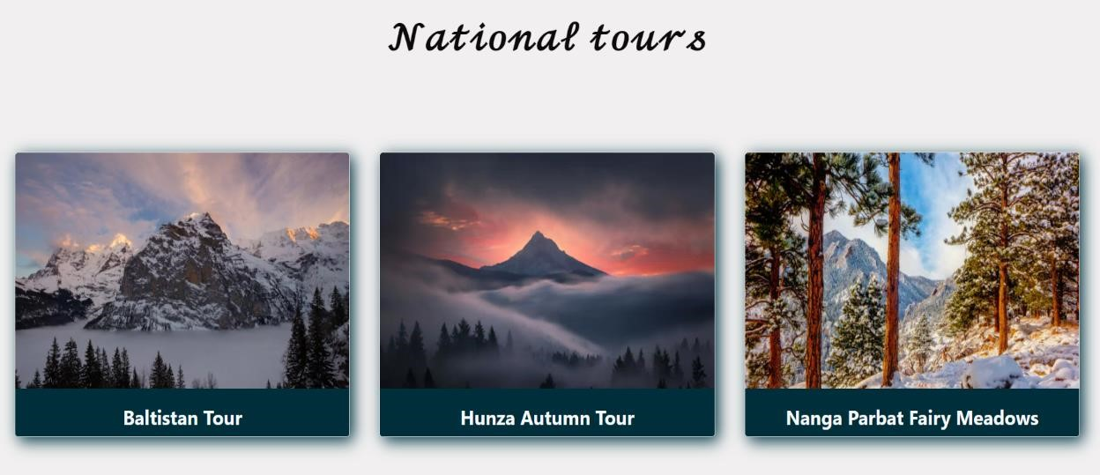

Figure 14: National Trips

"National trips" typically refer to journeys or travels within one's own country or nation. These trips involve visiting destinations, landmarks, attractions, or regions that are located within the borders of the traveller’s home country. Here are some key aspects and characteristics of national trips:

1. **Domestic Travel:** National trips involve traveling domestically, meaning that travellers do not cross international borders. Instead, they explore destinations and regions within their own country.

1. **Diverse Destinations:** National trips offer opportunities to explore the diverse landscapes, cultures, climates, and attractions within one's own country. These destinations may include cities, towns, coastal areas, mountains, national parks, historical sites, cultural landmarks, and more.

1. **Accessibility:** National trips are often more accessible and convenient for travellers compared to international travel. They may require less planning, fewer travel documents, and shorter travel times, making them suitable for weekend getaways, day trips, or longer vacations.

1. **Cultural Exploration:** Traveling within one's own country allows for cultural exploration and immersion in the local customs, traditions, cuisine, and way of life. It provides opportunities to learn about the history, heritage, and diversity of different regions and communities within the country.

1. **Outdoor Adventures:** National trips offer opportunities for outdoor adventures and recreational activities, such as hiking, camping, fishing, boating, skiing, wildlife watching, and exploring natural wonders. Many countries have national parks, forests, lakes, and mountains that are popular destinations for outdoor enthusiasts.

1. **Historical and Educational Experiences:** National trips may include visits to historical sites, museums, monuments, and educational attractions that offer insights into the country's past, culture, and heritage. These experiences can be both enriching and educational for travellers of all ages.

1. **Supporting Local Tourism:** Choosing to take national trips can contribute to supporting local economies, businesses, and tourism industries within one's own country. By patronizing local restaurants, accommodations, attractions, and small businesses, travellers can help stimulate economic growth and development.

1. **Environmental Considerations:** National trips may have lower environmental impacts compared to international travel, particularly in terms of carbon emissions from air travel. Traveling within one's own country can be a more sustainable and eco-friendly option for those concerned about environmental conservation.

Overall, national trips offer a diverse array of experiences and opportunities for travellers to explore and appreciate the beauty, culture, history, and natural wonders of their own country, fostering a deeper appreciation for their homeland and its many treasures.

#### 3.1.1 Book Now

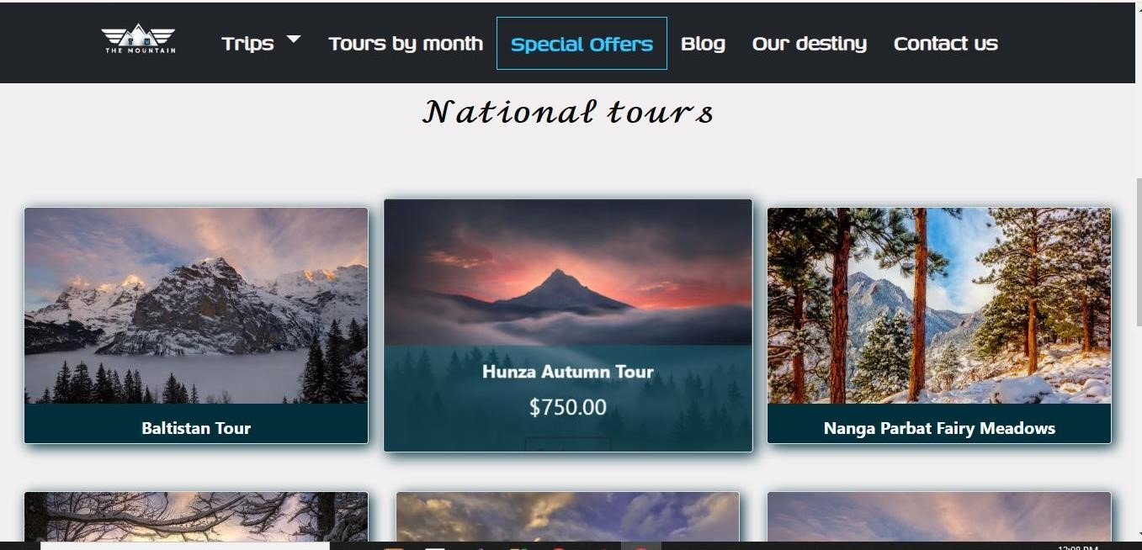

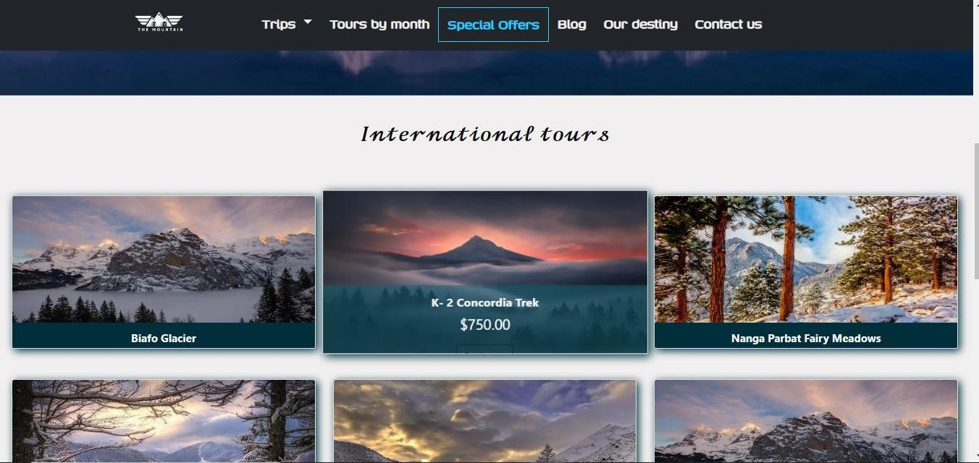

Figure 15: Book Now

Here are some key features and characteristics of a "Book Now" website:

1. **Booking System:** The website includes a booking system or functionality that allows users to name, email & message, and other relevant details to complete their reservation or booking online.

1. **User-Friendly Interface:** The website is designed with a user-friendly interface that makes it easy for visitors to navigate, search for available options, and complete the booking process efficiently.

1. **Secure Payment Processing:** The website includes secure payment processing capabilities to facilitate online transactions, allowing users to make payments for their bookings using credit cards, debit cards, or other payment methods.

3.Welcome (Tours by Months)

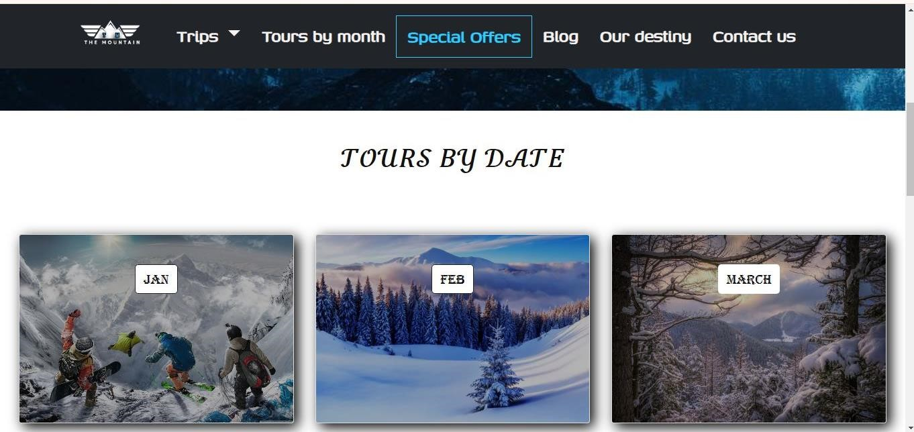

Figure 16: Tours by Month

"Tours by month" refers to a type of travel or tourism service that offers guided tours, excursions, or itineraries specifically tailored to different months of the year. These tours are designed to showcase destinations, attractions, or experiences that are particularly well-suited or unique during specific times of the year due to factors such as weather, seasonal events, natural phenomena, or cultural activities.

#### 1.1.1 International Pricing Table

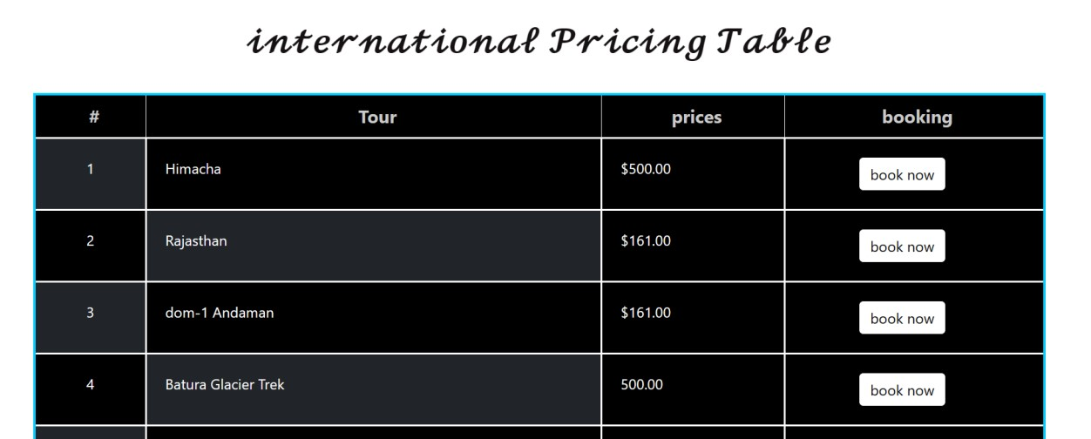

Figure 16: Pricing table

An "international pricing table" typically refers to a structured display of pricing information for products, services, or subscriptions offered by a business or organization that operates internationally or serves customers across different countries or regions. This pricing table is designed to provide clarity and transparency to customers regarding the costs associated with the offerings, considering factors such as currency exchange rates, taxes, and regional pricing differences.

Here are some key components and characteristics of an international pricing table:

1. **Product or Service Offerings**: The pricing table lists the various products, services, or subscription plans available for purchase or use. Each offering is typically accompanied by a brief description highlighting its features, benefits, and included amenities.

1. **Localized Pricing:** In some cases, businesses may implement localized pricing strategies that adjust prices based on factors such as purchasing power parity, market demand, or competitive pricing in specific regions. The pricing table may reflect these variations by displaying different prices for different countries or regions.

1. **Discounts and Promotions:** The pricing table may highlight any discounts, promotions, or special offers currently available for certain products or subscription plans. This could include limited-time discounts, bundle deals, or seasonal promotions.

1. **Terms and Conditions:** Providing links to terms and conditions, refund policies, and other relevant information ensures that customers have access to important details before making a purchase decision. This promotes transparency and builds trust with customers.

Overall, an international pricing table serves as a valuable tool for customers to compare pricing options, understand the costs associated with the offerings, and make informed purchasing decisions, regardless of their location or currency preference. It enhances user experience and facilitates global commerce for businesses operating across international markets.

### 4.Welcome (Special Offer)

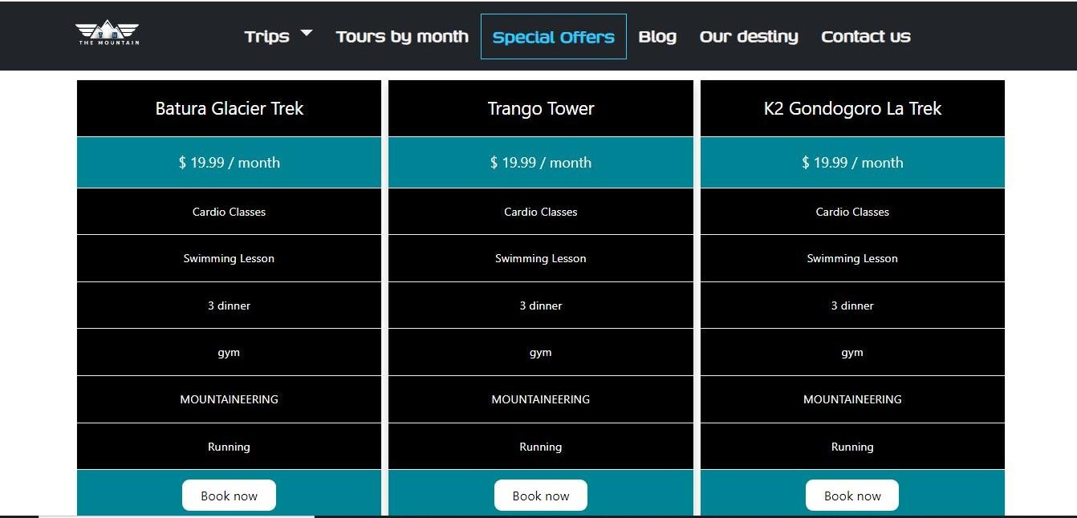

Figure 17: Special Offers

A "traveling special offer" typically refers to a promotional deal, discount, package, or incentive offered by travel-related businesses, such as airlines, hotels, tour operators, travel agencies, or online booking platforms, to encourage travellers to book their services or experiences. These special offers are designed to attract customers, increase bookings, and drive revenue by providing added value, cost savings, or exclusive benefits for a limited time or under specific conditions.

Here are some common types of traveling special offers:

1. **Discounts:** Businesses may offer discounted rates or price reductions on flights, accommodations, tour packages, rental cars, or activities to incentivize bookings. These discounts may be expressed as a percentage off the regular price or as a fixed dollar amount.

1. **Promo Codes:** Special offer promo codes or coupon codes may be provided to customers, allowing them to unlock exclusive savings or perks when booking online or through specific channels. Promo codes can be applied during the booking process to redeem the offer.

1. **Limited-Time Offers:** Travel businesses may introduce limited-time offers or flash sales, where special discounts or promotions are available for a short duration, typically ranging from a few hours to a few days. These time-sensitive offers create a sense of urgency and prompt customers to act quickly to secure the deal.

1. **Package Deals:** Businesses may create bundled package deals that combine multiple travel components, such as flights, accommodations, meals, transfers, and activities, into a single package at a discounted price. Package deals offer convenience and value for customers booking multiple services together.

1. **Upgrade Offers:** Travel businesses may offer complimentary upgrades or enhancements to customers who book certain services or packages. This could include room upgrades at hotels, cabin upgrades on flights, rental car upgrades, or complimentary amenities.

1. **Seasonal Promotions:** Special offers may be tailored to specific seasons or times of the year, such as holiday promotions, summer sales, winter getaway deals, or shoulder season discounts. These seasonal promotions align with travel trends and customer preferences for particular times of the year.

8. **Group Discounts:** Businesses may offer special discounts or incentives for group bookings, such as group travel packages, family vacation deals, or group tour discounts. These offers are designed to attract larger bookings and accommodate group travellers.

Overall, traveling special offers play a crucial role in attracting customers, boosting bookings, and driving revenue for travel businesses, while also providing travellers with opportunities to save money, access exclusive benefits, and enjoy memorable travel experiences at a discounted rate.

5.Welcome (Blog)

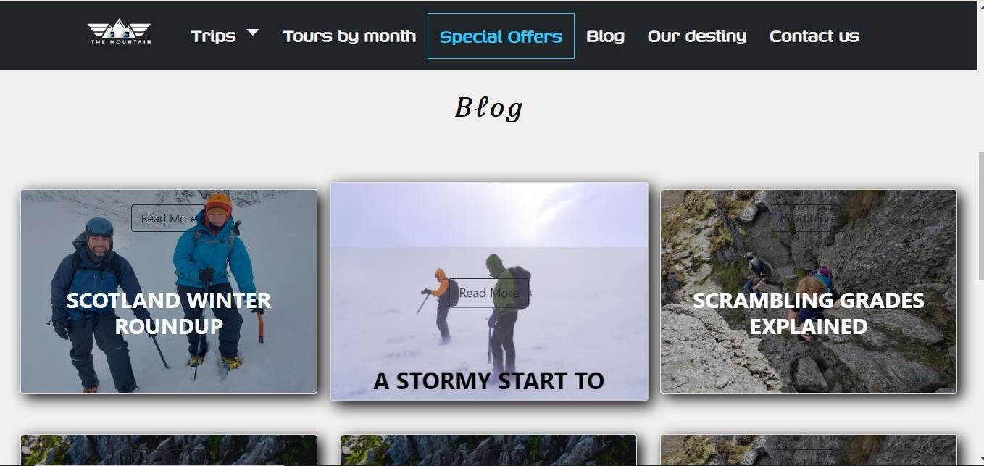

Figure 18: Blogs

A blog is a type of website or online platform where individuals or groups regularly publish written content, known as blog posts, typically in a chronological order with the most recent posts appearing first. Blogs often serve various purposes, including personal expression, sharing information, discussing topics of interest, providing commentary, or promoting products or services. Here are some key characteristics of blogs:

1. **Posts:** Blog posts are the main content published on a blog. They can cover a wide range of topics, including personal experiences, opinions, news, tutorials, how-to guides, reviews, interviews, and more. Posts are usually categorized or tagged to help organize and classify content.

1. **Frequency:** Blogs can be updated regularly, with new posts published daily, weekly, or at other intervals determined by the blogger's schedule and goals. Some blogs may follow a consistent posting schedule, while others may publish posts as events unfold or as inspiration strikes.

1. **Comments and Interaction:** Most blogs allow readers to leave comments on individual posts, fostering interaction and engagement between the blogger and their audience. Comments provide an opportunity for readers to share their thoughts, ask questions, provide feedback, or engage in discussions related to the post topic.

1. **Archives:** Blogs typically maintain archives of past posts, allowing visitors to access and browse older content. Archives may be organized by date, category, or tags, making it easier for readers to find posts on specific topics or from specific time periods.

1. **Social Sharing:** Blog posts are often accompanied by social sharing buttons, allowing readers to easily share posts on social media platforms like Facebook, Twitter, LinkedIn, Pinterest, or others. Social sharing helps increase the reach and visibility of blog content.

Overall, blogs provide a versatile platform for individuals and organizations to publish content, express themselves, engage with audiences, and participate in online communities around shared interests or topics.

### 5.Welcome (Customer Satisfaction)

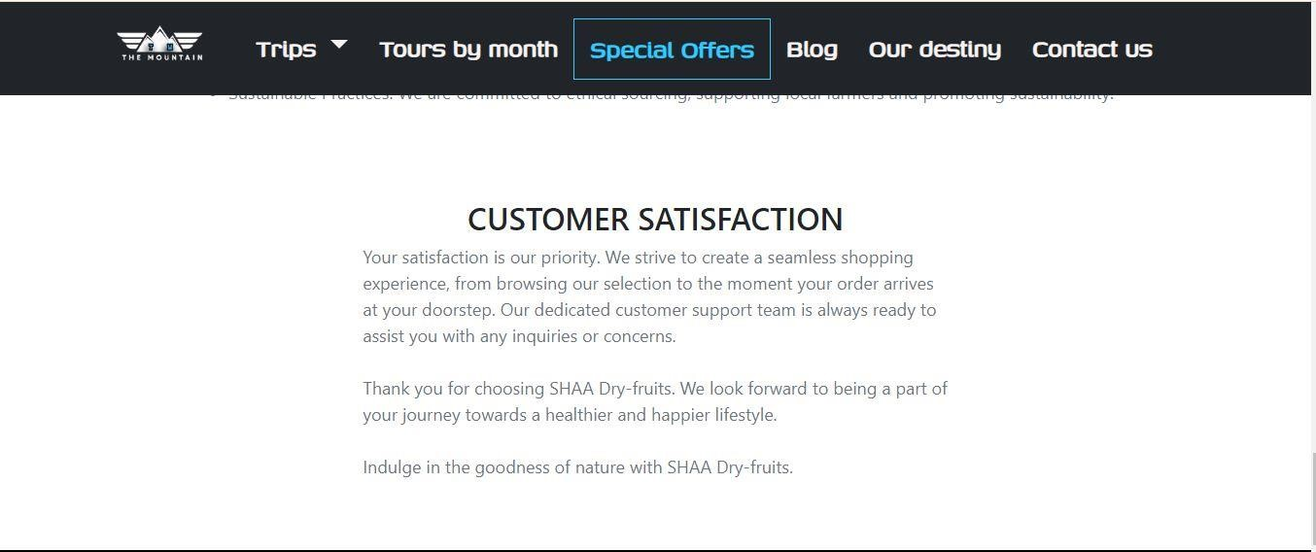

Figure 19: Customer Satisfaction

### 6.Welcome (Story)

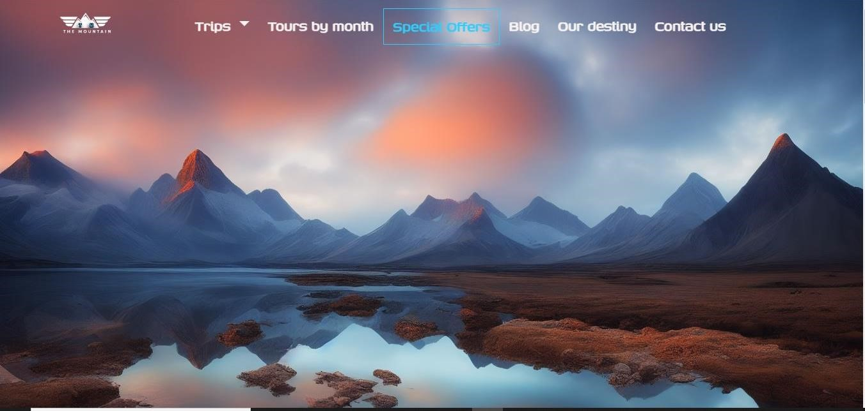

Figure 20: Story

The history of mountaineering is rich and diverse, spanning thousands of years and encompassing a wide range of cultures, regions, and motivations. Here's an overview of some key milestones and developments in the history of mountaineering:

1. **Early Exploration:** Mountaineering traces its roots back to ancient times when people began exploring and climbing mountains for various reasons, including religious rituals, hunting, gathering resources, and communication. Early civilizations in regions such as the Alps, the Andes, the Himalayas, and the Caucasus Mountains left evidence of human presence and activities in mountainous areas.

1. **Alpine Mountaineering:** The development of modern mountaineering is often associated with the exploration of the European Alps during the 18th and 19th centuries. Pioneering climbers and explorers, known as the "Golden Age" mountaineers, began ascending the highest peaks in the Alps, including Mont Blanc, the Matterhorn, and the Eager. These early climbers relied on basic equipment and techniques, often facing significant challenges and dangers during their ascents.

1. **Exploration and Mapping:** Mountaineering played a crucial role in the exploration and mapping of remote and inaccessible regions around the world. Expeditions to mountainous areas in Asia, Africa, the Americas, and Antarctica contributed to scientific discovery, geographical knowledge, and cultural exchange. Notable explorers and expeditions include the surveying of the Himalayas by British and European explorers in the 19th and early 20th centuries.

1. **Technical Advancements:** The evolution of mountaineering equipment, techniques, and training has progressed significantly over time. Innovations such as the introduction of crampons, ice axes, ropes, harnesses, and protective gear have improved climbers' safety and efficiency in challenging terrain. Training programs, guidebooks, and climbing schools have also contributed to the development of mountaineering skills and knowledge.

1. **High-Altitude Climbing:** The pursuit of high-altitude climbing and the conquest of the world's highest peaks became a focal point for mountaineers in the 20th century. Expeditions to peaks such as Mount Everest, K2, and the other eight-thousands in the Himalayas and Karakoram attracted international attention and challenged climbers with extreme altitude, harsh weather conditions, and technical difficulties. The first successful ascent of Mount Everest by Sir Edmund Hillary and Tensing Norgay in 1953 marked a significant milestone in mountaineering history.

1. **Exploration and Adventure:** Mountaineering continues to be a popular pursuit for adventurers, explorers, and outdoor enthusiasts around the world. Modern climbers engage in a wide range of activities, including rock climbing, ice climbing, alpine climbing, bouldering, and expedition climbing, each with its own challenges and rewards.

1. **Ethical and Environmental Considerations:** Mountaineering organizations and climbers increasingly emphasize the importance of responsible and sustainable climbing practices, environmental conservation, and respect for local cultures and communities. Initiatives such as Leave No Trace principles, ethical climbing guidelines, and conservation efforts aim to minimize the impact of mountaineering activities on fragile mountain ecosystems and cultural heritage sites.

Overall, the history of mountaineering reflects humanity's enduring fascination with mountains, exploration, and adventure, as well as our evolving understanding of the natural world and our place within it.

THANK YOU FOR READING THE

DOCUMATION PLEASE FOLLOW THE INSTRUCTION ABOVE!