EMAIL ASSISTANT MEMORY MAP
Reference name: Email Assistant Memory Map • Current state: short-term, semantic, episodic, and procedural
Core distinction Saver remembers one thread. Store keeps selected information across threads. Store memory is isolated per user_id; checkpoints are isolated per thread_id. “In-memory” means both disappear when the Python process stops.
Retrieval + feedback openai:text-embedding-3-small powers similarity search. Episodic examples come from human-approved corrections. Procedural rules use exact keys; a separate GPT optimizer proposes updates that the application saves.
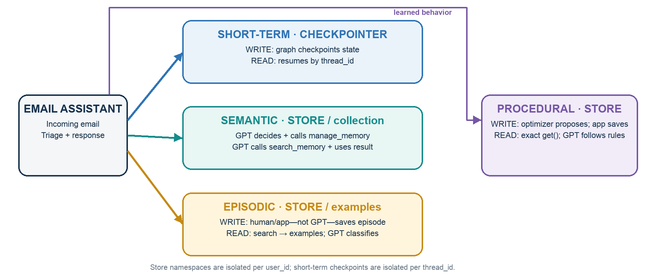
MEMORY | WRITE | READ | IDENTITY / SCOPE
Short-term | Graph/checkpointer automatically saves messages and state. | Saver restores the checkpoint for the same thread_id. | thread_id  one conversation
Semantic | GPT-4o-mini decides what to save and calls manage_memory. | GPT calls search_memory, then understands and uses returned facts. | user_id + collection  across threads
Episodic | Human/app—not GPT—saves the approved {email, label}. | App uses embedding search; GPT classifies from the examples. | user_id + examples  across threads
Procedural | Optimizer GPT proposes changes; the app saves approved instructions. | Application uses exact get(); router/agent GPT follows the rules. | user/app policy  across threads
Remember Episodic memory is what is stored; semantic search is how a relevant episode is selected; few-shot prompting is how it is used. Human review is selective—not requested after every classification—and the current lesson simulates the feedback.
Why useful Short-term: continue drafting within one email thread. Semantic: recall Alice’s earlier API endpoint request. Episodic: reuse John’s corrected “ignore” label for a similar FYI. Procedural: remember John’s revised deployment-FYI triage rule.

