AUTOMATIDATA
NYC Taxi & Limousine Commission Project
Course 3: Statistical Analysis Report
A/B Test — Payment Type vs. Fare Amount
Analyst | Walid
Client | New York City Taxi & Limousine Commission (TLC)
Consulting Firm | Automatidata
Project Stage | PACE: Analyze → Construct → Execute
Report Date | June 2026
Dataset | 2017 Yellow Taxi Trip Data (22,699 records)

Executive Summary
This report presents the findings of a statistical A/B test conducted on the 2017 NYC Yellow Taxi Trip Dataset on behalf of the New York City Taxi and Limousine Commission (TLC). The analysis was assigned by Luana Rodriguez, Senior Data Analyst at Automatidata, as part of the ongoing fare prediction project.
The central question is whether customers who pay by credit card tend to pay higher fare amounts than customers who pay by cash. A two-sample t-test was conducted at a 5% significance level. The results are statistically significant, showing that credit card customers pay a higher mean fare ($13.43) than cash customers ($12.21), a difference of approximately $1.22 per trip.
These findings provide actionable insight for TLC revenue strategy, while also surfacing important data quality issues and assumptions that must be addressed before any causal conclusions are drawn.

Project Background
Automatidata is a data consulting firm that transforms client data into actionable solutions. The current engagement with NYC TLC aims to develop a regression model that predicts taxi fares before a ride begins. This report covers the third stage of the project: statistical testing.

Team Members
Automatidata | NYC TLC
Udo Bankole — Director of Data Analysis  Deshawn Washington — Data Analysis Manager  Luana Rodriguez — Senior Data Analyst  Uli King — Senior Project Manager | Juliana Soto — Finance & Administration Head  Titus Nelson — Operations Manager

PACE Framework

Plan
Research Question: Does payment type (credit card vs. cash) have a statistically significant effect on the fare amount customers pay? Specifically, do customers who pay with credit cards tend to pay higher fare amounts than customers who pay with cash?
This question was identified as directly relevant to TLC's revenue analysis goals. Payment method could serve as a useful signal in identifying higher-value trip segments.

Hypotheses
H₀ (Null) | There is no difference in the average fare amount between customers who use credit cards and customers who use cash.
Hₐ (Alternative) | There is a difference in the average fare amount between customers who use credit cards and customers who use cash.
Significance Level | α = 0.05 (5%)
Test Type | Two-sample Welch's t-test (equal_var=False)

Analyze & Construct

Dataset Overview
The dataset contains 22,699 NYC taxi trip records from 2017, with 18 columns and zero missing values. The payment_type column is integer-encoded: 1 = Credit Card, 2 = Cash, 3 = No Charge, 4 = Dispute.

Descriptive Statistics — fare_amount
Statistic | Value
Count | 22,699
Mean | $13.03
Std Dev | $13.24
Min | -$120.00
25th Percentile | $6.50
Median (50th) | $9.50
75th Percentile | $14.50
Max | $999.99

Note: The minimum fare of -$120 and maximum of $999.99 indicate data quality issues. These anomalies should be addressed before building a predictive model, but were retained for the purpose of this hypothesis test.

Mean Fare by Payment Type
Payment Type | Count | Mean Fare Amount
1 — Credit Card | ~15,265 | $13.43
2 — Cash | ~7,267 | $12.21
3 — No Charge | ~168 | $12.19
4 — Dispute | ~~78 | $9.91

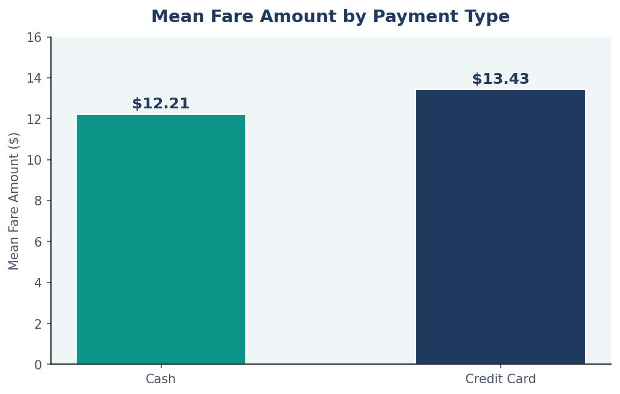
Figure 1. Mean fare amount by payment type. Credit card trips show a higher mean fare ($13.43) compared to cash ($12.21).
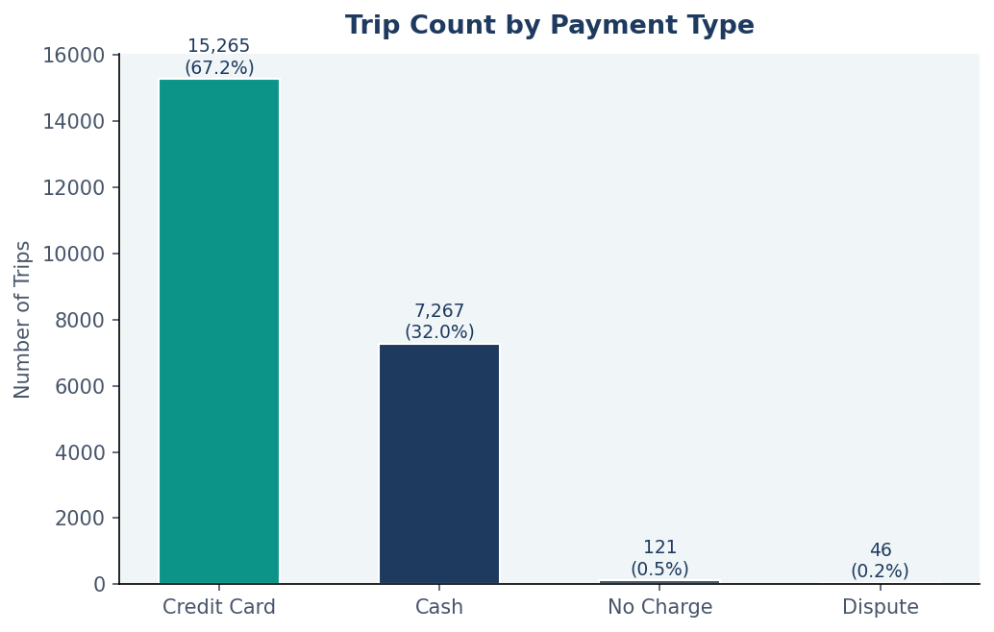
Figure 2. Trip count by payment type. Credit card is the dominant payment method (~67% of trips).

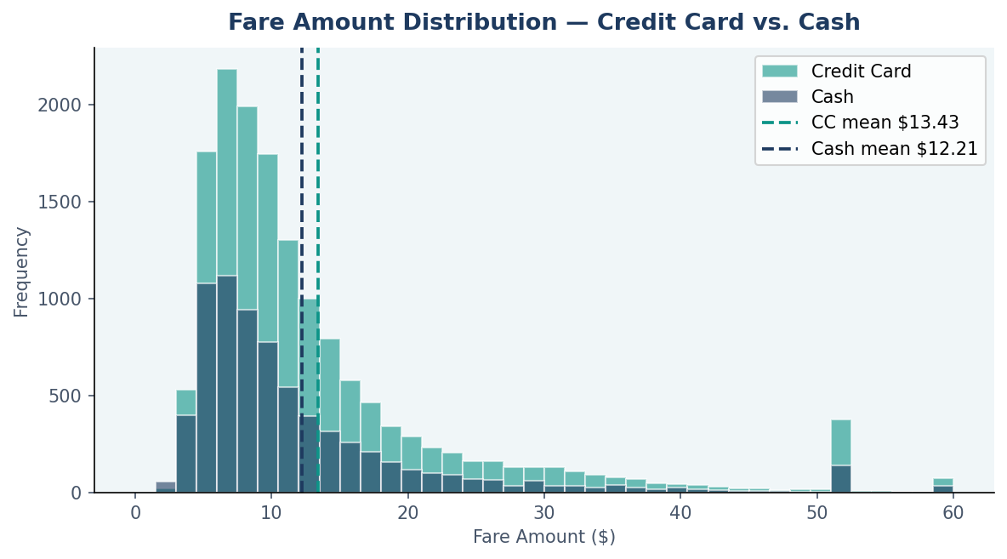
Figure 3. Overlaid fare amount distributions for credit card and cash trips. Both are right-skewed; credit card shows a slightly heavier right tail.
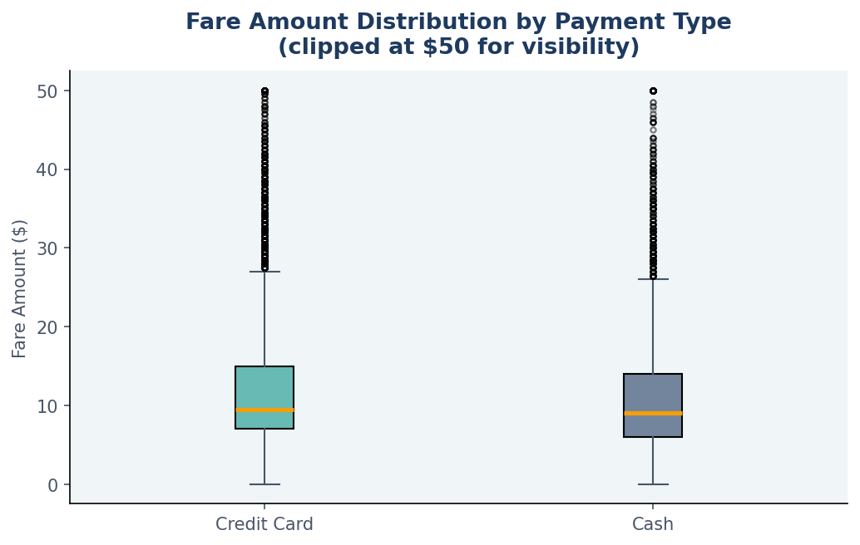
Figure 4. Box plot of fare amounts by payment type (clipped at $50 for visibility). The credit card median and spread are slightly higher.
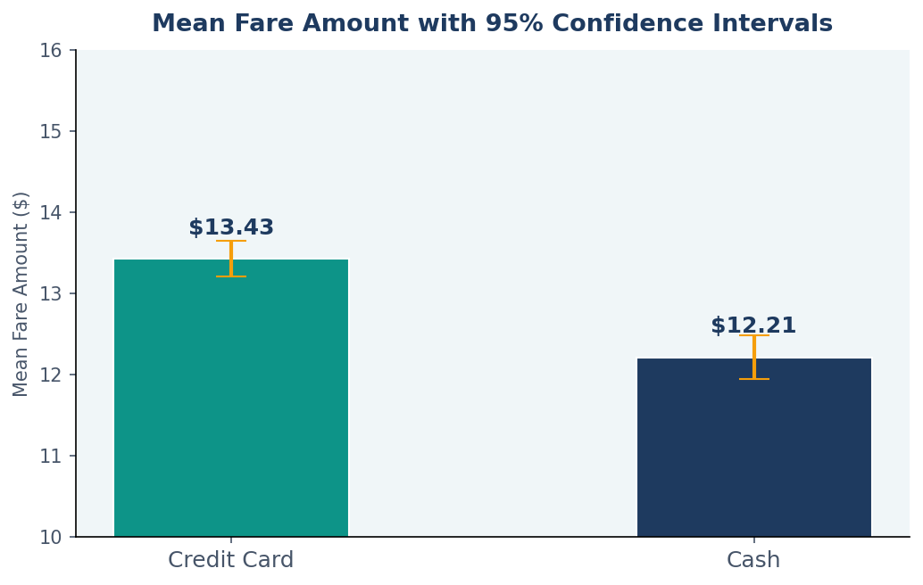
Figure 5. Mean fare amount with 95% confidence intervals. The non-overlapping CIs confirm the statistical significance of the difference.

Hypothesis Test — Two-Sample T-Test
The Welch's two-sample t-test was applied to compare mean fare amounts between credit card and cash payment groups. Welch's variant was used (equal_var=False) because the two groups have different sample sizes and potentially unequal variances.

Test Results
Metric | Value | Interpretation
T-Statistic | 6.8668 | Large positive value → credit card mean significantly higher
P-Value | < 0.0001 | Far below α = 0.05 threshold
Significance Level | 0.05 | 5% threshold chosen at project outset
Decision | Reject H₀ | Sufficient evidence to reject the null hypothesis

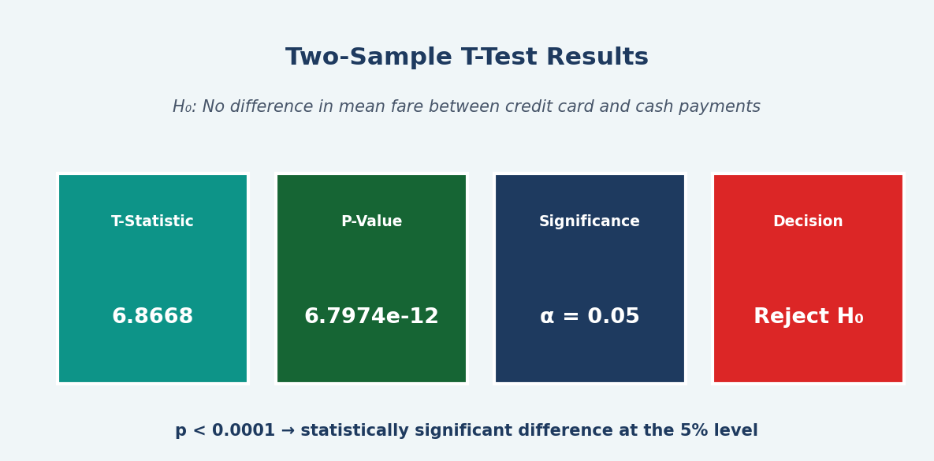
Figure 6. T-test result summary. T-statistic = 6.8668, p-value ≈ 0.0000. Null hypothesis rejected.

Decision
Since the p-value (< 0.0001) is far below the significance level of α = 0.05, we reject the null hypothesis. There is statistically significant evidence that credit card customers pay higher average fare amounts than cash customers (credit card mean: $13.43 vs. cash mean: $12.21, difference: ~$1.22).

PACE: Execute

Business Insights
- Credit card customers pay statistically significantly higher average fares ($13.43) than cash customers ($12.21). The ~$1.22 difference likely reflects that longer, higher-value trips — such as airport runs — are disproportionately paid by credit card.
- Payment type can serve as a revenue signal for TLC. Trips paid by credit card are associated with higher fares and, consequently, higher tip amounts (since cash tips are not recorded). Encouraging credit card adoption may improve revenue visibility and driver income tracking.
- The t-statistic of 6.8668 is large, indicating the effect is not marginal — the difference is robust across the dataset's 22,699 records.

Assumptions and Limitations
- Random assignment assumption: This A/B test assumes customers were randomly assigned to payment groups. In reality, customers self-select their payment method. Without true randomization, causal conclusions cannot be drawn — the observed difference may be driven by confounders such as trip distance, time of day, or pickup location.
- Cash tip underreporting: ~33% of trips are cash payments, for which tip amounts are recorded as $0. Any tip-based analysis is biased toward credit card behavior.
- Data quality issues: fare_amount has a minimum of -$120 and a maximum of $999.99. These anomalous records were retained for this statistical test but must be cleaned before regression modeling.
- Payment type codes 3 (No charge) and 4 (Dispute) were excluded from the A/B test — only types 1 and 2 were included.

Recommended Next Steps
- Clean anomalous records: remove negative fares, zero-distance trips with fares, and invalid trip durations before model training.
- Investigate confounders: conduct multivariate analysis to determine how much of the fare difference is attributable to payment type versus trip distance or RatecodeID.
- Expand to tip analysis: explore whether credit card tipping rates differ significantly by time of day, vendor, or trip duration — using only credit card records.
- Proceed to regression modeling: use trip_distance as the primary predictor of fare_amount, incorporating the engineered features from Course 2 (pickup_hour, day_of_week).
- Build Tableau stakeholder dashboard: visualize fare distributions, payment trends, and temporal patterns for Juliana Soto and Titus Nelson at TLC.

Conclusion
The hypothesis test confirms a statistically significant relationship between payment type and fare amount. Credit card customers pay higher average fares — a finding consistent across 22,699 records. While causal conclusions require caution given the self-selection bias in payment method, this result is a meaningful input for TLC's revenue strategy and supports continued progression toward the fare prediction regression model in Course 4.

