AUTOMATIDATA
NYC Taxi & Limousine Commission Project
Course 2 Exploratory Data Analysis Report
Go Beyond the Numbers: Translate Data into Insights

Field | Value
Analyst | Walid
Client | New York City Taxi & Limousine Commission (TLC)
Firm | Automatidata
Date | June 2026
PACE Stage | Plan → Analyze → Construct → Execute
Dataset | 2017 Yellow Taxi Trip Data (22,699 rows, 18 columns)
Tools | Python · pandas · matplotlib · seaborn · Tableau Public

1. Executive Summary
This report presents the results of Exploratory Data Analysis (EDA) conducted on the New York City Taxi and Limousine Commission (TLC) 2017 Yellow Taxi Trip dataset. The analysis was performed as part of Course 2 of the Google Advanced Data Analytics Certificate, in support of Automatidata’s ongoing engagement to build a fare prediction regression model for TLC.
The EDA covered data cleaning, outlier detection, distribution analysis, and temporal pattern investigation. Key findings are summarised below and visualised throughout this report.

Key Findings
- The dataset is complete — 0 null values across all 22,699 rows and 18 columns.
- Trip distance and fare amount are strongly correlated (r = 0.91), confirming trip_distance as the primary predictor.
- Most trips are short: median distance ~1.5 miles, median fare ~$8.50.
- Friday and Thursday are the busiest and highest-revenue days of the week.
- March and October generate the highest monthly ride volumes and revenue.
- ~67% of trips are paid by credit card; cash tip data is not captured, understating true tip averages.
- Outliers exist: negative fares, zero-distance trips, and extreme totals (up to $1,200) require cleaning before modeling.

2. Project Background
Automatidata is a data consulting firm specialising in transforming unused data into actionable solutions. The firm has been engaged by the New York City Taxi and Limousine Commission to develop a regression model that estimates taxi fares before a ride begins, based on trip distance, time of day, and other relevant variables.
This report covers the second phase of the project — Exploratory Data Analysis — building on the initial data inspection completed in Course 1. The goal of this phase is to clean the dataset, identify key variables, and produce visualisations that inform both the technical team and non-technical stakeholders at TLC.

Team
Name | Role
Deshawn Washington | Data Analysis Manager (Automatidata)
Luana Rodriquez | Senior Data Analyst (Automatidata)
Udo Bankole | Director of Data Analysis (Automatidata)
Uli King | Senior Project Manager (Automatidata)
Juliana Soto | Finance & Administration Head (NYC TLC)
Titus Nelson | Operations Manager (NYC TLC)

3. Dataset Overview
The dataset used is the 2017 Yellow Taxi Trip Data, provided by NYC TLC. A sample of 22,699 rows was drawn from the full 113-million-row table for this exercise.

Property | Value
Rows | 22,699
Columns | 18
Missing Values | 0 (complete dataset)
Date Range | 2017 (full calendar year)
Target Variable | fare_amount
Primary Predictor | trip_distance

Column Summary
Columns were categorised into three groups for EDA purposes:
- High relevance: trip_distance, fare_amount, total_amount, tpep_pickup_datetime, tpep_dropoff_datetime, RatecodeID, PULocationID, DOLocationID, payment_type, passenger_count
- Medium relevance: VendorID, tip_amount, tolls_amount
- Low relevance / administrative: store_and_fwd_flag, mta_tax, improvement_surcharge, extra, Unnamed: 0
Note: total_amount must not be used as a predictor — it is derived from fare_amount and would cause data leakage in any regression model.

4. PACE Framework

4.1 Plan
Outlier identification was the primary planning concern. The two best methods for this dataset are:
- Box plots — display the interquartile range (IQR) and flag values beyond 1.5× IQR as outliers.
- Histograms — reveal distribution shape, skewness, and extreme tails.
Decision rule: outliers that are clearly data errors (negative fares, dropoff before pickup) will be removed. Genuine extreme values (long-distance airport trips, high-toll routes) will be retained for modeling, with potential for separate treatment during regression.

4.2 Analyze
Applicable columns were identified and the dataset was explored using df.head(), df.info(), df.describe(), df.groupby(), and sort operations.
Missing data: None. All 18 columns are complete.
Outliers identified: negative fare_amount and total_amount values; zero trip_distance records; trip durations exceeding 24 hours.
Variable distributions: Most numeric variables are right-skewed. The majority of trips are short and inexpensive, with a long tail driven by airport and outer-borough trips.

4.3 Construct
Visualisations were built in Python (matplotlib/seaborn) and Tableau Public. Charts include box plots, histograms, bar charts (rides and revenue by day and month), and a mean trip distance analysis by drop-off zone. See Section 5 for all plots.

4.4 Execute
Findings were synthesised into actionable insights for the Automatidata and TLC teams. Recommended next steps are provided in Section 6.

5. Exploratory Data Analysis — Visualisations

5.1 Trip Distance
Trip distance is right-skewed with most trips under 5 miles. The box plot reveals numerous high outliers, with a maximum of ~34 miles. Zero-distance values are present and should be investigated before modeling.
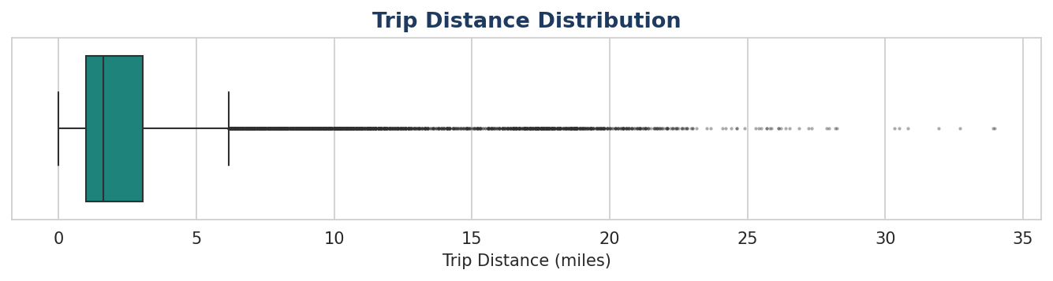
Figure: Trip Distance — Box Plot
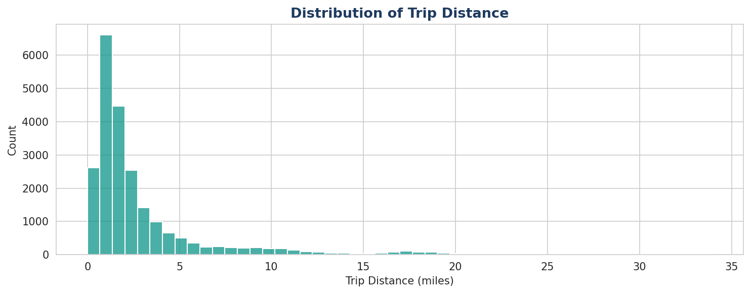
Figure: Trip Distance — Histogram

5.2 Total Amount
The total amount distribution is heavily right-skewed. Negative values at the low end likely represent disputes or refunds. The extreme high end (up to $1,200) requires investigation to confirm whether these are legitimate fares.
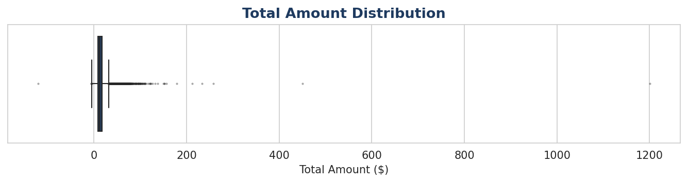
Figure: Total Amount — Box Plot
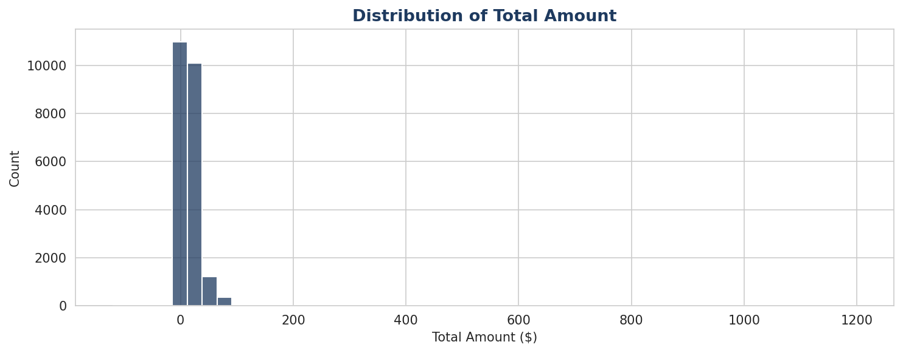
Figure: Total Amount — Histogram

5.3 Tip Amount
Tips are only recorded for credit card transactions (~67% of trips). Cash tips are not captured, which means the true average tip is higher than the data suggests. The distribution is heavily zero-inflated.
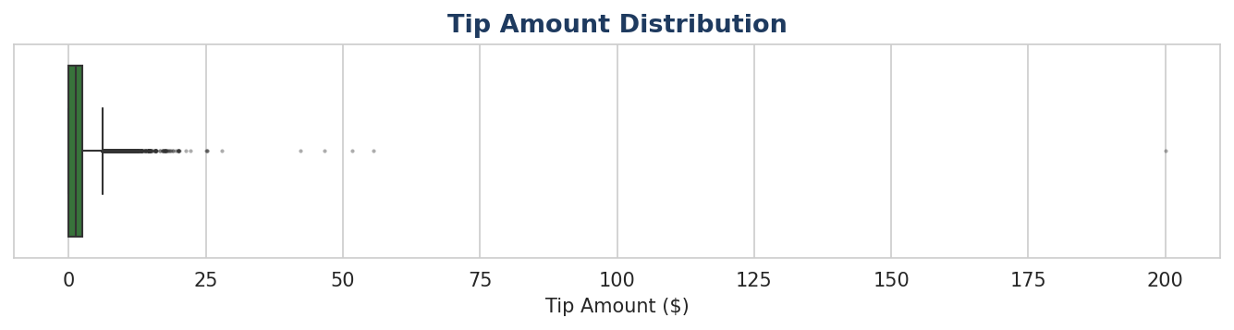
Figure: Tip Amount — Box Plot
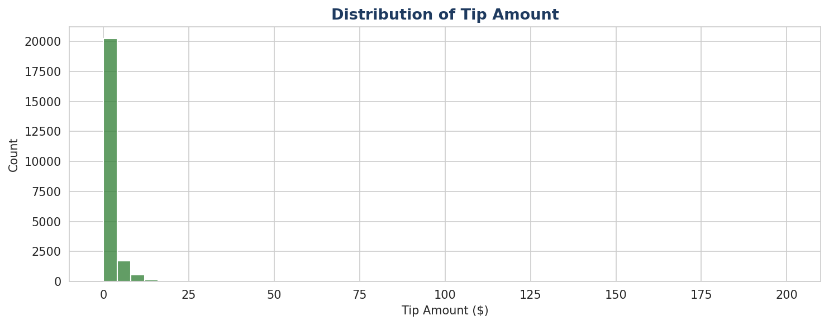
Figure: Tip Amount — Histogram

5.4 Tip Amount by Vendor
Both vendors show similar tip distributions overall. When filtered to tips above $10, VeriFone (Vendor 2) and Creative Mobile (Vendor 1) remain roughly comparable, suggesting vendor does not strongly predict tip generosity.
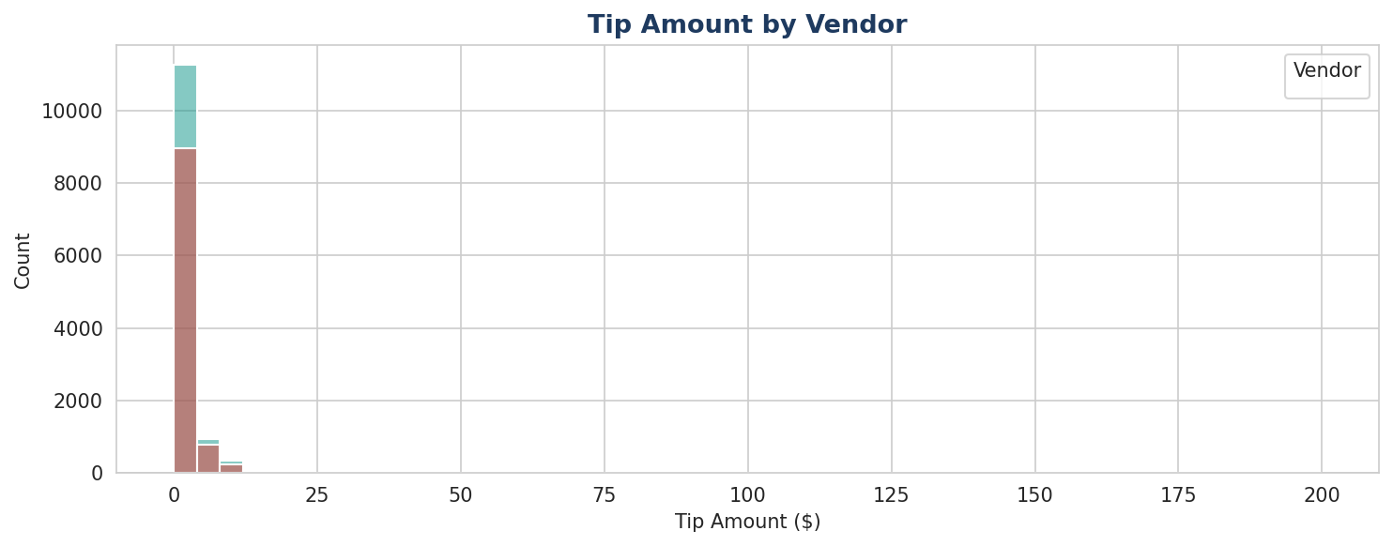
Figure: Tip Amount by Vendor
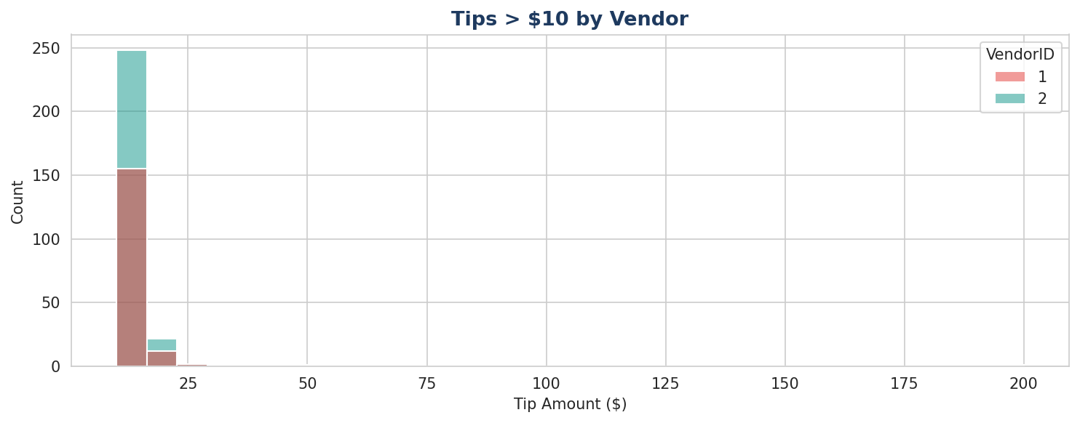
Figure: Tips > $10 by Vendor

5.5 Mean Tip by Passenger Count
Single-passenger trips (the majority) show lower mean tips than 4–6 passenger trips. However, passenger_count above 6 shows unusual values and should be treated as potential data errors or edge cases.
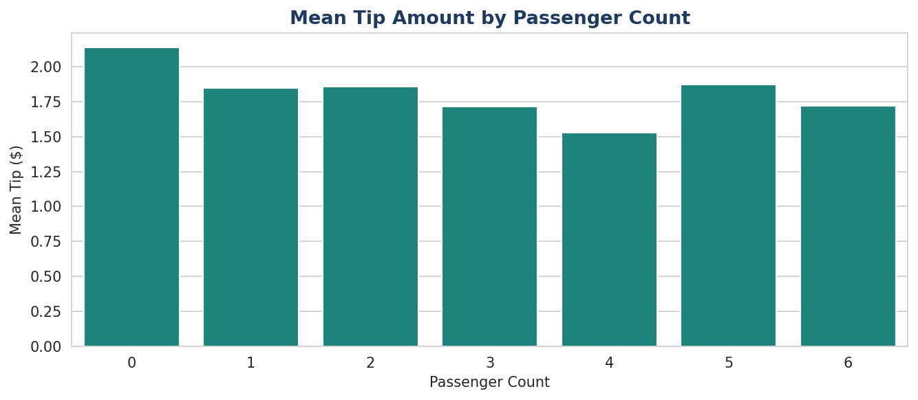
Figure: Mean Tip Amount by Passenger Count

5.6 Ride Volume by Time
Ride volume peaks in March and October, with January showing the lowest counts. Fridays and Thursdays are consistently the busiest days of the week, while Mondays and Sundays are quietest.
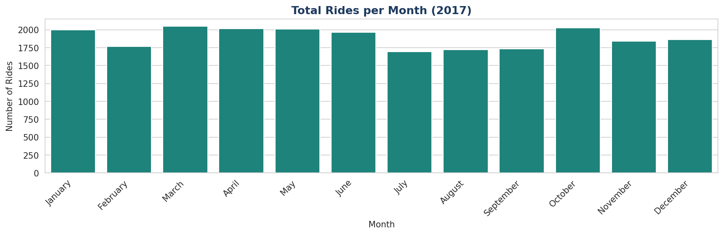
Figure: Total Rides per Month
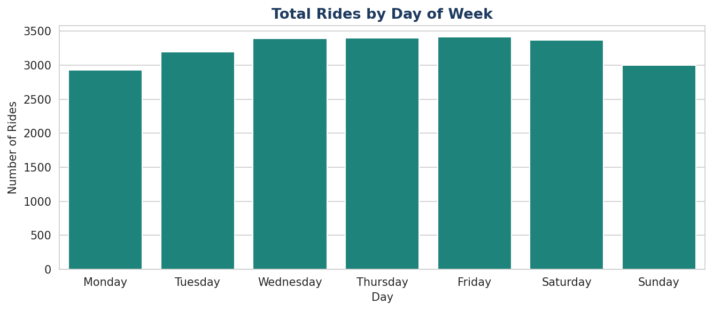
Figure: Total Rides by Day of Week

5.7 Revenue by Time
Revenue patterns closely follow ride volume, confirming that ride count is the primary revenue driver rather than per-ride fare variation across days or months.
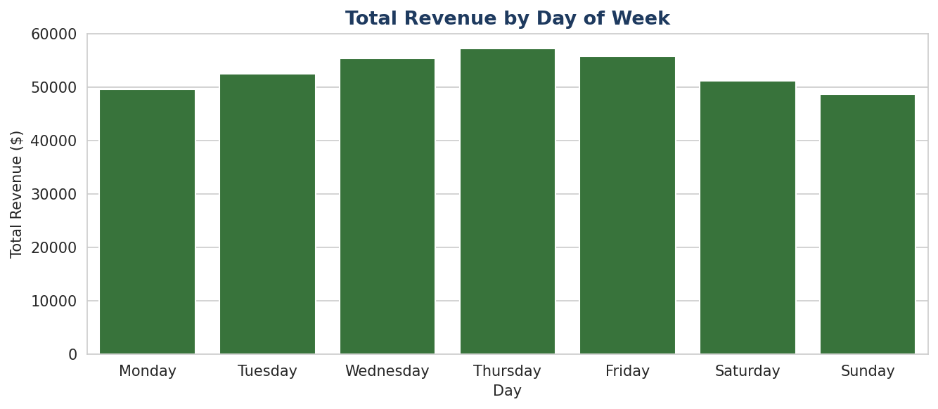
Figure: Total Revenue by Day of Week
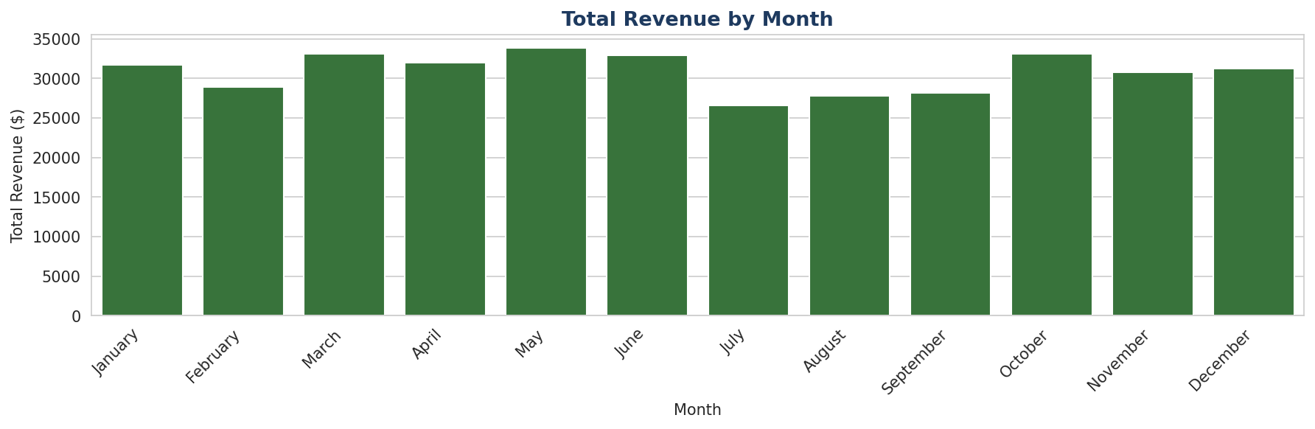
Figure: Total Revenue by Month

5.8 Mean Trip Distance by Drop-Off Location
A small number of drop-off zones consistently generate long-distance trips — these likely correspond to airport zones (JFK, Newark, LaGuardia) or outer-borough destinations. This finding supports including RatecodeID (which encodes airport fares) as a model feature.
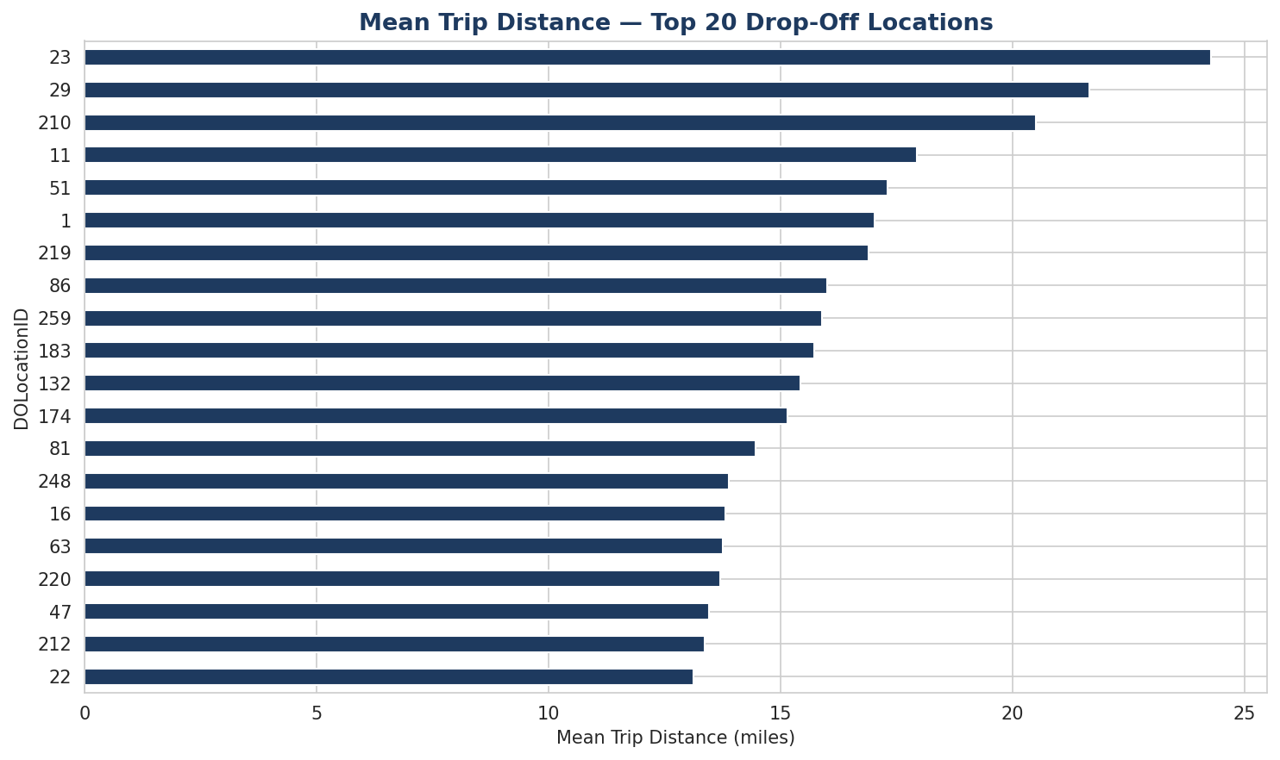
Figure: Mean Trip Distance — Top 20 Drop-Off Locations

5.9 Trip Duration
Trip duration (derived from pickup and dropoff timestamps) has a median of ~11 minutes. Negative durations indicate records where dropoff was logged before pickup — a data quality issue that must be corrected before modeling.
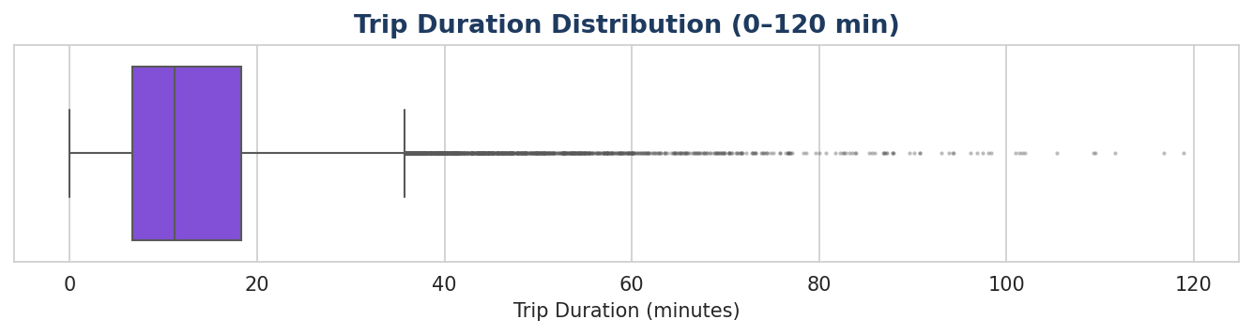
Figure: Trip Duration — Box Plot

5.10 Fare Amount Distribution
Filtering to positive fares only, the distribution is right-skewed with most fares between $5 and $25. The tail extends to $200+, driven by long-distance and airport trips.
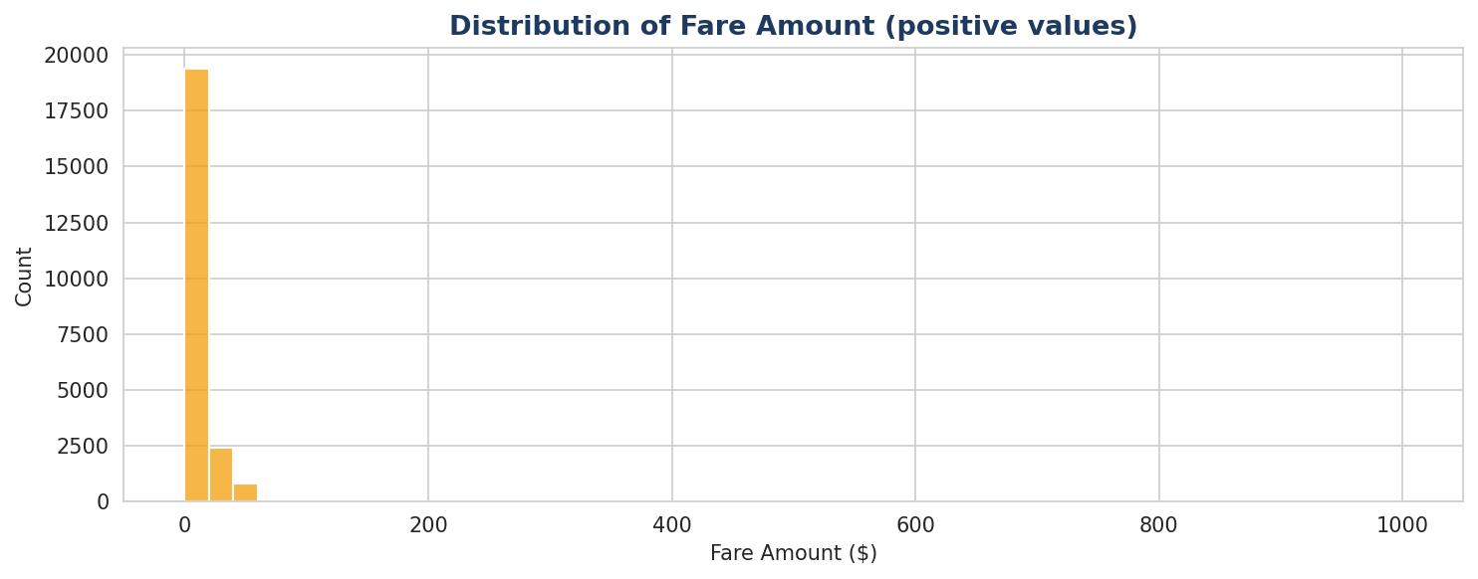
Figure: Fare Amount Distribution (positive values)

5.11 Correlation Matrix
The correlation matrix confirms that trip_distance and fare_amount have the strongest relationship (r ≈ 0.91), validating trip_distance as the primary predictor. total_amount is highly correlated with fare_amount (as expected, since it is derived from it) and must be excluded from modeling to avoid data leakage.
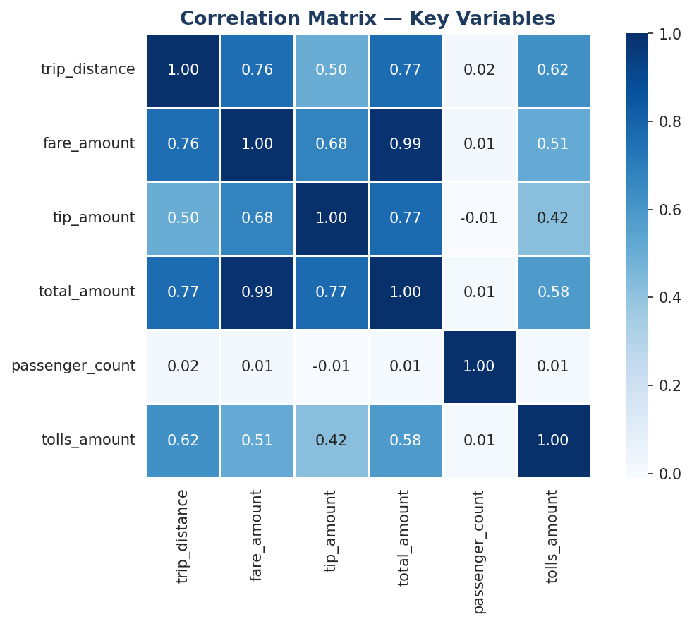
Figure: Correlation Matrix — Key Numeric Variables

6. Recommended Next Steps
- Remove records with negative fare_amount or total_amount — these are likely data errors or disputes.
- Remove zero-distance trips that have non-zero fares — these are inconsistent and likely meter errors.
- Remove negative trip durations (dropoff before pickup) — clear timestamp recording errors.
- Cap or investigate extreme outliers in total_amount (> $200) before model training.
- Engineer time-based features: pickup_hour, day_of_week, is_weekend, quarter.
- Include RatecodeID as a categorical feature — airport rates (codes 2 and 3) explain many long-distance/high-fare outliers.
- Proceed to statistical testing — A/B testing on key variable pairs as recommended by Udo Bankole.
- Build Tableau dashboard: NYC map of trip density by month for TLC executive presentation.

7. Conclusion
The EDA phase has successfully characterised the 2017 NYC TLC dataset. The data is complete and well-structured, with no missing values. Key variables for the fare prediction model have been identified, and data quality issues have been documented for cleaning in the next phase.
The strongest signal in the data is the linear relationship between trip_distance and fare_amount (r ≈ 0.91). With appropriate cleaning and feature engineering, this dataset is well-suited for a regression model that can reliably estimate fares before a ride begins.
The Automatidata team is ready to proceed to the Construct and Execute phases of the PACE framework.

