

Autonomous Mobile Robotics

HW1

Walid Shaker

Case1: v(t) = 0.5 m/s, ω(t) = 0 rad/s

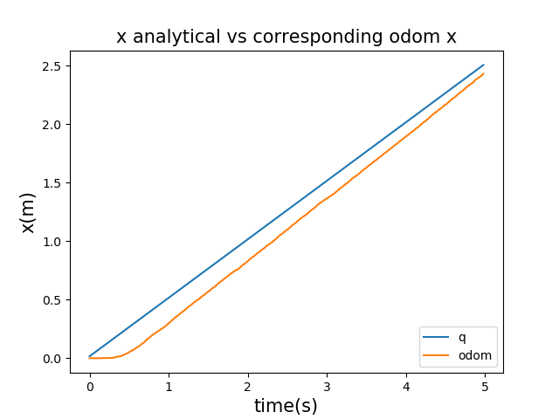

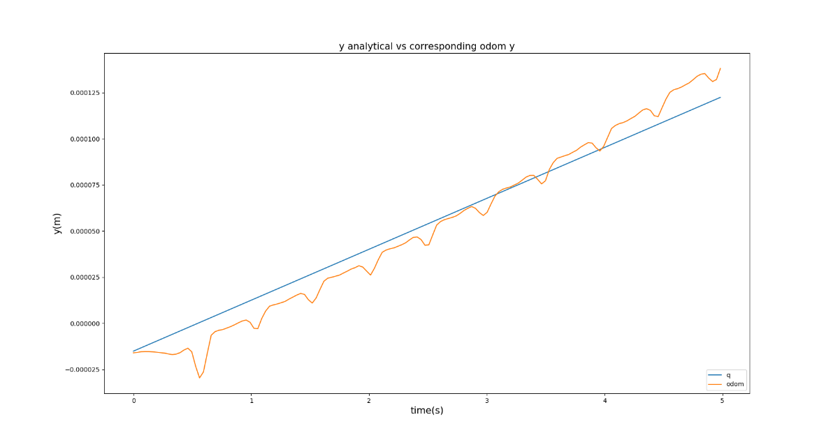

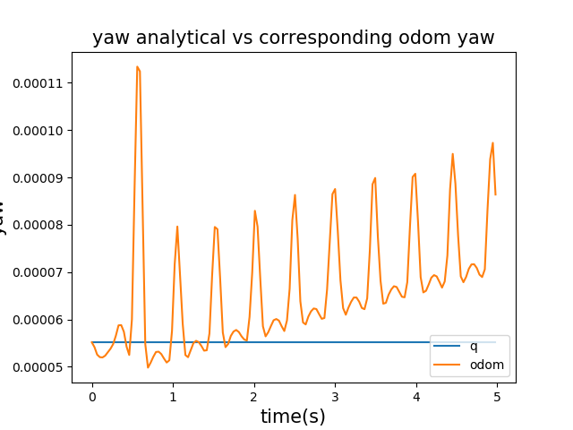

Case2: v(t) = 1.0 m/s, ω(t) = 2.0 rad/s

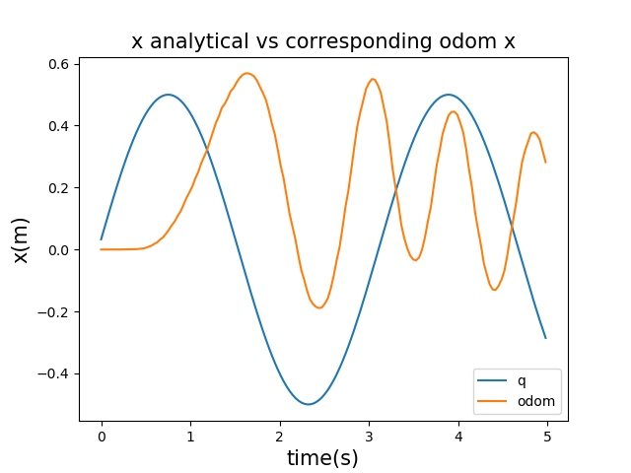

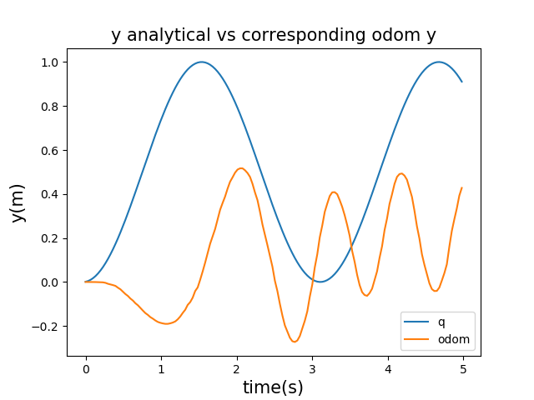

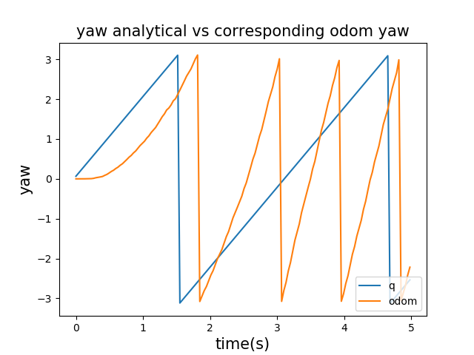

Case3: v(t) = 0 m/s, ω(t) = 2.0 rad/s

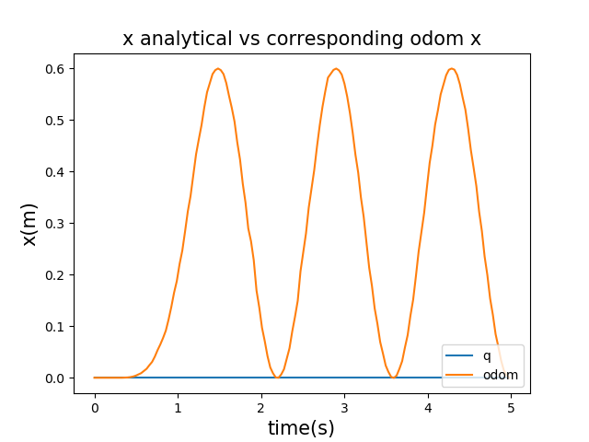

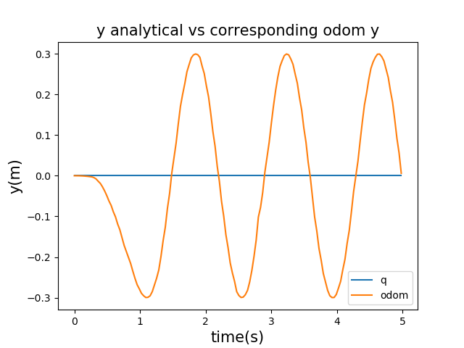

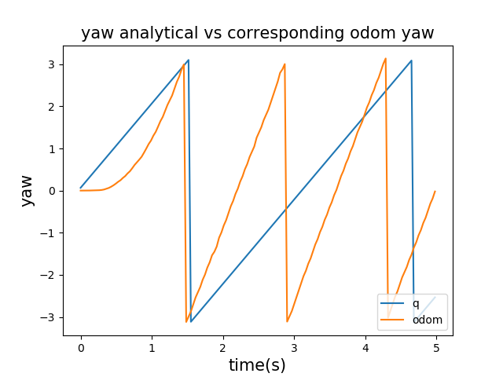

Case4: wheels angular velocities are ω(t)L = 20rad/s and ω(t)R = 18rad/s

        v = r/2\*(wR+wL) # Robot velocity

        w = r/L\*(wR-wL) # Robot angular velocity

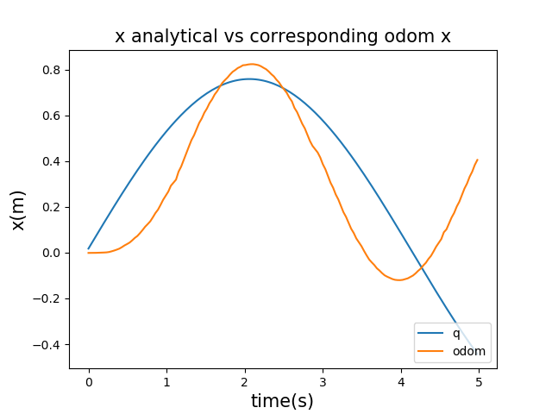

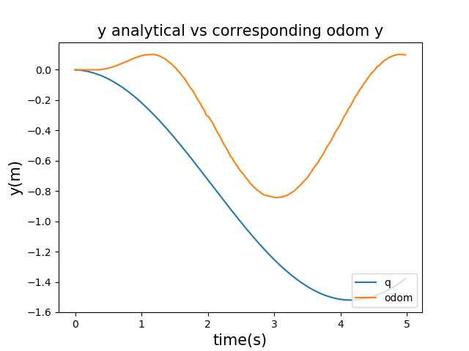

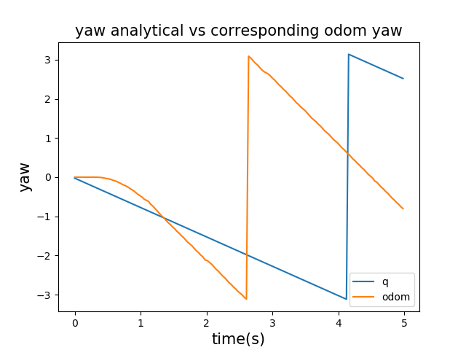

In all cases, the calculated and simulated path do not coincide. The odometry data show some errors due to multiple reasons. First of all, there is not any feedback controller to drive the robot at the desired path. Second, the simulation environment is not optimal, there might be a friction between wheels and ground which affects the odometry data.

The error can be reduced by feedback controller or apply Kalman filter.

The code is attached.