

Autonomous Mobile Robotics

HW2

Walid Shaker

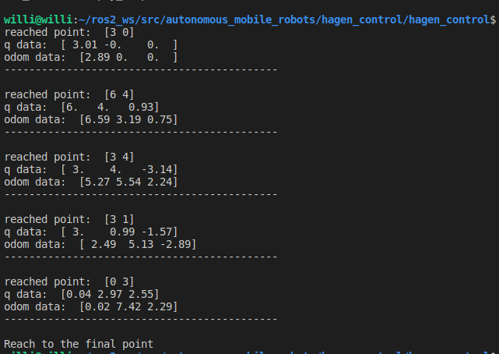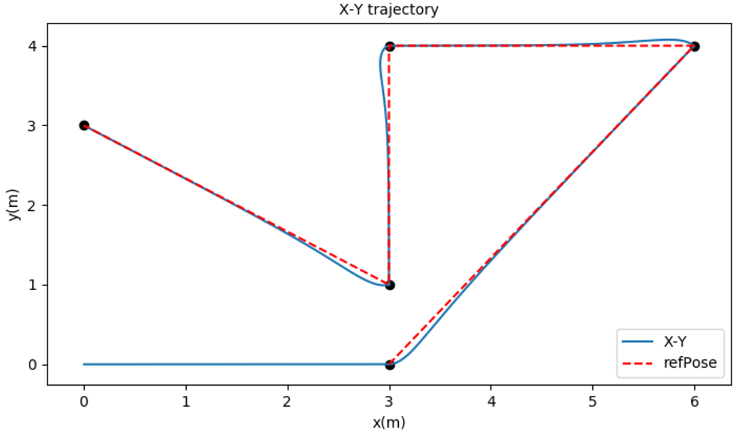**Code output:**

**Results:**

As shown in the output, the analytical solution (q) approximately matches the reference point defined. However, the odom data showed some deviation at the first point and started to diverge by time.

Initial pose is assumed to be [0, 0]

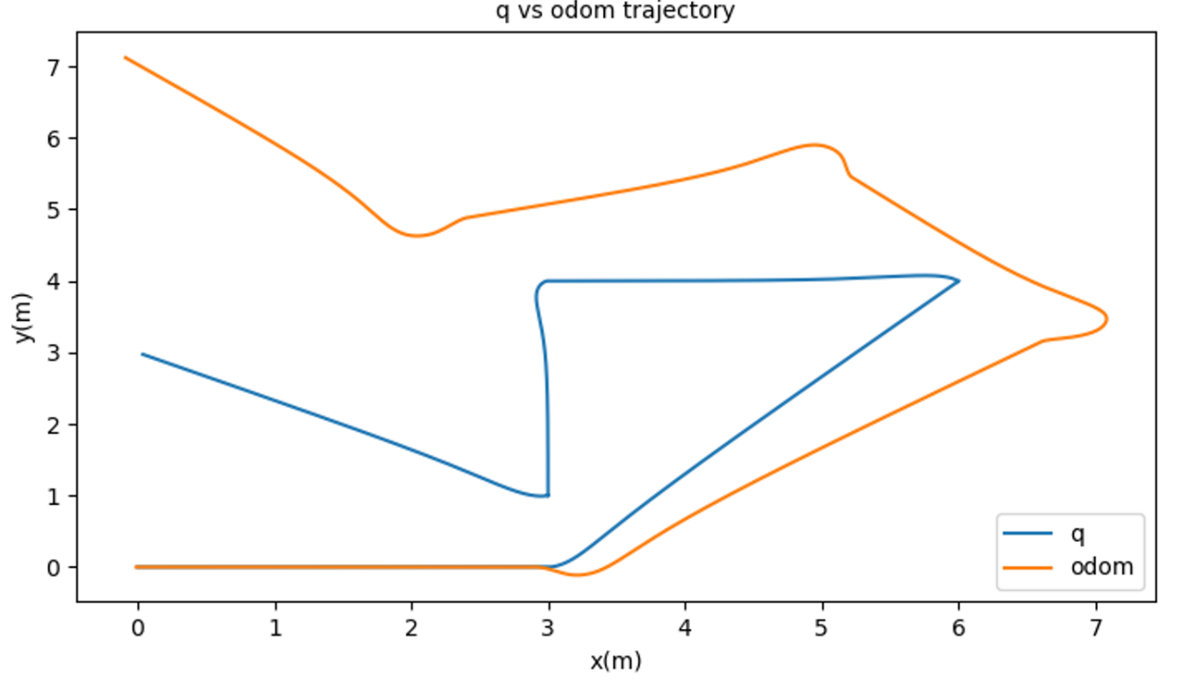In the previous figure, the refPose is plotted verses the q analytical. Due to the abrupt change in robot orientation, it results in non-smooth transitions which can be shown in the following figures.

In this figure, the calculated and simulated path do not coincide. The odometry data show some errors due to multiple reasons. First of all, there is not any feedback controller to drive the robot at the desired path. Second, the simulation environment is not optimal, there might be a friction between wheels and ground which affects the odometry data.

In the following page, x,y,and yaw are shown from the analytical calculation and the simulation data (odometery).

