

Autonomous Mobile Robotics

HW4

Walid Shaker

**Path Planning:**

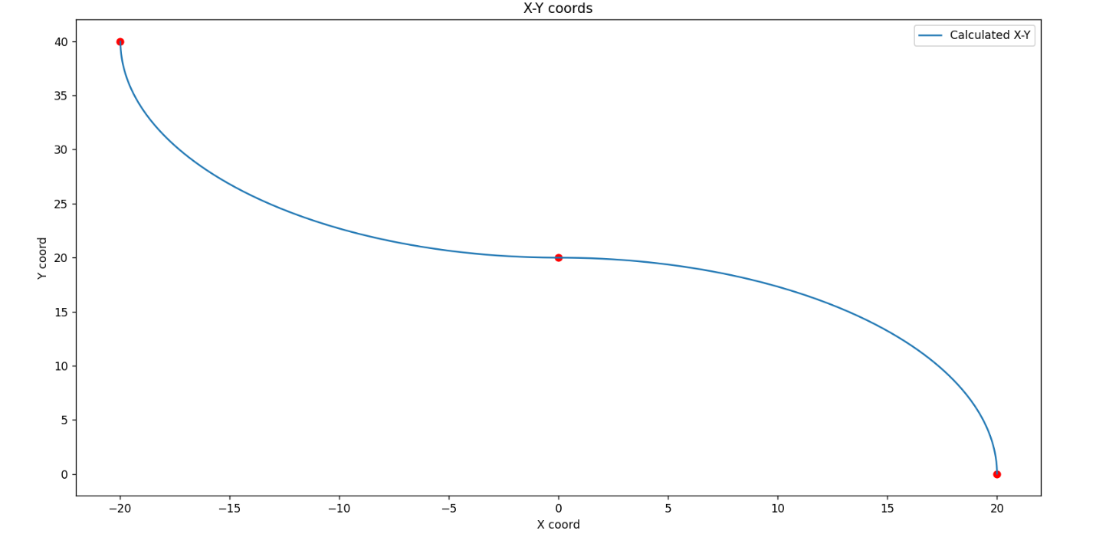The trajectory is defined using two circles as shown below. The code is attached.

Point B (starting point) is selected as (-20, 40)

Point A (final point) is (20,0)

Point C (midpoint) is (0,20)

Since $r = 20$, so if we set $v=0.5$, then $ω=0.025$

The simulation time from B to C ($t) = \frac{π/2}{ω}=62.83 sec$

So, the total time ($t_{f}$) that the vehicle takes from B to A is $125.6 sec$

Let the sampling time $dt=0.05$, so the number of iterations to reach final point $N= \frac{t_{f}}{dt}=2512$

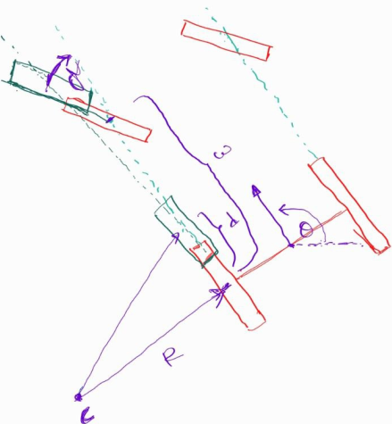**Motion Model: kinematics**

I used the same bicycle model explained in the lecture.

Robot pose ${[x, y, θ]}^{T}$

A robot can be control through linear and angular velocities $u = {[v, ω]}^{T}$

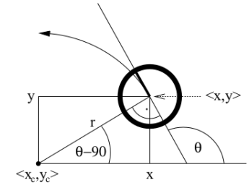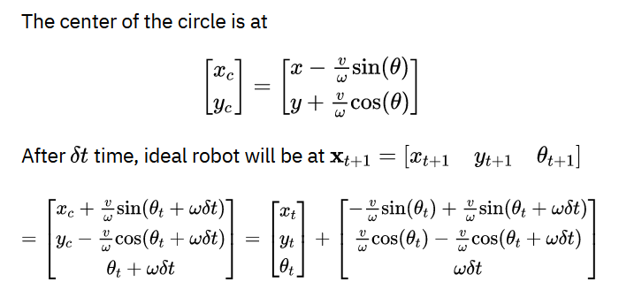

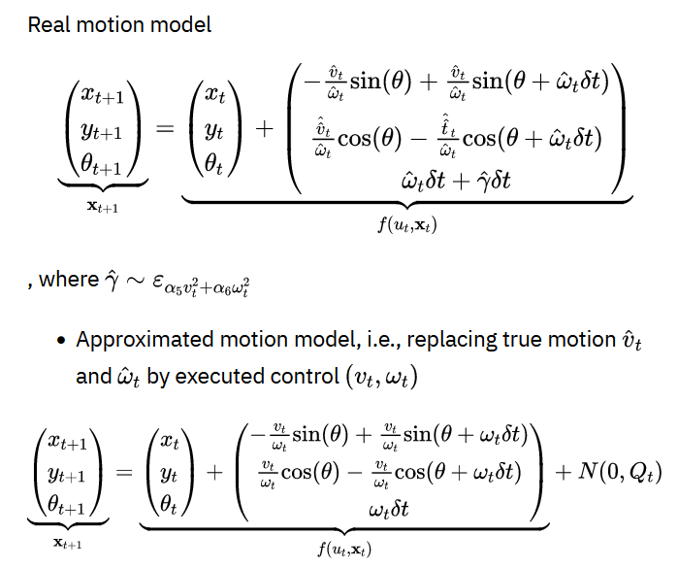

**Sensor Model: correction step**

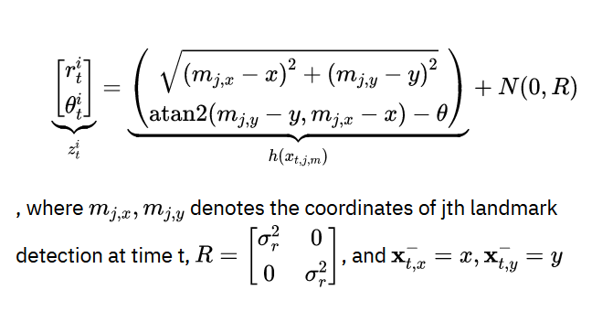

**PF with EKF**

Extended Kalman filter prediction and correction steps for each particle, and the real robot position and the estimated robot position are plotted over the time as shown below.

