# Software Design Specification

# Car Dealership Management System

Version 1.0

Prepared by: Abubakar Bammami Isa

Your Name(s)

Date: June 29th, 2025

# Table of Contents

Table of Contents

Software Design Specification 1

Car Dealership Management System 1

Table of Contents 2

1. Introduction 3

1.1 Purpose 3

1.2 Scope of the Development Project 3

1.3 Definitions, Acronyms, and Abbreviations 3

1.4 Overview of Document 3

2. System Architecture 4

2.1 System Architecture Overview 4

2.1.1 High-Level Architecture Diagram 4

4

2.1.2 Architecture Narrative 4

2.2 GUI Components with Layouts and Navigation 5

2.2.1 User Interface Issues 5

2.2.2 List of User Interface Screens and Reports 5

2.2.3 User Interface Screens and Reports 5

3. System Components 10

3.1 Class Diagram 10

10

3.2 Use Case Descriptions 10

3.2.1 Sequence Diagram for Use Case 12

4. Design Decisions and Tradeoffs 13

Appendix A: Use Case Diagrams 14

Appendix B: Data Dictionary 14

Appendix C: Inputs and Outputs 15

# 1. Introduction

## 1.1 Purpose

The purpose of this document is to present a detailed description of the Car Dealership Management System. It explains the system’s architecture, design decisions, and class relationships that define how the application works. This document will serve as a blueprint for developers during implementation.

## 1.2 Scope of the Development Project

The Car Dealership Management System is a desktop-based application designed to streamline car dealership operations. It enables vendors to upload cars, buyers to browse and contact sellers, and admins to receive general feedback messages. The system is built using C# and Windows Forms with SQLite as the local database engine.

## 1.3 Definitions, Acronyms, and Abbreviations

|  |  |
| --- | --- |
| Term | Definition |
| C# | Programming language used for application logic |
| Windows Forms | UI framework used for building the desktop app |
| SQLite | Local database used for storing car, vendor, and message data |
| DevExpress | UI toolkit for advanced components like RibbonForm and Panels |
| Admin | User role with full access to system features |
| Vendor | User who uploads and manages cars |
| Guest | User who browses cars and sends messages but cannot upload cars |

## 1.4 Overview of Document

This document describes the software design of the Car Dealership Management System. Section 2 covers the system architecture and GUI components. Section 3 includes class diagrams and use cases. Section 4 outlines major design decisions and trade-offs made during development.

# 2. System Architecture

## 2.1 System Architecture Overview

**The Car Dealership Management System uses** C# and Windows Forms for the user interface, with **SQLite** as the local database engine.

### 2.1.1 High-Level Architecture Diagram

### C:\Users\walid\Downloads\high-level architecture diagram.png

### 2.1.2 Architecture Narrative

**Screen Building Software:** Visual Studio was used to build the UI using Windows Forms.  
  
**Report Building Software:** Optional reports can be generated using iTextSharp or other PDF libraries.  
  
**Communication Tools:** Git / GitHub for version control.  
  
**Implementation Language:** C#, with SQLite for database handling.  
  
**CASE/Productivity Tools:** No external CASE tools were used.

## 2.2 GUI Components with Layouts and Navigation

### 2.2.1 User Interface Issues

The main users are Admin, Vendor, and Guest. The system uses DevExpress UI components for a modern look and feel.  
Users are expected to have basic computer knowledge.  
Navigation is handled via a ribbon menu with tabs: Home, Login, Upload, Inbox, Contact Us, Dashboard.

### 2.2.2 List of User Interface Screens and Reports

* SS1 - Home Page
* SS2 - Log In
* SS3 - Sign Up
* SS4 - Upload Car
* SS5 - View Car Details
* SS6 - Vendor Dashboard
* SS7 - Inbox Form
* SS8 - Contact Us

### 2.2.3 User Interface Screens and Reports

* SS1 - Home Page

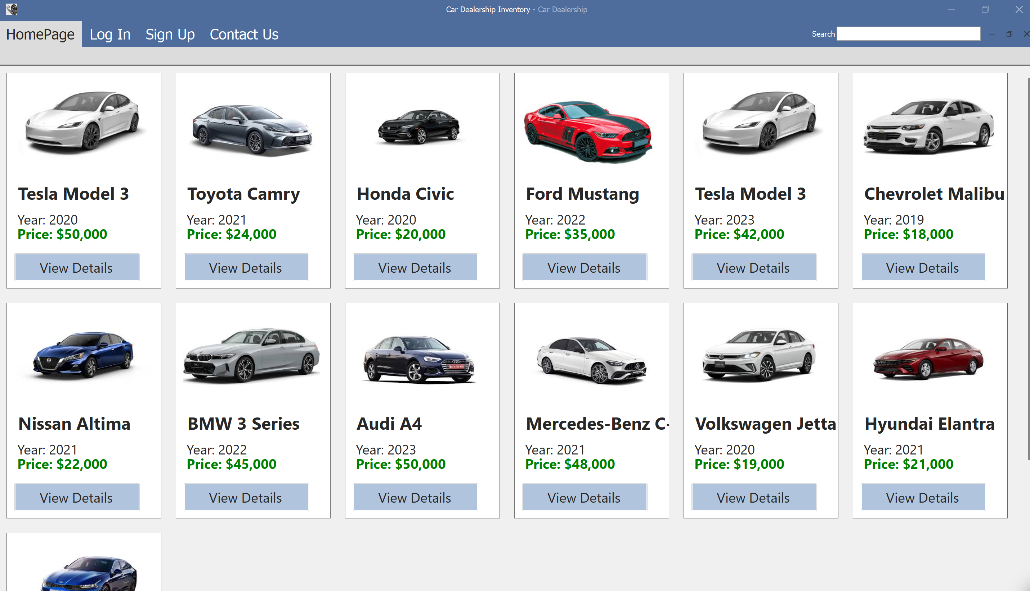

* SS2 – Log In

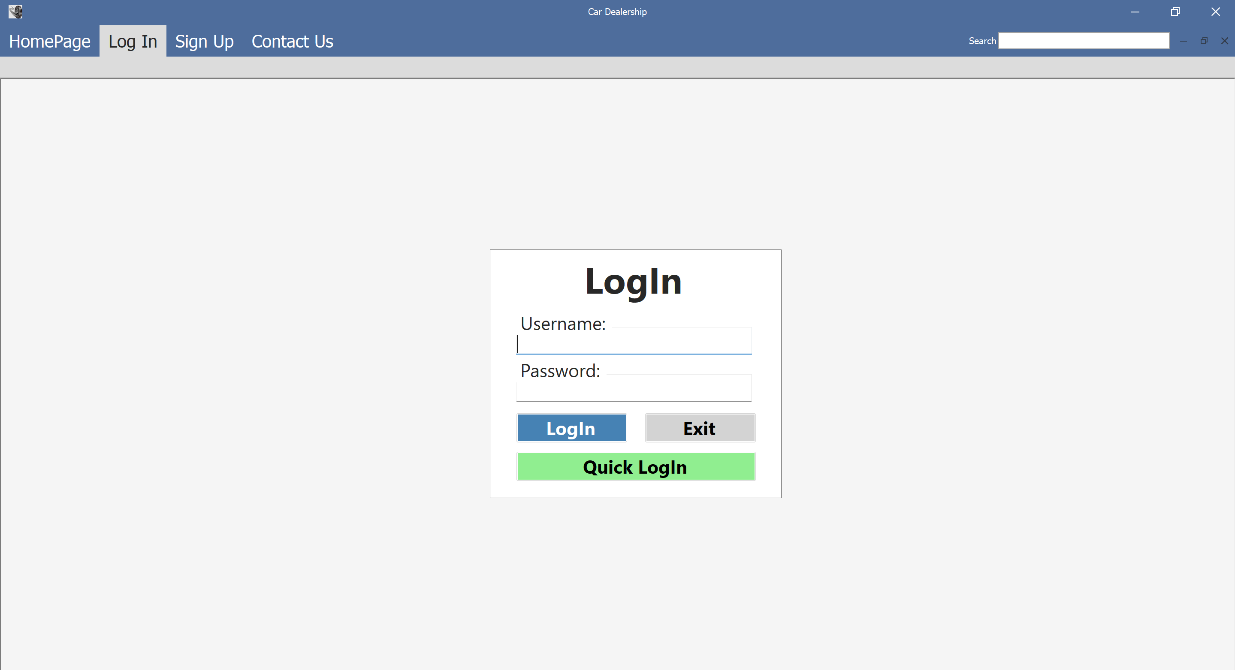

* SS3 - Sign Up

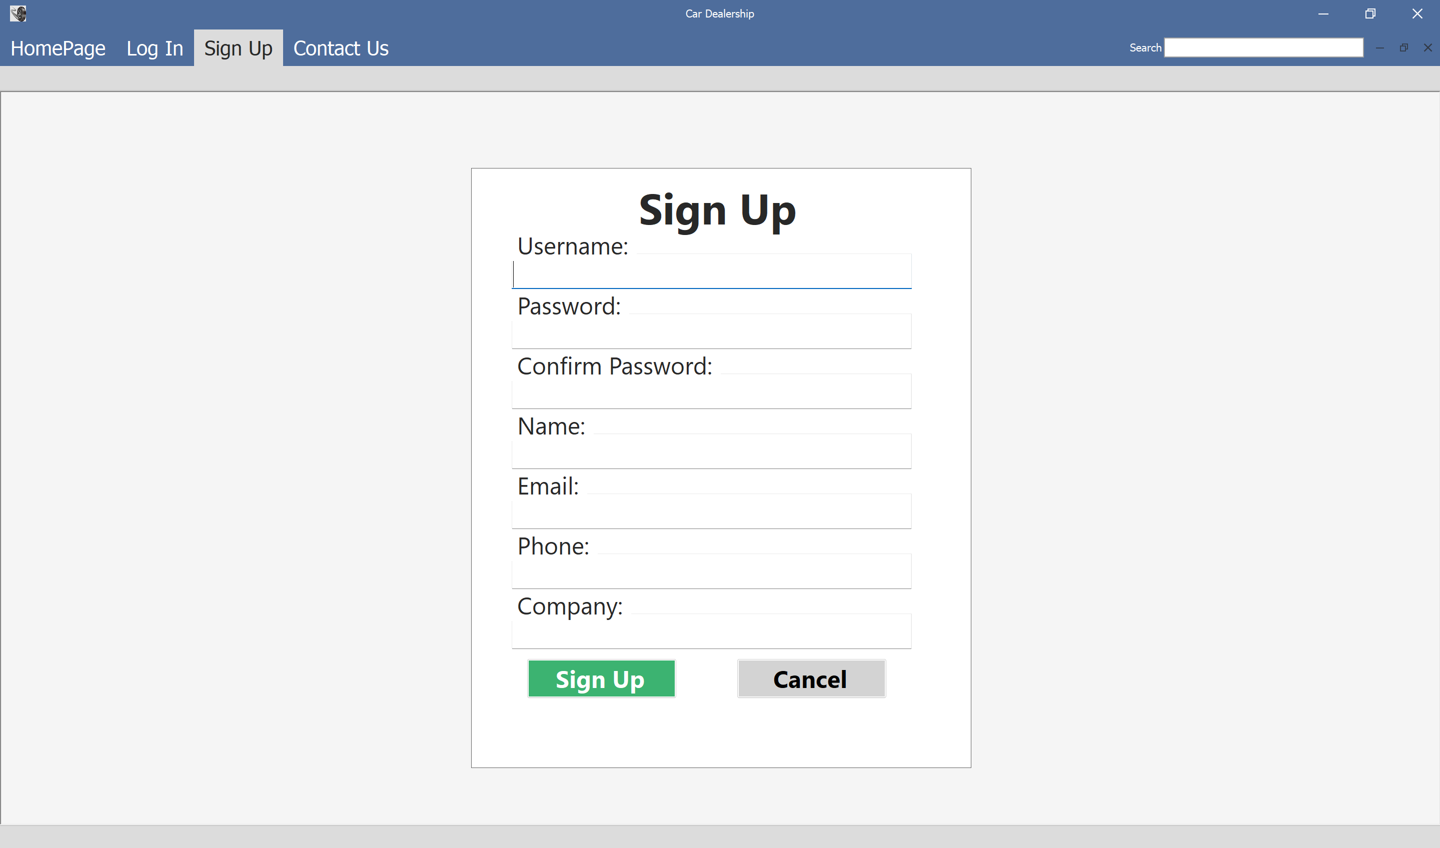

* SS4 - Upload Car

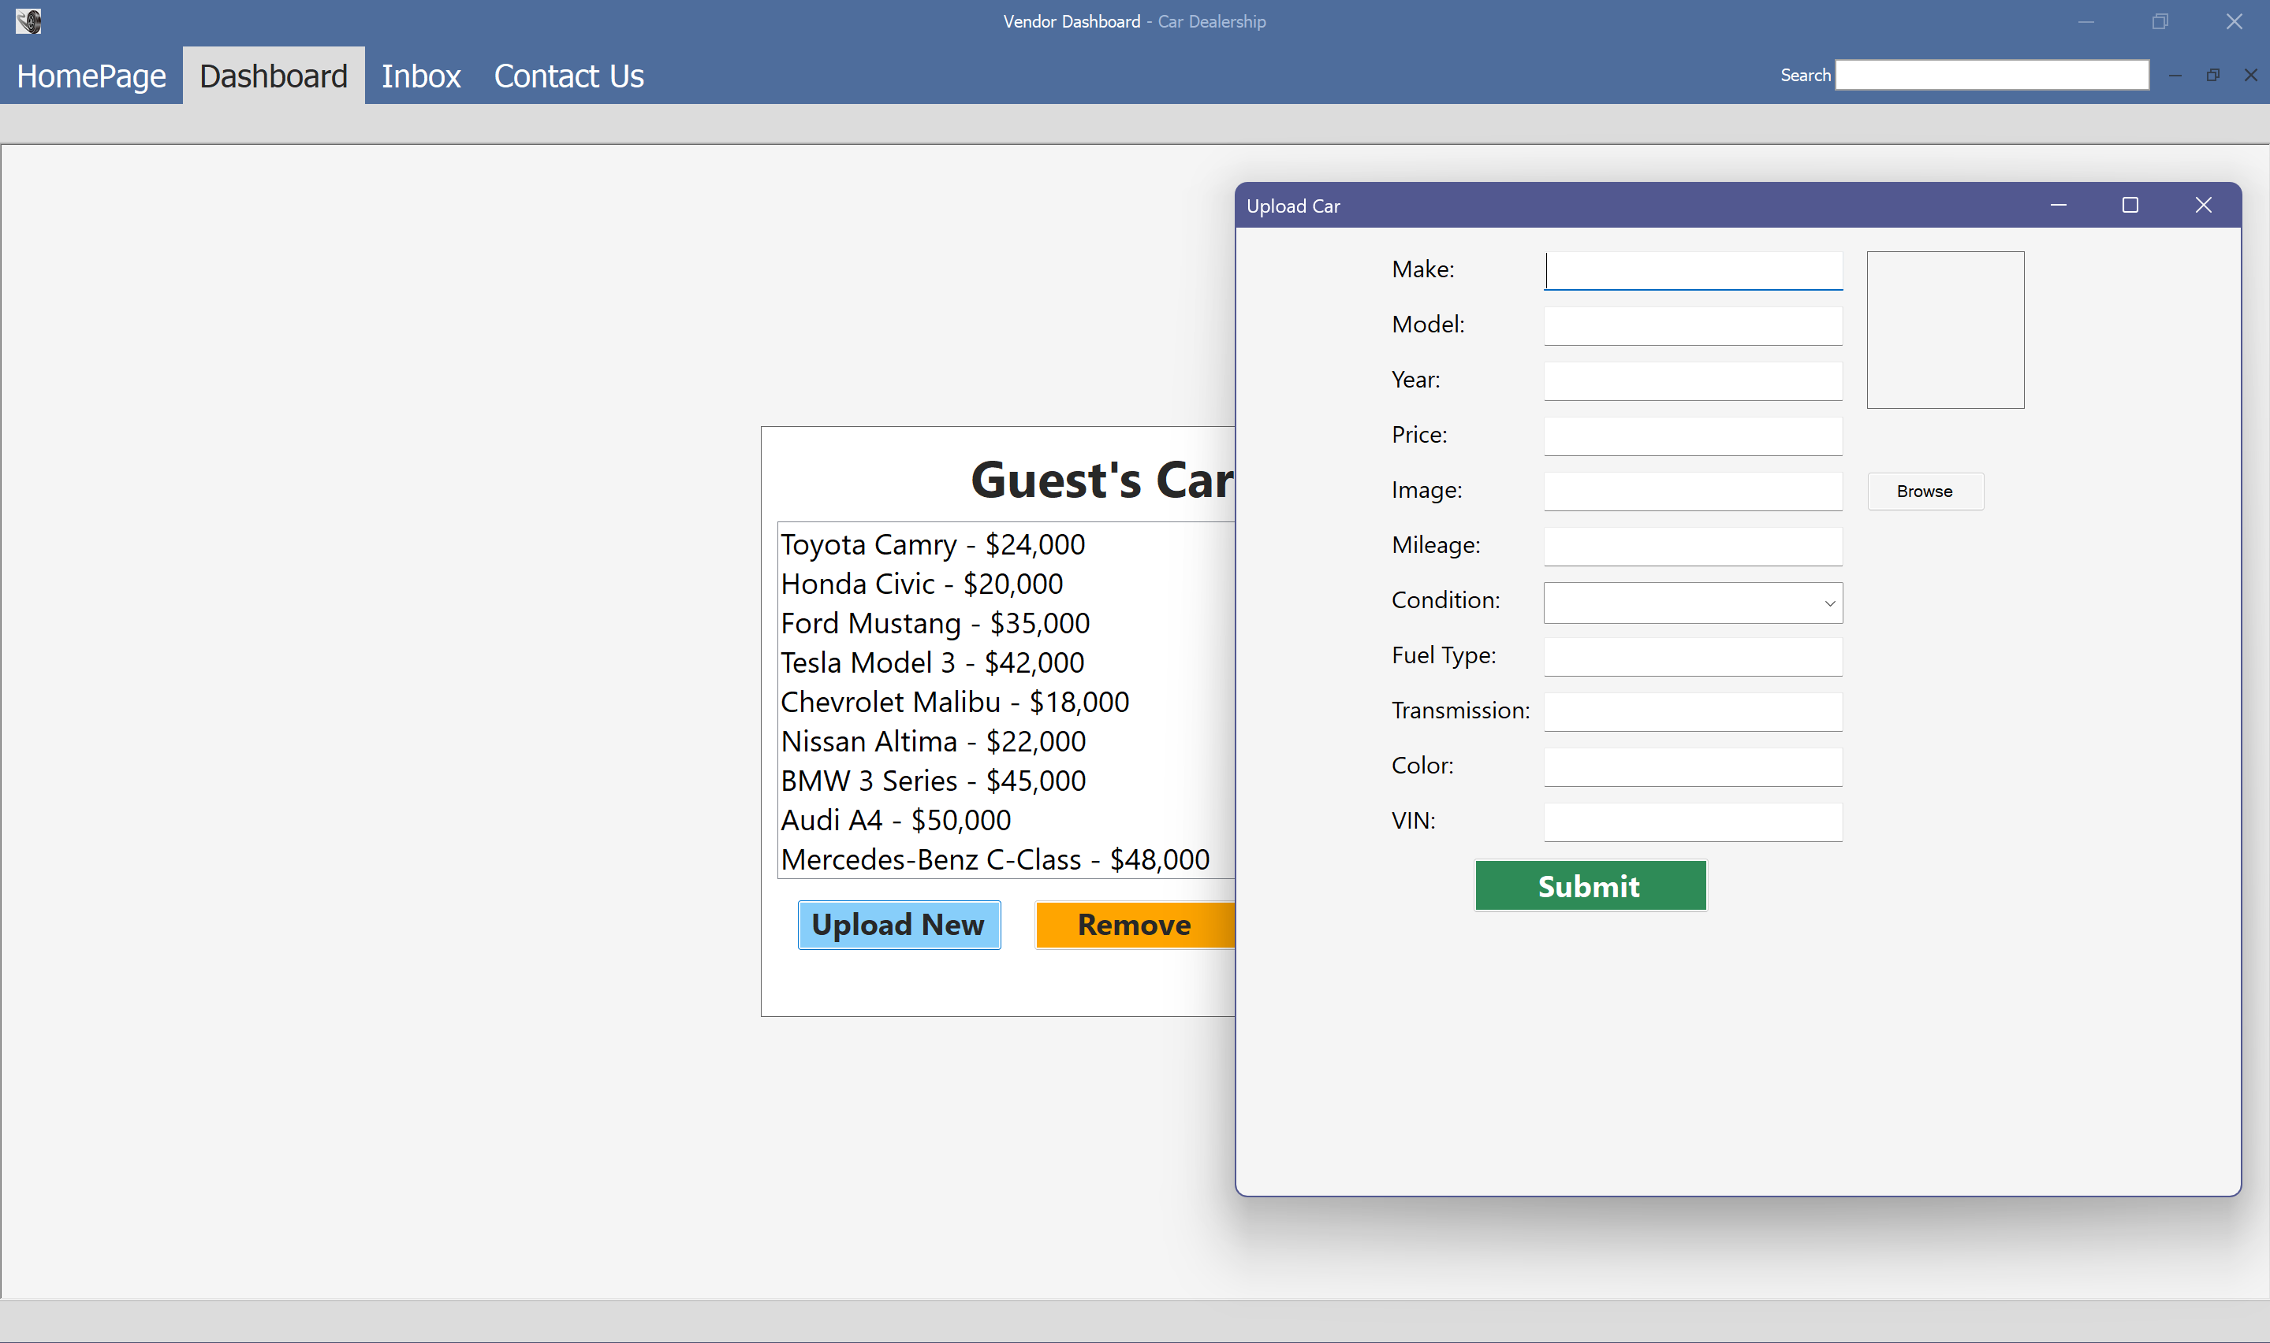

Opened from Dashboard.

* SS5 - View Car Details

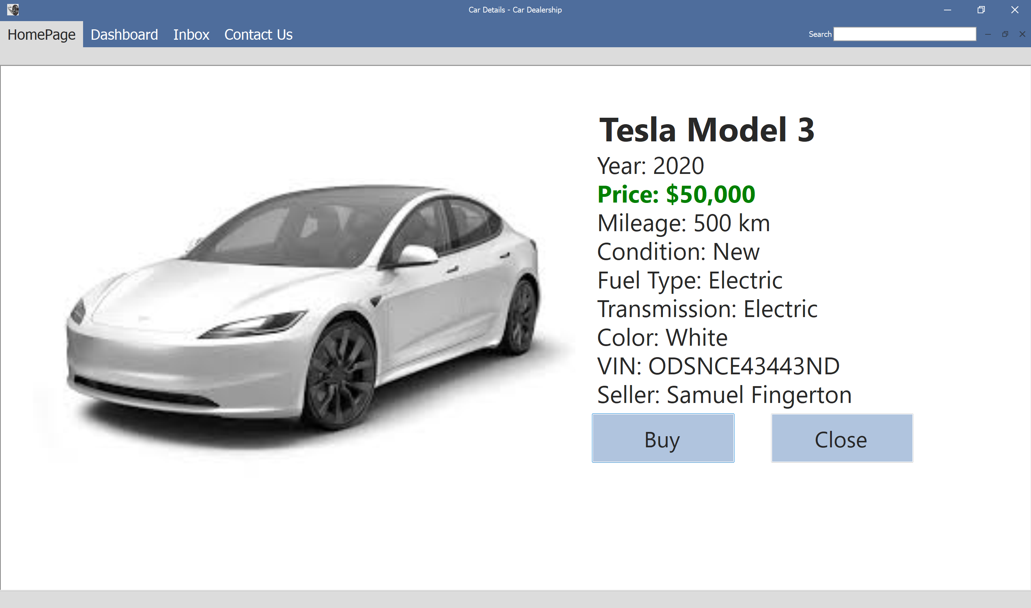

* SS6 - Vendor Dashboard

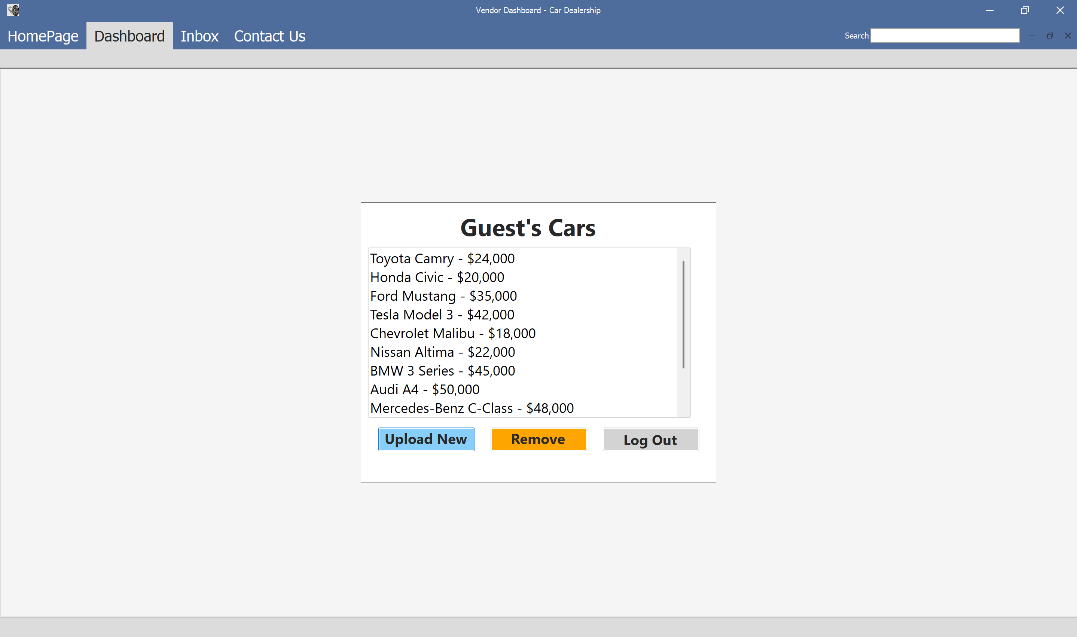

* SS7 - Inbox Form

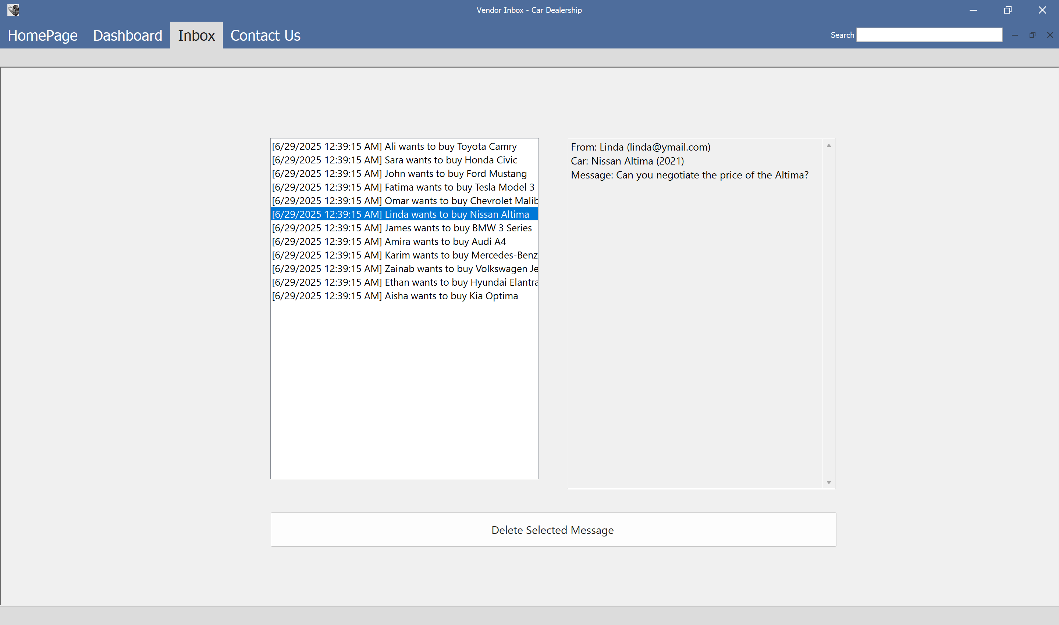

* SS8 - Contact Us

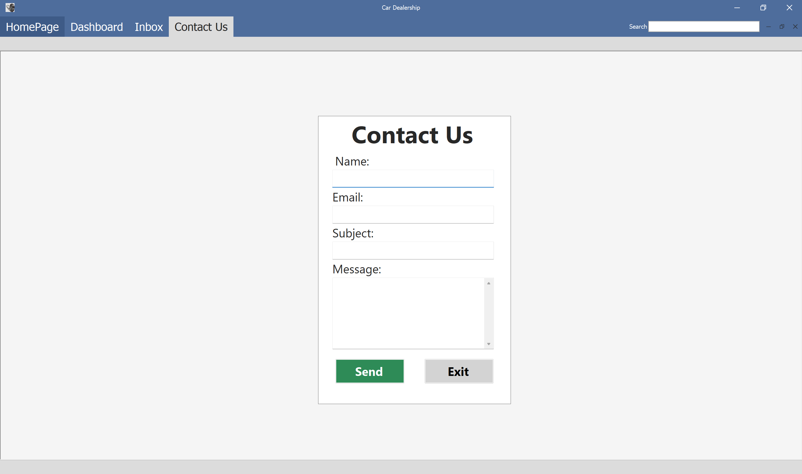

# 3. System Components

## 3.1 Class Diagram

## C:\Users\walid\Downloads\class diagram.png

## 3.2 Use Case Descriptions

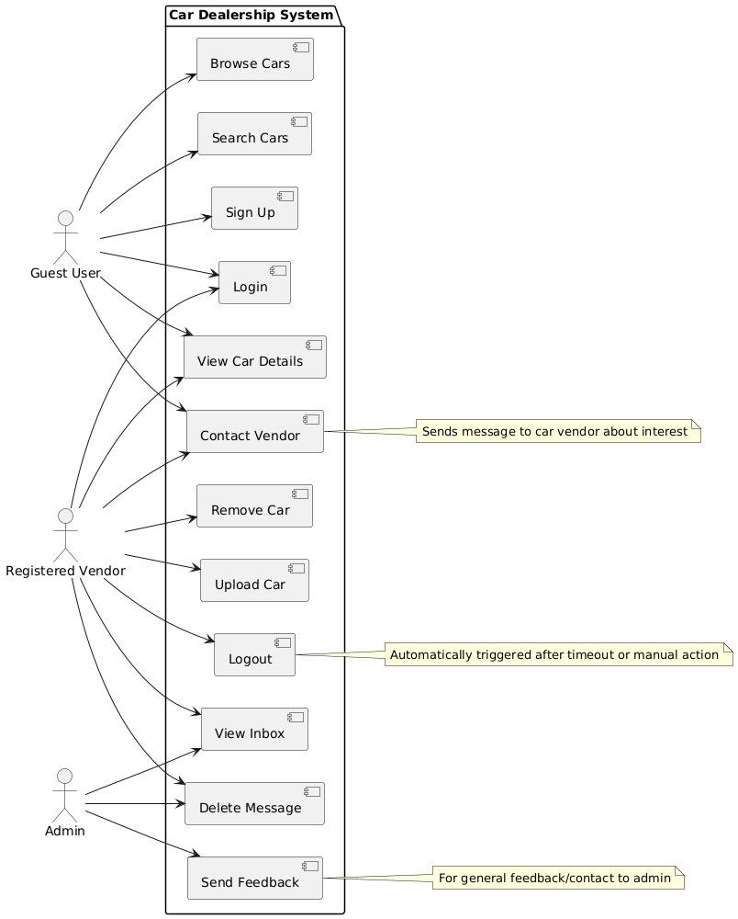

* Browse Cars
* Search Cars
* Sign Up
* Log In
* View Car Details
* Contact Vendor
* Remove Car
* Upload Car
* Log Out
* View Inbox
* Delete Message
* Send Feedback (By Contact Us)

### 3.2.1 Sequence Diagram for Use Case

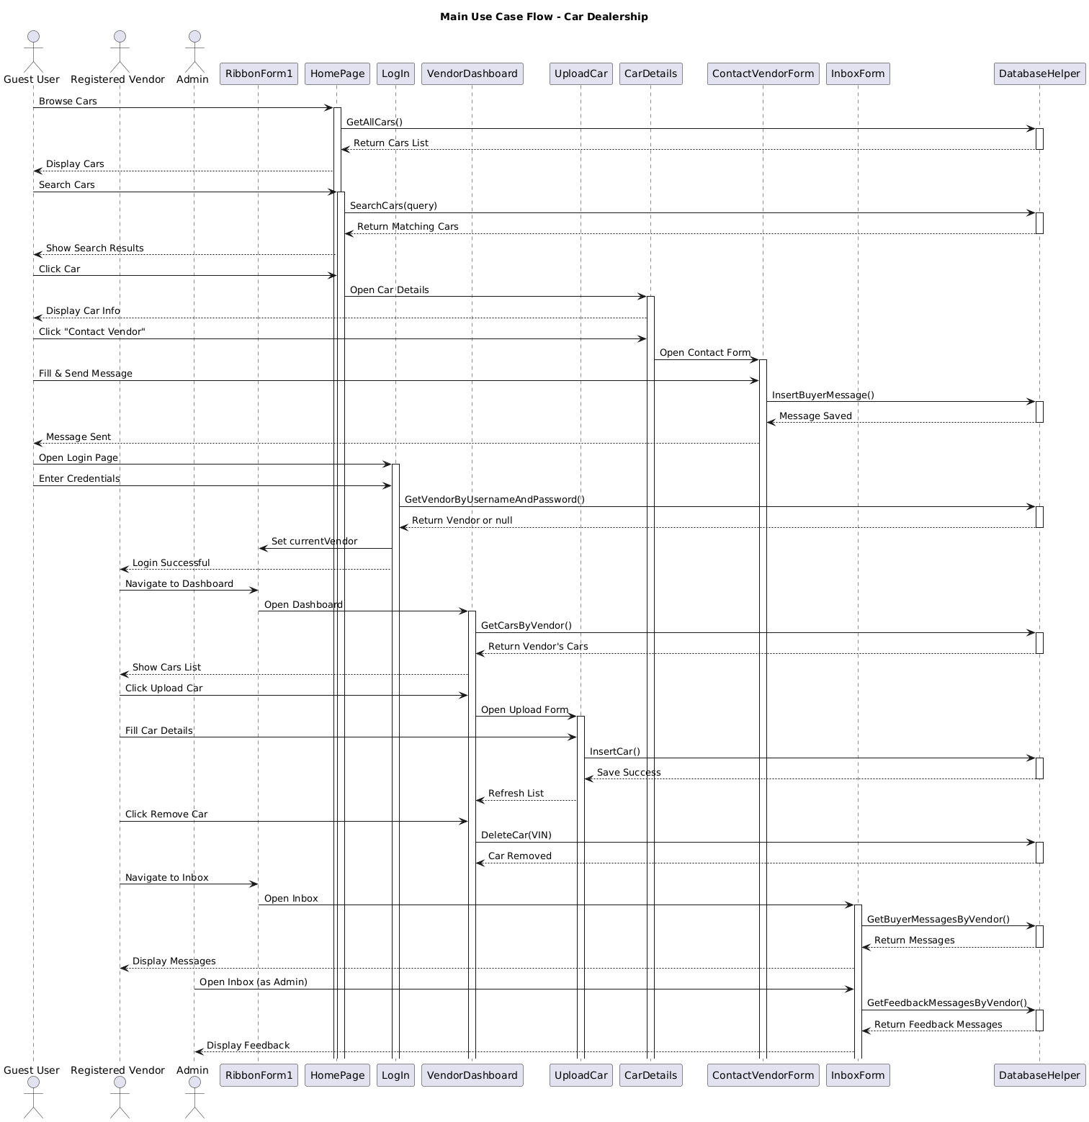

# 4. Design Decisions and Tradeoffs

**Language Choice:** C# was chosen due to its integration with Windows Forms and .NET ecosystem.  
  
**UI Framework:** Windows Forms was selected for simplicity and fast development.  
  
**Database Engine:** SQLite was used for lightweight, local storage without server dependency.  
  
**Design Tradeoff:** Plain text passwords were used for simplicity; hashing should be added later.  
  
**Scalability Consideration:** System supports only local operation; cloud sync is not included.

## Appendix A: Use Case Diagrams

## C:\Users\walid\Downloads\use cases.pngAppendix B: Data Dictionary

|  |  |  |
| --- | --- | --- |
| Term | Type | Description |
| Vendor | Entity | Represents a seller of cars |
| Car | Entity | Represents a car listed for sale |
| BuyerMessage | Entity | Message sent from buyer to vendor about a specific car |
| FeedbackMessage | Entity | General message sent to admin |
| DatabaseHelper | Helper Class | Handles all database interactions |
| RibbonForm1 | Main Form | Central navigation hub for all forms |
| HomePage | Form | Displays available cars to guest and logged-in users |
| InboxForm | Form | Allows vendors to view and delete messages |
| ContactUs | Form | Allows guests to send feedback to admin |
| VendorDashboard | Form | Allows vendors to manage their car listings |

## Appendix C: Inputs and Outputs

**Inputs:**- Username, password, car details, buyer messages, search queries  
**Outputs:**- Displayed car cards, inbox messages, login status, error messages