# Software Requirements Specification

**Car Dealership Management System**

Version 1.0

Prepared by: Abubakar Bammami Isa

Your Name(s)

Date: June 29th , 2025

## Table of Contents

Table of Contents

Software Requirements Specification 1

Table of Contents 2

1. Introduction 3

1.1 Purpose 3

1.2 Document Conventions 3

1.3 Intended Audience and Reading Suggestions 3

1.4 Product Scope 3

1.5 References 3

2. Overall Description 4

2.1 Product Perspective 4

2.2 Product Functions 4

2.3 User Classes and Characteristics 4

2.4 Operating Environment 4

2.5 Design and Implementation Constraints 4

2.6 User Documentation 4

2.7 Assumptions and Dependencies 4

3. External Interface Requirements 4

3.1 User Interfaces 4

5

3.2 Hardware Interfaces 5

3.3 Software Interfaces 6

3.4 Communications Interfaces 6

4. System Features 7

4.1 Browse Cars 7

4.2 Upload Car 8

4.3 Send Message to Vendor 8

4.4 View Inbox 9

4.5 Manage Account 10

5. Other Nonfunctional Requirements 10

5.1 Performance Requirements 10

5.2 Usability 10

5.3 Security Requirements 10

5.4 Software Quality Attributes 10

5.5 Business Rules 10

Appendix A: Glossary 10

## 1. Introduction

This document outlines the Car Dealership Management System, a desktop application designed to streamline car dealership operations. It will detail the system's purpose, features, user interfaces, functionalities, and how it responds to user interactions.

### 1.1 Purpose

The purpose of this document is to describe the requirements for the Car Dealership Management System, a Windows Forms desktop application built with C#. It enables vendors to upload cars, buyers to contact sellers, and an admin to receive general feedback messages.

### 1.2 Document Conventions

**Font:** Times New Roman  
**Font Size:** 18 for Main Headings, 14 for Subheadings, 12 for body text  
**Colors:** Blue headings, black text. **Image Indicators:** Purple highlighted text indicates where screenshots or diagrams should be inserted.

### 1.3 Intended Audience and Reading Suggestions

This document explains how the Car Dealership Management System works. It's meant for developers, testers, and project stakeholders. We'll explain the different types of users and what they can do, then break down the system’s features.  
Readers are encouraged to start from Section 2 to understand the application's structure and purpose.

### 1.4 Product Scope

The Car Dealership Management System is a desktop application designed to help dealerships manage car listings, vendor accounts, buyer messages, and general feedback. It allows vendors to list cars for sale, buyers to contact sellers, and an admin to receive general messages.

### 1.5 References

- C# Programming Guide  
- SQLite Documentation  
- DevExpress UI Controls Documentation  
- Software Requirements Specifications Template (Supermarket Management System)  
- iTextSharp PDF Library Documentation (Optional)

## 2. Overall Description

### 2.1 Product Perspective

The Car Dealership Management System is a single-user desktop application. It uses SQLite for local data storage and supports multiple roles: Admin, Vendor, and Guest User.

### 2.2 Product Functions

* Vendors can add, edit, delete, and view car listings.
* Buyers can browse cars, search, and send messages to vendors about specific vehicles.
* Admin receives general feedback messages from users.
* Users can log in securely and navigate between forms via ribbon menu.
* Data is stored locally in an SQLite database.

### 2.3 User Classes and Characteristics

* Admin: Full access to manage all messages and reports.
* Registered Vendor: Can upload/remove cars and receive messages.
* Guest User: Browses cars and sends messages but cannot upload cars.

### 2.4 Operating Environment

The system runs on Windows OS with .NET Framework 4.7.2 or later. It requires at least 2 GB RAM and 500 MB free disk space.

### 2.5 Design and Implementation Constraints

Time constraints limited optional features like PDF reporting and email notifications.

### 2.6 User Documentation

A user guide will be included in the form of a PDF document.

### 2.7 Assumptions and Dependencies

SQLite database is installed locally. Users have basic computer knowledge. DevExpress UI components are available.

## 3. External Interface Requirements

### 3.1 User Interfaces

The application includes a ribbon menu with Home, Login, Upload, Inbox, Contact Us, and Dashboard tabs. Each tab opens a corresponding form inside the main window. But the Dashboard and Inbox tabs are only visible when a user is logged in.

When not logged in.

### 

When logged in

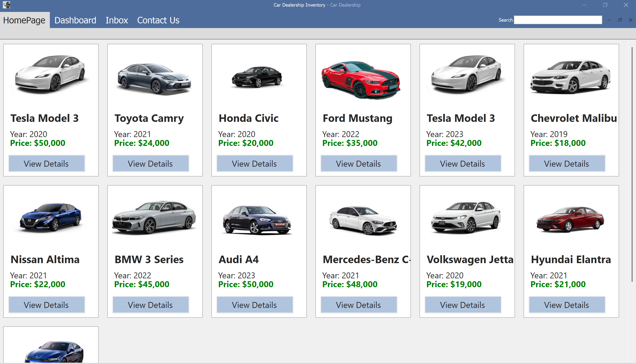

### 3.2 Hardware Interfaces

Standard PC with keyboard/mouse and display. No external hardware required.

### 3.3 Software Interfaces

Built with C# and Windows Forms. Uses SQLite for local database storage.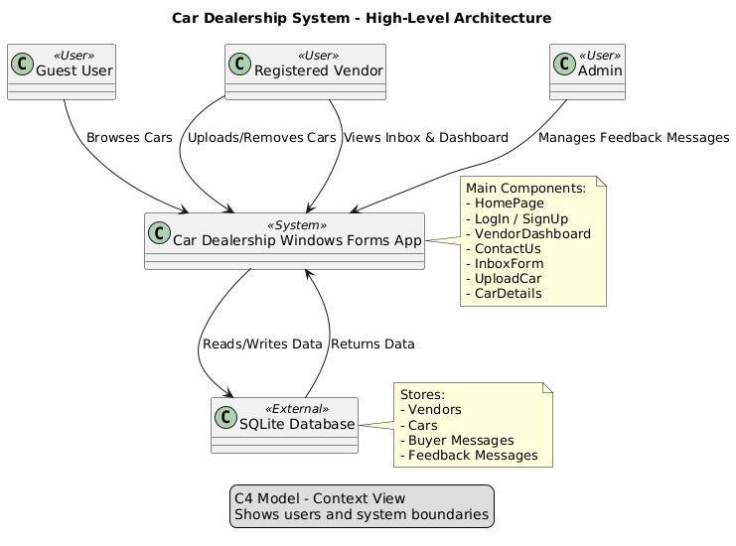

### 3.4 Communications Interfaces

Messages are exchanged between users via the local database.

## 4. System Features

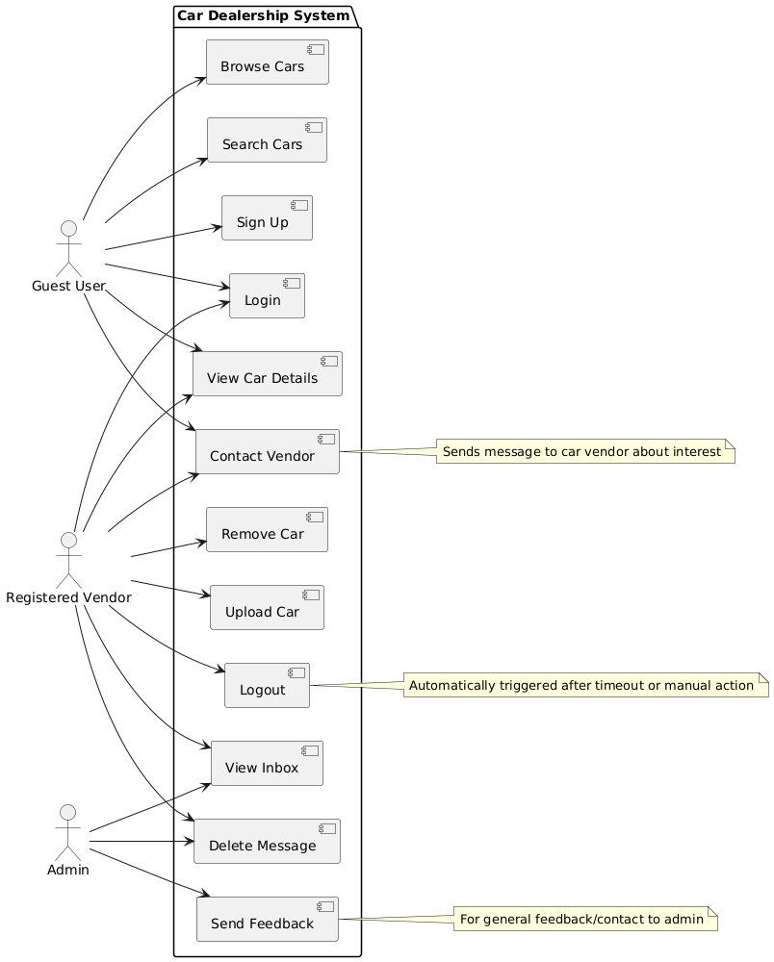

### 4.1 Browse Cars

Allows guest users to view all listed cars.

### 4.2 Upload Car

Allows registered vendors to upload a new car listing.

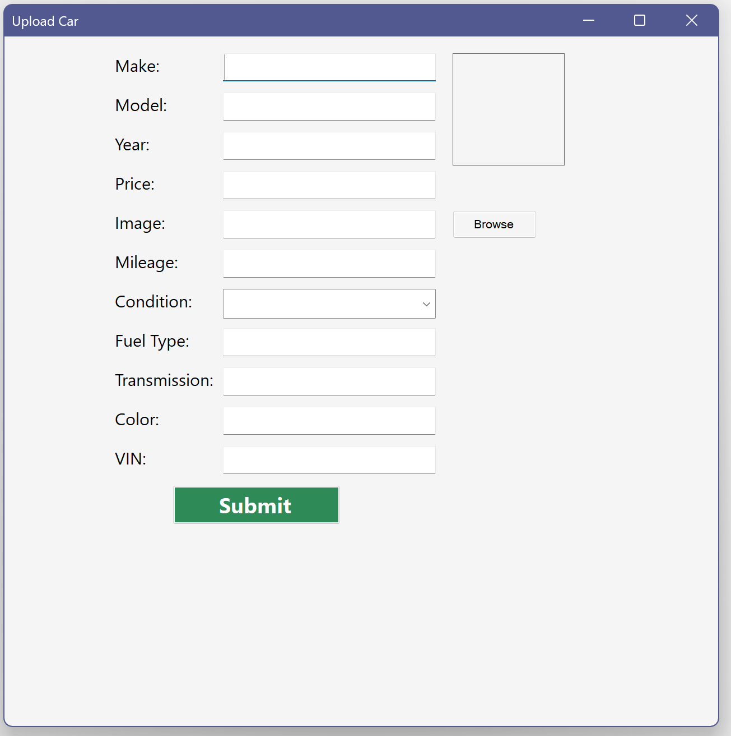

### 4.3 Send Message to Vendor

Allows guests and buyers to send messages to vendors about specific cars.

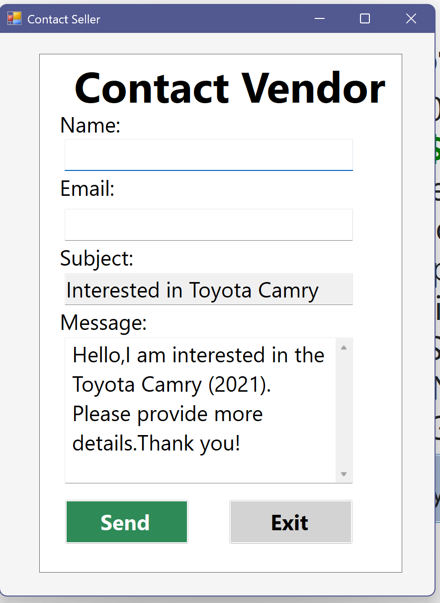

### 4.4 View Inbox

Allows vendors to view and delete messages from interested buyers.

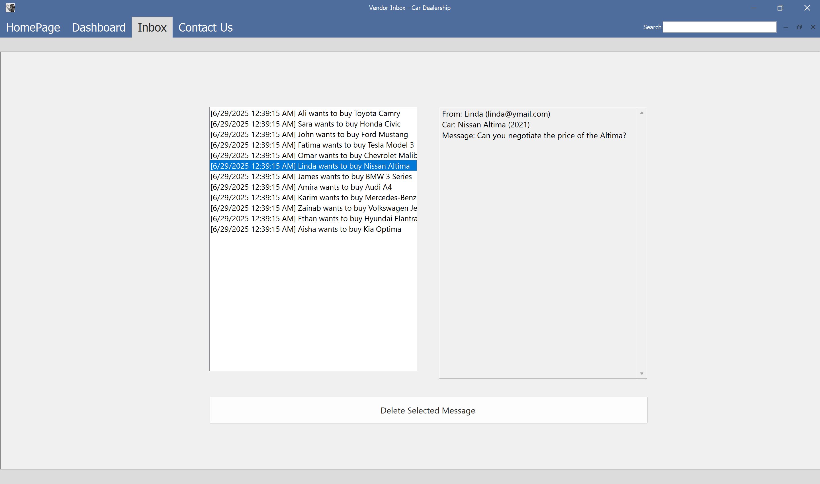

### 4.5 Manage Account

Allows users to sign up, log in, and update their account.

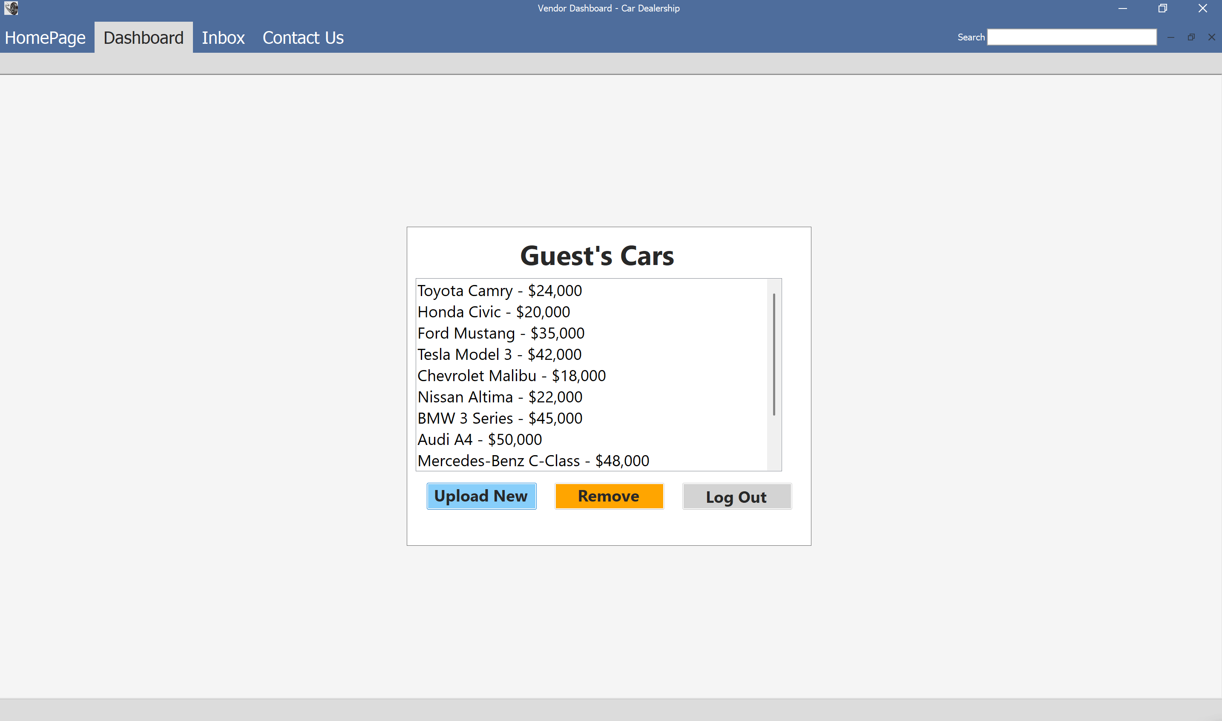

## 5. Other Nonfunctional Requirements

### 5.1 Performance Requirements

Fast loading of car listings and message inbox. Efficient filtering and searching across large datasets.

### 5.2 Usability

Intuitive UI using DevExpress components. Consistent layout and responsive design.

### 5.3 Security Requirements

Role-based access control. Passwords stored in plain text (can be improved with hashing).

### 5.4 Software Quality Attributes

Modular code structure for maintainability. Minimal crashes and consistent behavior.

### 5.5 Business Rules

Only vendors can upload cars. Only admins can view general feedback messages.

## Appendix A: Glossary

|  |  |
| --- | --- |
| Term | Definition |
| Vendor | User who uploads cars and receives messages |
| BuyerMessage | Message sent by a buyer about a specific car |
| FeedbackMessage | General message sent to the admin |
| SQLite | Local database used for storing car and user data |
| RibbonForm | Main navigation interface for the application |