Need to fix some issues which I found.

1. **When Inspect the homepage so some id showing undefined.**

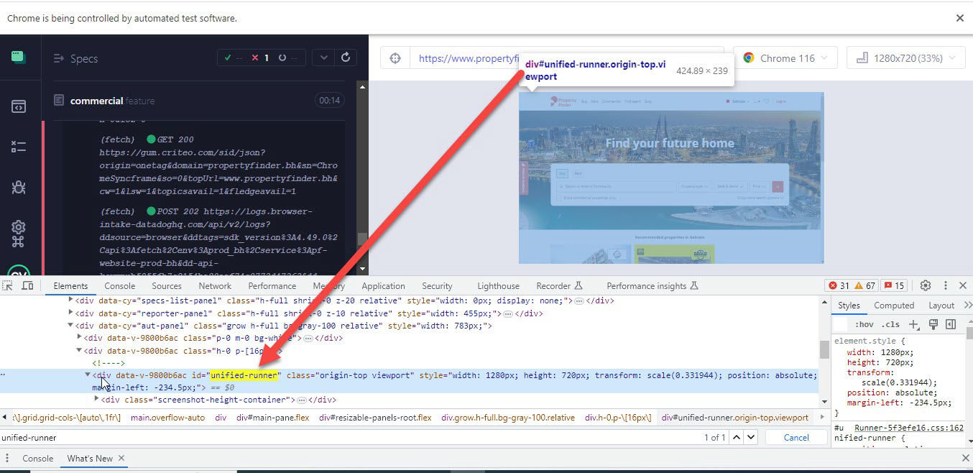

1. **When Max Price range is selected and click on Find Button on first click Find button not working to get the data.**  
   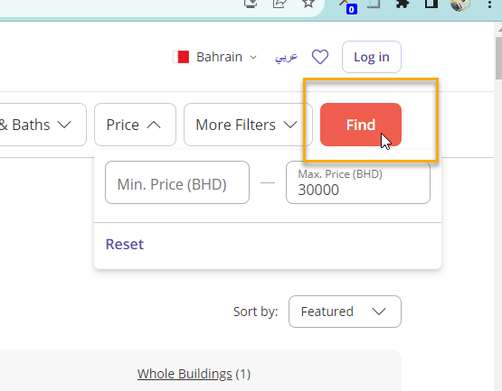

3**.Extra Space appearing between properties details container.**

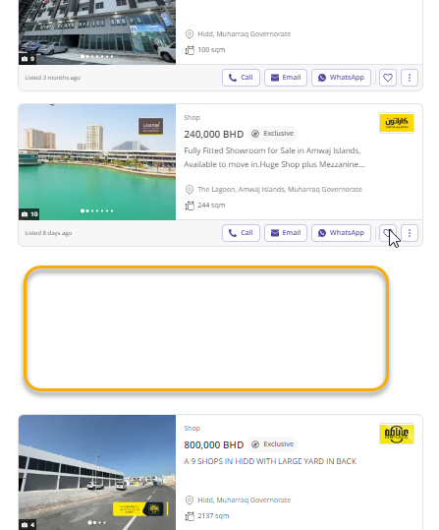

1. **When Click on Rent Navigation Button so UI just Expanding too much**   
   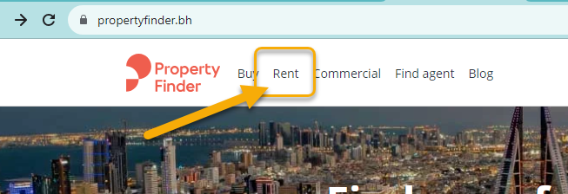

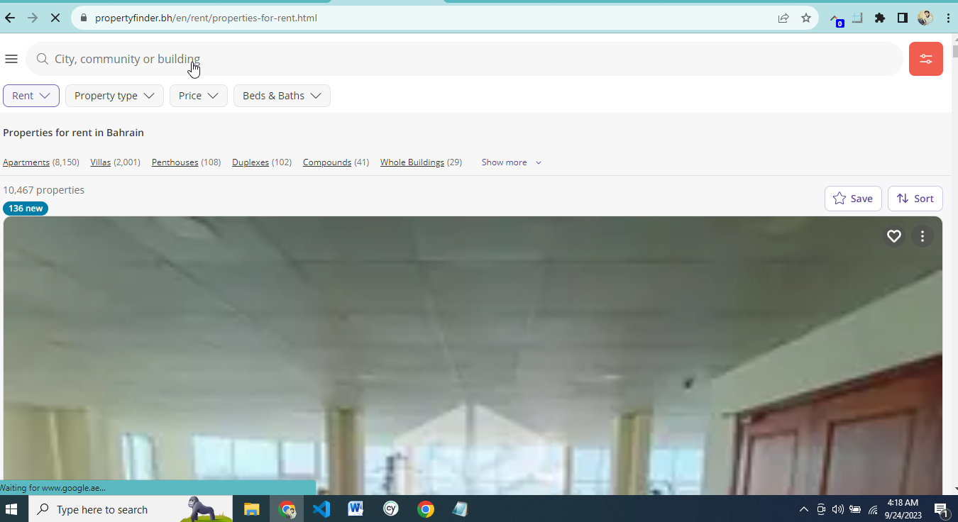

# 

1. **When click on Reset button price range popup move right side.**  
   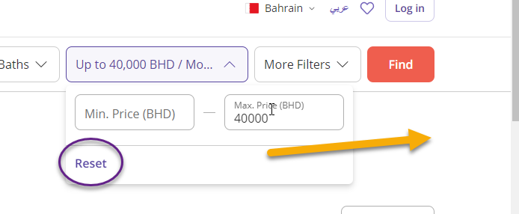

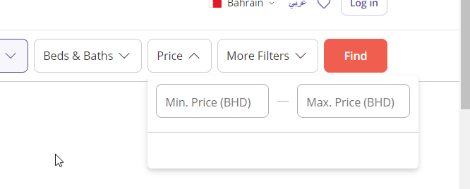

1. **When click on find Button so All button giving flicker.**
2. **In More Filter Popup when click on button no Clear and no Property found button give flicker also data are not showing and text are hiding.**  
   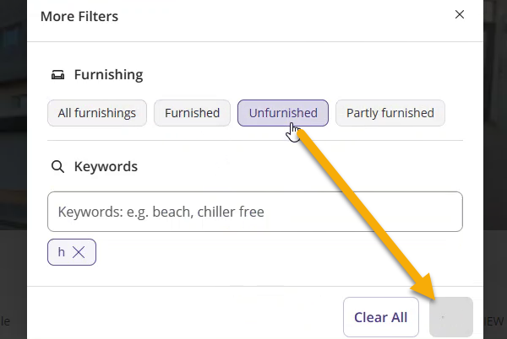
3. **Page should be reload for empty search when click on Find Button**   
   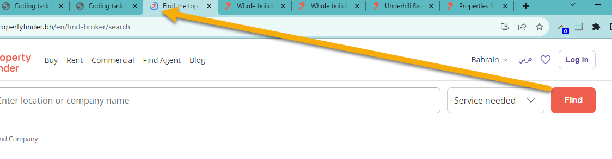
4. **Why These Text are showing like That when type too much text in the Search need to fix .**

**It should not break the UI.**  
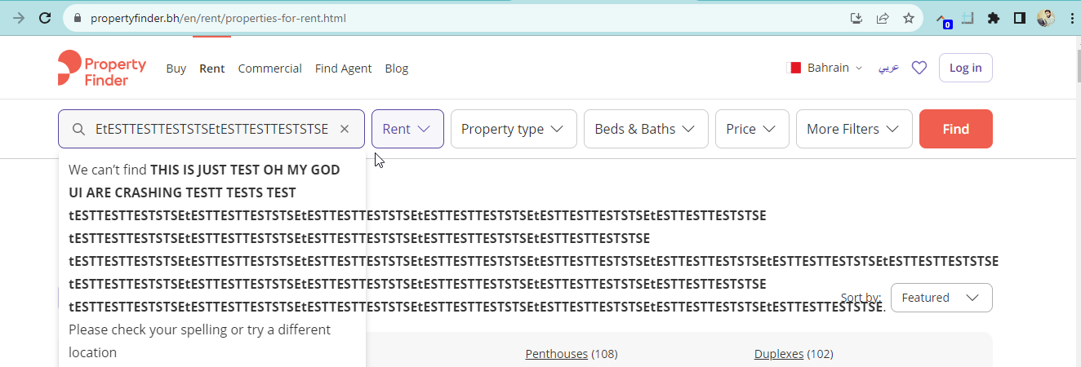

**9.When Scroll down Bedrooms popup giving flickering and hide other UI from top side.**

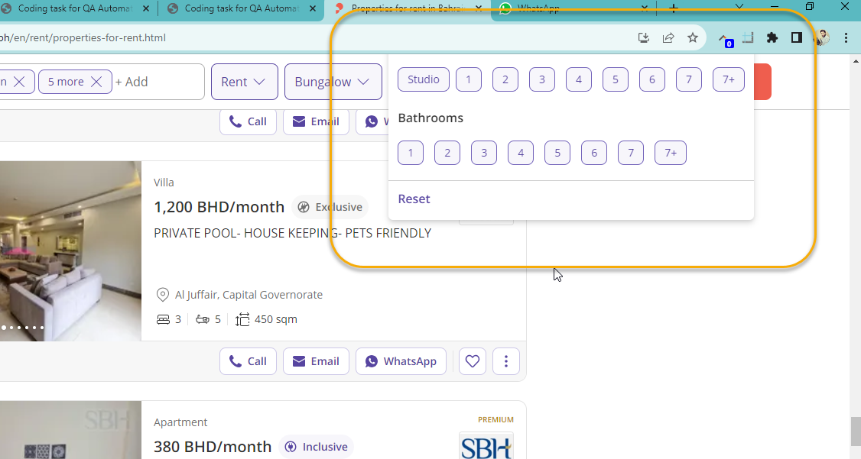

**10 . When Remove the Tag Search data but it still showing in Page .**  
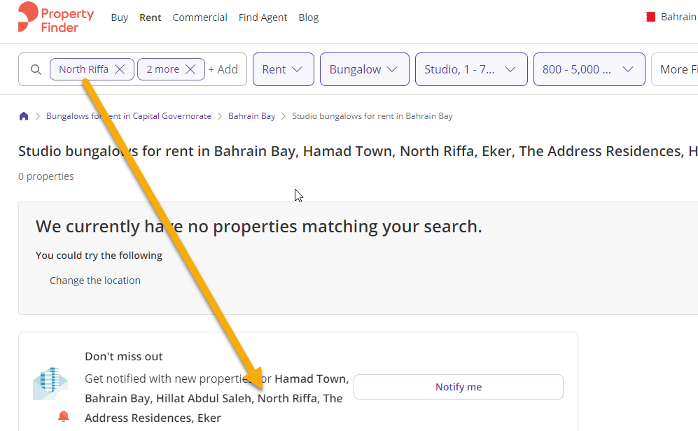

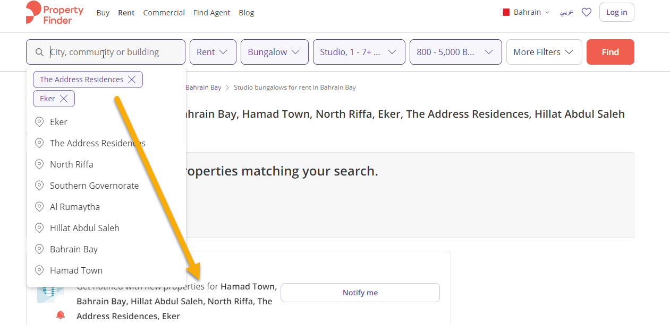

**11. Why these Extra Spaces are appearing Properties Images should be in same alignment.**

