

Project Report

On

E-commerce Pakayee Shop Webside

Submitted by

Walif Mamu 631431012

Nasrudin Yusof 621431040

Present

Prof. Sahidan Abdulmana

E-Business System, Semester 2

Fatoni Univeesity

**TABLE OF CONTENT**

1. Project overview
2. Project justification and planning
3. E- commerce architecture
4. Hardware requirement
5. Software requirement
6. CANVAS business model
7. Print screen of your website
8. Conclusion
9. References

Project Overview

e-commerce project involved creating an online shirt The customers can chose shirt man and women and purchase a variety of shirt. The aim of the project was to provide a convenient and eazy for shopping online.

Website Design and Development

Our designed and developed a visually appealing and easy-to-navigate website that includes clear and concise product descriptions and pricing information.

Marketing and Customer Service Strategies

we developed effective marketing and customer service strategies to promote our e-commerce shop and ensure customer satisfaction. This could include social media marketing, email campaigns, and targeted advertising. we also had a customer service plan in place, with responsive and helpful staff available to answer customer questions and resolve any issues that may arise.

Project justification and planning

Type of business

an online retail business, specifically in the retail industry of selling shirt. Our e-commerce website selling shirt is a B2C (Business-to-Consumer) business.

Functionalities

discount code = Used for discounting products

• Product detail = this function will show the information about shirt

• Shopping Cart = customer can select products in a virtual cart.

Delivery method

Our website, the customer can select the option to pay. You can pay by using Papal, credit card, online banking.

1. For the checkout, the customer selects the shipping option for standard, shuch as delivery destination,etc.

2. After the customer completes the purchase, the order details are sent to fulfillment team. The team then packages the product securely in a shipping box with any necessary packing materials.

3. The shipping box is then taken to a local drop-off location for the selected courier service or scheduled for a pickup from your fulfillment center.

4. The courier service picks up the shipping box and begins the shipping process. They provide a tracking number to your fulfillment team which is then passed on to the customer.

5. The customer can then use the tracking number to monitor the delivery status of their order through the courier service's website or mobile app.

6. Once the package is successfully delivered, the customer receives a confirmation email or notification from the courier service.

E-commerce architecture

Front-end web development: for the front-end, we use Wix.com to create the website like design, front, color etc.

Back-end web development: for the back-end, we also use Wix.com to manage all about back-end side. Such as the massage that we get from customers, list of order, or database.

Payment processing: This includes the software and systems needed to securely process and manage online payments, such as cash on delivery.

Hardware requirement

Computer: to access the software to develop the website.

Shipping and logistics: the company that shipping.

Software requirement

Website platform: we use Wix.com, we use this platform to do the whole web such as the design, add the product, massage from the customer or payment.

Payment gateway: PayPal

CANVAS business model

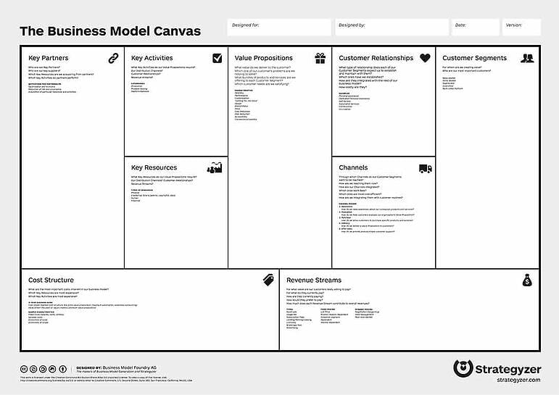

Print screen of your website

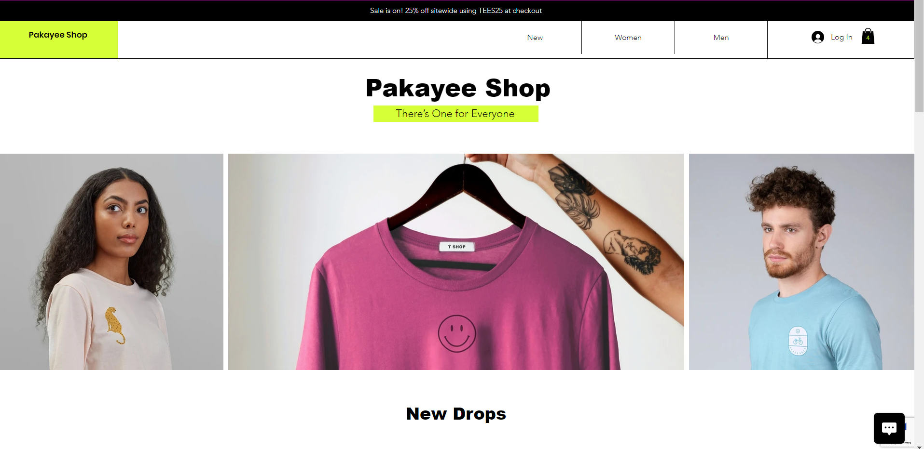 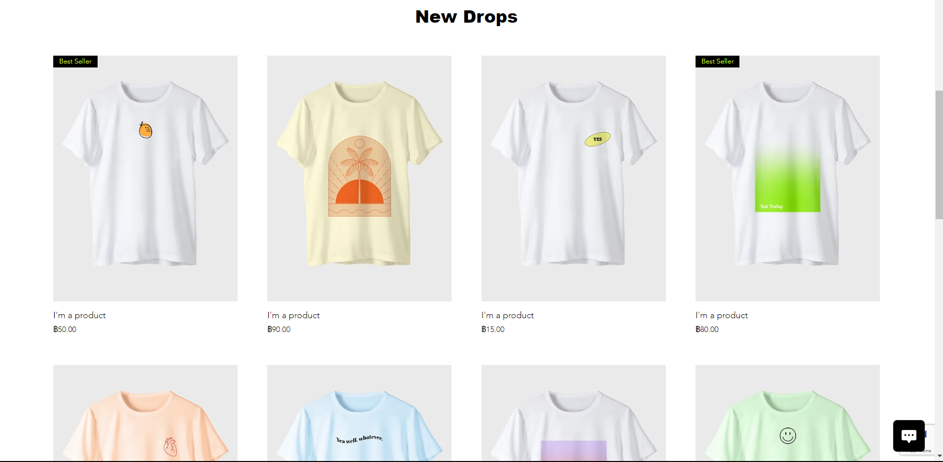 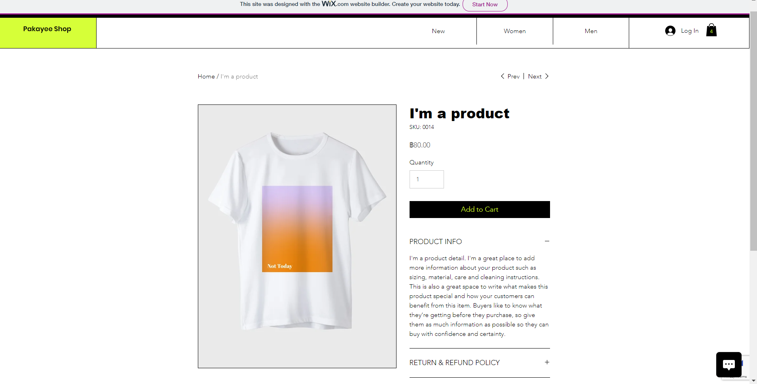 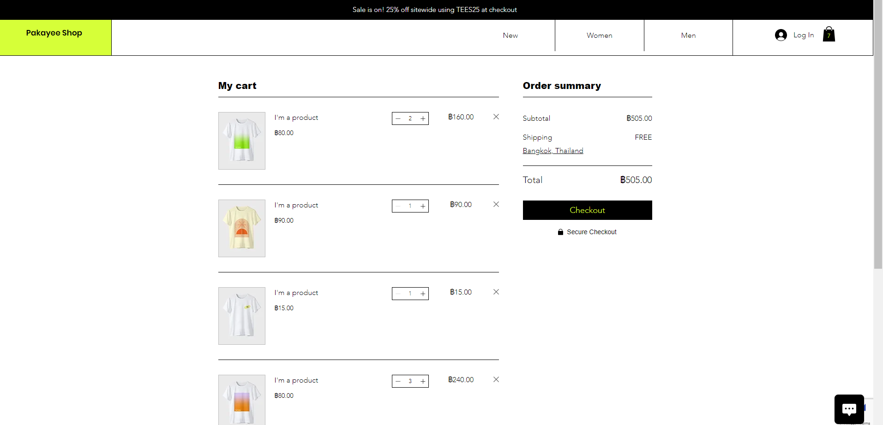

Conclusion

In conclusion, our e-commerce website is about shirt “Pakayee shop”There is no brand. It's a shirt that is comfortable to wear. We offer a wide range of comfortable shirts at affordable prices. This makes it easy for customers to find shirts that suit their style and budget. We have payment system and shipping to the customer. All both, front-end and back-end we use wix.com which allow the seller easy to create e-commerce website.

References

<https://ug631431012.wixsite.com/my-pakayee>

https://users.wix.com/signin?originUrl=https:%2F%2Feditor.wix.com%2Fhtml%2Feditor%2Fweb%2Frenderer%2Fedit%2Fe7ab0554-e647-4931-b238-b34fe511389c%3FeditorSessionId%3D3f1cf792-264a-4d78-8f12-f4e1e6ba4a52%26metaSiteId%3Dafe0fcdf-9bb7-49c5-b243-9f059e19f3fe%26fbclid%3DIwAR3-5G6XOaNtxOsqlTooAShmWBpzhhtA4zt6M7D8fDjZq9lwXMDthwG5UE0&redirectTo=https:%2F%2Feditor.wix.com%2Fhtml%2Feditor%2Fweb%2Frenderer%2Fedit%2Fe7ab0554-e647-4931-b238-b34fe511389c%3FeditorSessionId%3D3f1cf792-264a-4d78-8f12-f4e1e6ba4a52%26metaSiteId%3Dafe0fcdf-9bb7-49c5-b243-9f059e19f3fe%26fbclid%3DIwAR3-5G6XOaNtxOsqlTooAShmWBpzhhtA4zt6M7D8fDjZq9lwXMDthwG5UE0&overrideLocale=en&forceRender=true