|  |
| --- |
|  |
| WPPOOL: Growth Data Analysis |
| |  |  |  | | --- | --- | --- | | Waliul Islam |  | 3/8/25 | |

Contents

SECTION: 1 2

About WPPOOL 2

Tools Used for Analysis 2

SECTION: 2 3

1. Data Exploration & Cleaning 3

Data Cleaning: 3

Overview of the Dataset: 3

2. User Engagement Analysis 4

1 Identify the average number of sessions for Free vs. Pro users 4

2. Find the top 5 most active users based on total sessions 4

3. Identify the top 5 countries with the highest engagement. 5

3. Churn Analysis 5

1. Calculate the overall churn rate for Free vs. Pro users 5

2. Identify the top 3 factors contributing to churn using correlation or regression analysis. 6

3. Compare churn trends between Free and Pro users. 7

4. Revenue & Upgrade Trends 8

1. What percentage of users upgraded from Free to Pro? 8

2. Calculate the total monthly revenue from Pro users. 8

3. Which Pro plan (Basic, Standard, or Enterprise) contributes the most revenue? 8

4. Analyze how long it takes for Free users to upgrade based on country and engagement level. 9

5. Actionable Growth Recommendations 10

1. Suggest three strategies to reduce churn. 10

2. Propose two ways to increase Free-to-Pro conversions. 11

3. Identify potential market expansion opportunities based on country trends. 11

6. Conversion Rate Optimization (CRO) 13

If WPPOOL increases the landing page conversion rate by 10%, what would be the estimated impact on Pro upgrades? 13

7. Growth Strategy & KPI Recommendations 13

1. Identify 3 key performance indicators (KPIs) WPPOOL should track. 13

2. Suggest 2 actionable growth strategies WPPOOL can implement based on your analysis. 14

3. How would you measure the success of these strategies? 14

SECTION: 3 15

3 most favorite Books: 15

3 most favorite TV shows? 15

What motivates you the most in a workplace? 16

# SECTION: 1

## About WPPOOL

**1. What do we do at WPPOOL?**

WPPOOL is a software development business specializing in creating digital products for platforms like WordPress and WooCommerce. Their core products are themes and plugins for WordPress websites.

It's top products for WordPress are, **WP Dark Mode**, **FlexTable**, **Jitsi Meet**. Top product for WooCommerce store is **FlexStock.** Also, top top-performing premium plugin is **Formy Chat.**

These products/tools enhance the functionality and experience of the users of WordPress website.

**2. Who are our customers?**

WPPOOL has more than 24,000 present active end users who are comprised of WordPress website owners together with WooCommerce store managers and developers who need effective solutions to enhance their platforms

**3. What's unique about WPPOOL?**

WPPOOL establishes its position through four major characteristics which include:

* Innovative user-first designs
* Optimized performance in products
* Continuous updates to safeguard quality and security
* And specialized customer support services.

A fully remote operation at the company allows its team to develop innovative products designed for website management simplicity and business expansion.

## Tools Used for Analysis

1. SQL (Sqlite)
2. Excel
3. PowerBI

# SECTION: 2

## Data Exploration & Cleaning

### Data Cleaning:

1. Loaded the dataset into PowerBI
2. Checked empty and null values for each of the columns.
3. Found ***nulls*** at “pro_upgrade_date” column and ***empty*** values at “plan_type” column.
4. Replaced empty values from “plan_type” to “Free User”
5. Null values at “pro_upgrade_date” column derived from **Free** subscription type. So, no changes are made.
6. Checked for duplicates- Not found.

### Overview of the Dataset:

1. The dataset has a total of **13** columns and **20,000** rows.
2. The dataset presents data from **1/1/2023** to **1/1/2024.**
3. Users are divided into **Free** and **Pro** category. The number of free users are **15971** and pro users are **4029.** Moreover, Pro users are divided into three types:

* Basic (1361)
* Standard (1332)
* Enterprise (1336)

1. Users span **7 countries**: India, Canada, UK, USA, France, Germany, and Australia.
2. Users on average interact **92 times** with the plugin.
3. Users on average view **276 pages.**
4. Users clicked "Download Pro" a total of **2045 times.**
5. **19811** plugins were activated and **189** weren’t activated.
6. Users on average were active **91 days** in a year.
7. Average monthly revenue per customer is **$11**.
8. A total of **5705 (29%)** users have churned whereas **14295 (71%)** users are still active.

## 2. User Engagement Analysis

### Identify the average number of sessions for Free vs. Pro users

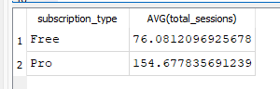

SQL CODE:   
SELECT

subscription_type,

AVG(total_sessions)

FROM wppool_growth_data_sample_20k

GROUP BY subscription_type;

### 2. Find the top 5 most active users based on total sessions

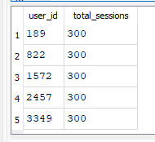

SQL CODE:

SELECT

user_id,

total_sessions

FROM wppool_growth_data_sample_20k

ORDER BY total_sessions DESC

LIMIT 5;

### 3. Identify the top 5 countries with the highest engagement.

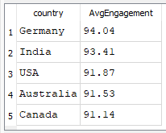

SQL CODE:

SELECT

country,

Round(AVG(total_sessions),2) AS AvgEngagement

FROM wppool_growth_data_sample_20k

GROUP BY country

ORDER BY AvgEngagement DESC

LIMIT 5

## 3. Churn Analysis

### Calculate the overall churn rate for Free vs. Pro users

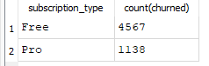

SQL CODE:

SELECT

subscription_type,

count(churned)

FROM wppool_growth_data_sample_20k

WHERE churned = 1

GROUP BY subscription_type

### Identify the top 3 factors contributing to churn using correlation or regression analysis.

I’ve first run the correlation matrix analysis. Then I ran regression analysis.

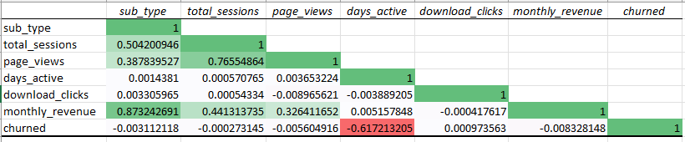

After running correlation analysis, I’ve found that only **“days_active”** is a strong variable for predicting the churn rate. Other variables like, “sub_type”, “total_sessions”, “download_clicks”, “monthly_revenue”, do not have a strong correlation with churn rate.

Then if we interpret the R Square(.3810), we can say that all these variables can only predict 38.10% of the churn rate.

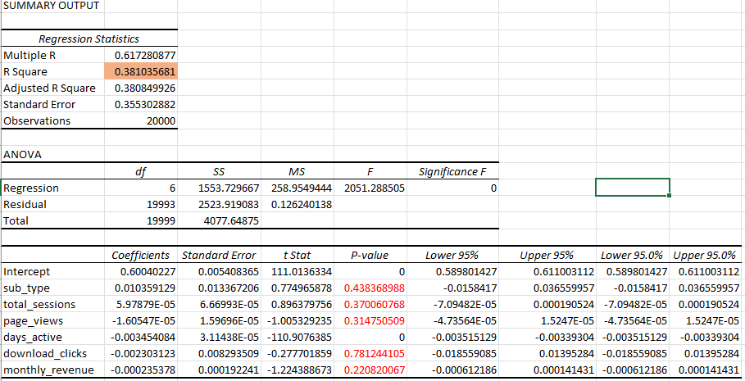

Moreover, the p-values are not statistically significant for all the variables other than “days_active”. This means, these variables can’t reliably predict churn rate.

Now in case of **“days_active”**, it has a strong negative relationship with the churn rate. This means, the more active the user, the less likely they will churn.

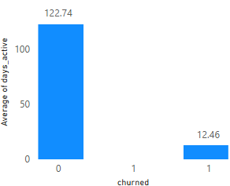

As we can see from the column chart, churned users on average are active for 12.46 days. On the other hand, active users are on average active for 122.74 days.

### Compare churn trends between Free and Pro users.

It is clearly evident that Free user churn the most compared to Pro user.

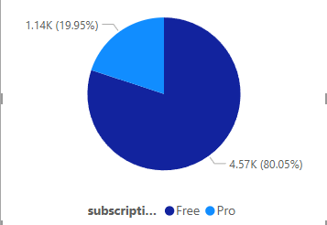

80% of the churned users are using Free subscription. On the other hand, only 20% of the Pro users churn.

## 4. Revenue & Upgrade Trends

### What percentage of users upgraded from Free to Pro?

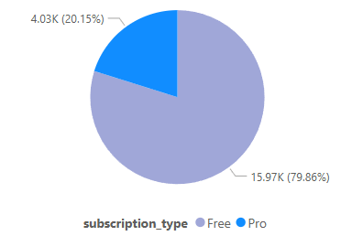

20.15% users upgraded from free to pro.

### Calculate the total monthly revenue from Pro users.

Total monthly revenue from pro users is 235,000.

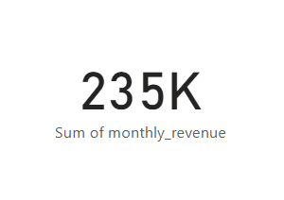

### Which Pro plan (Basic, Standard, or Enterprise) contributes the most revenue?

* Basic plan contributes the most. **(34.12%)**
* Enterprise plan is the second largest contributor. **(33.45%)**
* Standard plan contributes the least. **(32.43%)**

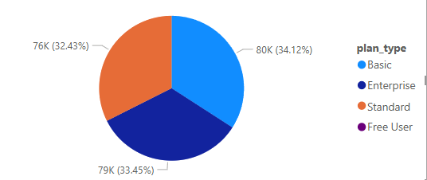

### Analyze how long it takes for Free users to upgrade based on country and engagement level.

***Upgrade Time Based on Country:***

As we can see from the bar chart, **UK** users take the least amount of time to upgrade, average upgrade time of **88 days**. On the other hand, **Australian**, and **Canadian** users take the most amount of time to upgrade, average of **94 days**.

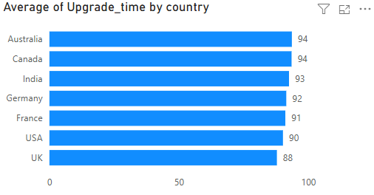

***Upgrade Time Based on Engagement Level:***

For this analysis, I’ve created 3 groups based on **“total_sessions”.**

* Low Engagement= total_sessions < 50
* Moderate Engagement = total_sessions <150
* High Engagement = total_sessions > 150

**CODE:** Engagement = IF(wppool_growth_data_sample_20k[total_sessions]<50, "Low Engagement", IF(wppool_growth_data_sample_20k[total_sessions] <150, "Moderate Engagement", "High Engagement")

**From the graph we can see:**

* Low engagement group (Sessions < 50) take longer to upgrade **(94 days)**.
* High engagement group (Session >150) takes the 2nd most time to upgrade **(92 days).**
* Surprisingly, the Moderate engagement group (Sessions <150 but >50) takes the least amount of days to upgrade **(90 days).**

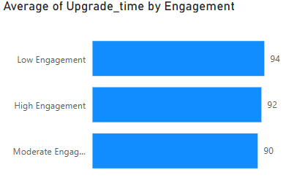

## 5. Actionable Growth Recommendations

### Suggest three strategies to reduce churn.

Since churn has a strong negative correlation with active days or engagement of users, our **strategies** to reduce churn would be to focus on **increasing user activity**.

To achieve this goal, we can implement some following ideas:

**Strategy 1: Guidance to New and Less active users**

* New users might face difficulty in finding their desired service or have trouble with some of the features. Also, one of the reason for low activity might be, the user not finding their desired feature of service.
* To reduce that we can offer quick “How-To” videos or interactive checklists to help them explore basic and advanced features.
* We can also identify users with low "days_active" early and provide **guided tooltips** or in-app tutorials.

**Strategy 2: Personalized Engagement Emails & Notifications**

* We can send behavior-based email reminders and in-app notifications to inactive users encouraging them to return.
* Also, personalized content like feature highlights, case studies, or user success stories to re-engage users.
* Moreover, we can offer free templates and extended trial periods for users who haven't logged in recently.

**Strategy 3: Gamification & Streak-Based Rewards**

* These two methods work tremendously well in keeping users engaged and active. One of the most successful examples is **Snapchat.** Its streak strategy increased its’ user engagement many times.
* We can also use these methods to boost our user engagement and activity.
* We can Introduce streak-based rewards (e.g., "Use WPPOOL for 7 days in a row and get a free premium feature for a week!").
* We can also introduce Reward milestones such as "X sessions completed" or "Y pages viewed" to reinforce engagement.
* We can also show progress bars or achievement badges for activation and plugin usage.

### Propose two ways to increase Free-to-Pro conversions.

I’ll discuss the two most successful conversion strategies.

* **Limited Pro Feature Access**
* **Temporary access** to premium features for a limited time (e.g., "Enjoy Pro features for 3 days!").
* Whenever a user tries to use a locked feature, show tooltips like **"This feature is available in Pro. Unlock it now!"**
* We can Create a **"Pro Trial Completion" Email Campaign** reminding users what they gained with Pro and why they should upgrade.
* **Data-Driven Upselling**
* We can show Free users their **personalized engagement stats** (e.g., “Users like you who upgraded to Pro increased their efficiency by 40%!”).
* Providing a dynamic comparison chart showing **how much more value** a Pro user gets compared to a Free user will also work as a persuader.
* We can display **success stories/testimonials and reviews** from businesses that saw growth after upgrading.

### Identify potential market expansion opportunities based on country trends.

**Targeting High-Engagement, Low-Conversion Countries**

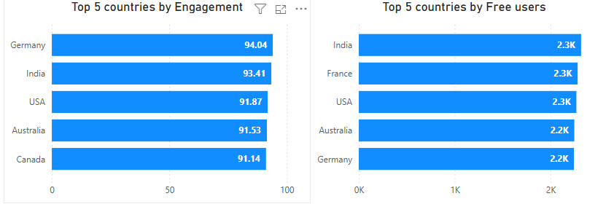

Some regions have a high number of Free users actively engaging with WPPOOL—frequent sessions, consistent usage—but they aren’t making the leap to Pro.

As we can see from the charts, while **India** is the 2nd most engaging country, it has the most free users.

The same goes for USA, Australia, and Germany.

These countries present a prime opportunity for tailored strategies. Adjusting pricing or offering special discounts based on local purchasing power could encourage more upgrades.

**Building Regional Connections**

To increase trust and visibility, collaborating with local influencers—bloggers, YouTubers, and industry experts—can showcase WPPOOL’s real-world impact and credibility.

Creating region-specific landing pages that address unique business challenges will help potential customers see WPPOOL as the perfect fit for their needs.

**Enhancing Accessibility & Support**

In regions where Free users are plentiful but engagement is lower, language barriers might be a factor. Translating key product pages, support documents, and tutorials can make WPPOOL more accessible.

Additionally, offering customer support or chatbot assistance in the most active languages will improve user experience and foster stronger connections.

## 6. Conversion Rate Optimization (CRO)

### If WPPOOL increases the landing page conversion rate by 10%, what would be the estimated impact on Pro upgrades?

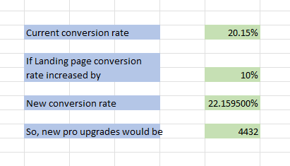

1. Current conversion rate: *Pro users/ Total Users*
2. New conversion rate: *Current conversion rate + (current conversion rate *10)*
3. So, New total pro users : New conversion rate * Total users

## Growth Strategy & KPI Recommendations

### Identify 3 key performance indicators (KPIs) WPPOOL should track.

1. **Pro Conversion Rate**

Currently at 20.14%, this metric tracks the percentage of free users who upgrade to Pro.

This is significant because Pro users generate all revenue, averaging $58.45 per Pro user per month.

Monitoring this KPI will provide a direct measure of monetization success.

1. **User Engagement**

By combining sessions, page views, and active days into a single engagement score, WPPOOL can better assess user activity.

This strong link between engagement and conversion makes it a key leading indicator for growth.

1. **Monthly Revenue**

Monthly revenue tracks recurring business from old customers also new business by new customers.

It’s an effective KPI to track **Growth** and **Quality of service provided**.

If the themes and plugins provided by WPPOOL satisfy the customers, they will keep using our service. If not, they will churn. So, monthly revenue can be a good indicator of **Quality of service.**  
  
On the other hand, monthly revenue will also increase if new customers use our products and services. Which can also be a good indicator of **Growth.**

1. **Additional Suggestion**

Another metric can be used, which is, **Customer Satisfaction Score.** It can indicate, products uniqueness, effectiveness, and service quality.

### Suggest 2 actionable growth strategies WPPOOL can implement based on your analysis.

NB: Strategies to reduce churn will also work as a growth driver. Those strategies have already been discussed in section 5 along with implementation plan.

### How would you measure the success of these strategies?

**For the Targeted Engagement Program:**

Key Metrics:

* Increase in **conversion rate** among targeted users vs. control group.
* Reduction in **average conversion time** (currently **91.51 days**).
* Higher **engagement scores** for users in the program.

Success Targets:

* **15% increase** in conversion rate for targeted users within 3 months.
* **20% reduction** in the time it takes to convert to Pro.
* **25% boost** in trial activation rates.

**For the Geographic-Focused Retention Program:**

Key Metrics:

* Reduction in **country-specific churn rates**.
* Improvement in **regional engagement**.
* Increase in **regional active user growth rates**.

Success Targets:

* **5% reduction** in churn across target regions within 6 months.
* **15% increase** in regional engagement score.
* **10% higher renewal rates** in key regions.

**Overall Business Impact Measurement:**

* Combine these initiatives to drive a **30% increase in total monthly recurring revenue within 12 months**.
* Conduct **quarterly strategy reviews** to measure progress and refine approaches.
* Tracking the impact of these initiatives on core business metrics, including **revenue growth, user growth, and retention** etc.

# SECTION: 3

### 3 most favorite Books:

I read books only to solve a specific problem in my life. Hence, I mostly read **non-fiction** books.

My 3 most favorite books are:

1. **Deep Work (Cal Newport):**

I read this book when I lacked discipline. I couldn’t focus longer which hampered my productivity and the quality of my study and work.

Reading this book taught me:

* How to achieve more with less time just by using absolute focus.
* How to create time blocks for the most important task I currently have.
* How to remove distractions.
* Why avoiding social media is good for me (My Facebook and Instagram remain deactivated most of the time. This book was one of the motivators for this action)

1. **Master Your Emotions (Thibaut Meurisse):**

I’ve always wanted to increase my emotional stability. The smallest of things had an impact on my emotional state. So, I decided to read this book.

Biggest lessons I picked up from this book is that:

* Emotions are like clouds. They are temporary and will fade away after a certain time.
* We should not hold onto our emotions. We should let them go, and like clouds they will pass away.

1. **SQL QuickStart Guide (Walter Shields):**

I first learned SQL from a course by UC, Davis University, on Coursera. Due to lack of practice, I forgot a lot of things. To level up my SQL game, I picked this book up. This book is one of the best book on SQL for beginners.

It’s so well written and I really liked the flow of this book. How one function leads to another. Also there are enough practice problems after each chapters.

I finished this book in **8 days**. I gave this book **5 star** on Goodreads.

### 3 most favorite TV shows?

I’m a huge fan of TV shows and anime. My favorite genre is Sitcom/Comedy. And my top 3 TV shows are:

1. **The Office**
2. **Friends**
3. **Suits**

Honorable mentions**:**

* **Panchayat**, **Ted Lasso**, **Vikings.**  Currently watching- **Game of Thrones.**

### What motivates you the most in a workplace?

I will divide it into two parts:

1. **Intrinsic Motivation:**

The two biggest Internal factors that motivates me are:

1. Growth: To be able to reach new heights of skill, expertise, and personality.
2. Recognition: Getting appreciation and positive feedback for the good work. And also constructive criticism and feedback for poor performance.
3. **Extrinsic Motivation:**

Extrinsic motivations also play a crucial role. For me, these are:

1. Proper compensation
2. Work life balance