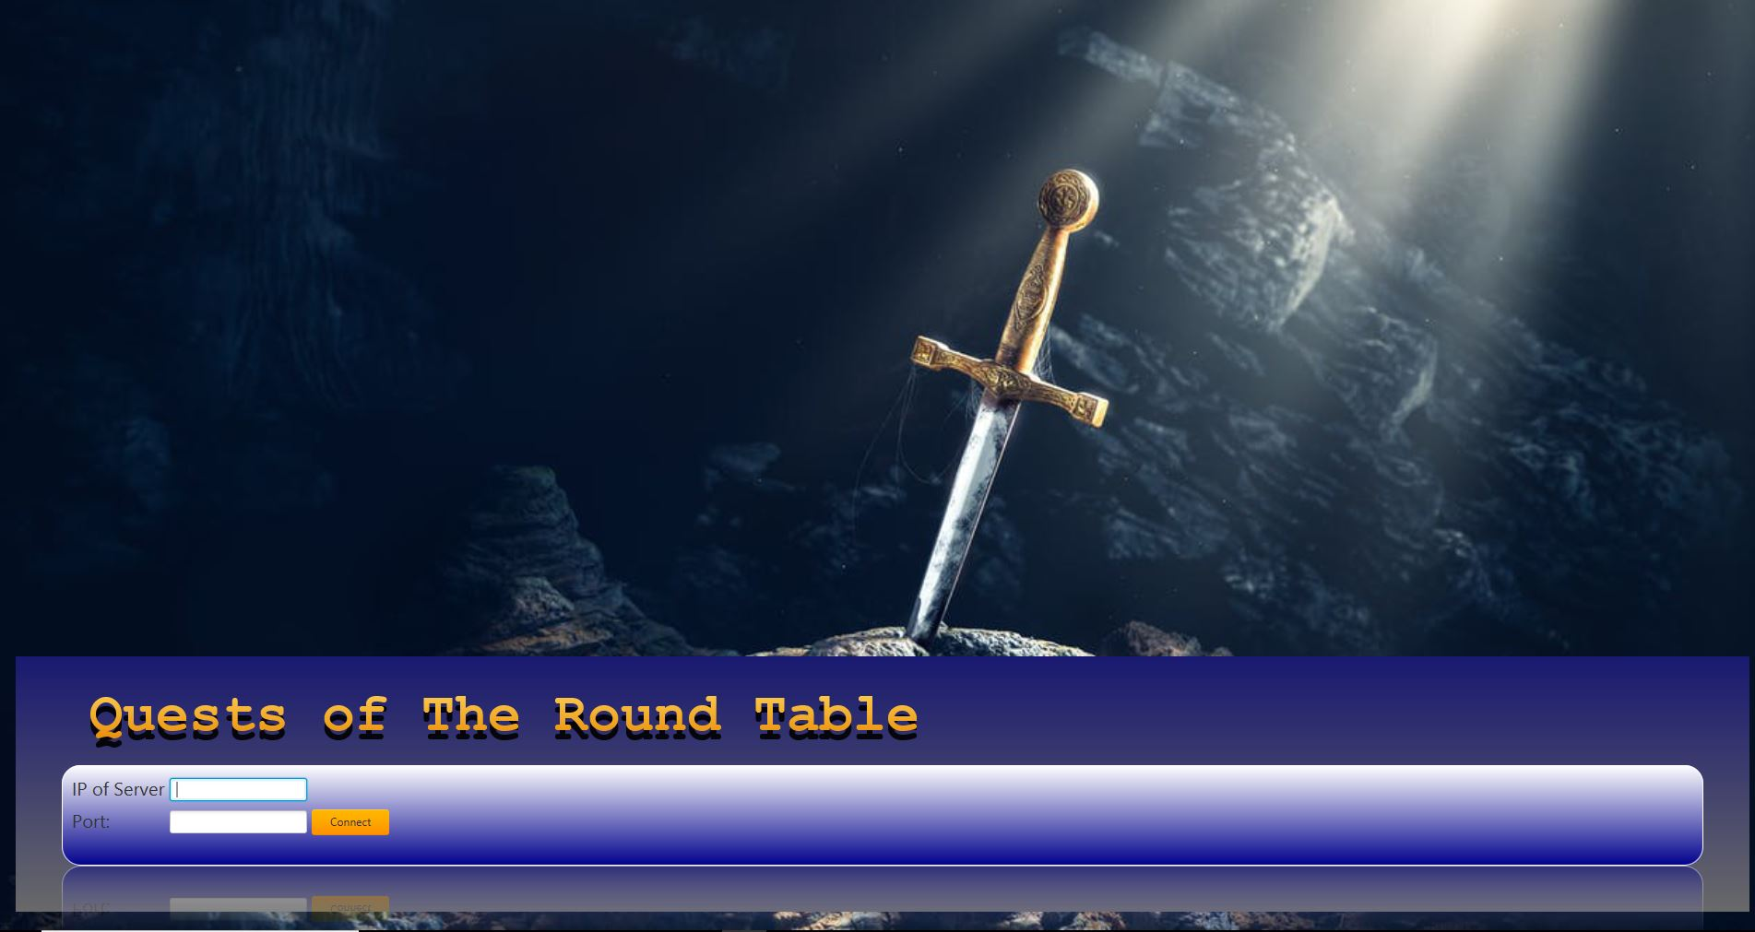

Board Game by Team 12

Ahmad Farhat

Mohamed Cheaito

Siraj Ahmadzai

Abhinav Gurung

Table of Contents

1. Introduction: 3

1.1 Motivation 3

2. Game Rules 4

3. Requirements 14

3.1 Non-Functional Requirements 14

3.3 Assumptions 14

4. Caveats 15

5. Use Cases 16

5.1 Use Case Diagram 16

5.2 Use Cases 17

6. Responsibilities 24

7. UML 25

7.1 Class Diagram – client 25

7.2 Class Diagram – Views 26

7.3 Class Diagram – Server 27

5.3 Class Diagram – Controller 27

5.4 Class Diagram – Model 28

# Introduction:

Quests of the Round Table is a Board game designed by Scott Kimball and published by Gamewright. The game comes with two decks of cards. The story deck determines what happens on each player's turn; a quest, a tournament, or a special event. The adventure deck holds the allies, foes, weapons, tests, and amour cards which get dealt and drawn into players' hands. Players begin the game as squires with a lowly battle strength of five and, by earning shields, try to be the first to progress through knight and champion knight to become a knight of the round table

## 1.1 Motivation

Outlined in this document are a brief introduction to the project, functional and non-functional requirements for the software, as well as use cases and assumptions made throughout the process. A proposal for the game's interface is also given.

This project aims to transform Quests of the Round Table into a networked multiplayer game, allowing people to play at distances using their computers. The official board game rules will be followed, with additions to accommodate network play on the computer platform. Therefore, the modelling process of coming up with requirements and use cases would be necessary in building a solid program

# 2. Game Rules

Below are scanned pages of the official game rules for Quests of the Round Table. Pages that were irrelevant to the project, such as two-player games, became omitted.

Each section has been given identifiers to use with requirements traceability, which can be seen as boxes next to the appropriate section. The notation for the identifiers, which will be used later on, begins with GR (Game rule).

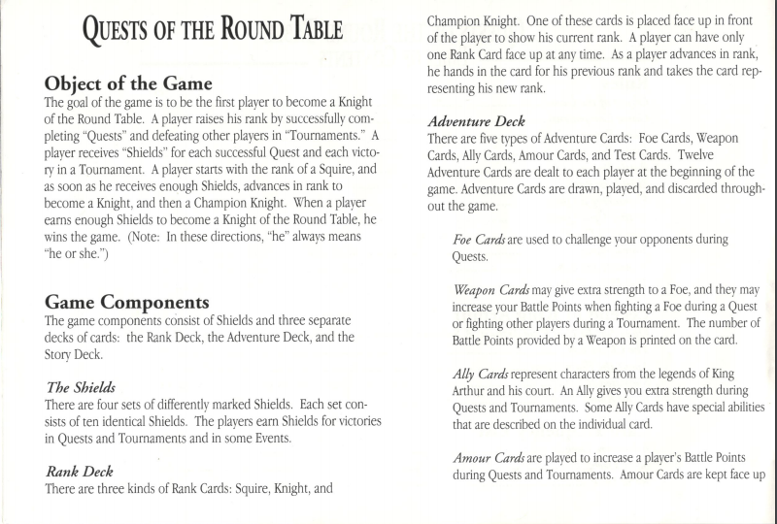

GR-01

GR-04

GR-03

GR-02

GR-05

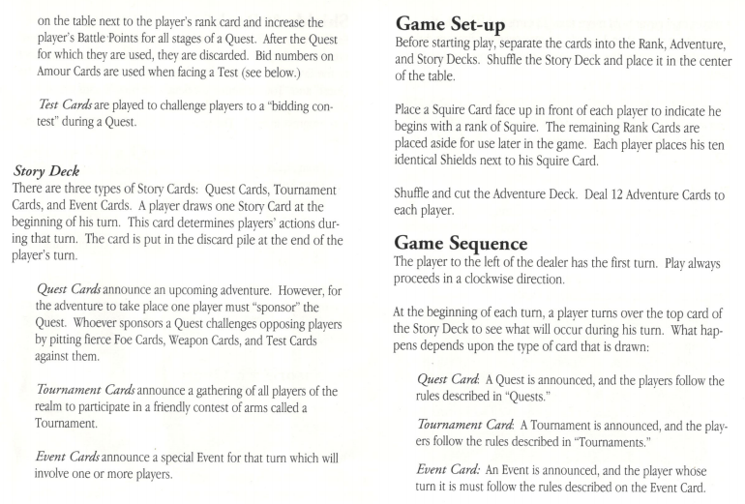

GR-11

GR-010

GR-09

GR-08

GR-06

GR-07

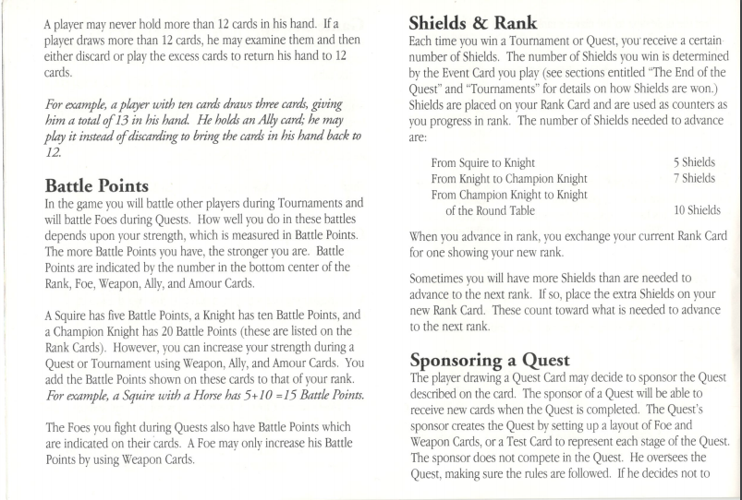

GR-12

GR-14

GR-13

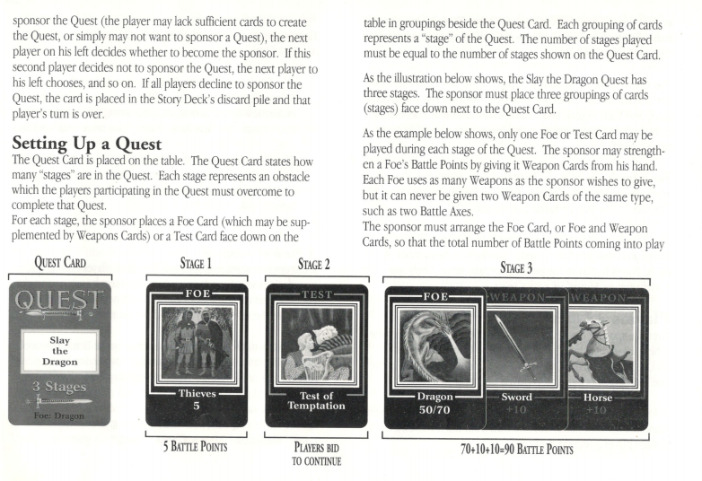

GR-15

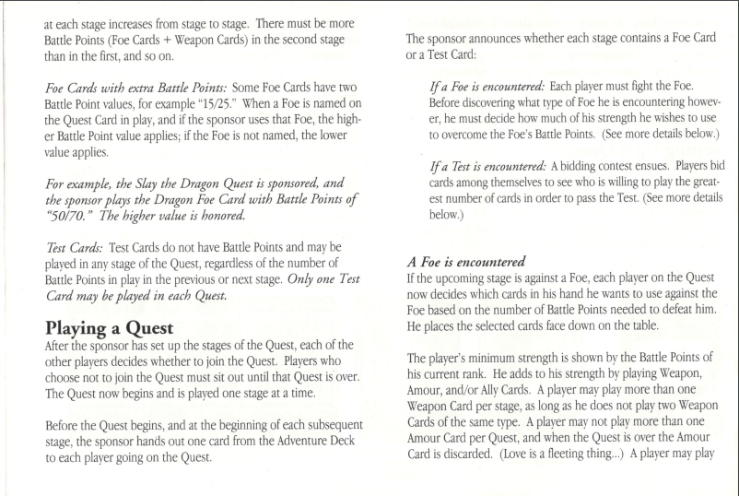

GR-16c

GR-16b

GR-16a

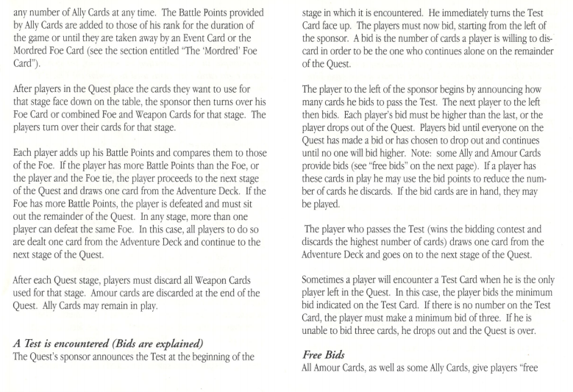

GR-16d

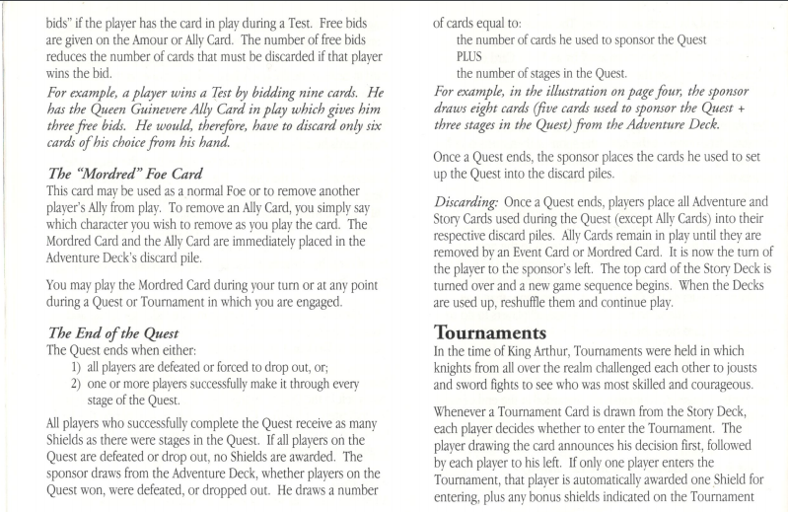

GR-19a

GR-18

GR-17

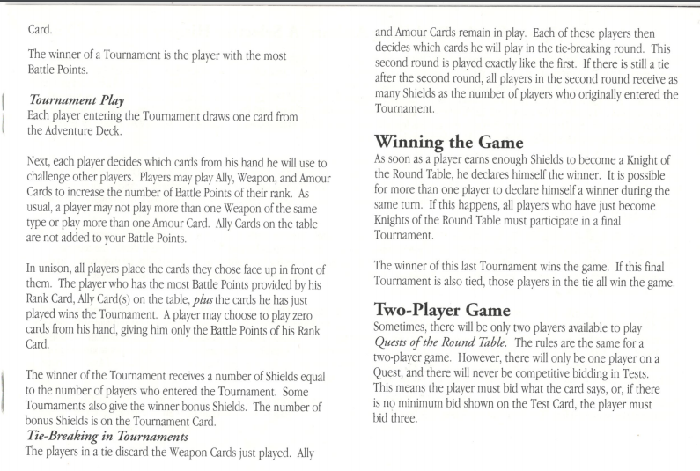

GR-21

GR-20

GR-19c

GR-19b

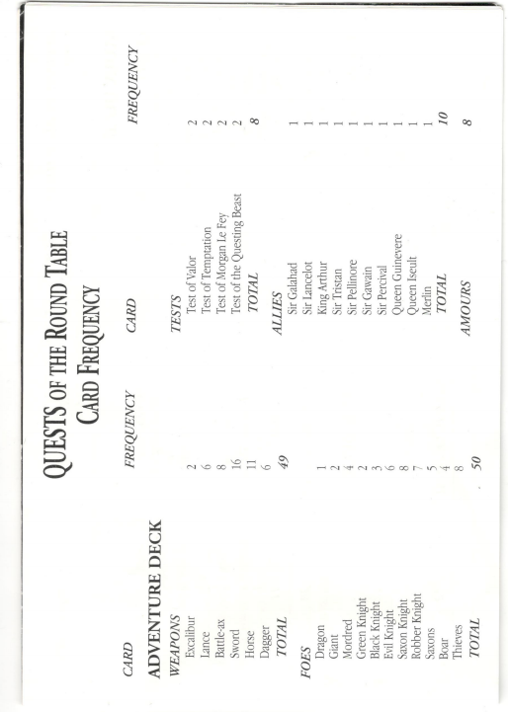

GR-22d

GR-22c

GR-22b

GR-22a

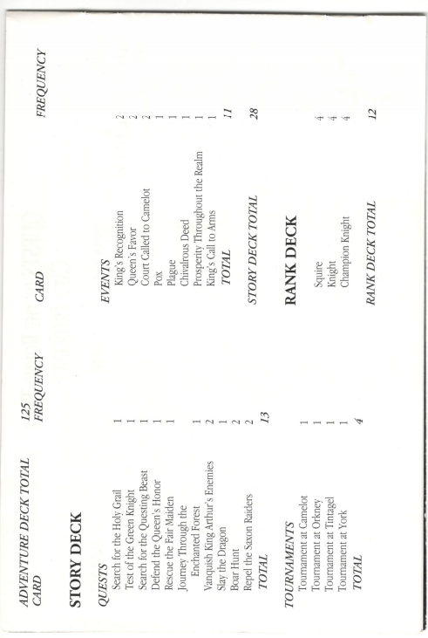

GR-24

GR-23c

GR-23b

GR-23a

# 3. Requirements

This section contains what features must be implemented. Each requirement has its own unique identifier, description, plus where the decision to come up with it can be traced to. The source of traceability may either be from the official game rules (see Game Rules for notation information), assumptions, other requirements, or team decisions.

## 3.1 Non-Functional Requirements

Non-functional requirements deal with the quality of which the program must satisfy. These concern aspects such as accessibility, usability, and maintainability.

|  |  |
| --- | --- |
| **ID** | **Non Functional Requirement** |
| NF-01 | The system can evaluate winning condition (end of game) |
| NF-02 | The system responds correctly to actions |
| NF-03 | The system does not stop functioning at any stage of the game |
| NF-04 | The server notifies observers every time the model changes |
| NF-05 | The system progresses the game continually (i.e. no user intervention required) |
| NF-06 | The system can add AI players to play if needed |

## 3.3 Assumptions

|  |  |  |  |
| --- | --- | --- | --- |
| **ID** | **Assumption** | **Justification** | |
| A-01 | Players will play the game as intended and will make no obvious efforts to create bugs or crash the game. | This game is not being created for a game development course. It is being created to showcase different types of technologies |

# 4. Caveats

|  |  |  |
| --- | --- | --- |
| **ID** | **Caveat** | **Justification** |
| **C-01** | The game is unplayable if a player is not responsive | The system relies on users doing their part to contribute to the game. If there is no action, the game will be left hanging |
| **C-02** | Merlin Ally Feature is missing | Did not have time |
| **C-03** | Mordred Feature is missing | Did not have time |

# 5. Use Cases

## 5.1 Use Case Diagram

The following diagram corresponds to the use cases in Section 4.2. Actors are depicted as stick figures. Ellipses represent use cases, dashed arrows with an <<include>> stereotype represent an “includes” relationship, and regular lines represent association.

## 

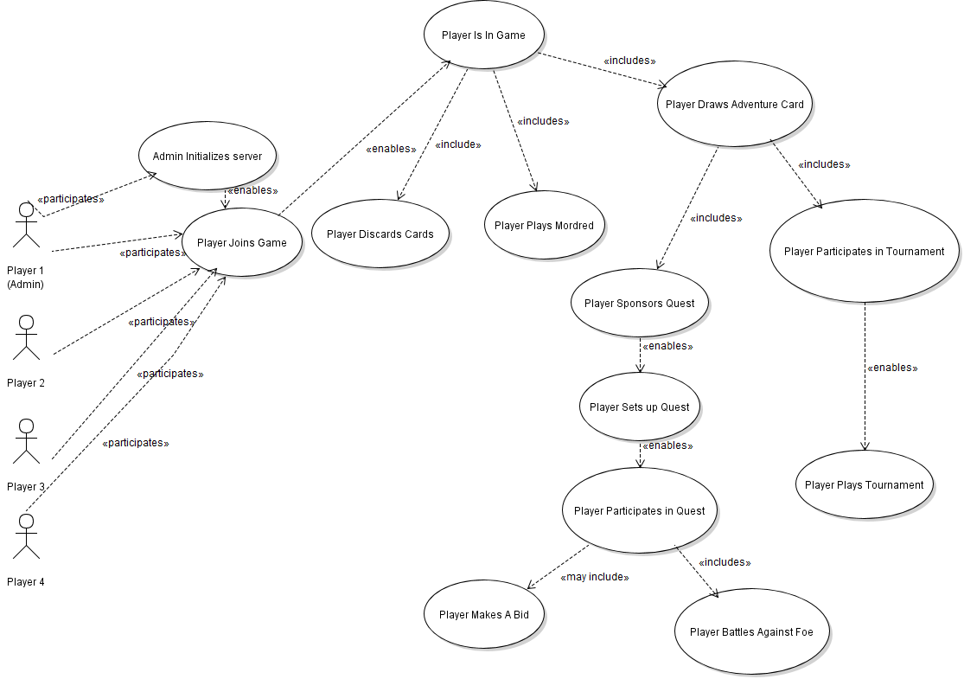

**Game**

|  |  |
| --- | --- |
| **UC-01** | **Admin Initializes Server** |
| **Description** | Initialization of Quests of the Round Table, so that players can connect and be placed into a game |
| **Actors** | Admin |
|  | Admin chooses to initialize Quests of the Round Table |
| **Pre-Condition** | None |
| **Main Sequence** | 1. Admin runs the server 2. Admin selects number of real players and AI players 3. Admin begins hosting games of Quests of the Round Table for 2, 3, or 4 Players |
| **Post-Condition** | Game server is running |
| **Resulting Event** | The game server is now awaiting connections from players |
| **Alternative Scenarios** | N/A |
| **Traceability** | GR-01, GR-20, NF-02, NF-06 |

## 5.2 Use Cases

|  |  |
| --- | --- |
| **UC-02** | **Player Joins Game** |
| **Description** | The event that occurs when all required human players are connected to the game server |
| **Actors** | Player |
|  |  |
| **Pre-Condition** | The server is up and running |
| **Main Sequence** | 1. Player launches client 2. Connects to server 3. Waits for other players to join (Same UC) |
| **Post-Condition** | Player is waiting for others to connect |
| **Resulting Event** | Player is connected on the server |
| **Alternative Scenarios** | N/A |
| **Traceability** | NF-02, NF-06 |

|  |  |
| --- | --- |
| **UC-03** | **Player Is In Game** |
| **Description** | The event that occurs when all required human players are connected to the game server. That is when the game is set up |
| **Actors** | Last required Player |
|  |  |
| **Pre-Condition** | All players now connected to the game |
| **Main Sequence** | 1. Last required player joins server ( <<include UC-02>>) 2. Player now can play the game 3. Repeat until winning conditions met    1. Draw Adventure card <<include UC-xx>>    2. Current player becomes the player to the left of Current Player |
| **Post-Condition** | A player has won |
| **Resulting Event** | The game ended |
| **Alternative Scenarios** | N/A |
| **Traceability** | GR-06, GR-07, GR-08, GR-13 |

|  |  |
| --- | --- |
| **UC-04** | **Player draws Adventure Card** |
| **Description** | Current player draws an adventure card, and acts depending on what is there |
| **Actors** | Current Player |
|  |  |
| **Pre-Condition** | No winner yet |
| **Main Sequence** | 1. Player draws an adventure card, do one of the following:    1. If drawn card is Tournament Card, run Player participates in Tournament <<include UC-05>>    2. If drawn card is Quest Card, run Player Sponsors Quest <<include UC-07>>    3. If drawn card is Event Card, run System runs Event <<include UC-014>> |
| **Post-Condition** | None |
| **Resulting Event** | Repetition of UC-04 through UC-03 |
| **Alternative Scenarios** |  |
| **Traceability** | GR-06, GR-09, GR-10, GR-15 |

|  |  |
| --- | --- |
| **UC-05** | Player participates in Tournament |
| **Description** | Players, starting from current player, are asked in turn if they would like to participate in a tournament |
| **Actors** | Player |
|  |  |
| **Pre-Condition** | The Story Card most recently drawn is a Tournament card |
| **Main Sequence** | 1. For each player, starting from current player:    1. Ask if player wants to play in tournament       1. If yes, player added to participants 2. Run Player Plays Tournament <<include UC-06>> |
| **Post-Condition** | None |
| **Resulting Event** | Tournament will be played |
| **Alternative Scenarios** |  |
| **Traceability** | GR-19a |

|  |  |
| --- | --- |
| **UC-06** | Player Plays Tournament |
| **Description** | Players take place in tournament |
| **Actors** | Players who decided to participate in tournament |
|  |  |
| **Pre-Condition** | Players decided already if they want to participate in tournament |
| **Main Sequence** | 1. For each player in participants:    1. Player draws a card from the adventure deck    2. Player plays weapons, allies/amours appropriately face-down for the tournament 2. All Participants reveal the cards they have laid down 3. Player with highest BP wins tournament |
| **Post-Condition** | None |
| **Resulting Event** | There is a winner in the tournament and winner gets as many shields as there were participants |
| **Alternative Scenarios** | If there is a tie, play a tie-breaker for a tournament (Repeat UC-06, with just the players in the tiebreaker) |
| **Traceability** | GR-19a, GR-19b, GR-19c |

|  |  |
| --- | --- |
| **UC-07** | **Player Sponsors Quest** |
| **Description** | Players, starting from current player, are asked in turn if they would like to sponsor a quest |
| **Actors** | Player |
|  |  |
| **Pre-Condition** | The Story Card most recently drawn is a Quest card |
| **Main Sequence** | 1. For each player, starting from current player:    1. Ask if player wants to sponsor quest       1. If yes, run Player Sets up Quest <<include UC-08>> 2. Sponsor draws as many Adventure Cards as they put into the quest PLUS as many cards as there are stages |
| **Post-Condition** | Quest is complete |
| **Resulting Event** |  |
| **Alternative Scenarios** | If Sponsor has more than 12 cards at hand after drawing: <<include Player discards card>> |
| **Traceability** | GR-14 |

|  |  |
| --- | --- |
| **UC-08** | **Player Sets up Quest** |
| **Description** | The player who sponsored the Quest, will now set up the quest |
| **Actors** | Player who is sponsoring the Quest |
|  |  |
| **Pre-Condition** | None |
| **Main Sequence** | 1. For the number of stages in the Quest, either:    1. Set up a Battle Stage with foes + weapons with BP more than the previous Battle Stage (if applicable), or    2. Set up a stage with a test (can only happen once) |
| **Post-Condition** | Quest is set up consisting of Battle Stages in ascending order and, optionally, at most one test. |
| **Resulting Event** | Run use case Player Participates in Quest UC-09 |
| **Alternative Scenarios** |  |
| **Traceability** | GR-15 |

|  |  |
| --- | --- |
| **UC-09** | Player Participates in Quest |
| **Description** | Every player except the Sponsoring Player decides if they would like to participate in the quest. Consequently, each participant plays out the stages of the quest |
| **Actors** | All players |
|  |  |
| **Pre-Condition** | A quest is set up |
| **Main Sequence** | 1. For every player, except the sponsoring player:    1. Player decides if they want to participate in quest 2. For all stages the sponsor set up    1. Sponsor announces stage type       1. If a Test, <<include>> UC-10 Player Makes a Bid, otherwise       2. <<include>> UC-11 Player Battles Against Foe |
| **Post-Condition** | All applicable players have said if they want to participate or not in Quest |
| **Resulting Event** | If at least one participant joined, run use case Player UC-10 |
| **Alternative Scenarios** | If no one wanted to participate, **do not run** 2) |
| **Traceability** | GR-16a |

|  |  |
| --- | --- |
| **UC-10** | Player Makes a Bid |
| **Description** | A test is run into and all players make a bid to proceed to next stage |
| **Actors** | All participants |
|  |  |
| **Pre-Condition** | Current stage is Test |
| **Main Sequence** | 1. For each Player in Participants, until there is a winner    1. Player announces bid    2. If bid is higher than previous one,       1. Player stays in bid, otherwise       2. Player drops out 2. Winner discards bid amount of cards <<include UC-12>> |
| **Post-Condition** | 1. Test Stage is complete  2. And either,   1. There is a winner at the end of this Test, or 2. There is no winner (no one bid) |
| **Resulting Event** | The winner will proceed to the next stage OR win the Quest |
| **Alternative Scenarios** | Under post-conditions, if b) occurs the Quest ends early and no one discards cards |
| **Traceability** | GR-16c |

|  |  |
| --- | --- |
| **UC-11** | Player Battles against Foe |
| **Description** | A foe is run into and players must battle it |
| **Actors** | All participants and the Sponsor |
|  |  |
| **Pre-Condition** | Current stage is a Battle Stage |
| **Main Sequence** | 1. For each player in participants:    1. Player draws one Adventure Card    2. Player decides which weapons, amours and/or allies to play 2. Sponsor reveals stage’s foe + weapons (if applicable) 3. For each Player in participants:    1. If Player matched stage’s BP or is higher, proceed to next stage, otherwise    2. Player drops from the Quest |
| **Post-Condition** | Battle Stage is complete |
| **Resulting Event** | The winner will proceed to the next stage OR win the Quest |
| **Alternative Scenarios** | If any Player has more than 12 cards at hand after drawing: <<include UC-12>> |
| **Traceability** | GR-16b |

|  |  |
| --- | --- |
| **UC-12** | Player Discards Cards |
| **Description** | A Player discards cards from hand |
| **Actors** | Player |
|  |  |
| **Pre-Condition** | Resultant from either  a) Having too many cards in hand, or  b) Winning Test Stage |
| **Main Sequence** | 1. If precondition is a):  Player discards down to 12 cards  2. If precondition is b):  Player discards the amount he bid MINUS any free bids he had in the first place |
| **Post-Condition** | Player has discarded cards back into the discard pile |
| **Resulting Event** | None |
| **Alternative Scenarios** |  |
| **Traceability** | GR-16d |

|  |  |
| --- | --- |
| **UC-13** | Player Plays Mordred |
| **Description** | A Player plays Mordred to kill (remove) someone’s Ally in play |
| **Actors** | Player |
|  |  |
| **Pre-Condition** | None |
| **Main Sequence** | 1. Player plays a Mordred Foe card  2. Player announces which Player’s Ally should be removed  3. Removed Ally’s Player discards that Ally back into the discard pile |
| **Post-Condition** | An Ally has been removed from play |
| **Resulting Event** | None |
| **Alternative Scenarios** |  |
| **Traceability** | GR-23c |

|  |  |
| --- | --- |
| **UC-14** | **System Runs Event Card** |
| **Description** | An event is run by the system, and acts appropriately depending on what event is drawn |
| **Actors** | System |
|  |  |
| **Pre-Condition** | An Event card is in play |
| **Main Sequence** | 1. The system checks the event  If Event is Chivalrous Deed  System awards players with the lowest rank with 3 shields  If Event is Pox  System removes 1 shield from every player except the one who drew it  If Event is Plague  System removes 1 shield from the player who drew it  If Event is King’s Recognition  System sets up 2 bounty shields as an award for the next Player(s) to  win the quest  If Event is Queen’s Favor  System hands out 2 Adventure Cards to lowest ranked Player(s) in the   game  If Event is Court Called to Camelot  System removes all Allies in play into discard pile  If Event is King’s Call to Arms  System determines highest ranked Player(s) and they must discard 1   Weapon. If not possible:  Player instead discards 2 Foes  If Event is Prosperity Throughout the Realm  System hands out 2 cards to each Player  Note: If in any of the situations above a Player ends up with more than 12 cards, OR has to discard cards, then run Player Discards Cards <<include UC-12>> |
| **Post-Condition** | None |
| **Resulting Event** | Repetition of UC-04 through UC-03 |
| **Alternative Scenarios** |  |
| **Traceability** | GR-06, GR-09, GR-10, GR-15 |

# 6. Design Decisions

This section documents design decisions that have been taken with respect to classes and objects chosen for the system. Included is a Unified Modeling Language (UML) diagram in Section 5.2.

## 5.1 – Decisions

|  |  |  |
| --- | --- | --- |
| **ID** | **Design Decision** | **Traceability** |
| DD-01 | **MVC model** | Group Decision |
| DD-02 | **1 UIController for each client vs 1 UIController for all clients** | Group Decision |
| DD-02 | **Command-based networking** | Group Decision |

# 7. Responsibilities

|  |  |  |
| --- | --- | --- |
| **ID** | **Responsibility** | **Use Case** |
| **R-1** | The system accepts connections from players. | UC-01 |
| **R-2** | The system sends information about game to all players | UC-03 |
| **R-3** | The system shuffles all the cards in each deck |  |
| **R-4** | The system sends the start message to all players. | UC-03 |
| **R-5** | The system sends a message/update to each player every time the model is updated |  |
| **R-7** | The system runs the game in co-ordination (responses) from the user |  |
| **R-8** | The system is able to determine when the game ends (i.e. when there is a winner) | UC-03 |

# UML

## Class Diagram – client

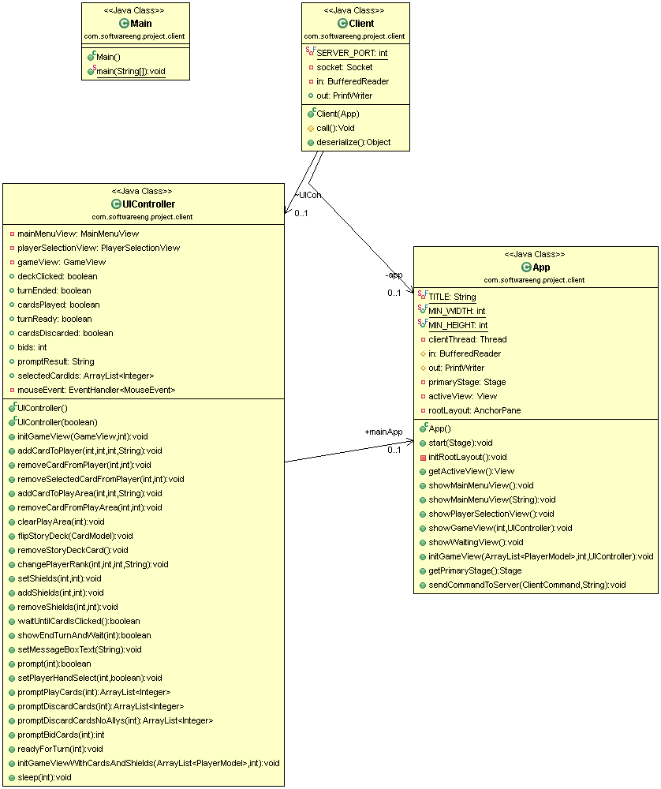

## Class Diagram – Views

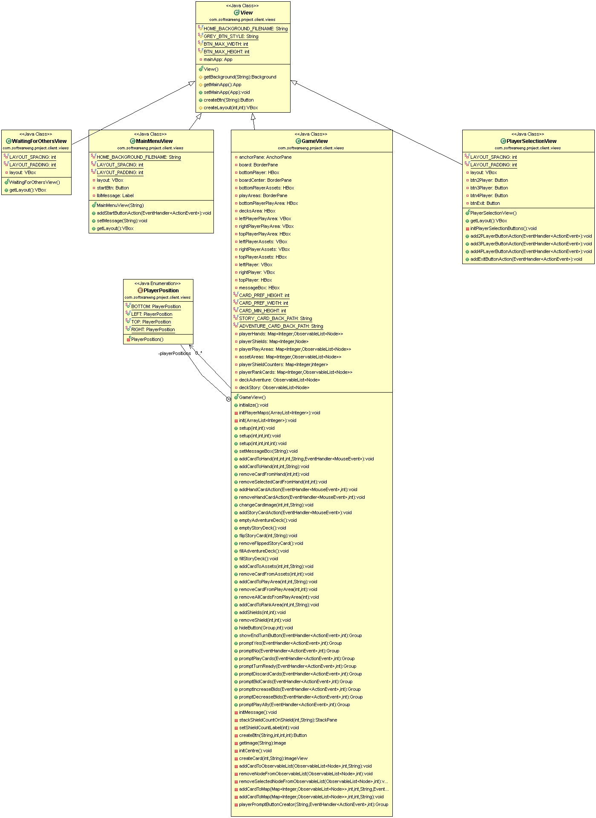

## 8.3 Class Diagram – Server

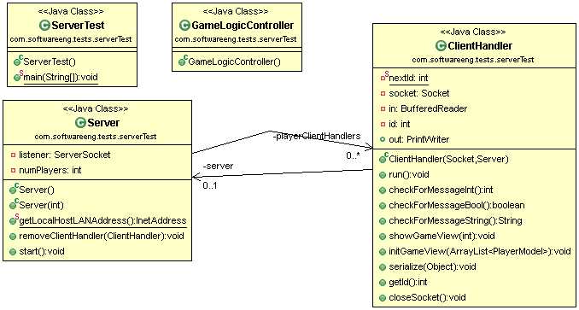

## 8.4 Class Diagram – Controller

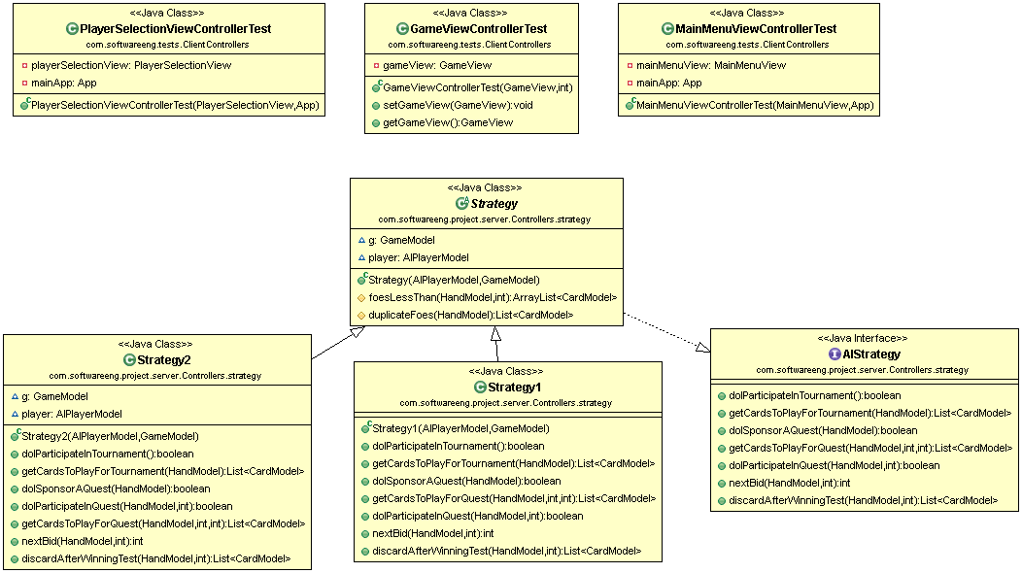

## 8.5 Class Diagram – Model

