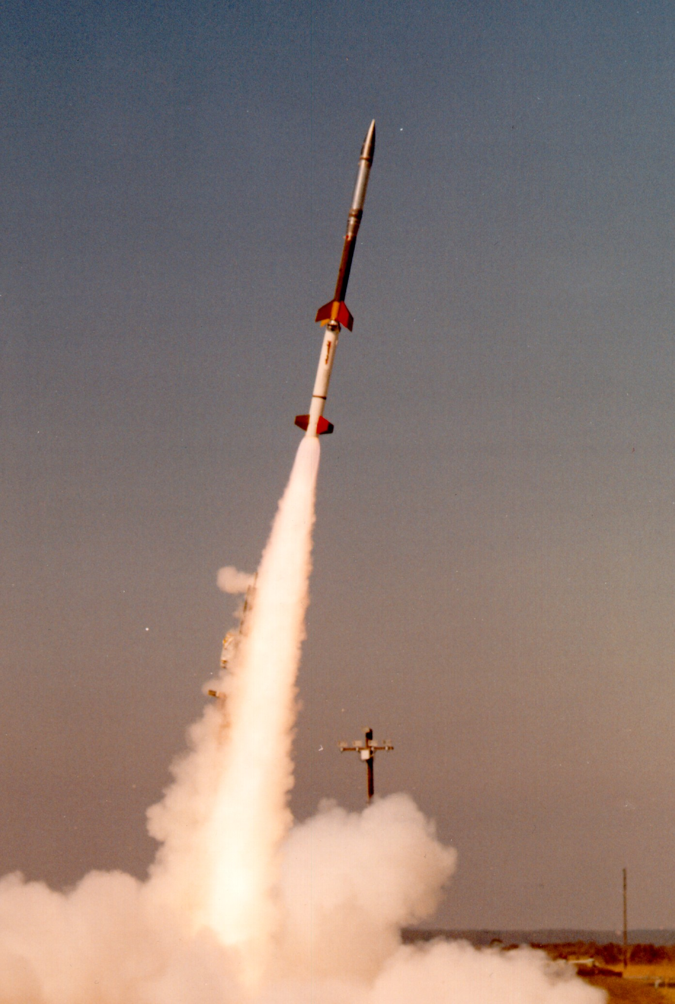

Extra Credit Assignment

Fundamentals of Physics

Debbie Walker

Full Sail University

The first physics concept notable in the above picture of a rocket was Newton’s third law of **Action and Reaction** which according to our lecture plan from Day 2, author unknown (2015) “Newton’s Laws-Momentum-Energy” states:

Whenever one object exerts a force on a second object, the second object exerts an equal and opposite force on the first.

So by observing the rocket photo above you can see that the enormous controlled explosion caused by a reaction from the rocket proton exchange membrane fuel cell (PEM) that forces gases through a catalyst on the negative side of the cell which then are stripped and carried to the positive side. According to Encyclopedia Britannica Online (2015), the positive charged cells pass through a “proton exchange membrane” to a catalyst on the electric circuit side, which “form water vapor (H2O) and heat…used to…power a motor.”

When this happens Action and Reaction (F = F) happens – which is to say two objects; the rocket and the energy, exert force on each other the same equal force is expelled. This gives the rocket the thrust and push it needs to exceed the gravity force’s weight (w = mg).

The second physics concept is the **Equilibrium Rule,** author unknown (2015) Motion,

EXTRA CREDIT ASSIGNMENT DAY 2

EXTRA CREDIT ASSIGNMENT DAY 2

“proton exchange membrane fuel cell.” Art. Encyclopedia Britannica Online. Web. 04 Feb. 2015.

[http://www.britannica.com/EBchecked/media/100899/Proton-exchange-membrane-fuel-cell-The proton-exchange-membrane-is](http://www.britannica.com/EBchecked/media/100899/Proton-exchange-membrane-fuel-cell-The%20proton-exchange-membrane-is)

Author Unknown (2015). Newton’s Laws-Momentum-Enegry [PowerPoint slides]. Retrieved from

<https://assethub.fso.fullsail.edu/assethub/Motion_07f53230-5265-4a07-8099->  
6d74ceb81de4.pdf

Author Unknown (2015). Motion [PowerPoint slides]. Retrieved from  
 <https://assethub.fso.fullsail.edu/assethub/NewtonsLaws-Momentum-Energy_d4335059-f95d->   
 4d8c-952f-f4b0d1eb62d0.pdf

References

EXTRA CREDIT ASSIGNMENT DAY 2