* Problem Solving
* **A Cat, a Parrot, and a Bag of Seed = Sequential flowchart (step by step)**
* A man has a bird, cat, and seed that he needs to get across a river. He can use a boat, but the boat has only enough room to carry one item across at a time.
* The man needs to transport all three items across a river in a boat without losing any of them.
* The problem does not say how many trips the man can make. The problem does not say that he even has to use a boat, or that he has to use that boat.
* We have to assume that in this cartoon-reality the bird and cat would not run off (even though they would realistically eat). We would also assume that the man could swim.
* For sure the man cannot leave the cat with the bird, or the cat may eat the bird, he can’t leave the bird with the seed, because the bird may eat the seed.
  + In the cartoon-world, the man could tie a string to the bird and let it fly, while putting the seed and cat into the boat as he swims behind pushing the boat to the other side of the river.
  + Since the boat only has room for two items, he could put the seed and the cat into the boat and either pull or push the boat across by swimming. Then he could row back and get the bird and bring it over to the other side of the river, too.
    - While this may work, it would depend on the deep, width and flow of the river and therefore would not be the safest option.
  + Man takes bird over and leaves seed with cat. Man goes back for seed and leaves cat. Once man gets to the other side, he picks up bird and goes back over for cat. Man leaves bird and takes cat. Man goes back for bird.
    - This option would guarantee that all the items would make it across the river without losing any of them, and even though it would potentially take longer to make more trips, it would assure that the man could successfully take all three items across the river without fail.
* **Sock in the dark = process of elimination**
* There are 20 socks in a drawer; 5 pairs of black, 3 brown and 2 white. You need to pull several pairs of socks from the drawer in the dark.
* Assume you there is no light available and that all the socks feel the same size, thickness and shape.
* 1. Task: find at least 1 pair of matching socks.
  + In order to guarantee at least 1 pair, you would have to pull 7. That would have included all of the brown and white and 2 of the black which would assure at least 1 pair was matched.
* 2. Task: find at least one pair of black, brown and white socks in the dark.
  + In order to guarantee one color of each color at least 9 pairs, or 18 socks would have to be pulled, that would only leave 1 pair up for chance and since ever color is represented by 2 pairs, this would cover all colors.
* **Predicting Buckets:**
* For the sake of this problem, I will be using 10 buckets instead of fingers to calculate the base of 10’s, which according to Staple says that, “In base ten, you have columns or "places" for 100 = 1, 101 = 10, 102 = 100, 103 = 1000, and so forth” (page 1, paragraph 5), as show in the fig. 1-3, below.



Fig. 1

* 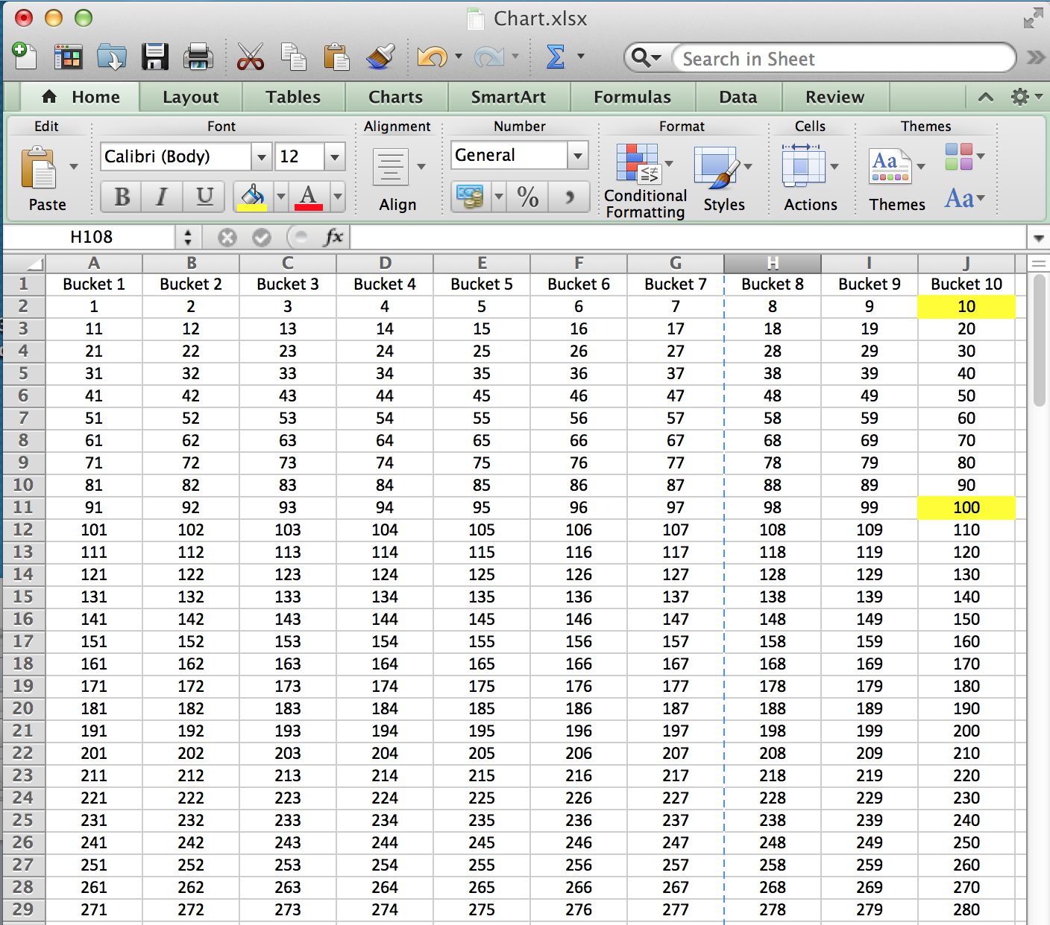
* Fig 2.
* 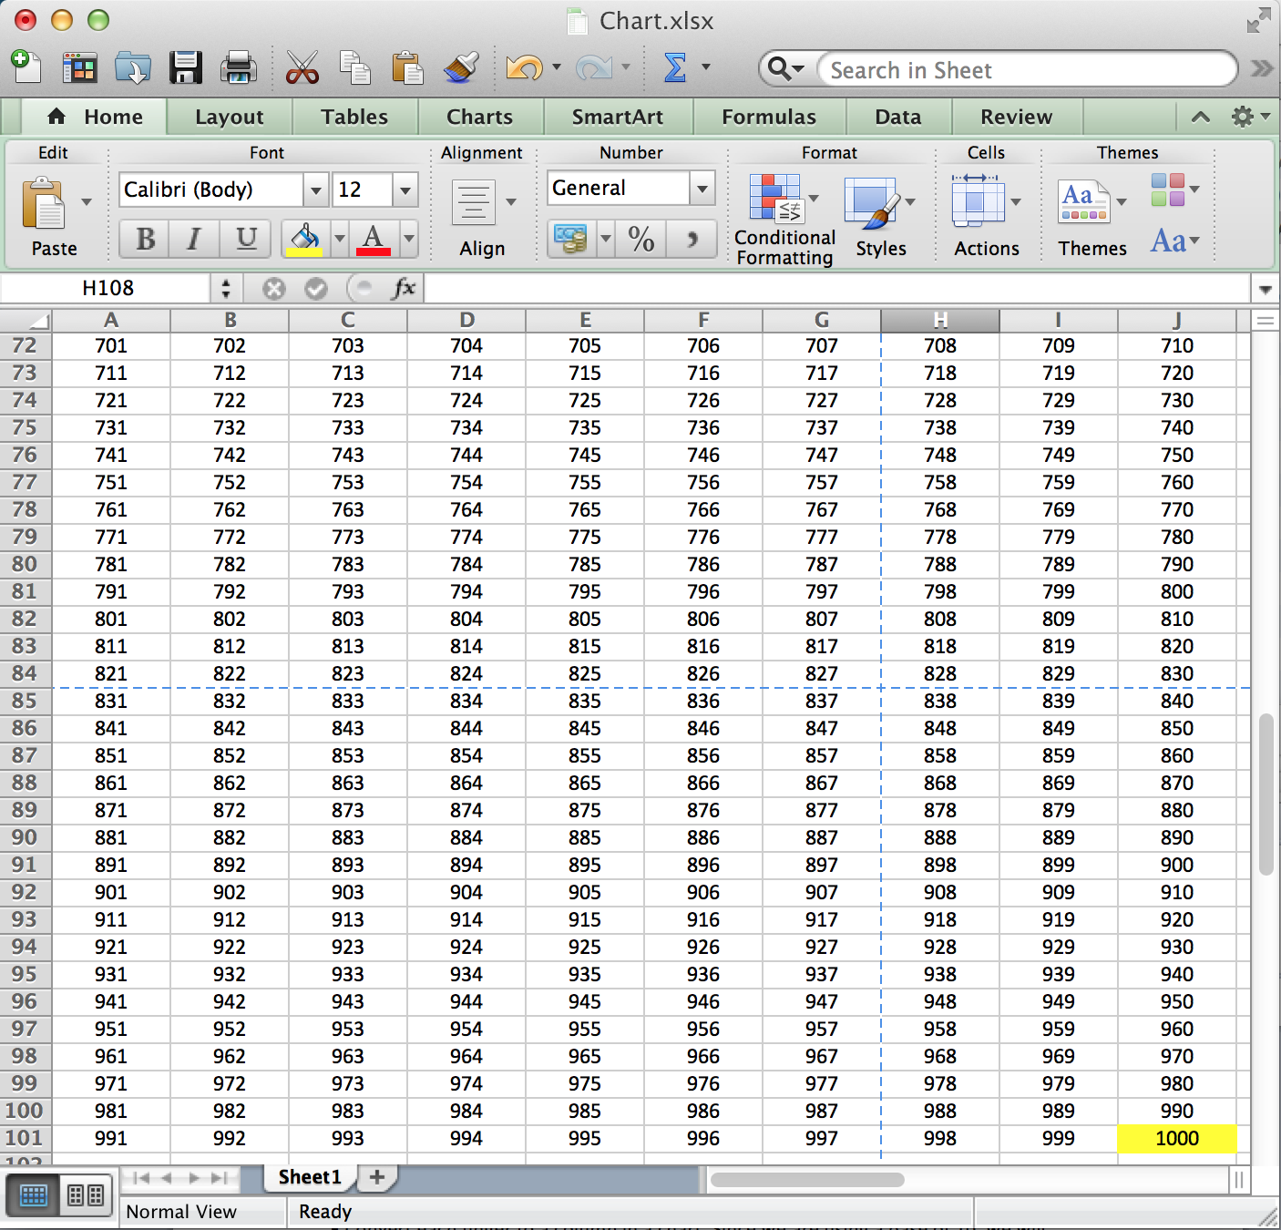
* Fig 3.
* This works because the base is in 10’s so it does not matter if it’s fingers, buckets, etc. This example shows that the container can be called anything, but the equation is the same.
* **Cited**
* Stapel, Elizabeth. "Number Bases: Introduction / Binary Numbers." Purplemath. Available from     http://www.purplemath.com/modules/numbbase.htm. Accessed 27 October 2014
* Flowcharts