UML Submission

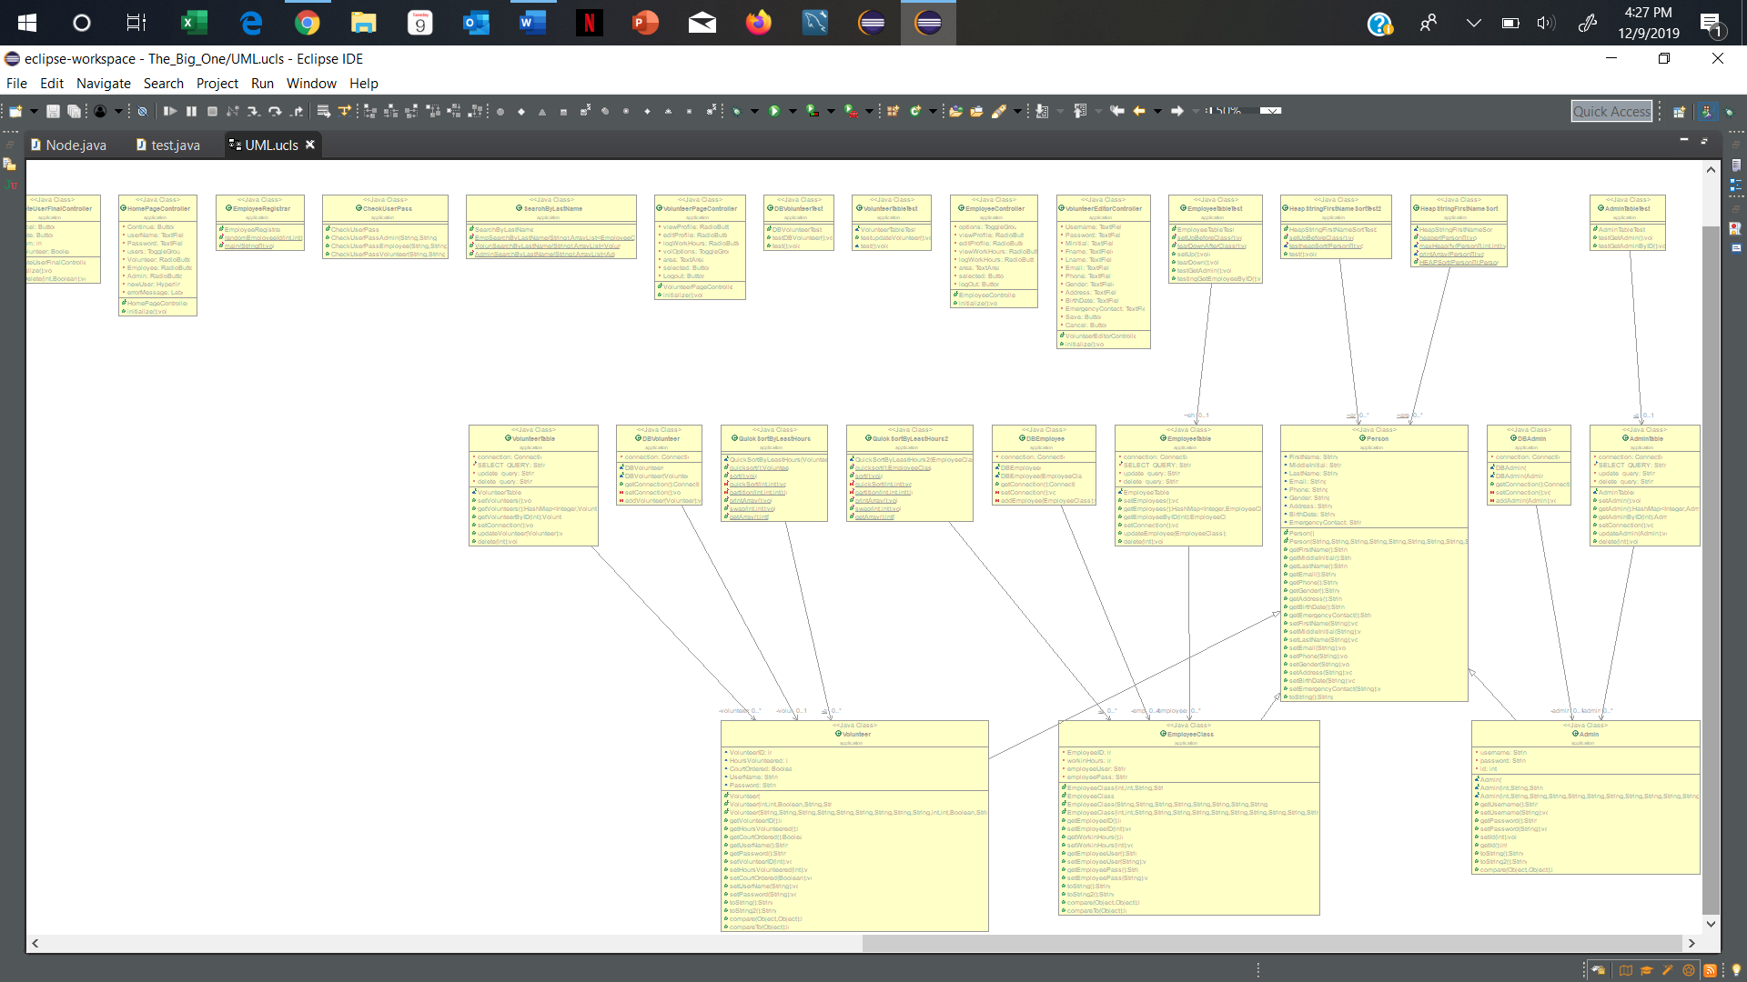UML Overview:

Person Classes and Junit test UML Tests Zoomed In:



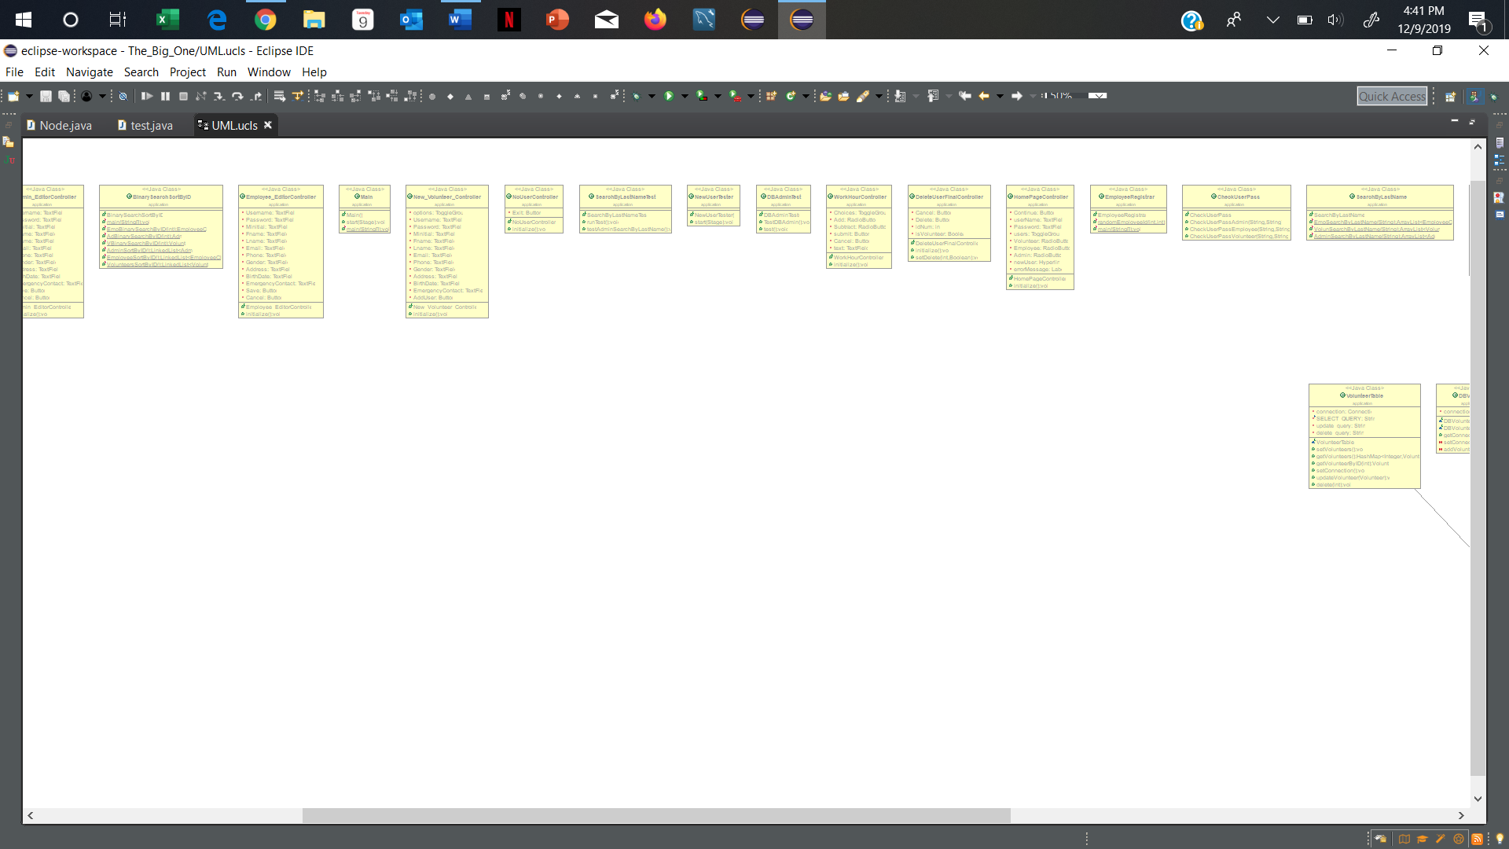FXML, Database, Table, search and sort classes Zoomed in:

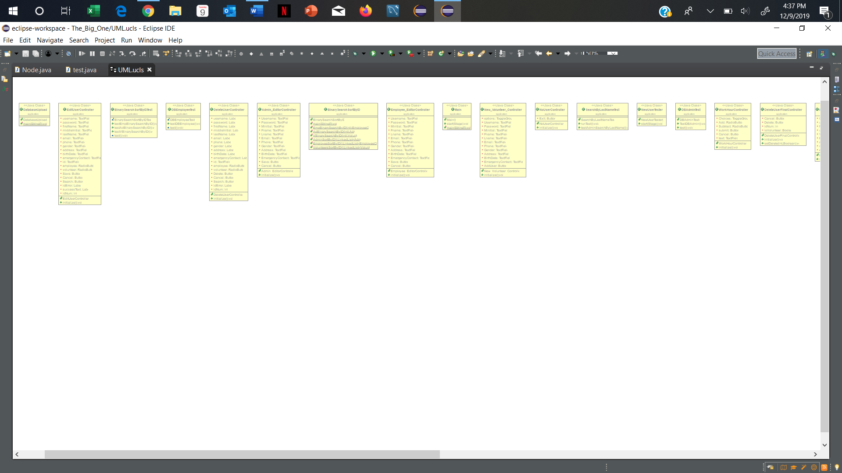

We also uploaded the UML code used to generate this UML Example on our git hub.