

IN654 Business Systems Development

CW1 Project Output:   
Source Code

By

Student 20140842

Bucks Student ID: 21402984

BSc (Hons) Software Engineering

**Buckinghamshire New University**

Table of Contents

Index Page 3

Index page: Result 5

Categories Page 6

Categories Page: Result 9

Cart page 10

Cart page: Result 13

Checkout page 14

Checkout page: Result 18

Confirmation page 19

Confirmation page: Result 22

Cascading Style Sheets 23

# Index Page

<%-- The instructions below are repeated on each page and allow the programme to run soley on Java and SQL rather than the intial HTML design. --%>

<%@taglib prefix="c" uri="http://java.sun.com/jsp/jstl/core"%>

<%@taglib prefix="sql" uri="http://java.sun.com/jsp/jstl/sql"%>

<%--

Document : index

Created on : 24-Oct-2016, 11:12:58

Author : Ed

--%>

<%@page contentType="text/html" pageEncoding="UTF-8"%>

<!DOCTYPE HTML PUBLIC "-//W3C//DTD HTML 4.01 Transitional//EN"

"http://www.w3.org/TR/html4/loose.dtd">

<%--<sql:query var="categories" dataSource="jdbc/BooksByBiggles">

SELECT * FROM category

</sql:query>--%>

<html>

<%-- This part defines the body tags of the page and links to the header located in a JSPF folder --%>

<body>

<div id="main">

<div id="header">

</div>

</div>

<%-- This section defines the layout and input on the left hand side of the page e.g. "Welcome text" --%>

<div id="indexLeftColumn">

<div id="welcomeText">

<p>Welcome to BooksByBiggles! Our Prices are Aces High! Here you will find a whole range of books suited to your expertise!</p>

</div>

</div>

<%-- This section defines the outcome for the right hand side of the page. In this case, this section is linked to the 'categories' page. --%>

<div id="indexRightColumn">

<c:forEach var="category" items="${categories}">

<div class="categoryBox">

<a href="category?"${category.id}>

<span class="categoryLabelText">${category.name}</span>

<img src="${initParam.categoryImagePath}${category.name}.jpg"

alt="${category.name}">

</a>

</div>

</c:forEach>

</div>

</body>

</html>

<%-- The sizes, colours, layouts and backgrounds for this page, can all be located within the CSS folder --%>

</div>

</div>

<%-- This section defines the outcome for the right hand side of the page. In this case, this section is linked to the 'categories' page. --%>

<div id="indexRightColumn">

<c:forEach var="category" items="${categories}">

<div class="categoryBox">

<a href="category?"${category.id}>

<span class="categoryLabelText">${category.name}</span>

<img src="${initParam.categoryImagePath}${category.name}.jpg"

alt="${category.name}">

</a>

</div>

</c:forEach>

</div>

</body>

</html>

<%-- The sizes, colours, layouts and backgrounds for this page, can all be located within the CSS folder --%>

## Index page: Result

# Categories Page

<%@taglib prefix="c" uri="http://java.sun.com/jsp/jstl/core"%>

<%@taglib prefix="sql" uri="http://java.sun.com/jsp/jstl/sql"%>

<%--

Document : category

Created on : 26-Nov-2015, 20:24:47

Author : Ed

--%>

<%--<sql:query var="categories" dataSource="jdbc/BooksByBiggles">

SELECT * FROM category

</sql:query>

<sql:query var="selectedCategory" dataSource="jdbc/BooksByBiggles">

SELECT name FROM category WHERE id = ?

<sql:param value="${pageContext.request.queryString}"/>

</sql:query>

<sql:query var="categoryProducts" dataSource="jdbc/BooksByBiggles">

SELECT * FROM product WHERE category_id = ?

<sql:param value="${pageContext.request.queryString}"/>

</sql:query>--%>

<%-- In this section, the category titles are layed out with links to the database, to call product information for a specific category when selected--%>

<div id="categoryLeftColumn">

<c:forEach var="category" items="${categories}">

<c:choose>

<c:when test="${category.name == selectedCategory.name}">

<div class="categoryButton" id="selectedCategory">

<span class="categoryText">

${category.name}

</span>

</div>

</c:when>

<c:otherwise>

<a href="category?${category.id}" class="categoryButton">

<span class="categoryText">

${category.name}

</span>

</a>

</c:otherwise>

</c:choose>

</c:forEach>

${category.name}

</span>

</div>

</c:when>

<c:otherwise>

<a href="category?${category.id}" class="categoryButton">

<span class="categoryText">

${category.name}

</span>

</a>

</c:otherwise>

</c:choose>  
</c:forEach>

</div>

<%-- Using information from the 'categoryLeftColumn', the right column displays product information from the selected category.

This also includes the display for the product table and the image retrieval for each individual product --%>

<div id="categoryRightColumn">

<p id="categoryTitle">${selectedCategory.name}</p>

<table id="productTable">

<c:forEach var="product" items="${categoryProducts}" varStatus="iter">

<tr class="${((iter.index % 2) == 0) ? 'lightBlue' : 'white'}">

<td>

<img src="${initParam.stockImagePath}${product.name}.jpg"

alt="${product.name}">

</td>  
<td>

${product.name}

<br>

<span class="smallText">${product.description}</span>

</td>

<td>&euro; ${product.price}</td>

<%-- This section creates a button which allows the customer to add products to cart which has been linked in the code below --%>

<td>

<form action="addToCart" method="post">

<input type="hidden"

name="productId"

value="${product.id}">

<input type="submit"

name="submit"

value="add to cart">

</form>

</td>

</tr>

</c:forEach>

</table>

</div>

Categories Page: Result  
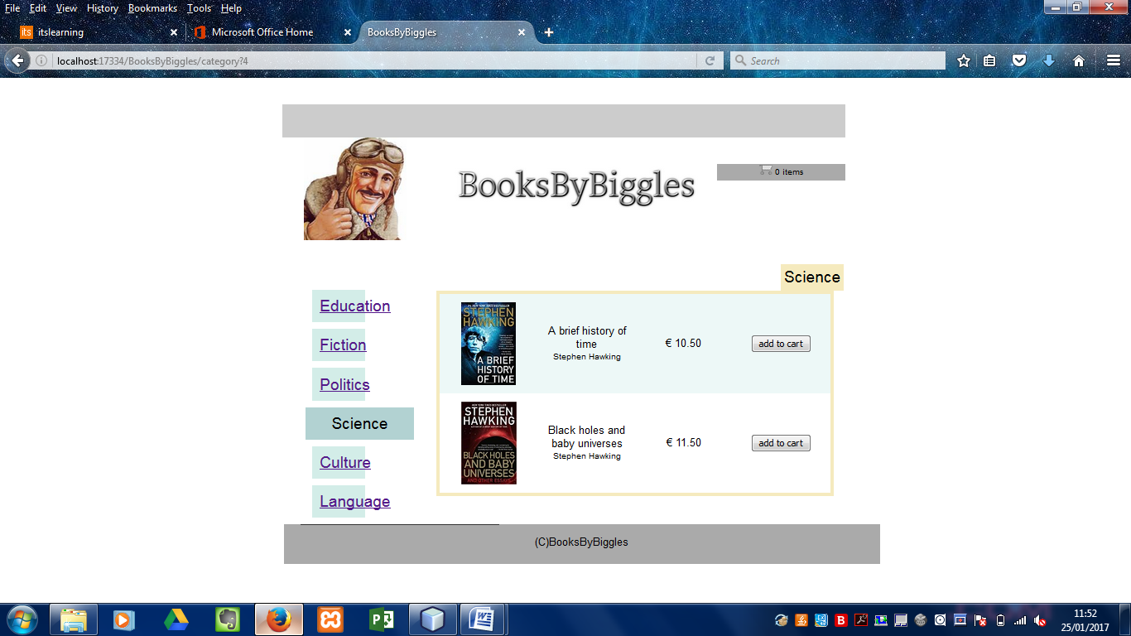

# Cart page

<div id="centerColumn">

<%-- Defines and displays cart number of items unless cart is empty --%>

<c:choose>

<c:when test="${cart.numberOfItems > 1}">

<p>Your shopping cart contains ${cart.numberOfItems} items.</p>

</c:when>

<c:when test="${cart.numberOfItems == 1}">

<p>Your shopping cart contains ${cart.numberOfItems} item.</p>

</c:when>

<c:otherwise>

<p>Your shopping cart is empty.</p>

</c:otherwise>

</c:choose>

<div id="actionBar">

<%-- clear cart widget --%>

<c:if test="${!empty cart && cart.numberOfItems != 0}">

<a href="viewCart?clear=true" class="bubble hMargin">clear cart</a>

</c:if>

<%-- continue shopping widget --%>

<c:set var="value">

<c:choose>

<%-- if 'selectedCategory' session object exists, send user to previously viewed category --%>

<c:when test="${!empty selectedCategory}">

category

</c:when>

<%-- otherwise send user to welcome page --%>

<c:otherwise>

view/index.jsp

</c:otherwise>

</c:choose>

</c:set>

<a href="${value}" class="bubble hMargin">continue shopping</a>

<%-- checkout widget --%>

<c:if test="${!empty cart && cart.numberOfItems != 0}">

<a href="checkout" class="bubble hMargin">proceed to checkout &#x279f;</a>

</c:if>

</div>  
  
<c:if test="${!empty cart && cart.numberOfItems != 0}">

<%-- cart subtotal --%>

<h4 id="subtotal">subtotal: &euro; ${cart.subtotal}</h4>

<%-- cart product list with cart table definition + layout --%>

<table id="cartTable">

<tr class="header">

<th>product</th>

<th>name</th>

<th>price</th>

<th>quantity</th>

</tr>  
  
<c:forEach var="cartItem" items="${cart.items}" varStatus="iter">

<c:set var="product" value="${cartItem.product}"/>

<tr class="${((iter.index % 2) == 0) ? 'lightBlue' : 'white'}">  
<td>

<img src="${initParam.stockImagePath}${product.name}.jpg"

alt="${product.name}">

</td>

<%-- Displays cart total prior to delivery charge--%>

<td>${product.name}</td>

<td>

&euro; ${cartItem.total}

<br>

<span class="smallText">( &euro; ${product.price} / unit )</span>

</td>

<%-- Allows user to update cart of added or removed products. Customer then sent to 'checkout' page upon using 'submit' button --%>

<td>  
  
<form action="updateCart" method="post">

<input type="hidden"

name="productId"

value="${product.id}">

<input type="text"

maxlength="2"

size="2"

value="${cartItem.quantity}"

name="quantity"

style="margin:5px">

<input type="submit"

name="submit"

value="update">

</form>

</td>

</tr>  
</c:forEach>

</table>

</c:if>

</div>

Cart page: Result  
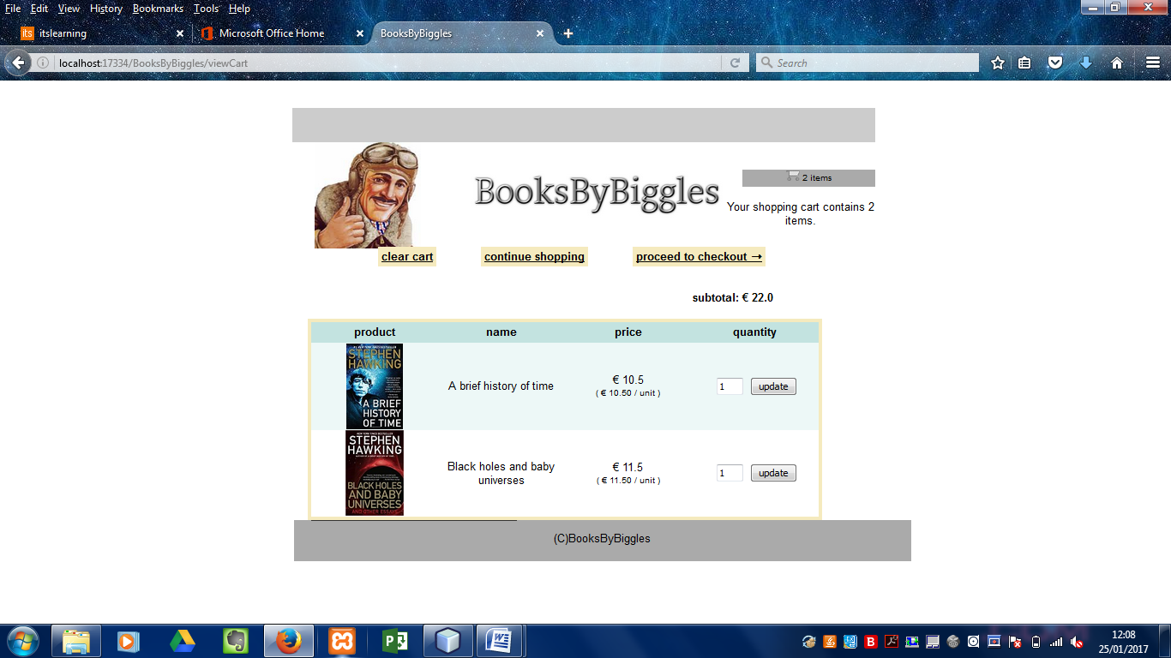

# Checkout page

<%--

Document : checkout

Created on : 26-Nov-2016, 20:25:19

Author : Ed

--%>

<%-- input customer details --%>

<div id="centerColumn">

<h2>checkout</h2>

<%-- text asking the customer to fill in customer details into the correct boxes --%>

<p>In order to purchase the items in your shopping cart, please provide us with the following information:</p>

<%-- data input fields for customer details corresponding with the correct fields in the database --%>  
<form action="purchase" method="post">

<table id="checkoutTable">

<tr>

<td><label for="name">name:</label></td>

<td class="inputField">

<input type="text"

size="31"

maxlength="45"

id="name"

name="name"

value="${param.name}">

</td>

</tr>

<tr>

<tr>

<td><label for="email">email:</label></td>

<td class="inputField">

<input type="text"

size="31"

maxlength="45"

id="email"

name="email"

value="${param.email}">

</td>

</tr>  
<tr>

<td><label for="phone">phone:</label></td>

<td class="inputField">

<input type="text"

size="31"

maxlength="16"

id="phone"

name="phone"

value="${param.phone}">

</td>

</tr>  
 <tr>

<td><label for="address">address:</label></td>

<td class="inputField">

<input type="text"

size="31"

maxlength="45"

id="address"

name="address"

value="${param.address}">

<br>

UK

<select name="cityRegion">

<c:forEach begin="1" end="10" var="regionNumber">

<option value="${regionNumber}"

<c:if test="${param.cityRegion eq regionNumber}">selected</c:if>>${regionNumber}</option>

</c:forEach>

</select>

</td>

</tr>  
<tr>

<td><label for="creditcard">credit card number:</label></td>

<td class="inputField">

<input type="text"

size="31"

maxlength="16"

id="creditcard"

name="creditcard"

value="${param.creditcard}">

</td>

</tr>  
<%-- this allows the customers purchase and personal details to appear on the confirmation page --%>

<tr>

<td colspan="2">

<input type="submit" value="submit purchase">

</td>

</tr>

</table>

</form>

<%-- information box containing sub total, delivery charge and final total costs --%>

<div id="infoBox">

<ul>

<li>Next-day delivery is guaranteed</li>

<li>A &euro; ${initParam.deliverySurcharge}

delivery surcharge is applied to all purchase orders</li>

</ul>

<table id="priceBox">

<tr>

<td>subtotal:</td>

<td class="checkoutPriceColumn">

&euro; ${cart.subtotal}</td>

</tr>

<tr>

<td>delivery surcharge:</td>

<td class="checkoutPriceColumn">

&euro; ${initParam.deliverySurcharge}</td>

</tr>

<tr>

<td class="total">total:</td>

<td class="total checkoutPriceColumn">

&euro; ${cart.total}</td>

</tr>

</table>

</div>

</div>

## Checkout page: Result

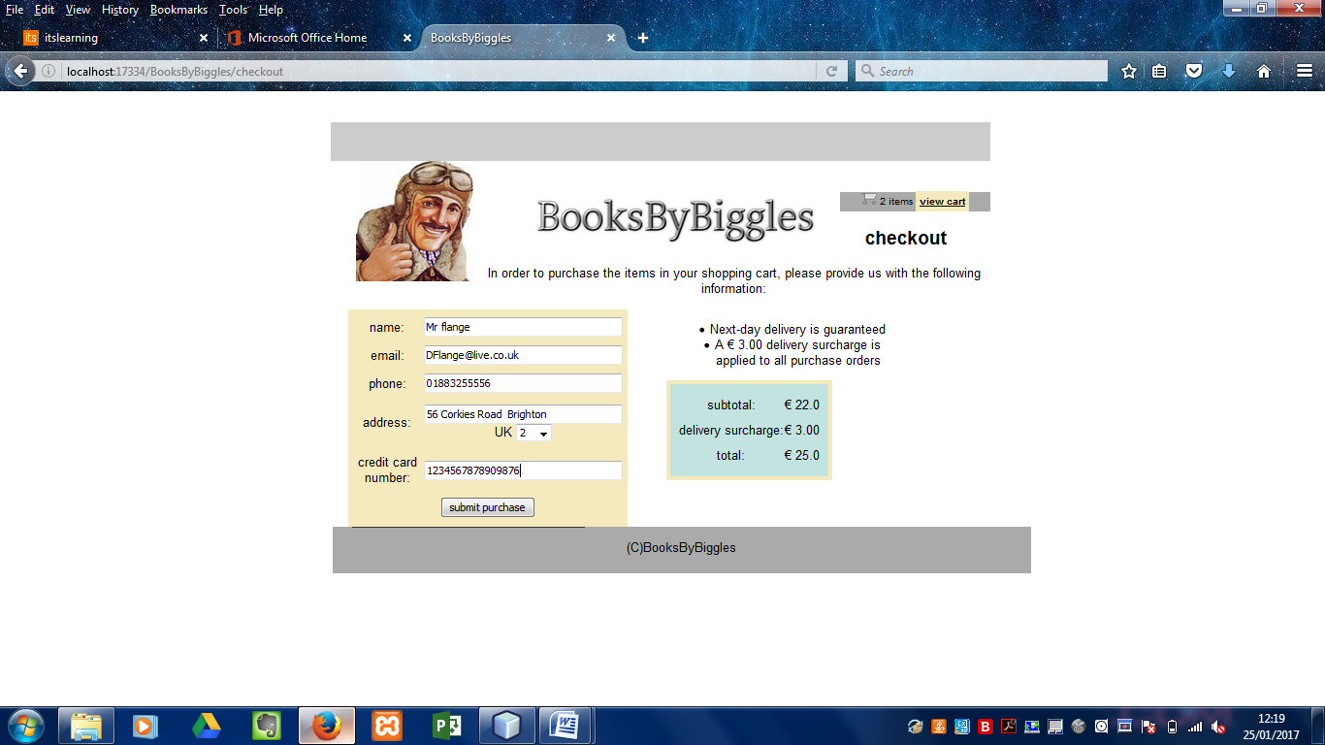

# Confirmation page

<%--

Document : confirmation

Created on : 14-Nov-2016, 12:55:51

Author : Ed

--%>

<%@page contentType="text/html" pageEncoding="UTF-8"%>

<!DOCTYPE HTML PUBLIC "-//W3C//DTD HTML 4.01 Transitional//EN"

"http://www.w3.org/TR/html4/loose.dtd">

<html>

<body>

<div id="singleColumn">

<%-- text confirming customer purchase --%>

<p id="confirmationText">

Thankyou for shopping at Books By Biggles! Please find your details below!

<br><br>

</p>

<%-- customer purchase summary --%>  
<div class="summaryColumn" >

<table id="priceBox">

<tr>

<td>subtotal:</td>

<td class="checkoutPriceColumn">

&euro; ${cart.subtotal}</td>

</tr>

<tr>

<td>delivery surcharge:</td>

<td class="checkoutPriceColumn">

&euro; ${initParam.deliverySurcharge}</td>

</tr>

<tr>

<td class="total">total:</td>

<td class="total checkoutPriceColumn">

&euro; ${cart.total}</td>

</tr></table>

</div>

<%-- customer details summary --%>

<div class="summaryColumn" >

<table id="deliveryAddressTable" class="detailsTable">

<tr>

<td class="name">name:</td>

<td class="name name">

${param.name}</td>

</tr> <tr>

<td class="email">email:</td>

<td class="email email">

${param.email}</td>

</tr> <tr>

<td class="phone">phone:</td>

<td class="phone phone">

${param.phone}</td>

</tr>

<tr>

<td class="address">address:</td>

<td class="address address">

${param.address}</td>

</tr>

<tr>

<td class="cityRegion">cityRegion:</td>

<td class="cityRegion eq regionNumber">

${param.cityRegion}</td>

</tr> <tr>

<td class="creditcard">creditcard Number:</td>

<td class="creditcard creditcard">

${param.creditcard}</td>

</tr>

</table>

</div>

</div>

</body>

## Confirmation page: Result

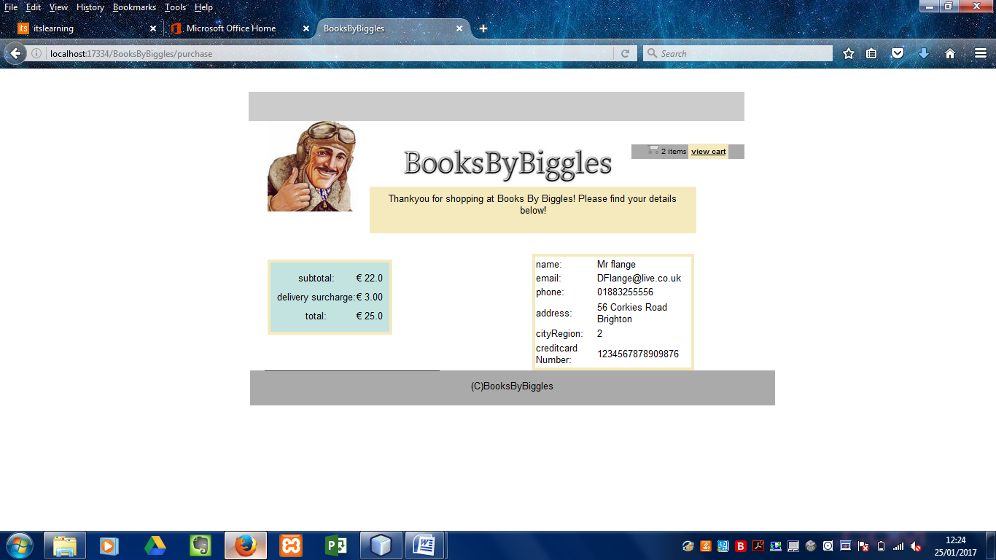

# Cascading Style Sheets

/*

Document : BooksByBiggles

Created on : 14-Nov-2016, 12:57:31

Author : Ed

Description:

Purpose of the stylesheet follows.

*/

/*

TODO customize this sample style

Syntax recommendation http://www.w3.org/TR/REC-CSS2/

*/

body {

font-family: Arial, Helvetica, sans-serif;

width: 850px;

text-align: center;

margin: 20px auto;

}hr {

border: 0;

background-color: #333;

height: 1px;

margin: 0 25px;

width: 300px;

}table {

margin: 0 20px;

border-spacing: 0;

text-align: center;

border: solid 5px #f5eabe;

}

/* general styles */

#main { background: #eee }

#singleColumn {

margin: 20px 30px;

text-align: center;

}

.lightBlue { background-color: #edf8f7 }

.white { background-color: #fff }

.bubble {

font-weight: bold;

background-color: #f5eabe;

padding: 5px;

color: inherit;

}.hMargin { margin: 0 30px }

.smallText { font-size: small }

.header {

background-color: #c3e3e0;

height: 30px;

}/* styles for elements contained in the header, i.e.,

shopping cart widget and logo */

#header {

height: 250px;

background: #aaa;

}

**#logo {**

**height: 155px;**

**width: 155px;**

**float: left;**

**margin-left: 30px;**

**margin-top: -20px;**

**}**

**#logoText {**

**float: left;**

**margin: 20px 0 0 70px;**

**/* font styles apply to text within img alt attribute */**

**font-family: 'American Typewriter', Courier, monospace;**

**font-size: 50px;**

**color: #333;**

**}#widgetBar {**

**height: 50px;**

**width: 850px;**

**float: right;**

**background: #ccc;**

**}**

**.headerWidget {**

**width: 194px;**

**margin: 20px 2px;**

**font-size: small;**

**float: right;**

**line-height: 25px;**

**background: #aaa;**

**}**

/* footer styles */

#footer {

height: 60px;

width: 900px;

clear: left;

background: #aaa;

}

/* index page styles */

#indexLeftColumn {

height: 300px;

width: 300px;

float: left;

background: #ccc;

}#indexRightColumn {

height: 400px;

width: 500px;

float: left;

background: #eee;

}

.categoryBox {

height: 140px;

width: 106px;

margin: 21px 14px 6px;

float: inherit;

background: #ccc;

}

.categoryLabelText {

line-height: 150%;

font-size: x-large;

}

/* category page styles */

#categoryLeftColumn {

width: 100px;

float: left;

margin-top: 200px;

margin-left: -600px;

padding-left: 5px;

}

#categoryRightColumn {

margin-top: 140px;

width: 100px;

float: right;

}.categoryButton {

margin: 10px 10px;

padding: 12px;

display: block;

background-color: #d3ede8;

}

#selectedCategory {

background-color: #b2d2d2;

margin-left: 1px;

width: 139px;

}

#categoryTitle {

margin: -34px 180px 0 0;

font-size: x-large;

float: left;

background-color: #f5eabe;

padding: 5px;

}

.categoryText {

line-height: 25px;

font-size: x-large;

}

#productTable { width: 600px }

#productTable tr { height: 150px }

#productTable td { width: 150px }

#productTable {float: right}/* cart page styles */

#actionBar {

margin: 30px;

width: 750px;

text-align: center;

}#subtotal { margin: 40px 0 20px 430px }

#cartTable { width: 750px }

#cartTable td {

width: 145px;

height: 90px;

}

/* checkout page styles */

#checkoutTable {

width: 360px;

background-color: #f5eabe;

float: left;

height: 280px;

}

#infoBox {

width: 300px;

padding-left: 30px;

float: left;

}

#priceBox {

padding: 10px;

margin: 10px 0;

height: 128px;

background-color: #c3e3e0;

}/* confirmation page styles */

#confirmationText {

margin: 0 20px 20px;

padding: 10px;

background-color: #f5eabe;

float: left;

width:540px;

}.summaryColumn {

margin-top: 15px;

width: 50%;

float: left;

}

#orderSummaryTable {

width: 100%;

text-align: left;

height: 200px;

}

#deliveryAddressTable {

width: 70%;

margin-left: 15%;

text-align: left;

height: 200px;

}